

Document name: | Flexible WorkingTime Guidelines  (including details of the Working Time Regulations)
Document type: | Human Resources
Staff group to whom it applies: | All staff within the Trust
Distribution: | The whole of the Trust
How to access: | Intranet and internet / ward folder
Issue date: | September 2014
Next review: | September 2016
Approved by: | Executive Management Team
Developed by: | HR / Policy Sub Group consisting of HR, Staff Side representatives and Managers
Director lead: | Director of Human Resources and Workforce Development
Contact for advice: | Human Resources Manager or Staff Side representative.

CONTENTS
Page Number

1. Introduction 1

- Scope 1
- Definitions 1

- Principles 2

- Impact of Legislation on Employment 3

  - Working Time Regulations 3
  - Flexible working Regulations 3
  - Miscellaneous factors 4

- Application Procedure 5

6.1 Guidance for Employees 5
6.2 Guidance for Line Managers 6
- Flexible Working Time Options: 7

7.1 Part-time Working 7
7.2 Job Share 8
7.3 Staggered/Compressed Working Hours 8
  - Flexi-Time 9
  - Annualised Hours 10
7.6 Term-time Working 11
7.7 Location Flexibility 12
8. Other Related Guidance 13
9. Fraud Awareness 13
10. Useful Contact Details 13
11. Equality Impact Assessment 13
12. Version Control Sheet 13

Appendices:
Appendix 1 Form - Working Record
Appendix 2 Form - Opt Out Agreement of the Working Time Regulations
Appendix 2a Standard letter – Agreement to work beyond the maximum weekly working time
Appendix 2b Form - Working Time Directive Monitoring
Appendix 2c Guidance on planning working time
Appendix 3 Form - Flexible Working Application (FW1)
Appendix 3a Form - Flexible Working Application Reply (FW2)
Appendix 3b Form - Extension of time limit (FW3)
Appendix 3c Form - Applicant’s Appeal against manager’s decision (FW4)
Appendix 3d Form - Reply to Applicant’s Appeal (FW5)
Appendix 4 Flexible Working Application flow chart
Appendix 5 Form - Managers Evaluation Checklist
Appendix 6 Equality Impact Assessment
Appendix 7 Version Control Sheet

1. INTRODUCTION

The Trust values its staff and seeks to ensure their health and well-being by providing a safe, healthy and flexible working environment. These guidelines are intended to support staff to achieve a healthy work-life balance whilst ensuring service provision is of a high quality, cost effective, flexible and responsive. The nature of the challenges facing the NHS requires managers to generate efficiencies and savings to maintain services. Managers will apply these guidelines mindful of these needs, which may result in fewer opportunities for flexible working.

  - The aim of these guidelines is to inform staff of the different flexible working options, the impact it may have on pay and benefits and the process for requesting flexible working.

  - A high level of attendance is crucial to the delivery of good quality services to people. Flexible and supportive working arrangements, which suit an individual’s changing circumstances and service needs/effeciencies are an important part of helping achieve this.

  - Flexible working requires a responsive and responsible approach. Anyone applying for a flexible working arrangement must consider the possible effects on colleagues, the service and their own terms and conditions. The Trust’s first aim must always be to meet its service needs and financial accountabilities.

  - The Trust also has an Agile Working Policy (see Trust Intranet) which sets out a framework whereby services/ways of working can be provided in a more effective and flexible way. Agile working is the term used by the Trust to describe how services can be reconfigured resulting in staff working from different locations, be that a Trust building, a community, or client site, or by varying degrees of home working and regular hot-desking. This is different from flexible working which is an individual rather than service wide arrangement.

2. SCOPE

2.1 These arrangements apply to all staff. The suitability of a post for flexible working is at the discretion of management and the quality of service delivery should always take priority.

2.2 In the event of an infectious outbreak, flu pandemic or major incident, the Trust recognises that it may not be possible to adhere to all aspects of these guidelines. In such circumstances staff should take advice from their manager.

3. DEFINITIONS

3.1 The term ‘flexible working’ describes a type of working arrangement which gives some degree of flexibility on how long, where and when the individual works. The flexibility can be in terms of working time, working location or the pattern of working. It covers a number of flexible working arrangements which are detailed in section 7.

4. PRINCIPLES

The following principles are offered as guidance to both managers and staff.

- All requests to work flexibly should be given timely and proper consideration and not unreasonably refused where service delivery can support the arrangement.

- It is recommended that any new system of working is trialled for an agreed period of up to 6 months.

- Staff working flexibly will be expected to record their hours worked and have these signed off by their manager.

- The interests and views of all staff affected by the request should be considered.

- If possible, teams should be empowered to find their own solutions to flexible working requests, which will be given due consideration by the managers.

- Standards and quality of service delivery cannot be compromised.

- The application of flexible working patterns should not result in the Service/Trust incurring additional costs and managers should seek to make efficiency savings where possible.

- Working patterns that may be detrimental to the individual’s ability to access training and update skills can only be considered as a short term option.

- The standard full time hours of staff are 37.5 hours excluding meal breaks.

- All staff must take an unpaid break of at least 20 minutes if working longer than six hours, this must not be taken at the beginning or end of the working hours.

- Some flexible working patterns may not be compatible with working extra hours outside of the existing pattern and this will need to be considered as part of the new arrangement.

- Any agreement to work flexibly is not automatically transferable upon change of role, work location, organisational change etc. In such circumstances staff should discuss their current arrangements with their manager to see if these can continue to be accomodated and a new Request Form completed if appropriate.

- Flexible working may be considered as part of a reasonable adjustments for staff with a disability, in line with the Trust’s Sickness Policy.

- Annual leave and public holidays will apply in accordance with Trust policy.

- Any deliberate attempt to falsify the hours worked, or otherwise abuse a flexible working arrangement may lead to disciplinary action and the withdrawl of the arrangement.

- When contemplating requesting flexible working, staff should consider the effect of their new working pattern on the service and their colleagues.

- Agreed flexible working arrangements should be discussed and reviewed regularly and the annual appraisal meeting presents such an opportunity. Managers should review the whole team/departments flexible working arrangements, at a specific point annually, to ensure they continue to meet both service and individual needs, eg, May each year enables changes in children’s schooling and child care arrangements, which come into effect in September to be considered fully.

- The manager should ensure records of working are retained under secure conditions. See Appendix 1, Flexible Working Recording Form.

- Employees attending dental/hospital appointment/treatment should make every effort to arrange appointments outside of working time. This time should be taken from any outstanding lieu/flexi time or worked back. See also Trust’s Special Leave Policy.

5. IMPACT OF LEGISLATION ON EMPLOYMENT

Managers may wish to consult with a HR representative when an individual requests a significant change in the method of working, or if the manager wishes to introduce a change, as this may result in a contractual change. The following legal requirements must be considered.

5.1 Working Time Regulations

The Regulations came into force on 1 October 1998 (amended in 2007 and subsequently amended on an almost annual basis) and implemented the provisions of the EC Working Time Directive placing restrictions on hours worked. The Trust discourages the working of long hours wherever possible, however staff may agree in writing to opt-out of the restrictions, particularly where there may be a conflict of interests. Staff are also required to get permission from their line manager before they engage in any additional work. If the combined hours worked each week exceed 48 hours on average, then a written opt out agreement, signed by both parties is required (see Appendix 2 – 2c). However, if managers believe this could be a health and safety risk, permission may be withheld. The main details of the Working Time Regulations are as follows:

- The Regulations allow a maximum working week of 48 hours per 7 day period (including Saturday and Sunday) when averaged over a 17 week reference period (other periods up to a maximum of 52 weeks can be agreed with employees and/or trade unions). Where the individual has agreed, in writing to an opt-out of these arrangements, this limit should not apply.

- The normal hours of work for ‘Night workers' (any one who works between 11pm and 6am), shall not exceed an average of 8 hours for each 24 hour period. Night workers must have a health assessment before undertaking night-time working and offered one at regular intervals thereafter.

- Adult workers are entitled to an (unpaid) rest period of 11 consecutive hours in each 24 hour period and 24 hours uninterrupted rest in any 7 day period or 48 hours in 14 days. (At least one day per week or two per fortnight must be taken as days off).

- Young workers (16 to 18 years) are restricted to working 8hrs per day/40hrs per week. Except in specific circumstances they cannot work between 10pm and 6am or 11pm to 7am. They are entitled to a rest period (unpaid) of 12 consecutive hours in each 24 hour period and to 48 hours uninterrupted rest in any 7 day period.

- Adult workers should take at least a 20 minute unpaid rest break when working time is over 6 hours (4.5 hours for young workers). Rest breaks must be taken within the working time and not at the beginning or end of it.

- There are a number of circumstances, in which the provisions relating to breaks in the working day, (ie, daily rest, weekly rest and night working), do not apply. Such exceptions would apply where there is a need for continuity of service (eg residential carers); where there is a need to provide security or protect persons or property (eg emergency call out services); where there is a foreseeable surge in activity (eg winter pressures); where there are unusual or unforeseen circumstances beyond the employers control (eg extreme unexpected weather conditions which demand extra work to be carried out). The regulations can be complex and Managers should seek advice from a HR representative as appropriate.

5.2 Flexible Working Regulations

The Regulations applied from April 2003 (enacted through the Employment Rights Act 2002 and several other pieces of legislation subsequently). They give employees a statutory right to apply for flexible working to facilitate the care of a child or an adult dependant. The Trust however accepts requests from all its staff who have at least 26 weeks continuous service, regardless of whether they are parents or carers. From June 2014 the legislation changes and will also be extended to all employees. Flexible working relates to the hours worked, times worked, and work location. The Trust has a duty to consider a request for flexible working and is entitled to refuse a request if one or more the following business-related reasons apply:

Burden of additional costs; if it will cost more to replace hours of work eg, agency costs | Detrimental impact on quality eg, continuity of care, skill mix, etc
Detrimental affect on ability to meet  Customer demand | Insufficiency of work during the periods  the employee proposes to work
Inability to reorganise work among existing staff; or to fill the hours | Detrimental impact on performance; eg. inability to retain clinical skills, adverse impact on colleagues working lives
Inability to recruit additional staff | Planned structural changes or any other substantial reason

5.3 Miscellaneous factors

- Managers should be minded that although a flexible working request can be refused; such a refusal may still be indirectly discriminatory, if it cannot be shown that the refusal was justifiable, as a proportionate means of achieving a legitimate aim. If in doubt contact a HR representantive.

- Staff taking up a flexible working option which result in their working reduced hours, will be paid on a pro-rata basis according to the number of hours worked. The employee should seek advice from Payroll services if necessary prior to agreeing a flexible working proposal, so that specific salary/pension details can be calculated and considered by the employee.

- Deductions from salary for the NHS Pension Scheme are made monthly and will continue at the normal percentage rate unless, during periods of unpaid leave (eg. Employment Break) the individual leaves the scheme (for periods of 12 months or more) or agrees to make retrospective contributions. Pension payments and benefits will be affected by a reduction in an employee's working hours, working year or periods of unpaid leave. Contact Pension/Payroll services, Kendray Hospital for advice.

6. APPLICATION PROCEDURE

6.1 Employees

- Employees must have 26 weeks services and not have made a previous application within the past 12 months. However, However the Trust may consider a new application where there has been a significant change in circumstances.

- Consider the practical implications of the request and how your department/service would cope, as well as the effect of the change on terms and conditions, such as pay and pension.

- Put your request in writing using the Application Form at Appendix 3. All parts of the form should be completed, signed and dated and returned to your line manager. A separate form should be completed for each flexible option you wish to be considered.

- It may be that your line manager might be able to meet your request in part, but not in full, or may need to defer a decision until after a trial period. How flexible can you be, might there be alternative ways to meet your needs?

- Get an agreement from your line manager as to when she/he will be able to give you an answer. This time period will need to reflect both the significance and urgency of your request. Your manager must consider the needs of the service and may not be able to accommodate your request.

- If your line manager is unable to grant your request, the reasons for this will normally be discussed with you and explained in writing to you. You may appeal against this decision to the next level of management. You should arrange to do this within 7 days from receiving the formal response from your line manager.

- Individuals may revert back to their original pattern of working within a trial period subject to their giving the agreed notice to enable their manager to make alternative arrangements. Thereafter it will be subject to agreement with their line manager. In circumstances where a service has been restructured to meet service demands there would be no automatic right to revert back and this would have to be agreed again with the line manager.

- Where flexible working has been agreed and individual’s needs change, it is expected that the individual would not unreasonably maintain the arrangements, particularly when other colleagues would themselves benefit from greater flexibility. The Trust reserves the right to terminate a flexible working agreement, following consultation with the individual, subject to four weeks notice in writing, if the service is adversely affected or the needs of the Trust/Service change. All Flexible Working arrangemts will be reviewed as necessary but at least in May each year as to whether they continue to meet service and individual needs.

6.2 Line Managers

- Should ensure that they deal with applications for flexible working in a timely manner, see Flow chart - Flexible working application process at Appendix 4. A checklist to assist managers in evaluating a flexible working request, Appendix 5

- Discuss the initial request with the individual(s), and remind them to put their request in writing to you, by completing the Application Form at Appendix 3. If you can agree their request immediately, without holding a meeting, then do so confirming agreement in writing. If you are unable to agree immediately, then agree with the individual(s) a date by which you will have completed your consideration of their request, taking account of its complexity, as well as its urgency.

- Consult as appropriate with relevant colleagues, other team members, your own manager, human resources representative etc, on the service and contractual implications of the proposal.

- Consider how best to accommodate the request without impairing service standards or, business related reasons for rejecting the request. Take account of “The Points to be considered” outlined in each option below.

- Requests should be considered in the order they are received. Having considered and approved the first request the business context will then have changed and can be taken into account when considering a second request.

- If more than one request is received, managers are not required by law to make a value judgement about the most deserving request. Each request should be judged on its own merits looking at the business impact and possible impact of refusing a request (see paragraph 5.2). Managers may seek the agreement of the employees concerned to consider some form of random selection to decide if unable to distinguish between all the requests.

- If unable to approve a request because of the adverse effect on service provision, managers may ask for volunteers from existing flexible working staff to revert back to their original or change to some other arrangement. The manager should also review the whole team/service as necessary but at least each year in May to determine the most effective way of delivering services and the possibility of increased (or decreased) capacity for granting new requests.

- Ensure that safe working systems can be put in place and that the health and safety of staff or others is not compromised. A risk assessment form, obtained from the Health and Safety section of the Trust’s Intranet, should be undertaken, taking due account of lone working, building security, use of equipment, shut down procedures, prohibited operations and less experienced or young employees etc.

- Hold a meeting with the individual(s), as soon as possible but normally within 28 days of receipt of their written application and give them the opportunity to bring a fellow worker, or Trade Union representative to the meeting.

- Requests may be declined where they cannot reasonably be met. However, it would not be within the spirit of the Guidelines if your only concern was that whilst you could accommodate one request, you could not necessarily accommodate others of a similar nature in the future. Each case must be considered within the existing circumstances.

- Write to the individual(s), normally within 14 days of the meeting informing them of your decision and the reasons for this (see Form at Appendix 3a). Following a trial period a further meeting should take place with the individual(s) and a decision made as to whether the arrangements will/will not continue. The outcome of the meeting should be confirmed in writing, normally within 14 days. The individual(s) should be advised that if dissatisfied with your decision, they may write to the next level of management within seven days of receipt of your letter. Please bear in mind the legitimate reasons for refusing a request for flexible working that are given under the Act and which are outlined in paragraph 5.2.

- The Trust is monitoring all applications and outcomes (supported or unsupported), local service monitoring will be through the HR Business Partners/Business Managers. Managers must send a copy of the Application Form and confirmation of outcome, to the Human Resources Department, Ward 2, Castleford Hospital, Lumley Street, Hight Town, Castleford, WF10 5L. Copies of all correspondence must be placed on the individual’s personal file. A Staff Changes Form (HRS3), should also be completed and processed in the usual way where there is a contractual change ie, a change in hours.

7. FLEXIBLE WORKING TIME OPTIONS

The menu of options is not exhaustive and staff may apply for alternative arrangements of their own devising that suit the service and their individual circumstances.

7.1 PART TIME WORKING – (Prevention of less Favourable Treatment Regulation 2000 Sl 2000/1551 Sexual Discrimination Act 1975)

Definition
Contracted to work less than the full time hours for the post on a permanent basis.

Points to be considered
- Part time staff should not be treated differently from full time staff

- How many working hours a week are required to meet service needs

- Are there any special overlaps required between the part-time postholders/and others

- Could service needs be covered without unreasonable additional cost

- What is the impact on the rest of the team

- Can temporary flexibility be shown in the event of a crisis over which the employee has little or no control

Impact on pay and benefits
Salary and all pay related benefits are reduced pro-rata to the full-time entitlement, eg:
- Pay awards/salary increase
- Death in-service benefits
- Pension
- Redundancy Pay
- Holiday and Special Leave/Pay
- Sick Pay and Maternity Pay

7.2 JOB SHARE

Definition
Two (or more) people voluntarily sharing the responsibilities of a full time post in a seamless manner. This arrangement has the constraint that if one party to the job share leaves the employment of the second party is affected. See the Trust's Internet - Job Share Scheme for more detail.

Points to be considered
- Can the duties/responsibilities be clearly defined and measured for each person
- Could two (or more) people provide the skills required
- Would the role benefit from longer than the normal full-time working hours per week and
are there funds for this
- Accountabilities for each “job sharer” will need to be clearly defined.
- What happens if one partner leaves the shared role:-
If a replacement can not be found the role should be offered on a full-time or increased hours to remaining “job sharer(s)”
If this is not acceptable to remaining “job sharer(s)” then replace with full-time employee

Impact on pay and benefits
Salary and all pay related benefits are reduced pro-rata to the full-time entitlement, eg:

- Pay award/salary Increases
- Pension/in-service death benefits
- Redundancy Pay
- Holiday and Special Leave/Pay
- Sick and Maternity Pay

7.3 STAGGERED/COMPRESSED WORKING HOURS

Definition
This allows normal working hours/days to be varied whilst working the contracted hours for the post. Compressed working results in longer hours being worked over fewer days in order for the remaining time/day to be taken as non-work time. For example, contracted hours may be worked over a 4.5 day week or, 9 day fortnight. Staggered working involves the individual working different start and finish times to colleagues. This can be flexible/fixed hours throughout the week or fixed on one or two days etc, to meet service/individual needs.

Points to be considered
- Actual working arrangements must be agreed with the manager to ensure service needs are met in full

- Weekend work is not included unless currently part of the working pattern or proposed new service

- Staggered hours cannot normally apply to staff that are rostered, it can only apply to those working a ‘standard’ working week and who are not required to handover to an oncoming shift

- Agree how the compressed week’s non-work time will be taken eg, on a fixed or rolling day basis. Non-work time not taken in an accumulation period cannot be carried forward and will be lost

- Annual leave /bank holiday entitlement should be calculated in hours

Impact on pay and benefits
Pay and benefits are not affected on the basis that the full-time hours for the job are worked over five days or less

7.4 FLEXITIME

Definition
Allows staff to vary their working hours within the boundaries of an agreed extended day to accommodate fluctuations in service delivery and staff needs. Staff may work flexibly outside a specified core band of hours, relevant to their Service/Department. The scheme allows for time to be accrued over a 4 week settlement period to be taken back during the next 4 week settlement period. The individual keeps a running total of hours worked. If the individual accrues hours in excess of that allowed as time off in lieu (usually a whole of half day), the hours will be disregarded and not paid.

Points to be considered
- Can the required level of service be provided at all times, particularly peak periods

- Does the service provision require a whole team approach

- Are there fluctuating service needs which can be accommodated by a flexible approach

Impact on pay and benefits
Pay and benefits are not affected on the basis that the individual’s contracted hours are worked over the settlement period.

Example of a flexitime scheme
As schemes already exist in some areas of the Trust these may continue unless the manager, in consultation with their teams agree to change to the one described below.

The day will be divided into ‘core hours’ relevant to the Service/Department, which must be covered and ‘flexihours’ where additional time may be worked and counted towards flexi hours:
Example of Core Hours: 10.00am - 12.00 midday and 14.00pm - 16.00pm
Example of Flexi hours: 8.00am - 10.00am and 16.00pm - 18.30pm

The working day width is usually from 08.00am – 18.30pm subject to service provision. However, it may be more practical for certain services to become operational before 8.00am.

Staff must take a minimum of 20 minute unpaid break if working over 6 hours and of not more than 2 hours duration. The above is subject to the agreement of the line manager and subject to adequate cover between core hours. Breaks are unpaid and in addition to the working day (eg, 7.5hrs for full time staff).

The balance carried forward from one settlement period of 4 weeks to the next should normally be the equivalent of the individual’s longest working day, ie +7.5 or -7.5 hours for full time staff. No more than this can be carried forward into the next 4 week settlement period.

Where an employee regularly accrues more than 7.5 hours per week and potentially 'loses' time or, where they regularly have a debit up to –7.5 hours, the manager should assess workload requirements in discussion with the employee.

Annual Leave is agreed/recorded in the usual way with the manager.

7.5 ANNUALISED HOURS

Definition
An arrangement in which the hours of work are spread unevenly throughout the year (or 3 or 6 month period). Particularly suitable in situations where there are predictable/unpredictable service fluctuations. Hours worked can be increased during peak periods and decreased/ceased during quieter periods.

Points to be considered
- Does the role show a peak and trough pattern which would lend itself to annualised hours/term time working, without an adverse affect on service needs

- Can the service accommodate/adapt to lengthy periods of absence or reduced hours. What maximum period of absence could the service/department tolerate

- How would the working pattern be arranged eg, agree number of hours/days per week/month/year, to be worked. Notional working patterns should be planned as far ahead as possible

- Example of calculation of annualised hours for an individual who works 4 hrs per day, 20 hrs per week, 5 days per week, 52 weeks per year = 20 x 52.142857 payment weeks per year, =1042.8 hrs per year

- Salary is paid over 12 equal monthly instalments with a recovery clause for any overpayment if the individual leaves before completing the contracted hours for the period

- Consider if the system requires careful planning including staff side consultation

- Hours worked should be recorded on a weekly basis and monitored on a monthly basis to ensure that at year end, the individual is on track to have worked the annual contracted hours. Any working which would accrue unsocial hours payment must be justified and authorised by the line manager prior to being worked. Overtime will not normally be paid for hours worked above 37.5 hours

- Annual leave should be calculated in hours

- Sick pay and monitoring only applies on ‘work’ days

Impact on pay and benefits
If the individual does not work the full time hours for the post, salary and all pay related benefits are reduced pro-rata to the full-time entitlement eg:-

- Pay awards/salary increases

- Death in-service Benefits

- NHS Pension Scheme benefits

- Redundancy Pay

- Holiday and Special Leave/Pay

- Sick Pay and Maternity Pay

7.6 TERM-TIME WORKING

Definition
Term-time working enables staff who have school age children to work during school time and spend time away from work during school holidays. It can be difficult to implement and is mainly used as a temporary short-term arrangement.

Points to be considered
- Can the service accommodate periods of absence during school holidays. Consider if the job needs to be covered during the periods of absence and if additional staff costs will be incurred as this would suggest term time working is not suited to meeting service needs.

- Do school holidays coincide with a natural dip in activity

- Are other skilled staff readily available to fill the gap during school holidays

- What would be the impact on other staff wishing to take leave during school holidays and could the service accommodate requests from other staff

- Salary is paid over 12 equal monthly instalments with a recovery clause for any overpayment if the individual leaves before completing the contracted hours for the period

- Term-time working staff only take ‘leave’ during school holidays as their monthly salary includes a payment for annual leave. Pay and annual leave is normally calculated over a working year of 39 working weeks

- Example of calculation of leave and general public holidays for 39 week, term-time working

Calculation of leave/public holidays if based on 52 working weeks per year:
27 days annual leave per year ÷ 5 days (working week) = 5.4 weeks annual leave per year.
8 public holidays ÷ 5 days =1.6 weeks public holidays per year.
5.4wks ₊ 1.6wks = 7wks total leave entitlement for full time staff per year.

Calculation if leave based on 39 working weeks term-time only per year:
52 wks - 7wks leave =45 weeks
39 weeks term time ÷ 45 weeks x 7 wks leave = 6.2 weeks leave
6.2 weeks x 5days (working week) = 30.45 days leave per year.

- Sick pay and monitoring only applies on ‘work’ days

Impact on pay and benefits
If the individual does not work the full time hours for the post, salary and all pay related benefits are reduced pro-rata to the full-time entitlement eg:-

- Pay awards/salary increases

- Death in-service Benefits

- NHS Pension Scheme benefits

- Redundancy Pay

- Holiday and Special Leave/Pay

- Sick Pay and Maternity Pay

7.7 LOCATION FLEXIBILITY

Definition
Location Flexibility is a practical consideration where an individual’s work is self-regulated and discrete to the extent that an employee can meet their contractual obligations working from a variety of locations or away from their office/normal work location on an occasional or temporary basis. This is different from Agile working where the service as a whole is provided in a more flexible way. See the Trust’s Agile Working Policy for information on changing Service working arrangements.

Points to be considered
- There should be clarity around what work will be accomplished by using different locations and what is deemed as base for travel expenses

- It is not likely to be suitable if the job involves constant personal interaction with colleagues/patients

- An employee must also be flexible to attend the Trust's offices for essential interaction with colleagues, and training or development courses as required

- Staff will be subject to the same performance measures, processes and objectives that apply to office based employees

- Additional costs must not be incurred as a consequence of the arrangements

- Staff must have access to the Trust’s network, a telephone/mobile phone and other equipment used regularly eg, printer and fax machine. Staff working from home on a regular basis should check with mortgage lenders, insurers or landlords to confirm there are no restrictions placed on home working. (See Trust’s Remote Working Policy for further details)

- Staff are responsible for equipment and to ensure that the alternative-working environment is ‘fit for purpose’. Staff must comply with the IT security and data protection requirements and maintain confidentiality of any Trust documents, files, papers etc
Impact on pay and benefits
Pay and benefits are not affected on the basis that the full-time hours for the post are worked. Staff working part-time will be entitled to salary and other benefits on a pro-rata basis.

8.0 OTHER RELATED GUIDANCE

The Trust has the following:
- Special leave Policy

- Adoption Rights and Benefits Policy

- Maternity Leave Policy

- Paternity Leave Guidance and Information

- Agile Working Policy

- Remote (including home) Working Policy

Please contact your line manager, Trust website/intranet or HR Manager for further information.

9.0 FRAUD AWARENESS

Fraud within the NHS is unacceptable and diverts valuable resources away from patient care. Any concerns over deliberate misapplication of the flexible options outlines in these Guidelines should be reported to your manager or Trust’s local Counter Fraud Specialist. Please refer to the Trust’s Fraud and Corruption Policy.

- USEFUL CONTACT DETAILS

- Department for Work and Pensions (DWP) www.dwp.gov.uk

- Inland Revenue Website:
www.inlandrevenue.gov.uk

- Go to www.direct.gov.uk

11.0 EQUALITY IMPACT ASSESSMENT

The EIA is included at Appendix 6.

12.0 VERSION CONTROL

The Version Control sheet is included at Appendix 7.
Appendix 1
WORKING RECORD FORM

Name ______________Department______________Hrs +/- forward__________ from previous month

Date | Morning |  |  | Afternoon |  |  | Daily | Weekly
 | In | Break | Total | In | Break | Total | Total | Total

Signed/date……………………………………………Signed/date…………………………………………
(Employee) (Manager)

To be retained by the manager
Appendix 2

Agreement to Opt Out of Regulation 4(1) of the Working Time Regulations
1998 About Maximum Weekly Working Time

1. I (name) ................................ agree with the South West Yorkshire Partnership NHS Foundation Trust, of Fieldhead, Ouchthorpe Lane, Wakefield, WF1 3SP, "the Trust" that the limit in regulation 4(1) of the Working Time Regulations 1998 shall not apply to me and that my average working time may therefore exceed 48 hours for each seven-day period (as defined by and calculated in accordance with the Working Time Regulations 1998).

2. This agreement shall apply from (date).................................. .

3. I agree that I will comply with any and all policies of the Trust, from time to time in force, which relate to its maintenance of records of my hours of work.

4. This agreement can be terminated by me giving at least seven days notice in writing to the Trust.

Signed: ............................................................. Date: .......................
(Employee)

Name: ..............................................................
(please print)

Signed: ............................................................. Date:………………...
(Manager)

Name: ..............................................................
(please print)

Copies to: The employee
The employees manager
Payroll, for personal file
Appendix 2a
DATE

Name
Address
Postcode

Dear Colleague

WORKING TIME REGULATIONS 1998 - AGREEMENT TO WORK BEYOND THE MAXIMUM WEEKLY WORKING TIME

I am writing to confirm the arrangements for individuals to work beyond the 48 hour per week average specified by the Working Time Regulations 1998.

The Working Time Regulations state that an employee cannot be required to work for more than an average of 48 hours per week, unless she/he signs an individual agreement, agreeing that this limit will not apply to him/her.

Although the Trust believes that it’s established working hours suit both its employees and service needs, we recognise that from time to time you may wish to work more than 48 hours per week. Particularly if you work significant amounts of voluntary overtime, or have another job with another employer. However, to do so you will need to sign and return the agreement (on the reverse of this letter) to me. The sole purpose of the agreement is to ensure that our current working practices comply with the law. There will be no change to your terms and conditions of employment as a result of this agreement.

If you have any concerns about this agreement, please contact me immediately. If you wish to subsequently cancel this agreement, you may do so by providing at least seven days notice.

Yours sincerely

Line manager

Copy to: Payroll for personal file

Appendix 2b

SOUTH WEST YORKSHIRE PARTNERSHIP NHS FOUNDATION TRUST

WORKING TIME DIRECTIVE MONITORING FORM (48 HOURS)

NAME: |  |  |  | JOB TITLE:
 |  |  |  | DIRECTORATE:
 | Week Commencing | Hours worked in this Trust | Hours (other paid work) |  | Week Commencing | Hours worked in this Trust | Hours (other paid work)
1. |  |  |  | 14.
2. |  |  |  | 15.
3. |  |  |  | 16.
4. |  |  |  | 17.
5.
6.
7.
8.
9.
10.
11.
12.
13.
SUB TOTAL |  |  |  | SUB TOTAL
 |  |  |  | 17 WEEKS TOTAL
 |  |  |  | 17 WEEKS AVERAGE
Have you signed an agreement to work more than an average 48 hours Yes/No
Signed: |  |  |  | Date:
On completion, please pass this form to your Manager
Signed:  (Manager) |  |  |  | Date:
Action required:

Form to be retained by Manager for 2 years.
Appendix 2c

GUIDANCE ON PLANNING WORKING TIME

The Working Time Regulations 1998 introduced measures which ensure that workers do not work excessive hours. The Regulations are viewed as an important piece of Health and Safety Legislation which helps protect the health of staff who work for the Trust from the potentially harmful effects of working continuously for excessively long periods. Also, when staff work excessive hours, there is a greater risk of accidents happening and mistakes being made.

The Working Time Regulations cover the following areas:
- An average 48 hour working week
- Four week’s paid annual holiday
- One day’s rest in seven (or two a fortnight)
- 11 hours rest between working days
- A 20 minute break if the working day exceeds 6 hours
- Health assessments for night workers
- An 8 hour limit on night working

The following good practice guidance has been developed to assist duty planning and use of overtime to help prevent excessive hours being worked.

As new services are planned and developed within the Trust, the following guidance will be adhered to to ensure the new service complies with the Working Time Regulations.

The Trust does not require staff to work more than their contracted hours. However, there may be occasions when staff are asked to undertake additional duties but, hours worked should not normally exceed an average of 48 hours per week (over a 17 week period).

Duty Planning

Those staff who wish to, or are likely to, exceed an average of 48 hours per week must agree to this by signing the accompanying agreement. This means they agree to working voluntarily beyond the 48 hour average specified in the Regulations. The following conditions are based on the Working Time Regulations and Good Practice and should be observed.

1. Ward Managers will supervise and monitor rota planning and work patterns.

2. All overtime/additional hours will be monitored by Ward Managers.

3. Staff who also undertake work outside of the Trust should be asked of additional hours already worked to ensure that they do not work excessive hours.

4. It is the responsibility of staff to advise of hours already worked when agreeing to work overtime for the Trust.

- No more than six consecutive days will be rostered, unless this is necessary and requested by the member of staff concerned.

6. Staff must have at least one day off per week (seven day period). Except where shift patterns provide for compensatory time off in the following seven day period (eg seven on, seven off night shifts), when at least two consecutive days off must be taken.

7. Staff should not work double shifts which include a night shift.

8. Where, exceptionally, staff are asked to work overtime during a period of annual leave, a record should be made on their leave card and care taken to ensure the legal minimum leave period of 4 weeks is taken.

The Working Time Regulations are complex and subject to change, advice can
be sought from a Human Resources representative
Appendix 3
Private & Confidential

FLEXIBLE WORKING APPLICATION FORM
(FORM FWR1)

NOTE TO THE EMPLOYEE(S) (an individual or team can submit an application)
You should first read the Trust’s Guidelines on Flexible Working. If you need further advice please contact, your Manager, HR or Trade Union representative.

It may take up to 14 weeks to consider your request before it can be implemented and possibly longer where difficulties arise. You should therefore, ensure that you submit your application well in advance of the date you wish the request to take effect.

It is important that you complete all the questions fully. Normally, within 28 days of receipt of your application, your manager will meet with you to discuss your request. If the request is granted, this would result in a temporary or substantive change to your terms of employment.

NOTE TO THE MANAGER
It is your responsibility to give serious/timely consideration to this request. Normally, within 28 days of receipt of the application, you should hold a meeting with the individual(s) to discuss the outcome of their request. You should confirm receipt of this application using the attached confirmation slip.

Form FWR2, the Flexible Working Application Reply Form is available to respond to this application. Please refer to the Trust’s Flexible Working Guidelines or contact a HR representative for assistance.

1a. Personal Details

Name: Job Title:

Print Department /

BDU

Manager:

Print Tel no:

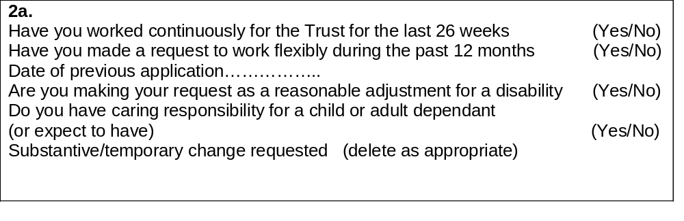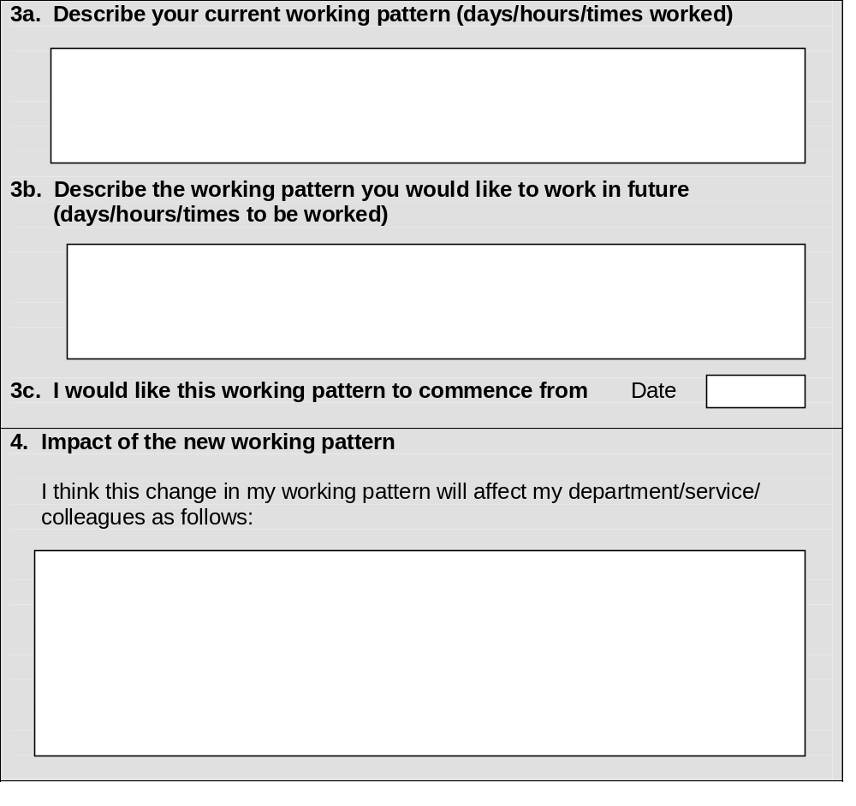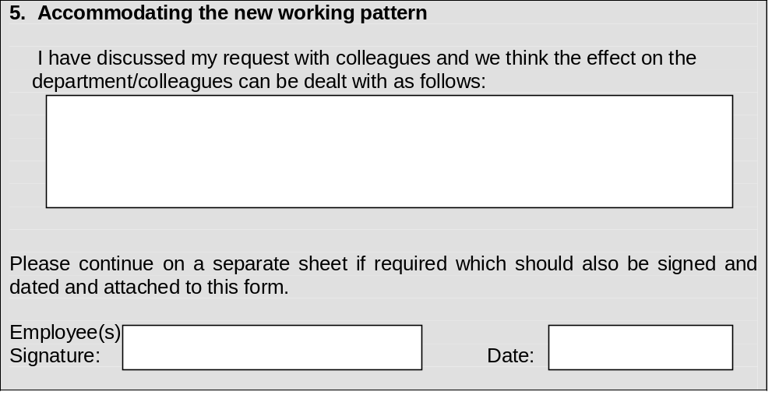 NOW PASS THIS APPLICATION TO YOUR MANAGER
………..………………………………………………………………………………………...

Cut this slip off and return it to your employee(s) in order to confirm your receipt of their application

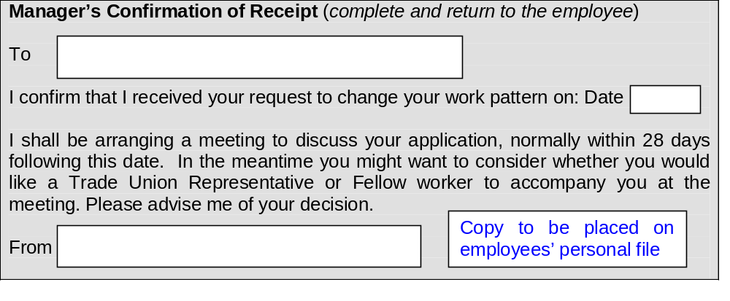

Appendix 3a
FLEXIBLE WORKING APPLICATION - REPLY FORM
(FORM FWR2)
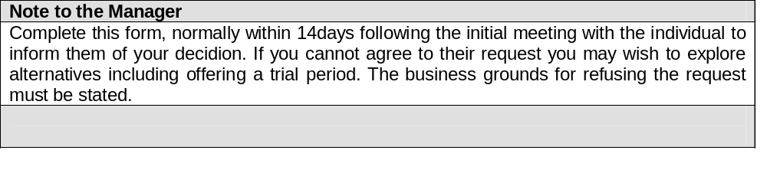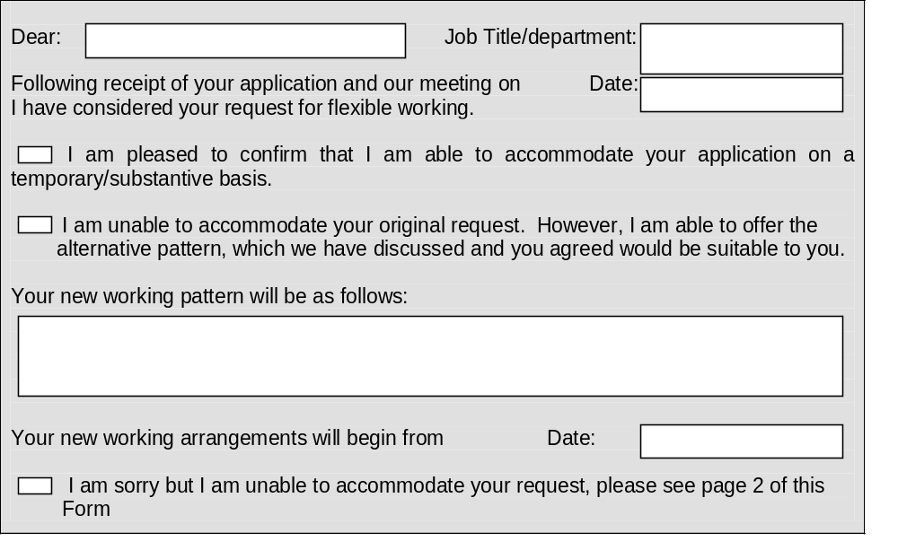
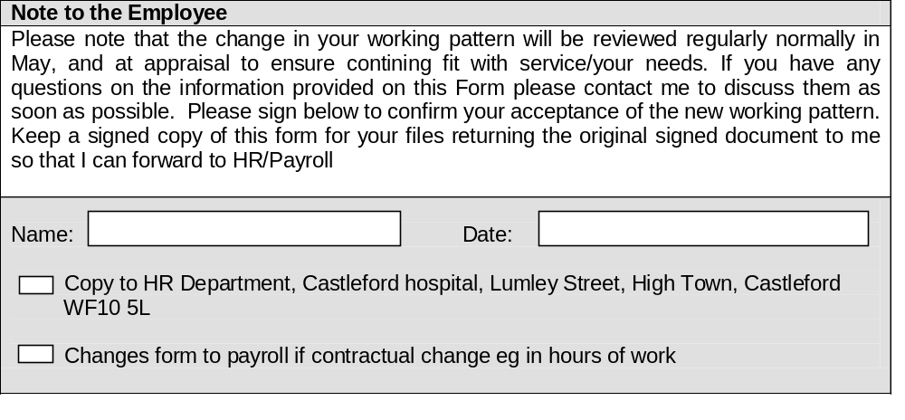 Manager’s grounds for refusal of request to work flexibly

(A list of valid grounds is included in paragraph 5.2)

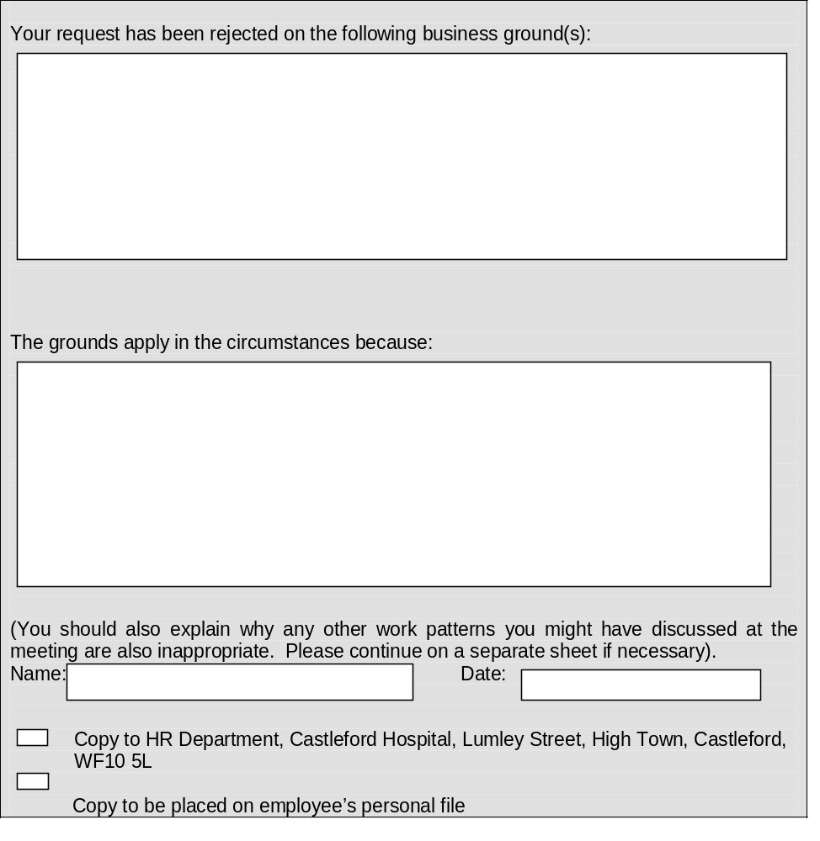
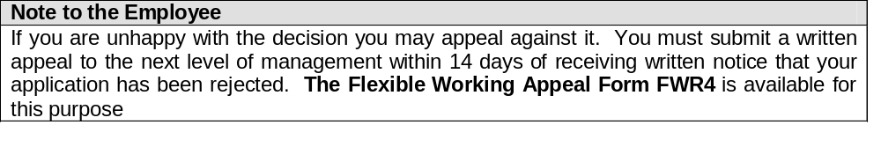
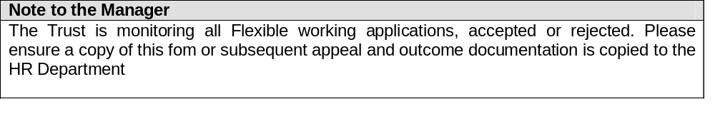
Appendix 3b
FLEXIBLE WORKING - EXTENSION OF TIME LIMIT FORM
(FORM FWR3)
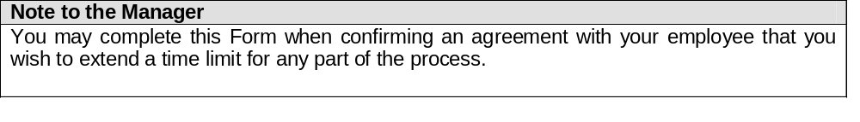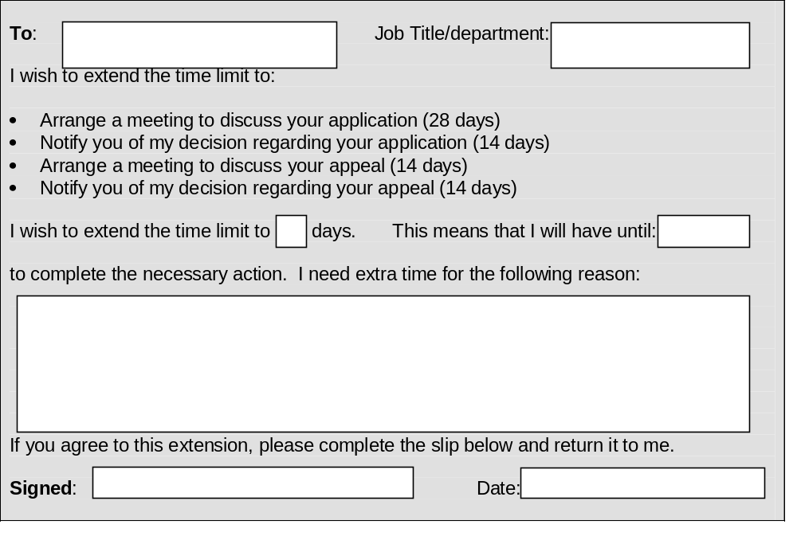NOW PASS THIS APPLICATION TO YOUR EMPLOYEE
…………………………………………………………………………………………………..
Cut this slip off and return it to your manager in order to confirm your acceptance of their request
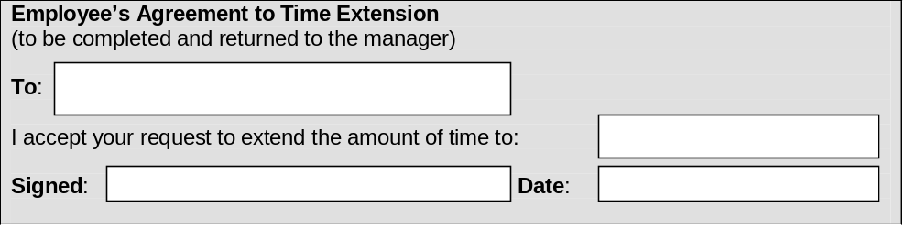 Copy: Payroll for personal file
Appendix 3c
FLEXIBLE WORKING REQUEST - APPEAL FORM
(FORM FWR4)

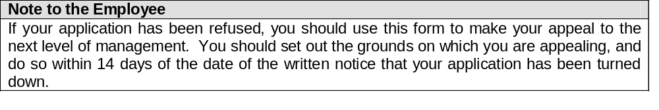
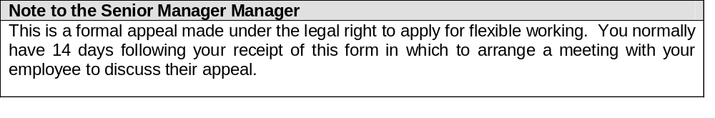
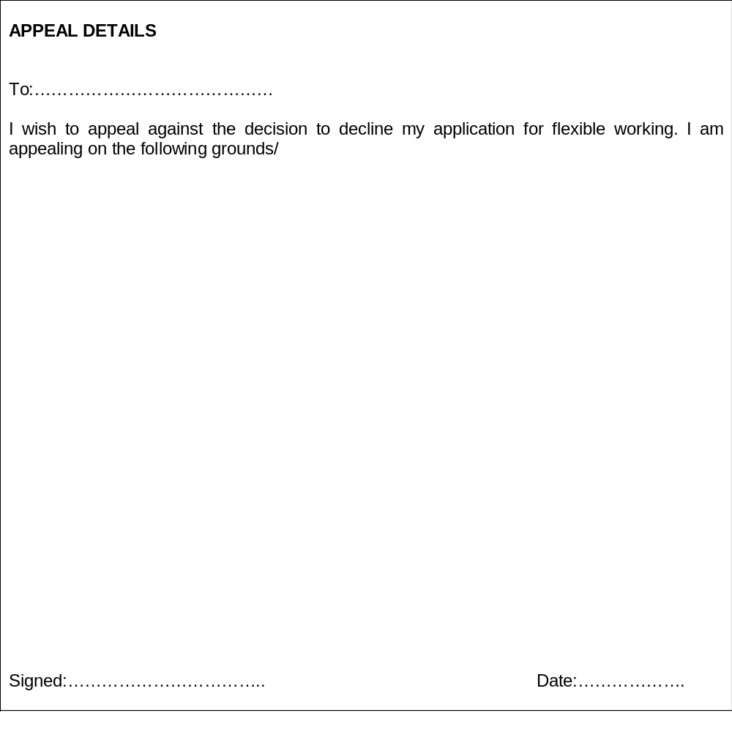
Appendix 3d

SUBMIT THIS FORM TO THE NEXT LEVEL OF MANAGEMENT

FLEXIBLE WORKING APPEAL REPLY FORM
(FORM FWR5)

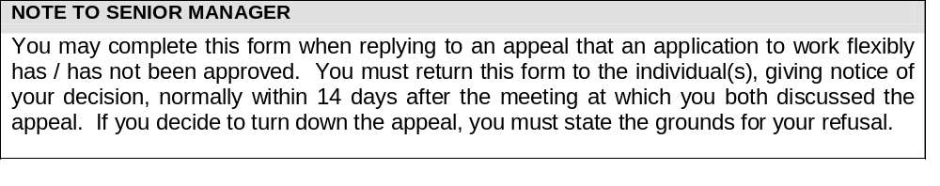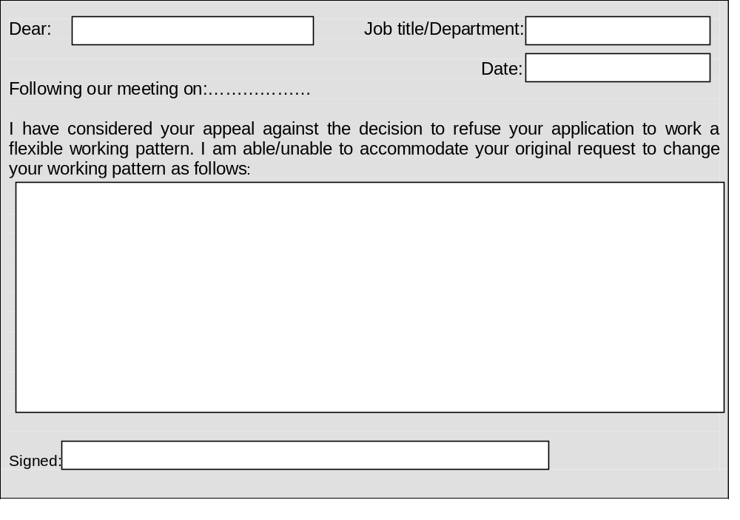
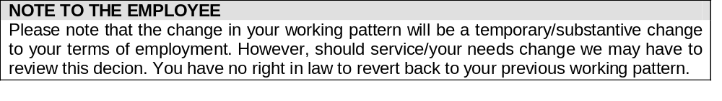Copy: To Applicant
HR Department, Castleford Hospital for personal file.
Appendix 4
FLEXIBLE WORKING APPLICATION PROCESS
Employee completes form FWR1 and sends to manager who checks eligibility and deals with request in a timely manner sends confirmation of request to staff

request is
REJECTED
Discuss request asap, normally within 28 days or form FWR3 sent to staff
Manager and employee meet to discuss the application if necessary
normally within
14 days
The manager discusses/writes notifying the employee of their decision on form FWR2
request is
ACCEPTED
Both the employee and the manager will need to consider what arrangements they need to make for when the working pattern is implemented. Manager sends a copy of the Application form to HR department, Castleford, for monitoring purposes and a staff changes form (if there is a contractual change eg, in hours) to payroll, Kendray, Barnsley

The employee needs to decide if they wish to appeal against the manager’s decision. If so, they must appeal in writing on form FWR4 setting out the grounds for their appeal to the next level of management

normally within
14 days

Senior Manager receives the employee’s written appeal

normally within
14 days

Senior Manager and employee to discuss the appeal
Both the employee and the manager will need to consider what arrangements they need to make for when the working pattern is implemented. Manager sends a copy of the Application form to HR department, Castleford for monitoring purposes and a staff changes form (if there is a contractual change eg in hours) to payroll, Kendary, Barnsley

normally within
14 days

request is
ACCEPTED
Senior manager writes notifying the employee of his/her decision on form FWR 5

Request is REJECTED

Appendix 5

Evaluating a request for flexible or part-time working – Manager’s Checklist
Which options are being considered (tick box)?

Part-time options | ✓ | Full-time options | ✓
Fixed part-time hours |  | Shift working
Term-time working
Voluntary reduced work time |  | Compressed hours
Flexible part-time hours |  | Flexitime
Job-share
Annual hours |  | Annual hours
Homeworking |  | Homeworking

GENERAL | Do you know why the employee has asked for this particular arrangement? Would another arrangement be equally suitable for their needs?
GENERAL | If the requested option is not referred to in the Guidance, it may still be considered if it meets service and individual needs.
GENERAL | Are there any other staff already working this arrangement, formally or informally? What feedback can you get from them to help you make your decisions?
GENERAL | Do you know anyone who is managing/has managed the proposed arrangement and can give you advice?

IMPACT ON THE SERVICE  SERVICE | What are the likely effects of this change to the service or other staff’s working arrangements?
IMPACT ON THE SERVICE  SERVICE | Will the benefits outweigh any potential adverse effects for service users/staff? How can any adverse impact be minimised?
IMPACT ON THE SERVICE  SERVICE | What is the likely impact on other staff? Will the benefits outweigh  any potentially adverse effects on other staff?
IMPACT ON THE SERVICE  SERVICE | Are there peaks and troughs of demand in the service which this new arrangement could meet?
IMPACT ON THE SERVICE  SERVICE | What are the implications for service/staff costs and cips?
IMPACT ON THE SERVICE  SERVICE | Will this arrangement increase the number of staff you need, if so can it be considered as a suitable option?
IMPACT ON THE SERVICE  SERVICE | Will it make current staff management arrangements more complex? If so how can this be managed?
 | Would the employee need any extra training or development in order to get the best out of the new arrangement? If so, how can the training be provided quickly and efficiently?
 | Does the employee work as part of a team? If so does s/he understand his/her obligations to the rest of the team under the new arrangements?

IMPACT ON STAFF MEMBER | Is the employee fully aware of the financial implications of changing their proposed way of working (including implications on pay, pension, travel etc)?
IMPACT ON STAFF MEMBER | Does the employee understand the implications for their own well- being?
IMPACT ON STAFF MEMBER | Has the employee discussed the proposed arrangement with family and others on whom the new arrangement may depend and obtained their support?
IMPACT ON STAFF MEMBER | If the request is for home working, does the employee understand that this is not a substitute for having childcare arrangements in place?
IMPACT ON STAFF MEMBER | Does the employee understand this will be a permanent change if it affects the weekly number of hours worked?

STAFF MANAGEMENT ISSUES | Will there be any need to change the way the employee’s  performance or attendance etc, is recorded?
STAFF MANAGEMENT ISSUES | How will the employee be kept informed of latest developments relevant to their work?
STAFF MANAGEMENT ISSUES | How will the employee keep you informed of latest developments relevant to their work?
STAFF MANAGEMENT ISSUES | Does there need to be any change to arrangements for clinical supervision, development and training?
STAFF MANAGEMENT ISSUES | What arrangements will be needed for team meetings if appropriate?
STAFF MANAGEMENT ISSUES | What arrangements will be needed for staff/clinical supervision and appraisal/performance management meetings
STAFF MANAGEMENT ISSUES | Are any special arrangements needed for holiday cover?
STAFF MANAGEMENT ISSUES | Will there be any additional travelling expenses or changes to travel or for claiming expenses?
STAFF MANAGEMENT ISSUES | Will there be a trial period, when will it be reviewed?
STAFF MANAGEMENT ISSUES | If the request is for home working have you considered the Health & Safety implications?

Appendix 6
EQUALITY INPACT ASSESSMENT

Date of Assessment: 16.06.2014
 | Equality Impact Assessment Questions: |  | Evidence based Answers & Actions:
1 | Name of the document that you are Equality Impact Assessing |  | Flexible WorkingTime Guidelines  (including details of the Working Time Regulations)
2 | Describe the overall aim of your document and context?  Who will benefit from this policy/procedure/strategy? |  | The overall aim of the Guidelines is to advise staff of Flexible working options available and the procedure for making a request.
3 | Who is the overall lead for this assessment? |  | Director of Human Resources and Workforce Development
4 | Who else was involved in conducting this assessment? |  | Members of the employment Policy sub Group, consisting of management and staff side representatives.
5 | Have you involved and consulted service users, carers, and staff in developing this policy/procedure/strategy?  What did you find out and how have you used this information? |  | As it is a staff specific policy, service users were not involved. Staff Side Organisations and managers in the EPG represent the interests of staff.  None available relevant to this policy.
6 | What equality data have you used to inform this equality impact assessment? |  | Currently only partial information is available. Flexible working arrangements for staff using e-rostering is partly available but very little exists. Very limited information is available for staff not on e-rostering and there is known to be wide spread under reporting.
7 | What does this data say? |  | Current data is inconclusive.
8 | Taking into account the information gathered above, could this policy /procedure/strategy affect any of the following equality group unfavourably: | Yes/No | No
8.1 | Race | No | However it is recognised that data is inconclusive.
8.2 | Disability | No | However it is recognised that data is inconclusive.
8.3 | Gender | No | However it is recognised that data is inconclusive.
8.4 | Age | No | However it is recognised that data is inconclusive.
8.5 | Sexual Orientation | No | However it is recognised that data is inconclusive.
8.6 | Religion or Belief | No | However it is recognised that data is inconclusive.
8.7 | Transgender | No | However it is recognised that data is inconclusive.
8.8 | Maternity & Pregnancy | No | However it is recognised that data is inconclusive.
8.9 | Marriage & Civil partnerships | No | However it is recognised that data is inconclusive.
8.10 | Carers*Our Trust requirement* | No | However it is recognised that data is inconclusive.
9 | What monitoring arrangements are you implementing or already have in place to ensure that this policy/procedure/strategy:- |  | Staff application which are/are not approved will be monitored by the HR Department and data for the previous 12 months will be considered as part of the next Policy review.
9a | Promotes equality of opportunity for people who share the above protected characteristics; |  | Flexible working is available to all staff and may be of benefit to staff with protected characteristics.
9b | Eliminates discrimination, harassment and bullying for people who share the above protected characteristics; |  | N/A
9c | Promotes good relations between different equality groups; |  | N/A
9d | Public Sector Equality Duty – “Due Regard” |  | N/A

10 | Have you developed an Action Plan arising from this assessment? | Need to consider how the system may be improved to record more conclusive data.
11 | Assessment/Action Plan approved by
 | (Director Lead) | Sign: Alan Davis Date: 22 October 2014  Title: Director HR and Workforce Development
12 | Once approved, you must forward a copy of this Assessment/Action Plan to the Equality and Inclusion Team:  inclusion@swyt.nhs.uk  Please note that the EIA is a public document and will be published on the web.  Failing to complete an EIA could expose the Trust to future legal challenge.

Appendix 7
Version Control Sheet

This sheet should provide a history of previous versions of the policy and changes made

Version | Date | Author | Status | Comment / changes
1 | Dec 2003 | Marilyn MacDougall HR Business Partner | Final | Final version approved by EMT
1.1 | March 2013 | James Corson HR Business Manager | Current | Interim amendment to recognise changes to legislation affecting the criteria for both Flexible working and Parental leave. The Guidelines will be more comprehensively reviewed later in the year.
2 | Oct 2014 | Marilyn Gill  HR Business Manager | Final | This policy replaces all similar previous policies covering Flexible Working, whether of the Trust or of any former organisations that applied to employees, who have now joined, or transferred to the Trust.

