Document name: | Raising Concerns/Freedom to Speak Up (Whistleblowing) Policy
Document type: | Human Resources Policy
What does this policy replace? | Update to previous version
Staff group to whom it applies: | All staff
Distribution: | The whole of the Trust
How to access: | Intranet
Issue date: | February 2019
Next review: | February 2023  Note: The Executive Management Team will review this policy on 6 April 2023
Approved by: | Executive Management Team
Developed by: | HR Business Partner
Director leads: | Director of Human Resources and Organisational Development
Contact for advice: | Human Resources  Freedom to Speak Up Guardians Trade Unions

Contents Page
- Introduction 3
- Purpose and Scope 3
- Purpose – what concerns can I raise? 3
- Responsibilities 4
  - Executive Management Team 4
  - Director of Nursing and Quality 4
  - Director of Human Resources, Organisational Development and Estates 4
  - Deputy Chair of the Trust Board 5
  - Freedom to Speak Up Guardians 5
  - Managers 5
  - Members of Staff and Others 5
  - Trade Unions 6
- Feel Safe to Raise Your Concern 6
- Confidentiality 6
- Who Can Raise Concerns? 6
- What will we do? 6
- Investigation 7
- Communicating With You 7
- How Will We Learn From Your Concern? 7
- Making a ‘Protected Disclosure’ 8
- National Freedom to Speak Up Guardian 8
- Who Should I Raise My Concern With? 8
- How Should I Raise My Concern? 10
- Advice and Support 10
- Equality Impact Assessment 10
- Version Control 10
Appendices

A A vision for raising concerns in the NHS B Equality Impact Assessment
- Version control sheet
- Raising Concerns Leaflet E Recording Form

Introduction (Speak Up – we will listen)

Speaking up about any concerns you have at work is really important. In fact, it’s vital because it will help us to keep improving our services for all service users and the working environment for our staff. Speaking up also helps us to live our trust values:
We put the person first and in the centre. We know that families and carers matter.
We are respectful, open, honest and transparent. We improve and aim to be outstanding.
We are relevant today and ready for tomorrow.

You may feel worried about raising a concern, and we understand this. But please don’t be put off. In accordance with our duty of candour, our senior leaders and entire board are committed to an open and honest culture. We will look into what you say and you will always have access to the support you need.

Purpose and Scope

The NHS standard integrated policy, produced by NHS Improvement was one of a number of recommendations of the review by Sir Robert Francis into whistleblowing in the NHS, aimed at improving the experience of whistleblowing in the NHS.

The national NHS policy has been adopted by South West Yorkshire Partnership NHS Foundation Trust.

Where necessary the national policy has been amended to reflect local circumstances and procedures.

The policy contains clear steps for staff to follow to raise concerns and how these concerns will be investigated and fed back.

The policy offers reassurance to staff that they will not be penalised for raising concerns.

Purpose – What concerns can I raise?

The policy is aimed at all staff and you can raise a concern about risk, malpractice or wrongdoing you think is harming the service we deliver. Just a few examples of this might include (but are no means restricted to):

  - Unsafe service user care
  - Unsafe working conditions
  - Someone committing a criminal offence

  - Inadequate induction or training for staff
  - Lack of, or poor, response to a reported safety incident
  - Suspicions of fraud (which can also be reported to the local counter- fraud specialist, details of whom can be found on the trust intranet http://nww.swyt.nhs.uk/fraud/Pages/default.aspx )
  - A bullying culture (across a team or organisation rather than instances of individual bullying)

For further examples, please see the Health Education England video.

Remember that if you are a healthcare professional you may have a professional duty to report a concern. If in doubt, please raise it.

Don’t wait for proof. We would like you to raise the matter while it is still a concern. It doesn’t matter if you turn out to be mistaken as long as you are genuinely troubled.

The policy is not for people with concerns about their employment that affect only them – that type of concern is better suited to our Grievance Procedure. Please see trust intranet for latest version or click on this link http://nww.swyt.nhs.uk/docs/Documents/568.doc

In addition some issues may require reporting in accordance with other policies and procedures e.g. Safeguarding, incident reporting etc.

Responsibilities

Executive Management Team

To approve this policy and ensure it has been developed according to agreed trust procedures.

To ensure that appropriate mechanisms are in place to enable individuals to raise their concerns. It must also ensure that these concerns are taken seriously and dealt with confidentially, within reasonable time limits and in the most appropriate way.

Director of Nursing and Quality

To act as lead director and Designated Senior Manager under this policy.

Director of Human Resources and Organisational Development

To ensure this policy is monitored as required and reviewed on a 3 yearly basis.

Deputy Chair of the Trust Board

To act as the designated “Senior Independent Director” to ensure that the trust adheres to accepted standards of behaviour in public life, including probity and integrity.

Freedom to Speak Up Guardians

To support the trust to continually build a healthy culture where staff feel safe and confident to raise concerns at work.

To provide confidential advice and support to staff in how to raise their concerns about service user safety and/or the way their concerns were handled.

To identify and report broad areas of concern with the Chief Executive and Executive Management Team.

The Trust is committed to the Freedom to Speak Up Guardian role and will periodically review its implementation.

For further details regarding Freedom to Speak Up Guardian’s please see http://nww.swyt.nhs.uk/whistleblowing/Pages/Freedom-to-speak-up- guardians.aspx

Managers

To be aware of this policy and how to deal with concerns raised (including concerns regarding fraud, corruption and bribery) in a timely manner.

To ensure appropriate action is taken to consider and resolve the concern and to clearly document all action taken to address the concern and the solutions reached.

To ensure that no member of staff is subject to a detriment for raising a concern.

To encourage open discussion around concerns as part of everyday business.

Members of staff and others

To understand the importance of raising concerns.

To raise honest and genuine concerns about any risk, malpractice or wrongdoing in accordance with this policy.

Contractors or employees of contractors may contact the Chief Executive or Director of Human Resources, Organisational Development and Estates.

Trade Unions

To support the implementation of this policy, provide advice and encourage their members to raise concerns through this policy.
To support and represent their members through any formal processes.

Feel safe to raise your concern

If you raise a genuine concern under this policy, you will not be at risk of losing your job or suffering any form of detriment as a result. We will not tolerate the harassment or victimisation of anyone raising a concern. Nor will we tolerate any attempt to bully you into not raising any such concern. Any such behaviour is a breach of our values as an NHS organisation and, if upheld following investigation, could result in disciplinary action.

Provided you are acting honestly and not making deliberate false or vexatious claims, it does not matter if you are mistaken or there is an innocent explanation for your concerns.

Confidentiality

We hope you will feel comfortable raising your concern openly, but we also appreciate that you may wish to raise it confidentially. This means that while you are willing for your identity to be known to the person you report the concern to, you do not want anyone else to know your identity. Therefore, we will keep your identity confidential, if that is what you want, unless required to disclose it by law (for example, by the police). Similarly, if your concern relates to a safeguarding issue we are obliged to disclose it. You can choose to raise your concern anonymously, without giving anyone your name, but that may make it more difficult for us to investigate thoroughly and give you feedback on the outcome.

Who can raise concerns?

Anyone who works for (or has worked) in the NHS, or for an independent organisation that provides NHS services can raise concerns. This includes agency workers, temporary workers, students, volunteers and governors.

What will we do?

We are committed to the principles of the Freedom to Speak Up review and its vision for raising concerns, and we will respond in line with them. Appendix A sets out the NHS vision for raising concerns.

We are committed to listening to our staff, learning lessons and improving service user care. On receipt, your concern will be recorded and you will receive an acknowledgement within 3 working days. The central record will record the date the concern was received, whether you have requested confidentiality, a summary of the concerns and the dates we have given you updates or feedback.

Investigation

Where you have been unable to resolve the matter quickly (usually within a few days) with your line manager, we will carry out a proportionate investigation – using someone suitably independent (usually from a different part of the organisation) and properly trained – and we will reach a conclusion within a reasonable timescale (which we will notify you of). Wherever possible we will carry out a single investigation (so, for example, where a concern is raised about a patient safety incident, we will usually undertake a single investigation that looks at your concern and the wider circumstances of the incident. If your concern suggests a serious incident has occurred, an investigation will be carried out in accordance with our Incident Reporting, Management and Investigation Policy). The investigation will be objective and evidence-based, and will produce a report that focuses on identifying and rectifying any issues, and learning lessons to prevent problems recurring.
We may decide that your concern would be better looked at under another process; for example, our policy for dealing with harassment and bullying. If so, we will discuss that with you.

Any employment issues (that affect only you and not others) identified during the investigation will be considered separately in accordance with the appropriate Trust Policy.

Communicating with you

We will treat you with respect at all times and will thank you for raising your concerns. We will discuss your concerns with you to ensure we understand exactly what you are worried about. We will tell you how long we expect the investigation to take and keep you up to date with its progress. We will inform you of the outcome of the investigation and wherever possible, we will share the full investigation report with you (while respecting the confidentiality of others).

How we will learn from your concern.

The focus of the investigation will be improving the service we provide for service users. Where it identifies improvements that can be made, we will track them to ensure necessary changes are made, and are working effectively. Lessons will be shared with teams across the organisation, or more widely, as appropriate.

Making a ‘protected disclosure’

There are very specific criteria that need to be met for an individual to be covered by whistleblowing law when they raise a concern (to be able to claim the protection that accompanies it). See details in section 14 regarding who you can make a protected disclosure to. To help you consider whether you might meet these criteria, please seek independent advice from the Whistleblowing Helpline for the NHS and social care, Public Concern at Work or a legal representative.

National Freedom to Speak Up Guardian

The National Guardian can independently review how staff have been treated having raised concerns where NHS trusts and foundation trusts may have failed to follow good practice, working with some of the bodies listed above to take action where needed.

Who should I raise my concern with?

Step one

If you have a concerns about a risk, malpractice or wrongdoing at work the easiest way to resolve your concern is to raise it informally or formally with your line manager (or lead clinician or tutor) and this can be either orally or in writing. Any concern you raise should be dealt with thoroughly, fairly and promptly. Most concerns will normally be successfully resolved in an informal manner.

Where a concern can be acted upon, managers must act promptly and provide written feedback on the action taken. Where it is not considered practicable or appropriate, a prompt and clear explanation should be confirmed in writing.

Managers must record all formal concerns on the template at appendix E and forward this to the trust Freedom to Speak Up Guardians so that a central record can be maintained.

If raising it with your line manager (or lead clinician or tutor) does not resolve matters, or you do not feel able to raise it with them you can speak to one of the people at step two.

Step two

Our Freedom to Speak Up Guardians play an important role acting as an impartial source of advice to staff at any stage of raising a concern, with access to anyone in the organisation, including Chief Executive, or if necessary, outside the organisation. The Guardians will:

  - Treat your concern with confidentiality unless otherwise agreed.
  - Ensure you receive timely support to progress your concern.
  - Escalate to the appropriate level of management any indications that you are being subject to detriment for raising your concern.

  - Remind the organisation of the need to give you timely feedback on how your concern is being dealt with.
  - Ensure you have access to personal support since raising your concern may be stressful.

If you want to raise the matter in confidence, please say so at the outset so that appropriate arrangements can be made.

Referral to the Designated Senior Manager

The Designated Senior Manager (DSM) is the Director of Nursing and Quality. It is their role to act as ‘facilitator’ in resolving your concern. They will arrange a meeting with you and your line/professional manager (if this is appropriate) within 14 calendar days and will provide a written response within 7 calendar days of the meeting. The DSM will normally ensure that the appropriate Director is aware of the issue and that their advice is sought in resolving the problem. These time limits may be extended with agreement of both parties for example, if further information or authority regarding the issue is required.

Referral to the Deputy Chair of the Trust Board

The Deputy Chair of the Trust Board is the designated ‘Senior Independent Director’.

The Deputy Chair, on receiving the concern will discuss the matter further with the Director of Human Resources, Organisational Development and Estates who will advise them on the matter and will provide appropriate administrative support as necessary.

The Deputy Chair will arrange to meet with you, discuss the concern and agree a timescale for a response. The initial response should normally be given in writing within 7 calendar days.

This will be the final stage of the internal procedures.

Referral to external bodies
You can raise concerns formally with external bodies as follows: NHS Improvement for concerns about:
  - How NHS trusts and foundation trusts are being run
  - Other providers with an NHS provider license
  - NHS procurement, choice and competition
  - The national tariff
Care Quality Commission for quality and safety concerns NHS England for concerns about:
  - Primary medical services (general practice)
  - Primary dental services

  - Primary ophthalmic services
  - Primary pharmaceutical services

Health Education England for education and training in the NHS NHS Protect for concerns about fraud and corruption
A full list of contact details can be found in a Department for Business and Skills document via the following link https://www.gov.uk/government/publications/blowing-the-whistle-list-of- prescribed-people-and-bodies--2

How should I raise my concern?

You can raise your concerns with any of the people listed above in person, by telephone or in writing (including email).

Whichever route you chose, please be ready to explain as fully as you can the information and circumstances that gave rise to your concern.

Advice and Support

Details of the local support available to you is on the Raising Concerns page on the trust intranet. http://nww.swyt.nhs.uk/whistleblowing/Pages/How-to- raise-a-concern.aspx

You can also contact the Whistleblowing Helpline for the NHS and social care (0800 724725), Public Concern at work (020 74046609), your professional body or trade union representative.

Equality Impact Assessment

The EIA is included at appendix B

Version Control

The version control sheet is included at appendix C

Appendix A
A vision for raising concerns in the NHS

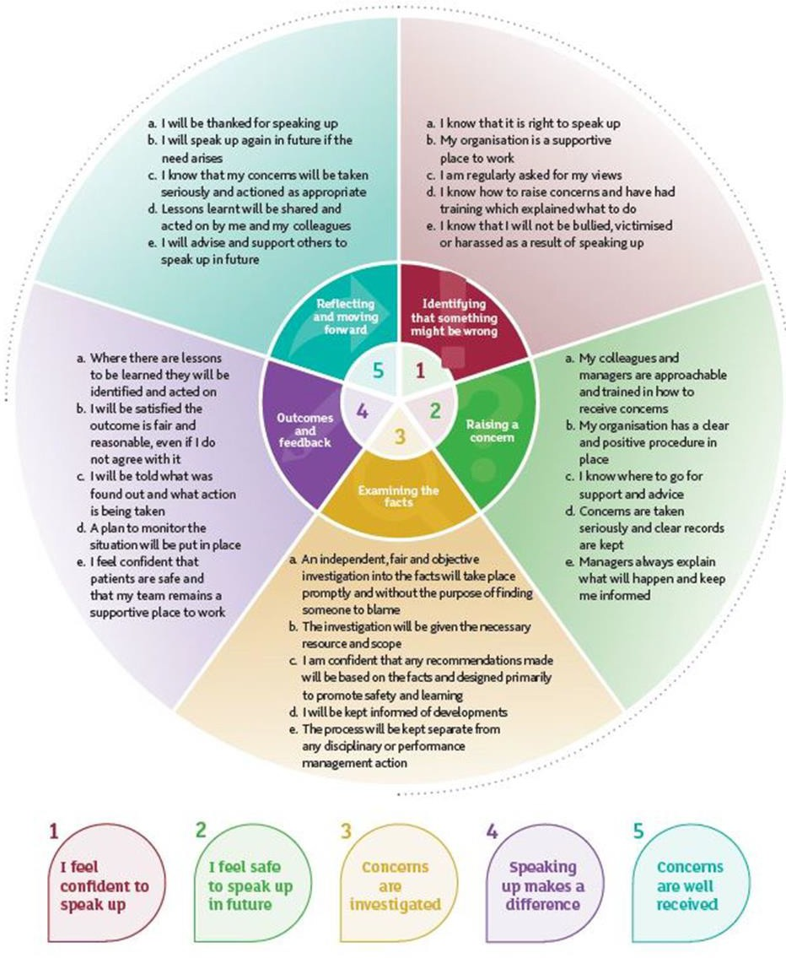

APPENDIX B

Equality Impact Assessment Date of Assessment: August 2018
 | Equality Impact Assessment Questions: |  | Evidence based Answers & Actions:
1 | Name of the document that you are Equality Impact Assessing |  | Raising Concerns (Whistleblowing) Policy
2 | Describe the overall aim of your document and context?  Who will benefit from this policy/procedure/strategy? |  | To encourage staff to raise concerns where they believe there is risk, malpractice or wrongdoing that they think is harming the service we deliver. It provided a mechanism where concerns can be quickly and appropriately addressed without staff suffering reprisal.  All staff
3 | Who is the overall lead for this assessment? |  | HR Business Partner
4 | Who else was involved in conducting this assessment? |  | The Employment Policy Group consisting of Managers, Staff Side and HR
5 | Have you involved and consulted service users, carers, and staff in developing this policy/procedure/strategy?  What did you find out and how have you used this information? |  | As it is a staff specific procedure, service users were not involved and Staff Side representatives represent the interests of staff generally throughout the Trust  N/A
6 | What equality data have you used to inform this equality impact assessment? |  | Data relating to previous concerns raised is minimal and therefore it is not possible to draw any significant conclusions.
7 | What does this data say? |  | N/A
8 | Taking into account the | Yes/No | Evidence based Answers & Actions. Where

 | information gathered above, could this policy  /procedure/strategy affect any of the following equality group unfavourably: |  | Negative impact has been identified please explain what action you will take to remove or mitigate this impact.
8.1 | Race | No | The policy applies equally to all staff whether they have a protected characteristic or not. There is no negative impact anticipated.
8.2 | Disability | No | The policy applies equally to all staff whether they have a protected characteristic or not.  There is no negative impact anticipated.
8.3 | Gender | No | The policy applies equally to all staff whether they have a protected characteristic or not.  There is no negative impact anticipated.
8.4 | Age | No | The policy applies equally to all staff whether they have a protected characteristic or not.  There is no negative impact anticipated.
8.5 | Sexual Orientation | No | The policy applies equally to all staff whether they have a protected characteristic or not.  There is no negative impact anticipated.
8.6 | Religion or Belief | No | The policy applies equally to all staff whether they have a protected characteristic or not.  There is no negative impact anticipated.
8.7 | Transgender | No | The policy applies equally to all staff whether they have a protected characteristic or not.  There is no negative impact anticipated.
8.8 | Maternity & Pregnancy | No | The policy applies equally to all staff whether they have a protected characteristic or not.  There is no negative impact anticipated.
8.9 | Marriage & Civil partnerships | No | The policy applies equally to all staff whether they have a protected characteristic or not.  There is no negative impact anticipated.
8.10 | Carers*Our Trust requirement* | No | The policy applies equally to all staff whether they have a protected characteristic or not.  There is no negative impact anticipated.
9 | What monitoring arrangements are you implementing or already have in place to ensure that this policy/procedure/strategy:- |  | A new central recording system has been established which will be administered by the Freedom to Speak Up Guardians which will enable further monitoring to take place in line with the Equality Act and any concerns identified.
9a | Promotes equality of opportunity for people who share the above protected characteristics; |  | All staff are entitled to and encouraged to raise concerns.

9b | Eliminates discrimination, harassment and bullying for people who share the above protected characteristics; | N/A
9c | Promotes good relations between different equality groups; | N/A
9d | Public Sector Equality Duty – “Due Regard” | N/A
10 | Have you developed an Action Plan arising from this assessment? | N/A
11 | Assessment/Action Plan approved by | N/A
 | (Director Lead) | Sign: Alan Davis Date: August 2018  Title:Director of Human Resources, Organisational Development and Estates
12 | Once approved, you must forward a copy of this Assessment/Action Plan to the Equality and Inclusion Team:  inclusion@swyt.nhs.uk  Please note that the EIA is a public document and will be published on the web.  Failing to complete an EIA could expose the Trust to future legal challenge.

Appendix C

Version Control Sheet

Version | Date | Author | Status | Comment / changes
1. | June 2018 | HR Business Partner | Past | New policy to replace all previous Whistleblowing policies. Policy written in line with national guidance.
2. | Febru ary 2019 | HR Business Partner | Past | Update of previous version.
3. | Febru ary 2022 | HR Business Manager | Current | Extension of existing policy with minor update to response times in line with audit recommendations.

Appendix D
Raising concerns leaflet -
http://nww.swyt.nhs.uk/whistleblowing/Documents/0555%20Raising%20conce rns%20at%20work.pdf

Appendix E
Recording Form
Raising Concerns (including whistleblowing)

Name of individual raising concern (leave blank if individual wishes to remain anonymous):
BDU/Department: |  | Service Line: |  | Location:

STEP 1
Name of Manager dealing with concern: |  |  | Date concern raised:
Nature of issue (please specify e.g. unsafe service user care: unsafe working conditions; fraud, bribery & corruption; a bullying culture etc.):
Description of actions taken (including dates) to deal with the concern:
Has the concern been resolved? (if not, refer the individual to Step 2 in the Raising Concerns (Whistleblowing Policy):
Manager’s signature: |  |  |  | Date:
Individual’s signature (unless anonymous): |  |  |  | Date:
Details of formal concerns raised will be held on a central trust database. The trust also wishes to analyse information collected in relation to the Equality Act 2010. This information will only be used for monitoring purposes in an anonymised format. Please indicate by initialling this box that you are happy for the Freedom to Speak Up Guardians to request your equality information from Human Resources.

Initials: Date:
Please send completed forms marked Private and Confidential to Freedom to Speak Up Guardians, Block 7, Fieldhead Hospital, Ouchthorpe Lane, Wakefield, WF1 3SP

STEP 2
Referral to Designated Senior Manager
Outcome of meeting:
Date of meeting:

Referral to Deputy Chair of the Trust Board
Outcome of meeting:
Date of meeting:

