

**Learning from healthcare deaths**

**1/4/2018-30/6/2018**

Report prepared by Patient Safety Support Team

28/9/18



# Learning from healthcare deaths Report: The right thing to do

**Annual Cumulative Report 2018/19 (covering the period 1/4/2018 – 30/6/18)**

1. **Background context**

**1.1 Introduction**

Scrutiny of healthcare deaths has been high on the government’s agenda for some time. In line with the National Quality Board report published in 2017, the Trust has had Learning from Healthcare Deaths policy in place since September 2017 that sets out how we identify, report, investigate and learn from a patient’s death. The Trust has been reporting and publishing our data on our website since October 2017.

Most people will be in receipt of care from the NHS at the time of their death and experience excellent care from the NHS for the weeks, months and years leading up to their death. However, for some people, their experience is different and they receive poor quality care for a number of reasons including system failure.

The Five Year Forward View for Mental Health identified that people with severe and prolonged mental illness are at risk of dying on average 15 to 20 years earlier than other people. Therefore, it is important that organisations widen the scope of deaths which are reviewed in order to maximise learning.

The Confidential Inquiry into premature deaths of people with learning disabilities showed a very similar picture in terms of early deaths.

The Trust has worked collaboratively with other providers in the North of England to develop our approach. The Trust will review/investigate reportable deaths in line with the policy. We aim to work with families/carers of patients who have died as they offer an invaluable source of insight to learn lessons and improve services.

**1.2 Scope**

The Trust has systems that identify and capture the known deaths of its service users on its electronic patient administration system (PAS) and on its Datix system where the death requires reporting.

The Trust’s Performance and Information team is also working with local registration of deaths services to ensure data on deaths is accurate and timely, and this will develop over time.

Whilst this work was being developed from April 2017 to September 2017 the Trust encouraged reporting of deaths on Datix, the Trust’s risk management system. Further details on this scope are available on request.

From 1 October 2017, the Trust introduced our [Learning from healthcare deaths – the right thing to do](http://www.southwestyorkshire.nhs.uk/wp-content/uploads/2017/10/1180.docx) policy which introduced a revised scope for reporting deaths. Staff must report deaths where there are concerns from family, clinical staff or through governance processes and where the Trust is the main provider of care, reporting these deaths on Datix within 24 hours of being informed.

Each reported death is reviewed in line with the three levels of scrutiny the Trust has adopted in line with the National Quality Board guidance:

1. Death certification
2. Case record review, through Structured Judgment Record Review (SJRR) or Managers 48 hour review acceptance by risk panel. This latter option was introduced in early 2018.
3. Investigation – that could be service level, serious incident reported on STEIS or other review e.g. LeDeR, safeguarding.

**1.3 Next Steps**

* A review of our Learning from healthcare deaths policy and procedures has been completed by internal audit providing significant assurance. The Mortality review group held a workshop in June 2018 where implementation of the audit findings was agreed. The actions include:
  + Review the Learning from Healthcare Deaths policy to include feedback from the audit findings and learning from the first six months of policy implementation in consultation with Northern Alliance colleagues.
  + Review terms of reference of the Mortality Review Group
  + Developing an annual work plan to support mortality work stream priorities
  + Further develop processes and consistency in data collection, analysis and sharing learning
  + Develop of processes to support bereaved families and carers.
* The resource and capacity to undertake and develop this work is significant and a business case to support this will be submitted to enable this work to take place.
* The Trust is planning additional training to further increase the number of Structured Judgment Record Reviewers.

1. **Annual Cumulative Dashboard Report 2017/2018 covering the period 1/4/2018 – 30/6/18**

Table 1 Summary of 2018/19 Annual Death reporting by financial quarter to 30/6/2018

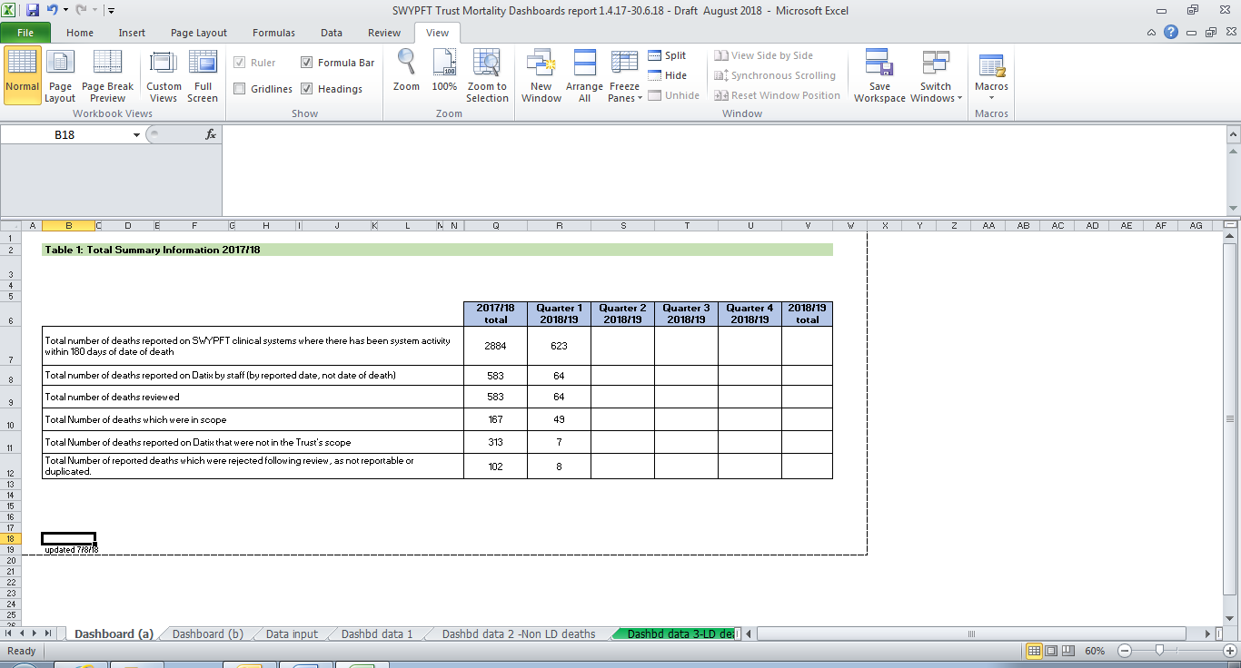

1Data extracted from Business Intelligence and Datix risk management systems. Data is refreshed each quarter so figures may differ from previous reports. Data changes where records may have been amended or added within live systems. Dashboard format and content as agreed by Northern Alliance group

Table 2 Breakdown of the total number of deaths reviewed by service area by financial quarter up to 30/6/2018

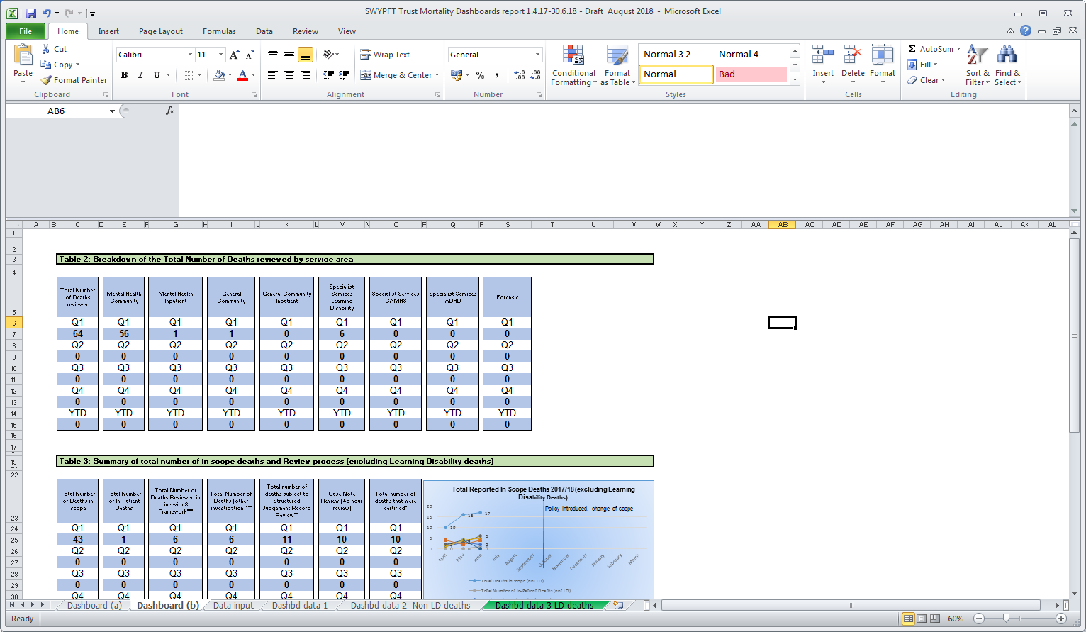

Table 3 Summary of total number of deaths in scope and resulting review process by financial quarter up to 30/6/2018 (excluding learning disability deaths)

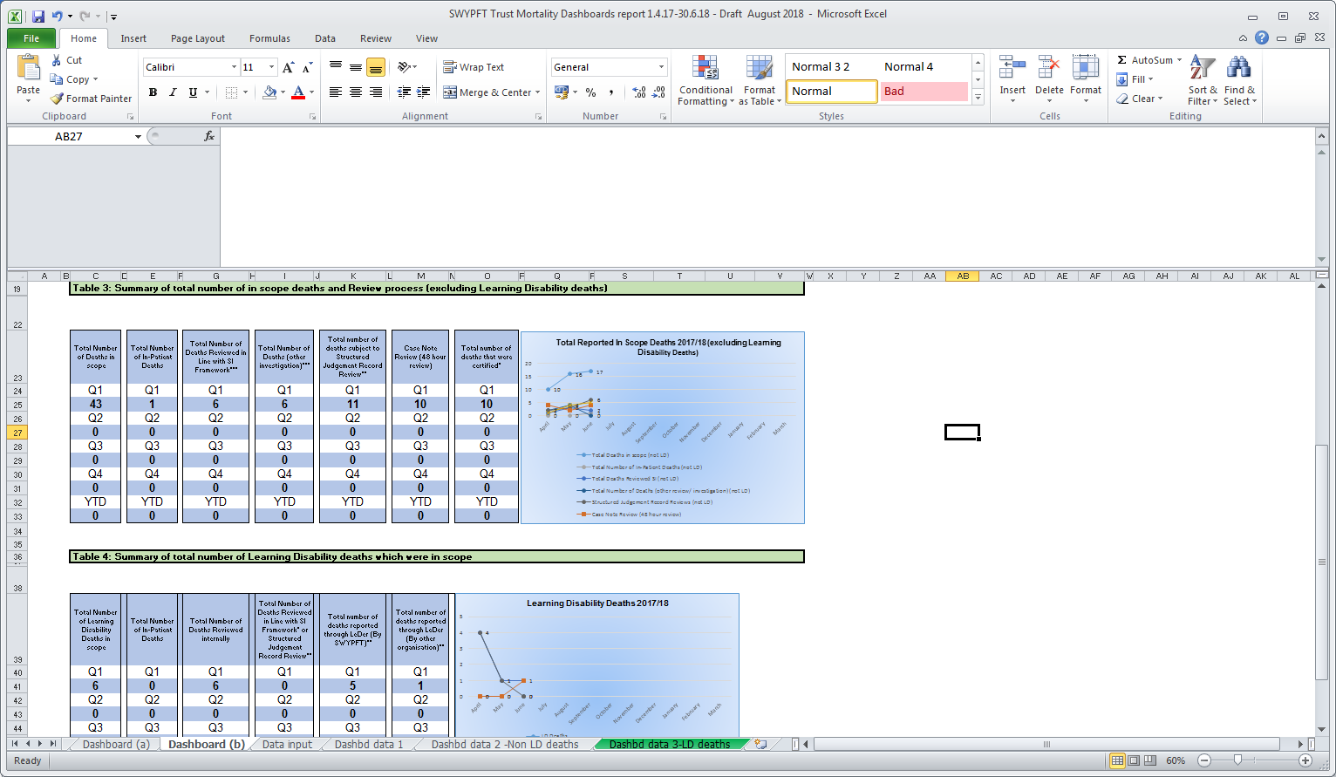

Table 4 S ummary of total number of Learning Disability deaths which where in scope by financial quarter up to 30/6/2018

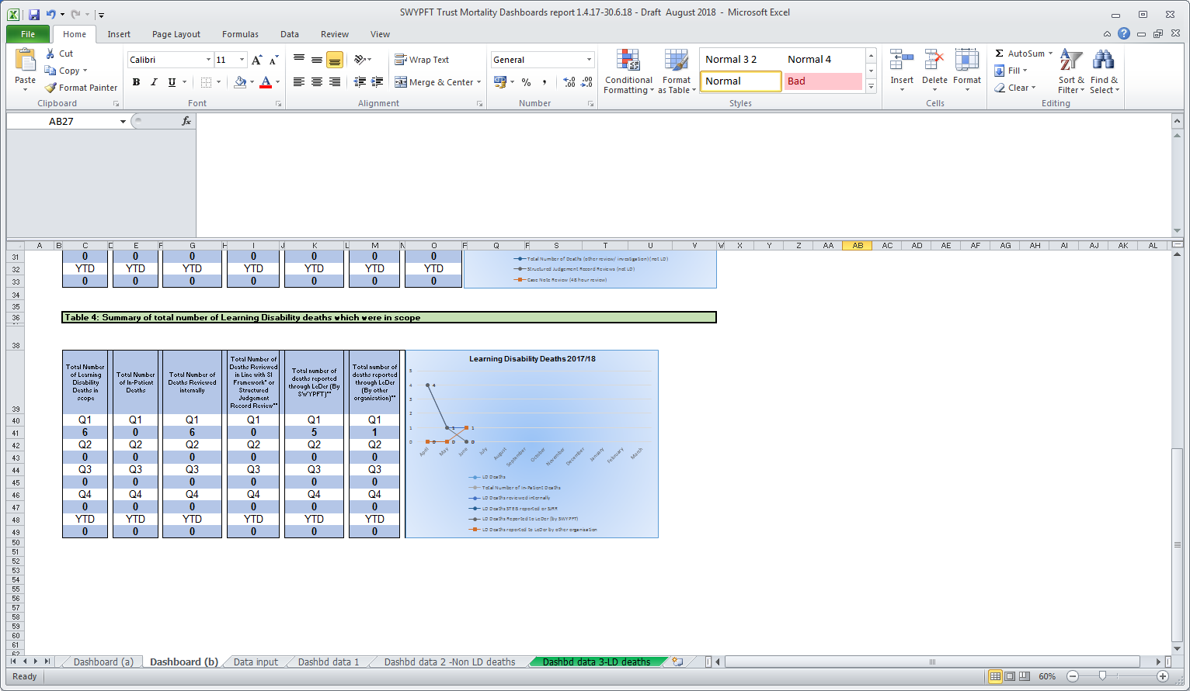

1. **Learning from Healthcare Death reviews and investigations**

This section of the report contains a summary of learning identified from reviews and investigations that have been completed so far for deaths reported between 1/4/17 – 30/6/18. Further learning will be added as these are completed.

**3.1 Learning from healthcare deaths reported as Serious Incidents**

This section provides information on deaths reported as Serious Incidents on Datix between 1 April 2017 and 30 June 2018.

|  |  |
| --- | --- |
| Number of deaths that were reported as serious incidents and investigations commenced | 53 |
| Number of investigations that have been completed (at 26/9/18) | 46 |
| Number of investigations completed to date resulting in recommendations (including to share learning) | 45 |
| Number of investigations completed to date resulting in recommendations for improvement | 33 |
| Number of investigations underway from 1/4/17 – 30/6/18 (learning identified through these investigations will be added at the conclusion of the investigation process). | 4 |

**3.1.1 Themes from completed Serious Incident investigations**

From the Serious Incidents that were reported on Datix between 1 April 2017 and 30 June 2018 where the investigation has been completed, 33 resulted in recommendations for improvement. The table below sets out the main themes from the resulting actions:

|  |  |  |
| --- | --- | --- |
| **Action theme** | **Number of times theme identified** | **Number of SI reports where theme appears** |
| A5 Record keeping | 28 | 18 |
| A4 Risk assessment | 11 | 8 |
| B1 Communication | 9 | 9 |
| B3 Carers/family | 9 | 8 |
| F1 Staff education, training and supervision | 9 | 6 |
| F2.1 Policy and procedure - in place but not adhered to | 9 | 8 |
| A1 Care pathway | 7 | 6 |
| A2 Care delivery | 6 | 4 |
| G1 Organisational systems, management issues | 6 | 5 |
| F2.2 Policy and procedures, not in place | 5 | 5 |
| F4 Team service systems, roles and management | 3 | 3 |
| A3 Care coordination | 2 | 2 |
| C1 Medicine management | 2 | 2 |
| F3 Staff attitude, conduct, professional practice | 1 | 1 |
| J1 Other | 1 | 1 |

The top theme, record keeping, is consistent with that identified in recent annual reports, [available here](http://nww.swyt.nhs.uk/incident-reporting/Pages/Incident-management-annual-report.aspx).

**3.2 Learning from Structured Judgment Record Reviews**

This section provides information on deaths reported on Datix between 1 April 2017 and 30 June 2018 which resulted in a Structured Judgment Record Review. All Structure Judgment Record Reviews that are complete are now approved by a clinical member of the Mortality Review Group before themes are entered into Datix.

|  |  |
| --- | --- |
| Number of Structure Judgment Record Reviews that were commissioned for deaths reported between 1/4/17 – 30/6/18 | 43 |
| Number of Structure Judgment Record Reviews that have been completed and approved (at 24/9/18). | 32 |
| Number of Structure Judgment Record Reviews that are underway | 3 |
| Number of Structure Judgment Record Reviews that are in the approval process | 8 |
| Number of Structure Judgment Record Reviews that have been referred for further investigation | 0 |

During a Structure Judgment Record Review, the reviewer assesses each phase of care and records their findings on a template under those headings. They also give a view on the care overall. Below is a summary of the rating for overall care, and examples of areas for improvement and positive practice.

**Assessment of Care Overall**

**57%** of reviews completed to date rated overall care as good or excellent

|  |  |  |  |  |  |  |  |  |  |  |  |  |  |  |  |  |  |  |  |  |  |  |  |  |  |  |  |  |  |  |  |  |  |  |  |  |  |  |  |  |  |  |  |  |  |  |  |  |  |  |  |  |  |  |  |  |  |
| --- | --- | --- | --- | --- | --- | --- | --- | --- | --- | --- | --- | --- | --- | --- | --- | --- | --- | --- | --- | --- | --- | --- | --- | --- | --- | --- | --- | --- | --- | --- | --- | --- | --- | --- | --- | --- | --- | --- | --- | --- | --- | --- | --- | --- | --- | --- | --- | --- | --- | --- | --- | --- | --- | --- | --- | --- | --- |
| |  |  |  |  |  |  |  |  | | --- | --- | --- | --- | --- | --- | --- | --- | |  | Very poor care | Poor care | Adequate care | Good care | Excellent care | Pending completion of SJRR or approval | Total | | 17/18 Q1 | 0 | 1 | 1 | 1 | 1 | 0 | 4 | | 17/18 Q2 | 0 | 0 | 3 | 3 | 0 | 0 | 6 | | 17/18 Q3 | 0 | 0 | 4 | 6 | 1 | 2 | 13 | | 17/18 Q4 | 0 | 0 | 3 | 4 | 0 | 2 | 9 | | 18/19 Q1 | 0 | 0 | 0 | 0 | 0 | 11 | 11 | | Total | 0 | 1 | 11 | 14 | 2 | 15 | 43 | |  |

**3.2.1 Areas to consider for improving practice**

The number of completed Structured Judgement Reviews remains relatively small in number, so care has to be taken when drawing conclusions about themes. Below are some examples of areas for improving practice identified from reviews for cases between 1 April 2017 and 30 June 2018. Further examples will be added as more reviews are completed, and themes identified as they emerge:

**Risk assessment and management**

* The person was at risk of falls and died as a result of a fall at home. There was no evidence of using the skills of the whole team in mitigating risk e.g. Occupational Therapy assessment.
* Risk assessments need to be comprehensively documented.
* Risks were identified and detailed in the progress notes as were the care plans associated with same. However the organisation of this information could have been more clearly documented within the assessments and care plans on RIO.
* Ensuring clearly defined contingency plans are available on the clinical system to ensure colleagues are directed to the risk assessments and offered guidance to support informed decision making at times of contact with services.
* The risk assessment is of a poor quality neither does it identify risk/risks appropriately, it also fails to provide any adequate risk management plan.
* The risk assessments are all, almost word for word duplicates, often mirroring the first assessment.
* A risk issue was identified however, this aspect of risk is not explored to either discount the risk or to raise awareness of the risk and manage it.
* No evidence of a risk assessment and risk management plan regarding transferring a patient from one Trust OPS inpatient unit to another [i.e. suitability of transport, number and type of escort required]
* No evidence to suggest that the Inter healthcare infection control transfer form was used particularly when it is known that the patient is doubly incontinent and a taxi was used.
* Risk assessment was a copy and paste of an earlier one, and included statements that were likely only relevant in the context of the first assessment such as attitude towards the assessor and that he was detained under the MHA when he was not on the later occasion.
* Alcohol use was cited as contributing factor in the service users mental health, however risk assessments did not make suggestions to address this risk
* Risk assessments were written at a time of crisis for the service user, and were reflective of risks then. There were no assessment and subsequent plan for his presenting needs while in the community.
* There was no evidence of an admission assessment being completed by the ward doctor, this would also include a capacity assessment and a VTE risk assessment, although there is a template for these in the admission documents.
* There is no plan for risk management on the second risk assessment although risks are care planned for in the CPA care plan.
* There is no Sainsbury’s level 2 risk assessment which would have been expected particularly as the service user was with IHBTT for 5 months.
* The service user was referred and would be seen within expected guidance from point of referral but this was already delayed due to the transfer care from Bradford into the Trust not having occurred. However, based on the information known about her risk history, her presentation during the assessment, the support she had and that she would be receiving a referral to a community team for follow up was considered an appropriate response

**Follow up**

* A service user was receiving Clozaril, it would have been expected that the service user was having his physical health checked routinely to monitor side effects; however it was unclear if this was the case. It was unclear in the clinical information system how the service user lived between being seen by Lead HCP and Clozaril team.
* It was not clear in the documentation that any action had been taken following 7 day discharge follow up.
* Ensuring review of both physical and mental health and ensuring this is documented

**Initial review**

* The process of the DNACPR could be improved upon but ultimately did not affect the standard of care delivered
* The importance of in-reach from one BDU to another until engagement/ transition of care is established.

**Ongoing care**

* Ongoing care seemed to be challenging because the SU’s situation was greatly influenced by social factors, alcohol use and what seemed to be a passive attitude towards change. The mental health team were supportive of the SU and his situation, but did not seem to be assertive in perusing a motivational approach. Care plans, while still current, were in some case several years old and there was no evidence of the having been reviewed. Other factors that could have been planned for, such as addressing the work situation, were not care planned. There seemed to be little consideration given to the welfare of the children living at home, or coordination with their social worker during some difficult situation.
* There is evidence that practitioners asked questions about use of illicit substances and gave advice about the detrimental effects this would have on mental health. It is unclear whether the offer of referral to drug and alcohol services was made.
* Patient transferred from inpatient unit to acute Trust, however there was no record keeping of the condition of the patient on the clinical information system, and the death was only documented on Datix later that morning. The clinical record should have been updated.
* Convening best interest case conference or strategy meeting to discuss service user’s capacity would be valuable. Robust plan to further review their capacity in the community would also be useful. Ensuring the Trust Covert medication policy is being followed.
* The severity of a service user’s condition by different practitioners and services was underestimated. There appeared to be a relative lack of knowledge across different services that a man presenting in his mid 50’s with severe treatment-resistant anxiety symptoms is likely to have a depressive illness of moderate to severe intensity. When reviewed by a senior practitioner, the severity was immediately noted who did a robust and well-recorded assessment. A senior review (or by someone having a higher level of training and awareness) earlier on in the episode of illness is likely to have identified the severity and risks at an earlier stage.
* Ensuring that when specific treatments cannot be provided, that this is documented clearly and explained. In this example, it appeared to lead to the service user being pre-occupied with a pathway that was not available until the point of death.

**3.2.2 Positive practice examples**

From the Structure Judgement Reviews that have taken place, there are many examples of positive practice which have been identified through the process:

* “Overall the care was excellent. Input from a wide variety of disciplines, with regular review and regular consideration of which pharmacological options would suit him and his circumstances best. High-quality physical health care. Measures taken to increase observation/avoid falls to keep him safe. Family indicated that they were happy with his care.”
* “Advocacy contacted on his behalf.”
* “Overall the patient was cared for and time being taken to engage with her….There was a multidisciplinary approach throughout involving specialist advisors for assessment and advice.”
* “When a fall occurred they were being observed constantly. Changes to presentation were discussed with the multidisciplinary team and the family.”
* “The family were involved in the resuscitation decision. A palliative approach was taken following difficulty swallowing and deterioration in physical health.”
* “From the care record there is evidence of structured risk assessments appertaining to the community aspect of care prior to admission. These were carried out by staff who had a good therapeutic working knowledge and relationship with the patient…close working relationships and coordination between the community and inpatient teams was evident.”
* The risk triggers were identified and the plan was adhered to resulting in an informal admission to the ward. This was in a timely manner and did not escalate to a formal admission under the mental health act.
* “Discharge was being planned from an early stage in the admission with the patient being actively involved in her care arrangements…The ward team were able to facilitate escorted home leave then worked with the community teams to increase the time spent at home. Good feedback from each visit is documented and provided a basis to inform the MDT of each stage to discharge.”
* “Well documented evidence of good and collaborative joint working evident which was person-centred and responsive to the needs.”
* “Family/carer views were taken on board throughout. The team listened and acted on family concerns”
* “Individual assessments at the outset of various trust services all complied with good practice guidelines and all risk assessments were completed.”
* “The in-patient stay was excellent, detailed investigations and plans made. Collaboration with spouse and evidence of plenty of MDT working. Good planned discharge and follow up all provided in a timely fashion.”
* “During an inpatient stay in hospital...evidence of prompt and thorough assessments following falls with clear action points”
* “Consultant Physician attended for physical health review- good MDT working”
* “There is evidence that staff encouraged and involved patient in variety of OT activities. In the nursing daily reviews, the staff start off RIO entries by highlighting the MHA detention status and Nursing Level of Observations- Good practice”
* “Covert medication plan was initiated during admission due to risks of non-concordance, family were informed.”
* "Attempts were made to be collaborative in devising and agreeing a care plan that met the service user needs. There was evidence of multi-agency working and sign posting to relevant agencies to support care and treatment."
* “The Care-coordinator had supported the patient to attend out-patient appointments, manage medication, gain new accommodation on three occasions, manage finances and had provided support on seven admissions and provided comprehensive follow up on discharge from the wards. The service user was often difficult to engage and frequently missed appointments which were always followed up by the Community Team. They had issues with alcohol and substance misuse and support was given to address. There was a pattern of relapse following increase in consumption of alcohol and/or illicit substances; when this did happen the Community Team dealt with this in a professional and non-judgemental manner. The Care-coordinator involved family members appropriately and demonstrated flexibility in order to ensure the service user received the care they needed. Every effort was made throughout the episode of care to make sure the service user was involved in decision making and their wishes around medication were taken into account and often a compromise was reached when the service user’s wishes were different to the medical recommendation.”
* “The service user’s care and treatment whilst an inpatient seemed to be compassionate and attentive. Staff responded to fluctuating needs promptly and they had good input from the MDT, including therapy staff. When the patient began complaining of transient pain in the leg with no apparent onset this was monitored for three days at which point the pain was more consistent and impacting on mobility. The patient was provided with an x-ray that showed an historic fracture that has reopened. From this point on care was delivered by general hospital staff which was appropriate”
* “Nutrition Risk Screening Tool [NRST] completed and a corresponding entry made in the Rio progress notes reporting that the patient had been referred to the dietician”
* “In-Patient Falls Risk Assessment completed and supported by a comprehensive Mobility Falls Management care plan with evidence that the care plan has been effectively evaluated.”
* “Patient was a planned transfer from the acute hospital. The admitting ward had received referral information prior to the transfer. The admitting nurse completed the admission assessment including patient history, social and physical. Risk assessments including nutrition, skin integrity, bed rails and care planning was commenced. The care planning is part of the stroke care pathway. Recording on Fluid balance charts and food charts and catheter care pathway commenced on admission.”
* “The risk assessment was completed within trust guidance; it was inclusive of history, intent and protective factors. It was clear, concise with a risk management plan.”
* “The overall risk assessment done for the Client has been excellent…there is good documentation of her current physical health problems and treatment received for it. There is a an accurate description of her relapse signatures and clear plans both in terms of actions to be taken for supporting her and urgent medical review with consideration of IHBTT involvement as well as a clear medication management plan so as to not delay the treatment and wait till she is reviewed by her own team doctor.”
* “There is ample evidence of regular comprehensive MDT reviews in which the relatives were fully involved. The MDT’s were thoroughly documented using a structured format”
* “The service user was monitored via 6 monthly outpatient clinics and attended monthly Clozaril clinics. He was often supported to attend by a member of the care home team. The focus of the contact was around symptom management and mental state examination, with some evidence of a bio-psychosocial reporting.”
* “Contact was made by SPA on the day the referral was received and the SU was seen in person with an interpreter within 8 days and picked up by IHBTT within 9 days of the referral being received. This is excellent practice.”
* “There were frequent MDT reviews, led by a medic which appraised risks, the ongoing situation and presenting needs.”
* “When transfer was needed to the Enhanced Team, IHBTT remained actively involved until a joint visit had taken place. A care coordinator was identified in the enhanced team two weeks after the initial telephone call.”

**3.2.3 Additional data**

Below is a summary of the ratings given for each phase of care:-

**Risk assessment:**

**25%** were rated good or excellent

|  |  |  |  |  |  |  |  |  |  |  |  |  |  |  |  |  |  |  |  |  |  |  |  |  |  |  |  |  |  |  |  |  |  |  |  |  |  |  |  |  |  |  |  |  |  |  |  |  |  |  |  |  |  |  |  |  |  |  |  |  |  |  |  |  |
| --- | --- | --- | --- | --- | --- | --- | --- | --- | --- | --- | --- | --- | --- | --- | --- | --- | --- | --- | --- | --- | --- | --- | --- | --- | --- | --- | --- | --- | --- | --- | --- | --- | --- | --- | --- | --- | --- | --- | --- | --- | --- | --- | --- | --- | --- | --- | --- | --- | --- | --- | --- | --- | --- | --- | --- | --- | --- | --- | --- | --- | --- | --- | --- | --- |
| |  |  |  |  |  |  |  |  |  | | --- | --- | --- | --- | --- | --- | --- | --- | --- | |  | Very poor care | Poor care | Adequate care | Good care | Excellent care | Not applicable | Pending completion of SJRR or approval | Total | | 17/18 Q1 | 0 | 1 | 2 | 0 | 1 | 0 | 0 | 4 | | 17/18 Q2 | 0 | 2 | 2 | 1 | 1 | 0 | 0 | 6 | | 17/18 Q3 | 0 | 1 | 6 | 0 | 1 | 3* | 2 | 13 | | 17/18 Q4 | 0 | 1 | 3 | 1 | 1 | 0 | 3 | 9 | | 18/19 Q1 | 0 | 0 | 0 | 0 | 0 | 0 | 11 | 11 | | Total | 0 | 5 | 13 | 2 | 4 | 3 | 16 | 43 |   *physical healthcare SJR template does not include risk assessment heading |  |

**Allocation/ Initial Review:**

**38%** were rated good or excellent

|  |  |  |  |  |  |  |  |  |  |  |  |  |  |  |  |  |  |  |  |  |  |  |  |  |  |  |  |  |  |  |  |  |  |  |  |  |  |  |  |  |  |  |  |  |  |  |  |  |  |  |  |  |  |  |  |  |  |  |  |  |  |  |  |  |
| --- | --- | --- | --- | --- | --- | --- | --- | --- | --- | --- | --- | --- | --- | --- | --- | --- | --- | --- | --- | --- | --- | --- | --- | --- | --- | --- | --- | --- | --- | --- | --- | --- | --- | --- | --- | --- | --- | --- | --- | --- | --- | --- | --- | --- | --- | --- | --- | --- | --- | --- | --- | --- | --- | --- | --- | --- | --- | --- | --- | --- | --- | --- | --- | --- |
| |  |  |  |  |  |  |  |  |  | | --- | --- | --- | --- | --- | --- | --- | --- | --- | |  | Very poor care | Poor care | Adequate care | Good care | Excellent care | Not applicable | Pending completion of SJRR or approval | Total | | 17/18 Q1 | 0 | 0 | 2 | 1 | 1 | 0 | 0 | 4 | | 17/18 Q2 | 0 | 2 | 2 | 1 | 1 | 0 | 0 | 6 | | 17/18 Q3 | 0 | 0 | 5 | 0 | 2 | 4 | 2 | 13 | | 17/18 Q4 | 0 | 0 | 4 | 2 | 1 | 0 | 2 | 9 | | 18/19 Q1 | 0 | 0 | 0 | 0 | 0 | 0 | 11 | 11 | | Total | 0 | 2 | 13 | 4 | 5 | 4 | 15 | 43 | |  |

**On-going Care:**

**61%** were rated good or excellent

|  |  |  |  |  |  |  |  |  |  |  |  |  |  |  |  |  |  |  |  |  |  |  |  |  |  |  |  |  |  |  |  |  |  |  |  |  |  |  |  |  |  |  |  |  |  |  |  |  |  |  |  |  |  |  |  |  |  |
| --- | --- | --- | --- | --- | --- | --- | --- | --- | --- | --- | --- | --- | --- | --- | --- | --- | --- | --- | --- | --- | --- | --- | --- | --- | --- | --- | --- | --- | --- | --- | --- | --- | --- | --- | --- | --- | --- | --- | --- | --- | --- | --- | --- | --- | --- | --- | --- | --- | --- | --- | --- | --- | --- | --- | --- | --- | --- |
| |  |  |  |  |  |  |  |  | | --- | --- | --- | --- | --- | --- | --- | --- | |  | Very poor care | Poor care | Adequate care | Good care | Excellent care | Pending completion of SJRR or approval | Total | | 17/18 Q1 | 0 | 1 | 1 | 0 | 2 | 0 | 4 | | 17/18 Q2 | 0 | 1 | 2 | 2 | 1 | 0 | 6 | | 17/18 Q3 | 0 | 0 | 4 | 5 | 2 | 2 | 13 | | 17/18 Q4 | 0 | 0 | 2 | 3 | 2 | 2 | 9 | | 18/19 Q1 | 0 | 0 | 0 | 0 | 0 | 11 | 11 | | Total | 0 | 2 | 9 | 10 | 7 | 15 | 43 | |  |

**Care During Admissions (where applicable):**

**53%** were rated good or excellent

|  |  |  |  |  |  |  |  |  |  |  |  |  |  |  |  |  |  |  |  |  |  |  |  |  |  |  |  |  |  |  |  |  |  |  |  |  |  |  |  |  |  |  |  |  |  |  |  |  |  |  |  |  |  |  |  |  |  |  |  |  |  |  |  |  |
| --- | --- | --- | --- | --- | --- | --- | --- | --- | --- | --- | --- | --- | --- | --- | --- | --- | --- | --- | --- | --- | --- | --- | --- | --- | --- | --- | --- | --- | --- | --- | --- | --- | --- | --- | --- | --- | --- | --- | --- | --- | --- | --- | --- | --- | --- | --- | --- | --- | --- | --- | --- | --- | --- | --- | --- | --- | --- | --- | --- | --- | --- | --- | --- | --- |
| |  |  |  |  |  |  |  |  |  | | --- | --- | --- | --- | --- | --- | --- | --- | --- | |  | Very poor care | Poor care | Adequate care | Good care | Excellent care | Not applicable | Pending completion of SJRR or approval | Total | | 17/18 Q1 | 0 | 0 | 1 | 0 | 2 | 1 | 0 | 4 | | 17/18 Q2 | 0 | 1 | 1 | 1 | 0 | 3 | 0 | 6 | | 17/18 Q3 | 0 | 0 | 4 | 2 | 2 | 2 | 3 | 13 | | 17/18 Q4 | 0 | 0 | 0 | 1 | 0 | 6 | 2 | 9 | | 18/19 Q1 | 0 | 0 | 0 | 0 | 0 | 0 | 11 | 11 | | Total | 0 | 1 | 6 | 4 | 4 | 12 | 16 | 43 | |  |

**Follow-up Management / Discharge:**

**63%** were rated good or excellent

|  |  |  |  |  |  |  |  |  |  |  |  |  |  |  |  |  |  |  |  |  |  |  |  |  |  |  |  |  |  |  |  |  |  |  |  |  |  |  |  |  |  |  |  |  |  |  |  |  |  |  |  |  |  |  |  |  |  |  |  |  |  |  |  |  |
| --- | --- | --- | --- | --- | --- | --- | --- | --- | --- | --- | --- | --- | --- | --- | --- | --- | --- | --- | --- | --- | --- | --- | --- | --- | --- | --- | --- | --- | --- | --- | --- | --- | --- | --- | --- | --- | --- | --- | --- | --- | --- | --- | --- | --- | --- | --- | --- | --- | --- | --- | --- | --- | --- | --- | --- | --- | --- | --- | --- | --- | --- | --- | --- | --- |
| |  |  |  |  |  |  |  |  |  | | --- | --- | --- | --- | --- | --- | --- | --- | --- | |  | Very poor care | Poor care | Adequate care | Good care | Excellent care | Not applicable | Pending completion of SJRR or approval | Total | | 17/18 Q1 | 0 | 1 | 1 | 1 | 1 | 0 | 0 | 4 | | 17/18 Q2 | 0 | 0 | 2 | 2 | 1 | 1 | 0 | 6 | | 17/18 Q3 | 0 | 1 | 2 | 1 | 2 | 3 | 4 | 13 | | 17/18 Q4 | 0 | 0 | 1 | 2 | 1 | 3 | 2 | 9 | | 18/19 Q1 | 0 | 0 | 0 | 0 | 0 | 0 | 11 | 11 | | Total | 0 | 2 | 6 | 6 | 5 | 7 | 17 | 43 | |  |

**End of Life care**

**100%** of relevant cases in inpatient carewere rated good or excellent

|  |  |  |  |  |  |  |  |  |  |  |  |  |  |  |  |  |  |  |  |  |  |  |  |  |  |  |  |  |  |  |  |  |  |  |  |  |  |  |  |  |  |  |  |  |  |  |  |  |  |  |  |  |  |  |  |  |  |
| --- | --- | --- | --- | --- | --- | --- | --- | --- | --- | --- | --- | --- | --- | --- | --- | --- | --- | --- | --- | --- | --- | --- | --- | --- | --- | --- | --- | --- | --- | --- | --- | --- | --- | --- | --- | --- | --- | --- | --- | --- | --- | --- | --- | --- | --- | --- | --- | --- | --- | --- | --- | --- | --- | --- | --- | --- | --- |
| |  |  |  |  |  |  |  |  | | --- | --- | --- | --- | --- | --- | --- | --- | |  | Very poor care | Poor care | Adequate care | Good care | Excellent care | Not applicable | Total | | 17/18 Q1 | 0 | 0 | 0 | 0 | 0 | 4 | 4 | | 17/18 Q2 | 0 | 0 | 0 | 0 | 0 | 6 | 6 | | 17/18 Q3 | 0 | 0 | 0 | 3 | 0 | 10 | 13 | | 17/18 Q4 | 0 | 0 | 0 | 0 | 0 | 9 | 9 | | 18/19 Q1 | 0 | 0 | 0 | 0 | 0 | 11 | 11 | | Total | 0 | 0 | 0 | 3 | 0 | 40 | 43 | |  |

**Quality of the patient record in enabling good quality of care to be provided:**

**46%** were rated good or excellent

|  |  |  |  |  |  |  |  |  |  |  |  |  |  |  |  |  |  |  |  |  |  |  |  |  |  |  |  |  |  |  |  |  |  |  |  |  |  |  |  |  |  |  |  |  |  |  |  |  |  |  |  |  |  |  |  |  |  |
| --- | --- | --- | --- | --- | --- | --- | --- | --- | --- | --- | --- | --- | --- | --- | --- | --- | --- | --- | --- | --- | --- | --- | --- | --- | --- | --- | --- | --- | --- | --- | --- | --- | --- | --- | --- | --- | --- | --- | --- | --- | --- | --- | --- | --- | --- | --- | --- | --- | --- | --- | --- | --- | --- | --- | --- | --- | --- |
| |  |  |  |  |  |  |  |  | | --- | --- | --- | --- | --- | --- | --- | --- | |  | Very poor quality | Poor quality | Adequate quality | Good quality | Excellent quality | Pending completion of SJRR or approval | Total | | 17/18 Q1 | 0 | 0 | 2 | 1 | 1 | 0 | 4 | | 17/18 Q2 | 0 | 1 | 1 | 4 | 0 | 0 | 6 | | 17/18 Q3 | 0 | 0 | 6 | 3 | 2 | 2 | 13 | | 17/18 Q4 | 0 | 0 | 5 | 1 | 1 | 2 | 9 | | 18/19 Q1 | 0 | 0 | 0 | 0 | 0 | 11 | 11 | | Total | 0 | 1 | 14 | 9 | 4 | 15 | 43 | |  |

**3.3 Learning from other Investigations**

1. **Service level investigations**

Of the 16 service level investigations for deaths reported between 1 April 2017 and 31 March 2018, 6 investigations have been completed (at 27/9/18).

The areas identified for improvement are summarised and themed below:

**Care delivery**

* Although teams have systems and processes there are times when an individual staff member has not taken responsibility for tasks allocated to them and care delivered was not provided as planned.

**Risk assessment**

* Ensuring Sainsbury’s level 1 risk assessment is completed at the appropriate time.
* Completion of a Level 1 risk assessment at a medical review does not always happen however the formulation relating to risk is documented in the Medical Care Plan. This will be reviewed as part of the trust wide review of risk assessment documentation, in the transition to a new electronic records system. This review is underway and will give consideration to developing a more formative approach to risk assessment.
* When no face to face contact has been possible and service user contacts the team; to ensure that a qualified member of staff speaks with the service user in order to carry out a risk assessment in relation to urgency of assessment required.

**Record keeping**

* Need to check details on system at the time of taking a verbal referral e.g. GP details and address of patient.

**Communication**

* There were some communication issues between teams regarding attendance at A&E.
* Ensuring that when a patient does not attend for an outpatient appointment, that this is referred to the duty worker to follow up as per procedure.

1. **Safeguarding reviews**

Between 1/4/17 – 30/6/18, there are two deaths that are being reviewed through safeguarding processes. Learning will be updated when this is available.

1. **Learning disability reviews**

The Mortality Review Group has agreed that for any learning disability deaths, the managers 48 hour review will be completed, and in some cases a Structured Judgement Review will be requested to enable internal learning. This is alongside the LeDeR programme.

Feedback from the Learning Disability Mortality Review programme (LeDeR) has been limited to date. The Learning Disabilities Mortality Review (LeDeR) Programme annual report December 2017 tells us that:

* From 1st July 2016 to 30th November 2017, 1,311 deaths were notified to the LeDeR programme nationally.
* By 30 November 2017, 103 reviews had been completed and approved by the LeDeR quality assurance process.
* From the 103 completed reviews, there were 189 learning points or recommendations identified. In each review that identified one or more learning points, the average number of learning points and/or recommendations was 2.8.
* Thirty-six reviews (35%) did not identify any learning.
* Priority is being given to themed reviews of death of young people aged 18-24 years and people from black and minority ethnic background.

|  |  |
| --- | --- |
|  | The most commonly reported learning and recommendations were made in relation to the need for:  a) Inter-agency collaboration and communication  b) Awareness of the needs of people with learning disabilities  c) The understanding and application of the Mental Capacity Act (MCA).  Most of the learning to-date echoes that of previous reports of deaths of people with learning disabilities, and the importance of addressing this cannot be over-estimated. We have a responsibility to families and others to ensure that any learning points at individual level are taken forward into relevant service improvements as appropriate.  As a result of the reviews completed, some actions have already been taken to improve service provision for people with learning disabilities. These have included, for example, strengthening discharge planning processes, and the provision of reasonable adjustments for people with learning disabilities. |