

**Learning from healthcare deaths**

**1/4/2018-30/9/2018**

Report prepared by Patient Safety Support Team

2/11/18



# Learning from healthcare deaths Report: The right thing to do

**Annual Cumulative Report 2018/19 (covering the period 1/4/2018 – 30/9/18)**

1. **Background context**

**1.1 Introduction**

Scrutiny of healthcare deaths has been high on the government’s agenda for some time. In line with the National Quality Board report published in 2017, the Trust has had Learning from Healthcare Deaths policy in place since September 2017 that sets out how we identify, report, investigate and learn from a patient’s death. The Trust has been reporting and publishing our data on our website since October 2017.

Most people will be in receipt of care from the NHS at the time of their death and experience excellent care from the NHS for the weeks, months and years leading up to their death. However, for some people, their experience is different and they receive poor quality care for a number of reasons including system failure.

The Five Year Forward View for Mental Health identified that people with severe and prolonged mental illness are at risk of dying on average 15 to 20 years earlier than other people. Therefore, it is important that organisations widen the scope of deaths which are reviewed in order to maximise learning.

The Confidential Inquiry into premature deaths of people with learning disabilities showed a very similar picture in terms of early deaths.

The Trust has worked collaboratively with other providers in the North of England to develop our approach. The Trust will review/investigate reportable deaths in line with the policy. We aim to work with families/carers of patients who have died as they offer an invaluable source of insight to learn lessons and improve services.

**1.2 Scope**

The Trust has systems that identify and capture the known deaths of its service users on its electronic patient administration system (PAS) and on its Datix system where the death requires reporting.

The Trust’s Performance and Information team is also working with local registration of deaths services to ensure data on deaths is accurate and timely, and this will develop over time.

Whilst this work was being developed from April 2017 to September 2017 the Trust encouraged reporting of deaths on Datix, the Trust’s risk management system. Further details on this scope are available on request.

From 1 October 2017, the Trust introduced our [Learning from healthcare deaths – the right thing to do](http://www.southwestyorkshire.nhs.uk/wp-content/uploads/2017/10/1180.docx) policy which introduced a revised scope for reporting deaths. Staff must report deaths where there are concerns from family, clinical staff or through governance processes and where the Trust is the main provider of care, reporting these deaths on Datix within 24 hours of being informed.

Each reported death is reviewed in line with the three levels of scrutiny the Trust has adopted in line with the National Quality Board guidance:

1. Death certification
2. Case record review, through Structured Judgement Review (SJR) or Managers 48 hour review acceptance by risk panel. This latter option was introduced in early 2018.
3. Investigation – that could be service level, serious incident reported on STEIS or other review e.g. LeDeR, safeguarding.

**1.3 Next Steps**

* A review of our Learning from healthcare deaths policy and procedures has been completed by internal audit providing significant assurance. The Mortality review group held a workshop in June 2018 where implementation of the audit findings was agreed. The actions include:
  + Review the Learning from Healthcare Deaths policy to include feedback from the audit findings and learning from the first six months of policy implementation in consultation with Northern Alliance colleagues. This is on track for completion in January 2019 to incorporate national guidance.
  + Review terms of reference of the Mortality Review Group. This has been completed.
  + Developing an annual work plan to support mortality work stream priorities. This is now part of the mortality review group.
  + Further develop processes and consistency in data collection, analysis and sharing learning – work continues.
  + Develop of processes to support bereaved families and carers. A working group has been established to progress this.
* The Trust is planning additional training to further increase the number of Structured Judgement Reviewers. Further training has been held and additional dates scheduled.

1. **Annual Cumulative Dashboard Report 2018/2019 covering the period 1/4/2018 – 30/9/18**

Table 1 Summary of 2018/19 Annual Death reporting by financial quarter to 30/9/2018

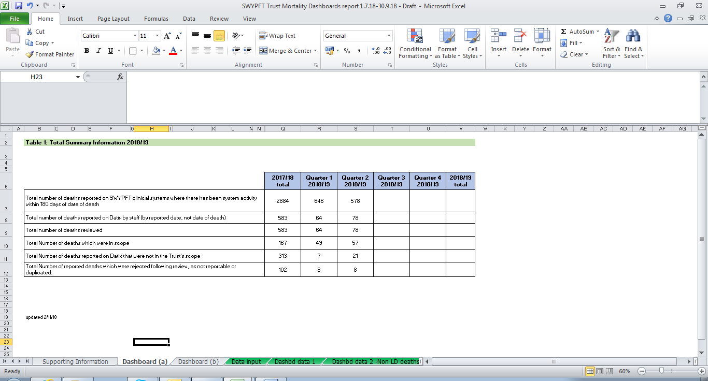

1Data extracted from Business Intelligence and Datix risk management systems. Data is refreshed each quarter so figures may differ from previous reports. Data changes where records may have been amended or added within live systems. Dashboard format and content as agreed by Northern Alliance group

Table 2 Breakdown of the total number of deaths reviewed by service area by financial quarter up to 30/9/2018

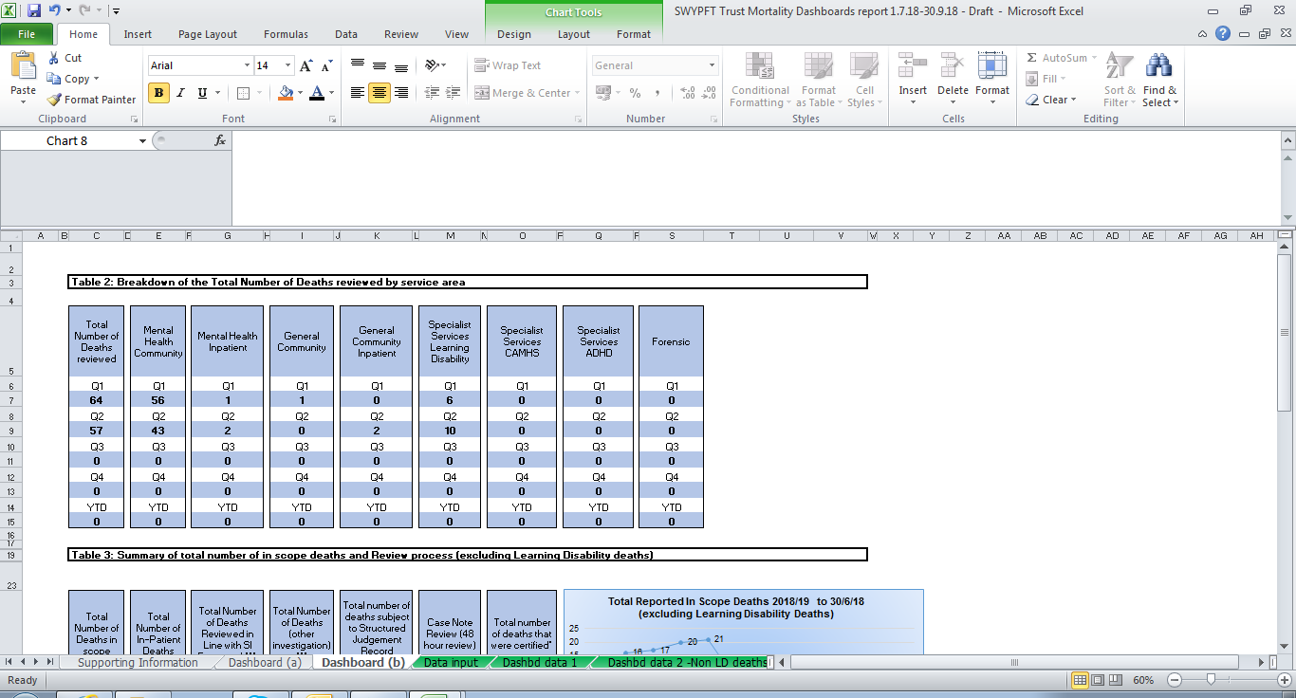

Table 3 Summary of total number of deaths in scope and resulting review process by financial quarter up to 30/9/2018 (excluding learning disability deaths)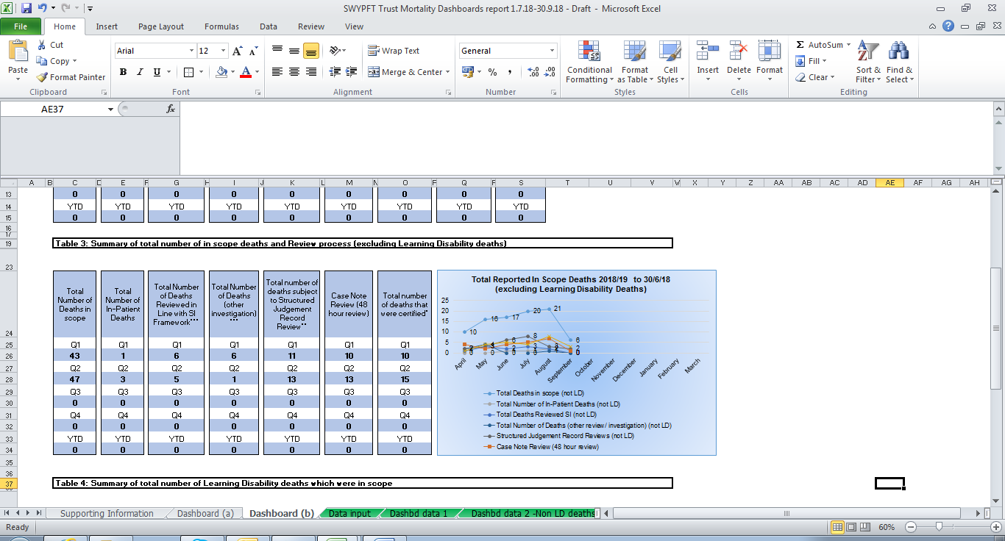

Table 4 S ummary of total number of Learning Disability deaths which where in scope by financial quarter up to 30/9/2018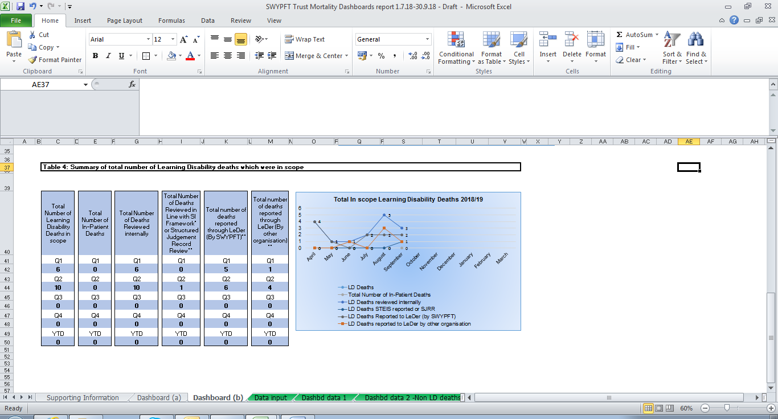

1. **Learning from Healthcare Death reviews and investigations**

This section of the report contains a summary of learning identified from reviews and investigations that have been completed so far for deaths reported between 1/4/17 – 30/9/18. Further learning will be added as these are completed.

**3.1 Learning from healthcare deaths reported as Serious Incidents**

This section provides information on deaths reported as Serious Incidents on Datix between 1 April 2017 and 30 September 2018.

|  |  |
| --- | --- |
| Number of deaths that were reported as serious incidents and investigations commenced (including those that were later de-logged as SIs) | 58 |
| Number of investigations that have been completed (at 17/12/18) | 49 |
| Number of investigations completed to date resulting in recommendations (including to share learning) | 48 |
| Number of investigations completed to date resulting in recommendations for improvement | 37 |
| Number of investigations reported between 1/4/17 – 30/9/18 which are underway (learning identified through these investigations will be added at the conclusion of the investigation process). | 9 |

**3.1.1 Themes from completed Serious Incident investigations**

From the Serious Incidents that were reported on Datix between 1 April 2017 and 30 September 2018 where the investigation has been completed, 37 resulted in recommendations for improvement. The table below sets out the main themes from the resulting actions:

|  |  |  |
| --- | --- | --- |
| **Action theme** | **Number of times theme identified** | **Number of SI reports where theme appears** |
| A5 Record keeping | 29 | 18 |
| A4 Risk assessment | 14 | 8 |
| B1 Communication | 14 | 9 |
| F2.1 Policy and procedure - in place but not adhered to | 10 | 8 |
| B3 Carers/family | 9 | 8 |
| F1 Staff education, training and supervision | 9 | 6 |
| A1 Care pathway | 7 | 6 |
| A2 Care delivery | 6 | 4 |
| G1 Organisational systems, management issues | 6 | 5 |
| F2.2 Policy and procedures, not in place | 6 | 4 |
| F4 Team service systems, roles and management | 4 | 3 |
| A3 Care coordination | 2 | 2 |
| C1 Medicine management | 2 | 2 |
| F3 Staff attitude, conduct, professional practice | 1 | 1 |
| J1 Other | 1 | 1 |

The top theme, record keeping, is consistent with that identified in recent annual reports, [available here](http://nww.swyt.nhs.uk/incident-reporting/Pages/Incident-management-annual-report.aspx).

**3.2 Learning from Structured Judgement Reviews**

This section provides information on deaths reported on Datix between 1 April 2017 and 30 September 2018 which resulted in a Structured Judgement Review. All Structure Judgement Reviews that are complete are now approved by a clinical member of the Mortality Review Group before themes are entered into Datix.

|  |  |
| --- | --- |
| Number of Structure Judgement Reviews that were commissioned for deaths reported between 1/4/17 – 30/09/18 | 57 |
| Number of Structure Judgement Reviews that have been completed and approved (at 17/12/18). | 41 |
| Number of Structure Judgement Reviews that are underway | 5 |
| Number of Structure Judgement Reviews that are in the approval process | 11 |

During a Structure Judgement Review, the reviewer assesses each phase of care and records their findings on a template under those headings. The sections below show examples from the thematic findings for positive practice and areas for improvement from reviews for cases between 1 April 2017 and 30 September 2018. Further examples will be added as more reviews are completed.

**3.2.1 Assessment of Care Overall**

**56%** of reviews completed to date rated overall care as good or excellent

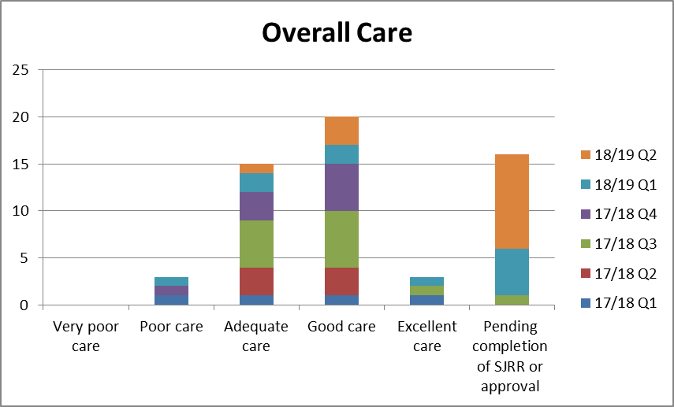

**3.2.2 Phases of care findings**

Below is a summary of the ratings given for each phase of care:-

**Risk assessment:**

**35%** were rated good or excellent

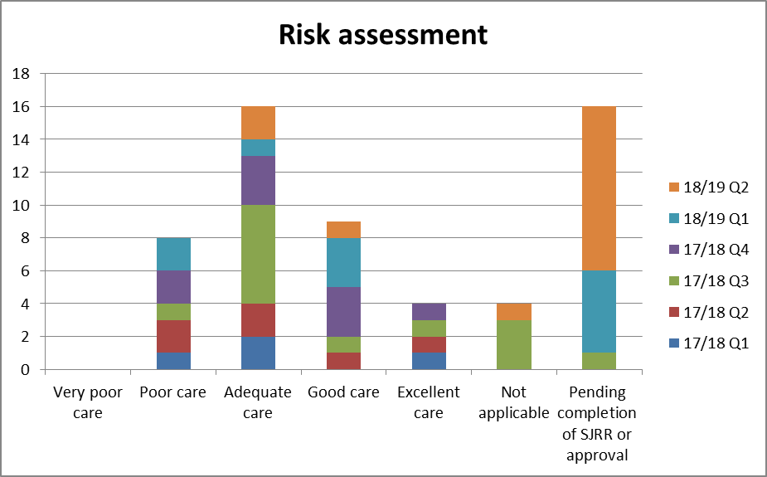

**Risk assessment - positive practice examples**

* “The risk assessment was completed within trust guidance; it was inclusive of history, intent and protective factors. It was clear, concise with a risk management plan.”
* “The overall risk assessment done for the Client has been excellent…there is good documentation of her current physical health problems and treatment received for it. There is a an accurate description of her relapse signatures and clear plans both in terms of actions to be taken for supporting her and urgent medical review with consideration of IHBTT involvement as well as a clear medication management plan so as to not delay the treatment and wait till she is reviewed by her own team doctor.”
* “Individual assessments at the outset of various trust services all complied with good practice guidelines and all risk assessments were completed.”
* “A risk assessment was completed within 24 (working) hrs of 1st planned contact with service user.”
* “Trust policy is that the risk assessment should be reviewed and updated whenever there are changes in clinical risk and at each Care Programme Approach Review. This took place when there was an identifiable change to clinical risk, which is good practice”  
  The risk assessment completed on 06/07/17 identified a number of risks which were then included in the care plan, which is good practice.
* “The risk initial assessment was of a high standard, using the correct paperwork and including detailed summaries at each section. The content was comprehensive, taking account of recent history, relevant longer term history and cataloguing recent incidents that may impact on ongoing risk. The clinical presentation was described well, giving the reviewer a sense that they could understand why the decisions made about care were taken.”
* “The history was taken from more than one person and observed risk behaviour within the clinical interactions recorded. Notably, this included considering the behaviour of significant others, identified as being at risk, but also potentially contributing to this through tolerance of violence and minimising the impact of this. This represents good formulation of risk, anticipating change and the potential for ongoing harm, informing the clinical management strategy.”
* “The assessment of risk in all areas continued through the episode of care, being clearly documented in the progress notes and any interventions needed put in place to address these”

**Risk assessment and management – areas for improvement examples**

* The person was at risk of falls and died as a result of a fall at home. There was no evidence of using the skills of the whole team in mitigating risk e.g. Occupational Therapy assessment.
* Risk assessments need to be comprehensively documented.
* Risks were identified and detailed in the progress notes as were the care plans associated with same. However the organisation of this information could have been more clearly documented within the assessments and care plans on RIO.
* Ensuring clearly defined contingency plans are available on the clinical system to ensure colleagues are directed to the risk assessments and offered guidance to support informed decision making at times of contact with services.
* The risk assessment is of a poor quality neither does it identify risk/risks appropriately, it also fails to provide any adequate risk management plan.
* The risk assessments are all, almost word for word duplicates, often mirroring the first assessment.
* A risk issue was identified however, this aspect of risk is not explored to either discount the risk or to raise awareness of the risk and manage it.
* No evidence of a risk assessment and risk management plan regarding transferring a patient from one Trust OPS inpatient unit to another [i.e. suitability of transport, number and type of escort required]
* No evidence to suggest that the Inter healthcare infection control transfer form was used particularly when it is known that the patient is doubly incontinent and a taxi was used.
* Risk assessment was a copy and paste of an earlier one, and included statements that were likely only relevant in the context of the first assessment such as attitude towards the assessor and that he was detained under the MHA when he was not on the later occasion.
* Alcohol use was cited as contributing factor in the service users mental health, however risk assessments did not make suggestions to address this risk
* Risk assessments were written at a time of crisis for the service user, and were reflective of risks then. There were no assessment and subsequent plan for his presenting needs while in the community.
* There was no evidence of an admission assessment being completed by the ward doctor, this would also include a capacity assessment and a VTE risk assessment, although there is a template for these in the admission documents.
* There is no plan for risk management on the second risk assessment although risks are care planned for in the CPA care plan.
* There is no Sainsbury’s level 2 risk assessment which would have been expected particularly as the service user was with IHBTT for 5 months.
* The service user was referred and would be seen within expected guidance from point of referral but this was already delayed due to the transfer care from Bradford into the Trust not having occurred. However, based on the information known about her risk history, her presentation during the assessment, the support she had and that she would be receiving a referral to a community team for follow up was considered an appropriate response
* There is little evidence relating to physical health concerns, care and treatment, contained within the clinical record.  
  The distinct lack of clearly identifiable investigation into the service user’s vascular health and impact on wellbeing, is a point for further learning.
* The risk assessment was not updated at the CPA review meeting when there were changes in clinical risk, as per policy.
* Trust policy is that people on CPA should have a level two risk assessment completed, but no level two risk assessment was completed. This was less than good practice.  
  A risk assessment identified a number of risks. A risk regarding falls did not have a specific intervention. The physical causes to the falls were being investigated by the GP but it is not clear how this was reviewed. This element of risk assessment could have been clearer.

**Allocation/Initial Review:**

**46%** were rated good or excellent

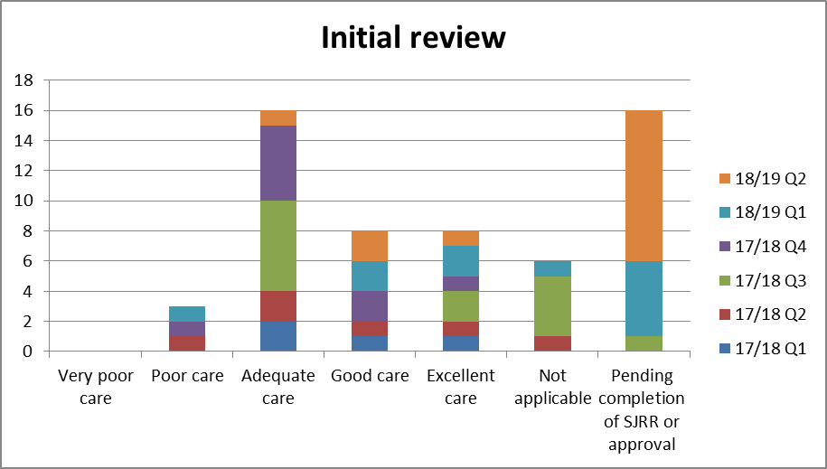

**Initial review positive practice examples**

* “Contact was made by SPA on the day the referral was received and the SU was seen in person with an interpreter within 8 days and picked up by IHBTT within 9 days of the referral being received. This is excellent practice.”
* The patient was discharged from hospital on My Care Plan. He was fast tracked to Continuing Health Care. Pre-emptive drugs were made available on discharge in line with best practice.
* In line with best practice when the patient was seen at home by the neighbourhood nursing service, a Waterlow Risk assessment was completed and advice given to the patient about the prevention of pressure areas. A profiling bed and mattress was ordered as the patient had previously been offered these prior to his discharge but had declined them. He had changed his mind following discharge.
* Following assessment and risk assessment a rapid change of management plan was made informed by the risk assessment. This was good because the staff present responded to the risk assessment, changing the destination of care to one with much higher levels of supervision and observation (ward admission). A legal framework (MHA) was also placed around this, taking account of the patient’s needs, lack of capacity and significant others distress. All parties were consulted, including the team where care was initially intended to be given, giving balanced decision and ensuring the patient was allocated to appropriate care.
* The initial review took place the day after the date of referral, which is within the 14 days response time for the service. The GP referring asked for an early review and this was provided, which was good practice.   
  The initial review was arranged so that a family member was able to attend, which is good practice.   
  A risk assessment, care plan and CPA review were completed following the initial review which was good practice.   
  The initial review highlighted the services users and families concerns, expected outcomes and some initial interventions. This was good practice.

**Initial review areas for improvement examples**

* The process of the DNACPR could be improved upon but ultimately did not affect the standard of care delivered
* The importance of in-reach from one BDU to another until engagement/ transition of care is established.

**On-going Care:**

**56%** were rated good or excellent

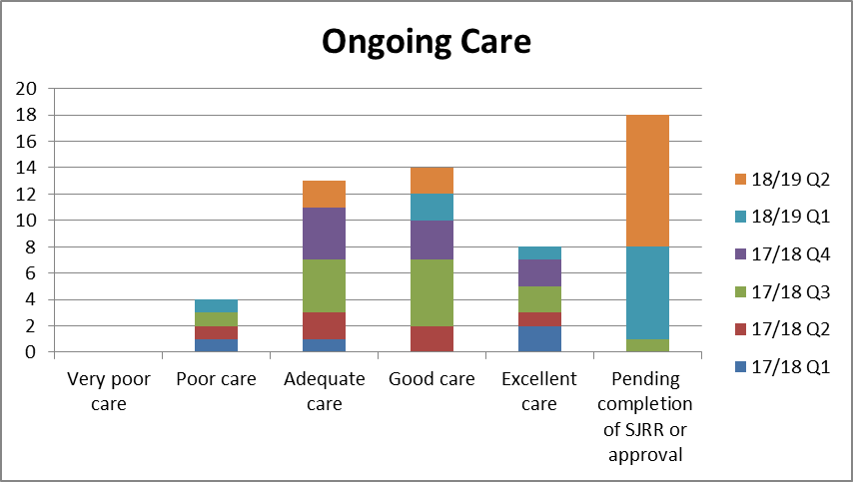

**Ongoing care – positive practice examples**

* “From the care record there is evidence of structured risk assessments appertaining to the community aspect of care prior to admission. These were carried out by staff who had a good therapeutic working knowledge and relationship with the patient…close working relationships and coordination between the community and inpatient teams was evident.”
* “When transfer was needed to the Enhanced Team, IHBTT remained actively involved until a joint visit had taken place. A care coordinator was identified in the enhanced team two weeks after the initial telephone call.”
* “Overall the patient was cared for and time being taken to engage with her….There was a multidisciplinary approach throughout involving specialist advisors for assessment and advice.”
* “Well documented evidence of good and collaborative joint working evident which was person-centred and responsive to the needs.”
* “Family/carer views were taken on board throughout. The team listened and acted on family concerns”
* "Attempts were made to be collaborative in devising and agreeing a care plan that met the service user needs. There was evidence of multi-agency working and sign posting to relevant agencies to support care and treatment."
* “The Care-coordinator had supported the patient to attend out-patient appointments, manage medication, gain new accommodation on three occasions, manage finances and had provided support on seven admissions and provided comprehensive follow up on discharge from the wards. The service user was often difficult to engage and frequently missed appointments which were always followed up by the Community Team. They had issues with alcohol and substance misuse and support was given to address. There was a pattern of relapse following increase in consumption of alcohol and/or illicit substances; when this did happen the Community Team dealt with this in a professional and non-judgemental manner. The Care-coordinator involved family members appropriately and demonstrated flexibility in order to ensure the service user received the care they needed. Every effort was made throughout the episode of care to make sure the service user was involved in decision making and their wishes around medication were taken into account and often a compromise was reached when the service user’s wishes were different to the medical recommendation.”
* Pressure area care was in place and the patient was regularly having checks to his pressure areas, staff had documented the occasions the patient declined a visual inspection by the nursing staff. Waterlow risk assessment of pressure ulcers was conducted in line with Trust policy. The records show that advice on the prevention of pressure areas was regularly given.
* There was evidence of good multidisciplinary working as the patient was also seen by the Assistant Community Matron, Community Matron and GP in addition to the NNS as part of the patient’s ongoing care. Evaluation of the patient’s condition occurred on a regular basis.
* Good level of communication was maintained when the service user was out for the booked home visits or did not attend an outpatient appointment. Carer issues were identified and a referral for a carers assessment was discussed and made. The service responded to an increase in service user needs by providing more frequent interventions and medication monitoring, and outpatient appointments with a psychiatrist were arranged. An appropriate level of care was provided. Regular appointments were booked to provide and review care and progress.
* Cognitive testing was undertaken when impairment was noted. This was all good practice.
* A Do not attempt CPR was completed by the consultant, with the patient’s wife being consulted on this. During cardiac arrest this was produced and the instruction followed, leading to Cessation of CPR (which was being performed by the crash team) and patient death. This is considered to be good care, enacting a difficult process in challenging circumstances. Following death, the staff acted sensitively and with compassion towards the patient’s wife, this also being considered good care.  
  No copy of the DNACPR was available in the records accessed, but review suggests it was stored and readily accessed in the clinical area.

**Ongoing care – areas for improvement examples**

* Ongoing care seemed to be challenging because the SU’s situation was greatly influenced by social factors, alcohol use and what seemed to be a passive attitude towards change. The mental health team were supportive of the SU and his situation, but did not seem to be assertive in perusing a motivational approach. Care plans, while still current, were in some case several years old and there was no evidence of them having been reviewed. Other factors that could have been planned for, such as addressing the work situation, were not care planned. There seemed to be little consideration given to the welfare of the children living at home, or coordination with their social worker during some difficult situation.
* There is evidence that practitioners asked questions about use of illicit substances and gave advice about the detrimental effects this would have on mental health. It is unclear whether the offer of referral to drug and alcohol services was made.
* Patient transferred from inpatient unit to acute Trust, however there was no record keeping of the condition of the patient on the clinical information system, and the death was only documented on Datix later that morning. The clinical record should have been updated.
* Convening best interest case conference or strategy meeting to discuss service user’s capacity would be valuable. Robust plan to further review their capacity in the community would also be useful. Ensuring the Trust Covert medication policy is being followed.
* The severity of a service user’s condition by different practitioners and services was underestimated. There appeared to be a relative lack of knowledge across different services that a man presenting in his mid 50’s with severe treatment-resistant anxiety symptoms is likely to have a depressive illness of moderate to severe intensity. When reviewed by a senior practitioner, the severity was immediately noted who did a robust and well-recorded assessment. A senior review (or by someone having a higher level of training and awareness) earlier on in the episode of illness is likely to have identified the severity and risks at an earlier stage.
* Ensuring that when specific treatments cannot be provided, that this is documented clearly and explained. In this example, it appeared to lead to the service user being pre-occupied with a pathway that was not available until the point of death.
* 2 small pressure areas were noted to the bony prominences on the patient’s buttock. The pressure area is not classified according to grade within the records. Grading of a pressure area is best practice.

**Care During Admissions (where applicable):**

**57%** were rated good or excellent

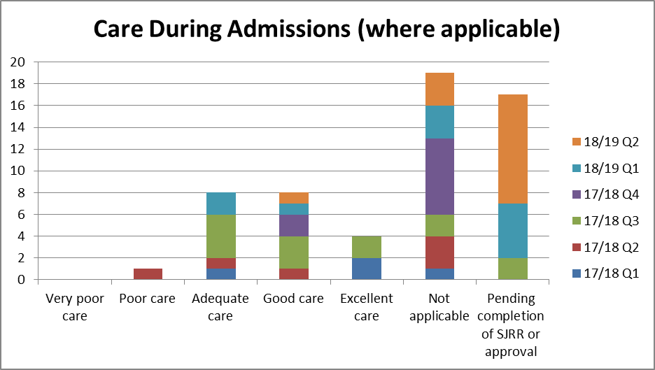

**Care During Admissions – positive practice examples**

* The risk triggers were identified and the plan was adhered to resulting in an informal admission to the ward. This was in a timely manner and did not escalate to a formal admission under the Mental Health Act.
* “Discharge was being planned from an early stage in the admission with the patient being actively involved in her care arrangements…The ward team were able to facilitate escorted home leave then worked with the community teams to increase the time spent at home. Good feedback from each visit is documented and provided a basis to inform the MDT of each stage to discharge.”
* “Nutrition Risk Screening Tool [NRST] completed and a corresponding entry made in the Rio progress notes reporting that the patient had been referred to the dietician”
* “In-Patient Falls Risk Assessment completed and supported by a comprehensive Mobility Falls Management care plan with evidence that the care plan has been effectively evaluated.”
* “Patient was a planned transfer from the acute hospital. The admitting ward had received referral information prior to the transfer. The admitting nurse completed the admission assessment including patient history, social and physical. Risk assessments including nutrition, skin integrity, bed rails and care planning was commenced. The care planning is part of the stroke care pathway. Recording on Fluid balance charts and food charts and catheter care pathway commenced on admission.”
* “The in-patient stay was excellent, detailed investigations and plans made. Collaboration with spouse and evidence of plenty of MDT working. Good planned discharge and follow up all provided in a timely fashion.”
* “During an inpatient stay in hospital...evidence of prompt and thorough assessments following falls with clear action points”
* “Consultant Physician attended for physical health review- good MDT working”
* “There is evidence that staff encouraged and involved patient in variety of OT activities. In the nursing daily reviews, the staff start off RIO entries by highlighting the MHA detention status and Nursing Level of Observations- Good practice”
* “When a fall occurred they were being observed constantly. Changes to presentation were discussed with the multidisciplinary team and the family.”
* “The family were involved in the resuscitation decision. A palliative approach was taken following difficulty swallowing and deterioration in physical health.”
* “Covert medication plan was initiated during admission due to risks of non-concordance, family were informed.”
* “The service user’s care and treatment whilst an inpatient seemed to be compassionate and attentive. Staff responded to fluctuating needs promptly and they had good input from the MDT, including therapy staff. When the patient began complaining of transient pain in the leg with no apparent onset this was monitored for three days at which point the pain was more consistent and impacting on mobility. The patient was provided with an x-ray that showed an historic fracture that has reopened. From this point on care was delivered by general hospital staff which was appropriate”
* “Overall the care was excellent. Input from a wide variety of disciplines, with regular review and regular consideration of which pharmacological options would suit him and his circumstances best. High-quality physical health care. Measures taken to increase observation/avoid falls to keep him safe. Family indicated that they were happy with his care.”
* Following assessment and risk assessment a rapid change of management plan was made informed by the risk assessment. This was good because the staff present responded to the risk assessment, changing the destination of care to one with much higher levels of supervision and observation (ward admission). A legal framework (MHA) was also placed around this, taking account of the patient’s needs, lack of capacity and significant others distress. All parties were consulted, including the team where care was initially intended to be given, giving balanced decision and ensuring the patient was allocated to appropriate care.

**Follow-up Management / Discharge:**

**56%** were rated good or excellent

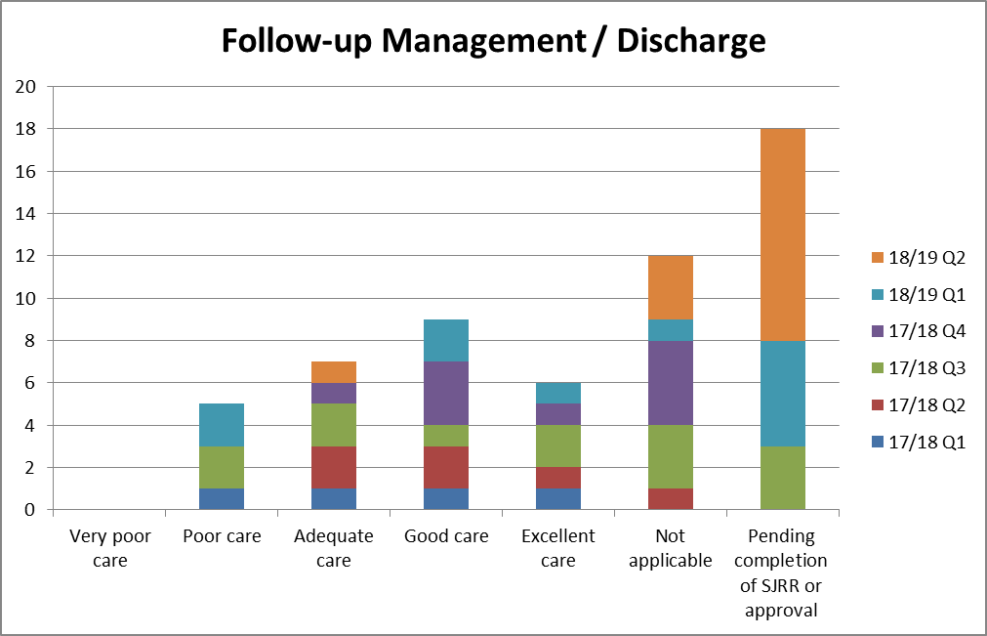

**Follow-up Management / Discharge – positive practice examples**

* “Advocacy contacted on his behalf.”
* “The service user was monitored via 6 monthly outpatient clinics and attended monthly Clozaril clinics. He was often supported to attend by a member of the care home team. The focus of the contact was around symptom management and mental state examination, with some evidence of a bio-psychosocial reporting.”
* “There is ample evidence of regular comprehensive MDT reviews in which the relatives were fully involved. The MDT’s were thoroughly documented using a structured format”
* “There were frequent MDT reviews, led by a medic which appraised risks, the ongoing situation and presenting needs.”
* Care period with current care coordinator, following discharge 2010, appears to have been beneficial in that re-admission to hospital has not been required.

**Follow-up Management / Discharge – areas for improvement examples**

* A service user was receiving Clozaril; it would have been expected that the service user was having his physical health checked routinely to monitor side effects; however it was unclear if this was the case. It was unclear in the clinical information system how the service user lived between being seen by Lead HCP and Clozaril team.
* It was not clear in the documentation that any action had been taken following 7 day discharge follow up.
* Ensuring review of both physical and mental health and ensuring this is documented

**End of Life care**

**100%** of relevant cases in inpatient carewere rated good or excellent

**Follow-up Management / Discharge – positive practice examples**

* The patient was discharged from hospital on My Care Plan with pre-emptive medication in place. There was regular discussion with the patient about end of life care and his preferences for care. The patient wanted to remain at home and not be escalated to hospital this was facilitated by the whole multidisciplinary team.
* There is good evidence that My Care Plan was reviewed appropriately as it was discontinued on 21st June when the patient had not deteriorated further since his discharge from hospital and then re-commenced on 20th July when the patient’s condition had started to deteriorate.
* The GP was asked to visit appropriately when the patient started to deteriorate. The possibility of sub-cutaneous fluids was considered and discussed with the patient’s wife and this deemed as not appropriate as it was end of life deterioration and not an acute medical condition
* The use of pre-emptive medication is also appropriate. Oramorph was used by the patient to manage his pain initially, the use of the pre-emptive medication was discussed with the patient and his wife regularly and advice was given to contact the service if pain relief was required or the patient became too unwell to swallow.
* SAF T was inserted when the patient required the pre-emptive medication and was left in place in case further doses were required or a syringe driver needed to be initiated
* Good evidence of multidisciplinary working and involvement of the patient and his family in his care. The Community Matron discussed the discontinuation of My Care Plan with the patient, GP and District Nursing Sister who were all in agreement. Discussion also took place at the Palliative Care meeting with the GP, Specialist Palliative care and District Nursing team present.

**Follow-up Management / Discharge – areas for improvement examples**

* When pre-emptive medication was used Midazolam, hyoscine and morphine was given. Detail around the assessment and decision making for giving all the 3 medication at the same time is lacking.

**Quality of the patient record in enabling good quality of care to be provided:**

**51%** were rated good or excellent

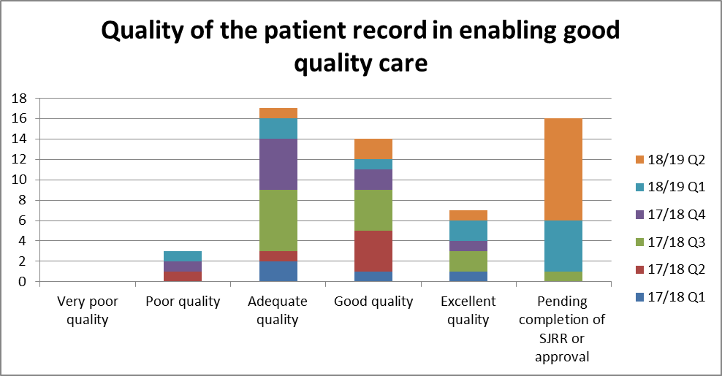

**3.3 Learning from other Investigations**

1. **Service level investigations**

Of the 17 service level investigations for deaths reported between 1 April 2017 and 30 September 2018, 13 investigations have been completed (at 18/12/18).

The areas identified for improvement are summarised and themed below:

**Care delivery**

* Although teams have systems and processes there are times when an individual staff member has not taken responsibility for tasks allocated to them and care delivered was not provided as planned.
* Care coordinators in the Enhanced and Core Pathways to be reminded about their responsibilities to directly supervise the work of the MHSW as part of the service user’s care plan.
* The manager of the MHSW team will ensure there is regular opportunity at team meetings for caseload and workload discussion and that any issues arising are flagged with the relevant care coordinator as necessary.
* MHSWs should be reminded by their manager that it is their responsibility to read the notes of the service user prior to visits and any planned interventions.
* Managerial supervision in accordance with the Council’s Dignity at Work policy should be carried out with all members of the MHSW team.
* MHSWs should be encouraged by their manager to take opportunities to network and communicate effectively with other colleagues in the Drury Lane Hub.
* Calderdale IHBTT did not offer a full assessment of this man’s needs. The writer’s opinion is that this would have been helpful and felt supportive to X but do not think this contributed to the death of X.
* Kirklees IHBTT offered an assessment and no further follow-up was offered.
* Yorkshire Ambulance service did not appear to follow up with appropriate services when X refused to get into ambulance.
* The stepping down from FACT to case management, this is not in line with good practice and normal practice within the team.
* Poor caseload management and contingency planning to cover staff leave

**Risk assessment**

* Ensuring Sainsbury’s level 1 risk assessment is completed at the appropriate time.
* Completion of a Level 1 risk assessment at a medical review does not always happen however the formulation relating to risk is documented in the Medical Care Plan. This will be reviewed as part of the trust wide review of risk assessment documentation, in the transition to a new electronic records system. This review is underway and will give consideration to developing a more formative approach to risk assessment.
* When no face to face contact has been possible and service user contacts the team; to ensure that a qualified member of staff speaks with the service user in order to carry out a risk assessment in relation to urgency of assessment required.
* Level 1 risk assessment identified several risk indicators for ‘suicide’ that were recorded as unknown. It is the view of the investigator that some of these could have been completed from the information already provided e.g. ‘previous attempts on life’. It is the view of the investigator however, that this would not have influenced the care and treatment of the service user.

**Record keeping**

* Need to check details on system at the time of taking a verbal referral e.g. GP details and address of patient.
* Rio documentation was not fully updated within a timely manner.
* It is documented that Practitioner advised family member to contact the police when she telephoned and requested support from IHBTT. There is however, no documentation to state that family member agreed to this plan even though Practitioner stated that this was agreed. It is the view of the investigator that consideration could have been given to arranging to speak to family member after the police had been informed.
* Documentation was not up to date on the trust's clinical record keeping system and this was not in line with good practice within the service.

**Communication**

* There were some communication issues between teams regarding attendance at A&E.
* Ensuring that when a patient does not attend for an outpatient appointment, that this is referred to the duty worker to follow up as per procedure.
* Although case for concern discussed within the weekly MDT , actions that were agreed within the MDT were not carried through

**Families and Carers**

* Staff member not making all reasonable attempts to contact family member and discuss concerns as voiced by the service user and not informing the GP at the point of discharge from the service of these concerns.
* Discharging the service user without contact from family member

**Infection Prevention and Control**

* Access to antiviral swabs was not available on the ward. These were not part of the essential items checklist.
* Vaccinations were offered to patients at the start of the flu campaign but were not offered again to those declining or admitted after the initial vaccination program although the service user in question did receive the antiviral Flu vaccination.
* Mandatory training for IPC was below the trust target. The training is not accessible on site at Poplars and Poplars is isolated from the sites where training is offered. Practically, it is difficult to release staff during shift to attend training at an alternative venue with several staff non-car drivers.
* The use of face masks was not followed correctly. Staff reported being unaware of covering the use of face masks in training.

1. **Safeguarding reviews**

Between 1 April 2017 and 30 September 2018, there are three deaths that have been/are being reviewed through safeguarding processes. Learning will be updated when this is available.

* One case has had a review completed which identified several recommendations for the safeguarding board, one of which was to highlight the importance of recording and appropriately responding to all incidents of self harm and raising awareness of the antecedents of suicide in children and young people.
* One case was reviewed at a SAR panel but it was decided that the case did not meet the criteria as all agencies had worked together. The service user had been under mental health services for many years, and he did not engage well with either mental health services or physical health services. He did not adhere to his medical treatment regimen for his diabetes and this resulted in an amputation of a limb. He continued to neglect his personal care needs and declined treatment for his mental health condition. His physical health continued to deteriorate due to non-compliance and was admitted to the general hospital, where he continued to decline some treatments. Staff were in constant contact with the service user to encourage him to have treatment and attempts were made to undertake capacity assessments but when discussing treatment he refused to speak with staff and often became hostile in manner and requested them to leave. He was placed under safeguarding to ensure all services involved communicated and discussed the risks the service user was putting himself under.

1. **Learning disability reviews**

The Mortality Review Group has agreed that for any learning disability deaths, the managers 48 hour review will be completed, and in some cases a Structured Judgement Review will be requested to enable internal learning. This is alongside the LeDeR programme.

Feedback from the Learning Disability Mortality Review programme (LeDeR) has been limited to date. The Learning Disabilities Mortality Review (LeDeR) Programme annual report December 2017 tells us that:

* From 1st July 2016 to 30th November 2017, 1,311 deaths were notified to the LeDeR programme nationally.
* By 30 November 2017, 103 reviews had been completed and approved by the LeDeR quality assurance process.
* From the 103 completed reviews, there were 189 learning points or recommendations identified. In each review that identified one or more learning points, the average number of learning points and/or recommendations was 2.8.
* Thirty-six reviews (35%) did not identify any learning.
* Priority is being given to themed reviews of death of young people aged 18-24 years and people from black and minority ethnic background.

|  |  |
| --- | --- |
|  | The most commonly reported learning and recommendations were made in relation to the need for:  a) Inter-agency collaboration and communication  b) Awareness of the needs of people with learning disabilities  c) The understanding and application of the Mental Capacity Act (MCA).  Most of the learning to-date echoes that of previous reports of deaths of people with learning disabilities, and the importance of addressing this cannot be over-estimated. We have a responsibility to families and others to ensure that any learning points at individual level are taken forward into relevant service improvements as appropriate.  As a result of the reviews completed, some actions have already been taken to improve service provision for people with learning disabilities. These have included, for example, strengthening discharge planning processes, and the provision of reasonable adjustments for people with learning disabilities. |