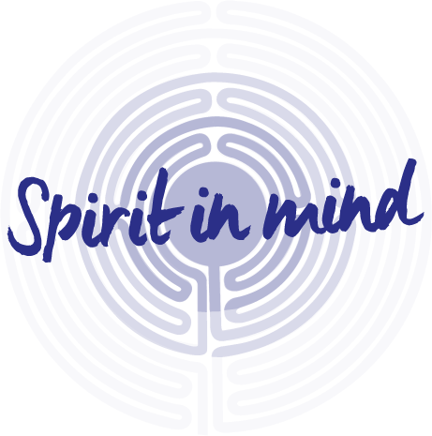

Registered Charity No:
1055931-14
The Compassion Hub

The Compassion Hub is an informal special interest group which brings together people seeking to explore the field of compassion and its development and application across a range of disciplines including healthcare, business and education.

Friday, 29th March 2019 : 1.15pm – 3.00pm
at Dewsbury Minster

Expanding Circles of Compassion

Hanif Sidat leads on a discussion of an integrative model which locates the emergence of compassion in the wider field of human development

Please let us know if you are coming by contacting either:

Debby Walker, Tel: 01924 316282 debby.walker@swyt.nhs.uk
Angie Barker, Tel: 01924 316281 angie.barker@swyt.nhs.uk

www.Spiritinmind.org.uk
@spiritinmindnhs


Believing that it is our nature to enjoy giving and receiving in a compassionate manner, I have been preoccupied most of my life with two questions: What happens to disconnect us from our compassionate nature, leading us to behave violently and exploitatively? And conversely, what allows some people to stay connected to their compassionate nature under even the most trying circumstances?

Our task must be to free ourselves by widening our circle of compassion to embrace all living creatures. Albert Einstein

While studying the factors that affect our ability to stay compassionate, I was struck by the crucial role of language and our use of words. I have since identified a specific approach to communicating – both speaking and listening – that leads us to give from the heart, connecting us with ourselves and with each other in a way that allows our natural compassion to flourish. I call this approach Nonviolent Communication, using the term nonviolence as Gandhi used it, to refer to our natural state of compassion when violence has subsided from the heart.

When we give from the heart, we do so out of the joy that springs forth whenever we willingly enrich another person’s life. This kind of giving benefits both the giver and the receiver. The receiver enjoys the gift without worrying about the consequences that accompany gifts given out of fear, guilt, shame or desire for gain. The giver benefits from the enhanced self-esteem that results when we see our efforts contributing to someone’s well-being.

It is our nature to enjoy giving and receiving compassionately. We have, however, learned many forms of life-alienating communication that lead us to speak and behave in ways that injure others and ourselves. One form of life-alienating communication is the use of moralistic judgments that imply wrongness or badness on the part of those who don’t act in harmony with our values. Another is the use of comparisons which can block compassion both for others and for ourselves. Life-alienating communication also obscures our awareness that we are each responsible for our own thoughts, feelings and actions. Communicating our desires in the form of demands is yet another characteristic of language that blocks compassion.

From: ‘Nonviolent Communication: A Language of Life’,
Marshall B. Rosenberg

