Children’s Speech and Language Therapy

Help your child to ask for what they want

Your child may ask for things by:

Looking at you
Smiling at you
Pulling your hand towards something
Pointing to the object
Giving you the object
Saying a sound
Making a sign/ action
Saying a word, even if it is not clear
Saying a sentence

Give your child chance to ask for things by:

Placing a favourite object out of reach…. then waiting

This might be a toy that your child plays with a lot.
Wait until he does something to ask for it. Then say the name of the toy and give it to him.

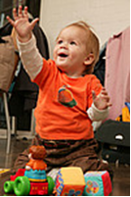

Waiting gives them time to think.

It helps them know that they can try to tell you.
Help your child to ask for what they want
Children’s speech and language therapy
New Street Health Centre, Upper New Street, Barnsley, S70 1LP Telephone: 01226 433119/433115
Email: childrensspeech.therapy@swyt.nhs.uk Web: www.barnsleyspeechtherapy.co.uk

Your child may ask for things by:

Looking at you
Smiling at you
Pulling your hand towards something
Pointing to the object
Giving you the object
Saying a sound
Making a sign/action
Saying a word, even if it is not clear
Saying a sentence

Give your child chance to ask for things by:

Offering a little bit….. then waiting

Give your child a little bit. Then wait so he can ask for more. This could be with food or toys, for example bubbles. As soon as he does, give him a little bit more and so on.

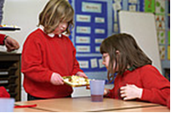
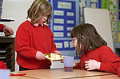

Waiting gives them time to think.

It helps them know that they can try to tell you.

Help your child to ask for what they want
Children’s speech and language therapy
New Street Health Centre, Upper New Street, Barnsley, S70 1LP Telephone: 01226 433119/433115
Email: childrensspeech.therapy@swyt.nhs.uk Web: www.barnsleyspeechtherapy.co.uk

Your child may ask for things by:

Looking at you
Smiling at you
Pulling your hand towards something
Pointing to the object
Giving you the object
Saying a sound
Making a sign/action
Saying a word, even if it is not clear
Saying a sentence

Give your child chance to ask for things by:

Choosing an activity your child needs help with… then waiting

Children love bubbles, wind-up toys and musical toys. Your child needs help to make these toys work. Wait for your child to ask. Then do the activity for a short time, stop and wait for him to ask again.



Waiting gives them time to think.

It helps them know that they can try to tell you.

Help your child to ask for what they want
Children’s speech and language therapy
New Street Health Centre, Upper New Street, Barnsley, S70 1LP Telephone: 01226 433119/433115
Email: childrensspeech.therapy@swyt.nhs.uk Web: www.barnsleyspeechtherapy.co.uk

Your child may ask for things by:

Looking at you
Smiling at you
Pulling your hand towards something
Pointing to the object
Giving you the object
Saying a sound
Making a sign/action
Saying a word, even if it is not clear
Saying a sentence

Give your child chance to ask for things by:

Offering a choice….then waiting

Hold two objects in your hands. Say the two words. Then wait for your child to choose.

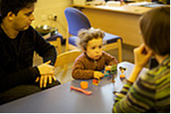

Waiting gives them time to think.

It helps them know that they can try to tell you.

Help your child to ask for what they want
Children’s speech and language therapy
New Street Health Centre, Upper New Street, Barnsley, S70 1LP Telephone: 01226 433119/433115
Email: childrensspeech.therapy@swyt.nhs.uk Web: www.barnsleyspeechtherapy.co.uk

Your child may ask for things by:

Looking at you
Smiling at you
Pulling your hand towards something
Pointing to the object
Giving you the object
Saying a sound
Making a sign/action
Saying a word, even if it is not clear
Saying a sentence

Give your child chance to ask for things by:

Pausing a familiar activity… then waiting

Activities like tickling, swinging or singing a song can last a long time. Pause the activity. Wait for your child to request more – they may look at you, say ‘more’ etc.

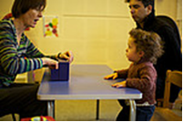

Waiting gives them time to think.

It helps them know that they can try to tell you.

Help your child to ask for what they want
Children’s speech and language therapy
New Street Health Centre, Upper New Street, Barnsley, S70 1LP Telephone: 01226 433119/433115
Email: childrensspeech.therapy@swyt.nhs.uk Web: www.barnsleyspeechtherapy.co.uk

Your child may ask for things by:

Looking at you
Smiling at you
Pulling your hand towards something
Pointing to the object
Giving you the object
Saying a sound
Making a sign/action
Saying a word, even if it is not clear
Saying a sentence

Give your child chance to ask for things by:

Watching when things go wrong… and waiting

When spoons fall on the floor, crayons break, or juice gets spilt, we react and fix these problems quickly. Next time, wait a few seconds. This lets your child do or say something.

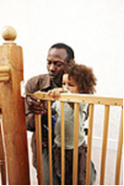

Waiting gives them time to think.

It helps them know that they can try to tell you.

