

**Non-Executive Director**

**Candidate Information Pack**

**2019**

**Contents**

Welcome letter from the Chair 3

About us 4

Advertisement 7

Job description 9

Recruitment timetable 11

How to apply 12

**Welcome from Angela Monaghan, Chair**

Dear candidate,

Thank you for your interest in the appointment of a Non-Executive Director to join the Board of our Trust. I hope that the demanding, but very rewarding opportunity catches your imagination and that you are encouraged to apply. This crucial role provides an excellent opportunity and comes at an exciting time for our Trust. Our ambitious programme of transformation reflects the challenging times in which we operate, will transform the lives of those who use our services and bring benefits to the communities we serve.

We are committed to continuous improvement and high quality in all we deliver for our service users, their carers and their families. Our talented and dedicated staff provide a range of expanding community, mental health and learning disability services to the people of Barnsley, Calderdale, Kirklees and Wakefield. We also provide specialist medium secure services across a regional footprint, encompassing the whole of Yorkshire and the Humber, plus a number of wellbeing and other services across South and West Yorkshire.

Our mission is to ***help people reach their potential and live well in their community***. Our successful track record is based on service innovation, developed in partnership with service users, our staff and stakeholders, and partner agencies. The vast majority of Trust services have been rated Good or Outstanding by the Care Quality Commission (CQC) and the organisation is rated Good for being well led. However, we are rated as Requires Improvement overall by the CQC which reflects pressures and challenges in a small number of service areas. Further information is available on their website: [Care Quality Commission](http://www.cqc.org.uk/provider/RXG/reports) (<http://www.cqc.org.uk/provider/RXG/reports>).

The Trust is seeking to appoint an outstanding individual, who is both financially qualified and has senior-level financial management experience, to join our strong Board. The successful candidate will bring the capability and enthusiasm to support our ambitious vision within the context of significant change, transformation and opportunity, both within the organisation, the region and the wider NHS. The successful candidate must also be able to demonstrate experience of working in or with large, complex organisations, an ability to engage positively and collaboratively in Board discussions, and the potential to act as an ambassador for the Trust. They will also bring strong relationship management and influencing skills, have experience of making autonomous decisions and have a passion for delivering quality and excellence.

Interested applicants must live within South or West Yorkshire and we welcome applications from all aspects of society, including people from BAME communities, people with disabilities, younger people, service users and carers.

I trust the information in this pack will give you a flavour of our organisation, our values and priorities. If you share our ambition for success and can offer the commitment needed, please see details within this pack regarding how to apply for the role and our drop-in recruitment/information event, where you can meet members of our Trust Board. Prospective candidates wishing to discuss the role informally may speak to either myself, the Chief Executive or Deputy Chair.

I wish you the very best in your application.

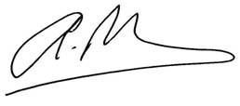

Angela Monaghan

**Chair**

**About us**

**Background**

We are a NHS foundation trust that provides community, mental health and learning disability services to the people of Barnsley, Calderdale, Kirklees and Wakefield. We also provide medium secure (forensic) services to the whole of Yorkshire and the Humber (area covered by Doncaster Metropolitan Borough Council, Rotherham Metropolitan Borough Council, Sheffield City Council, Bradford Metropolitan District Council and Leeds City Council).

Over 1 million people live in Barnsley, Calderdale, Kirklees and Wakefield across urban and rural communities from a range of diverse backgrounds. We aim to match the community’s needs with locally sensitive and efficient services.

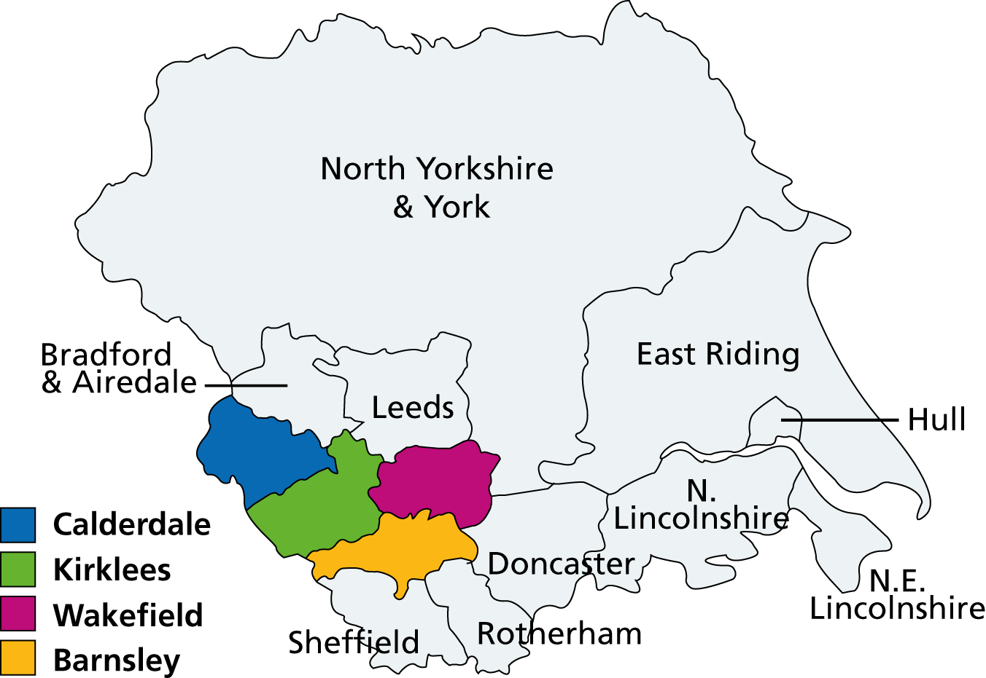

We work with other local NHS organisations to provide comprehensive health care to people in our area. We also work closely with Local Authorities (social care) and with other government departments and voluntary organisations. Working in partnership is very important to us and is vital if we are to continue delivering high quality services for local people.

Working in partnership also means working with the members of our foundation trust, who can have a say in how we run the Trust and how they wish our services to be developed. Over 9,000 local people have joined us as members, and our staff are members, too.

Foundation trusts are a different kind of NHS organisation known as a ‘public benefit corporation’. They are still part of the NHS and operate according to NHS principles - free care, based on need, not ability to pay - but they are run locally and are accountable to their members.

To provide the flexible, individually tailored care that local people have told us they want, we work from a variety of sites as well as with people in their own homes. 98% of our services are community-based and are well supported by inpatient services for when people need care or assessment in a hospital setting.

The Trust, which was first established in 2002, now employs around 4,100 staff, in both clinical and non-clinical support services, and has a turnover of over £220 million.

**Our mission**

**We help people reach their potential and live well in their community.**

**Our values**

* We put the person first and in the centre.
* We know that families and carers matter.
* We are respectful, honest, open and transparent.
* We improve and aim to be outstanding.
* We are relevant today and ready for tomorrow.

**Our strategic objectives 2019/20**



1. **Improve health**

* Working with our partners to join up care in our

Communities

Improve our mental health offer for older people

* Advance our wellbeing and recovery approach

1. **Improve care**

* Provide safe care every time and in every service
* Provide all care as close to home as possible
* Make care quickly and easily available to reduce waiting times
* Embed #allofus

1. **Improve resources**

* Spend money wisely and reduce waste
* Make the most of our clinical information
* Make better use of digital technology

1. **Making SWYPFT A Great Place to Work**

* Support the wellbeing of #allofus
* Have better conversation with all of our people
* We will not tolerate bullying and harassment

**Our services**

To provide the flexible, individually tailored care that local people have told us they want, we work from a variety of sites as well as with people in their own homes. Our community-based services are well supported by inpatient services for when people need care or assessment in a hospital setting. In addition, clinics are delivered in a number of other premises, including GP surgeries, health centres and community buildings.

**In Barnsley, Calderdale, Kirklees and Wakefield we provide care to:**

* adults of working age (aged 18 to 65) with a mental health problem;
* services to people as young as 14 experiencing the first signs of psychosis;
* child and adolescent mental health services;
* older people (over 65) with a mental health problem;
* people (mainly adults) with a learning disability whose behaviour challenges services, with intensive support needs and/or a mental health problem; and
* medium secure forensic services for people with a mental health problem and/or learning disability.

**In Barnsley we also provide:**

* inpatient services;
* partnership services;
* children's services;
* community rehabilitation;
* services for people with long-term conditions; and
* primary care and preventative services.

We are active partners in two Integrated Care Systems (ICSs):

* West Yorkshire and Harrogate Health and Care Partnership; and
* South Yorkshire and Bassetlaw ICS

and we play a key role in the place-based health and care partnerships in Barnsley, Calderdale, Kirklees and Wakefield.

A fuller description of [our services](http://www.southwestyorkshire.nhs.uk/our-services/) can be found on our website at: http://www.southwestyorkshire.nhs.uk/our-services/.

**Links to further information**

**How we’re run**

Further information on [how our organisation runs](http://www.southwestyorkshire.nhs.uk/about-us/how-we-are-run/), including members, Members’ Council, and the Trust Board, can be found on our website at: http://www.southwestyorkshire.nhs.uk/about-us/how-we-are-run/.

**Our Constitution**

Our [Constitution](http://www.southwestyorkshire.nhs.uk/wp-content/uploads/2017/06/Constitution-including-Standing-Orders-APPROVED-BY-TB-31.01.17-and-MC-....pdf) can be found on our website at:

<http://www.southwestyorkshire.nhs.uk/about-us/how-we-are-run/trust-board/constitution-self-certification/>

**Annual report and accounts**

Our [Annual Report](http://www.southwestyorkshire.nhs.uk/about-us/performance/annual-report/) and accounts can be found on our website at: <http://www.southwestyorkshire.nhs.uk/about-us/performance/annual-report/>.

**Quality account**

Our [Quality Accounts](http://www.southwestyorkshire.nhs.uk/quality-innovation/quality-account/) can be found on our website at: <http://www.southwestyorkshire.nhs.uk/quality-innovation/quality-account/>.

**Creative Minds**

Information on our [Creative Minds](http://www.southwestyorkshire.nhs.uk/quality-innovation/creative-minds/) approach can be found on our website at: http://www.southwestyorkshire.nhs.uk/quality-innovation/creative-minds/.

**Regulators (NHS Improvement and Care Quality Commission (CQC))**

Further information on the Trust can be found on the [NHS England](https://www.gov.uk/government/groups/south-west-yorkshire-partnership-nhs-foundation-trust) website at: <https://www.gov.uk/government/groups/south-west-yorkshire-partnership-nhs-foundation-trust> and

[Care Quality Commission](http://www.cqc.org.uk/provider/RXG/reports) (CQC) website (<http://www.cqc.org.uk/provider/RXG/reports>).

**Advertisement**

**Non-Executive Director**

**South West Yorkshire – £13,584 (2.5/3 days per month)**

South West Yorkshire Partnership NHS Foundation Trust is an award winning organisation which exists to help people reach their potential and live well in their communities.

Our compassionate, dedicated and enthusiastic staff are committed to living our values every day:

* We put the person first and in the centre
* We know that families and carers matter
* We are respectful, honest, open and transparent
* We improve and aim to be outstanding
* We are relevant today and ready for tomorrow

Our values guide us in providing a range of community, mental health and learning disability services to more than a million people across Barnsley, Calderdale, Kirklees and Wakefield. We also provide some medium secure (forensic) services to the whole of Yorkshire and the Humber and some wellbeing services in other parts of Yorkshire.

We’re looking for a Non-executive director who is financially qualified, with senior-level financial management experience, to join our strong, unitary Board in guiding our workforce to deliver the highest quality care for local people. You’ll have the ability to build strong relationships, provide support and constructive challenge to the Executive team, and help us to continue to improve the services we deliver. You will bring the capability and enthusiasm to support our ambitious vision and goals within the context of significant change, transformation and opportunity, both within the organisation and in the wider NHS.

You will demonstrate an ability to engage positively and collaboratively in Board discussions and act as an ambassador for the Trust. You should also bring strong relationship management skills and have a passion for delivering excellence. Able to champion our drive for service excellence, you will demonstrate experience of working, ideally at Board level, in large, complex, customer-focused organisations.

You must live within South or West Yorkshire and we welcome applications from all aspects of society, including people from BAME communities, people with disabilities, younger people, service users and carers.

**If you share our ambition for success and can offer the commitment needed, please attend one of our drop in recruitment/information events to meet members of our Trust Board. Further information about the drop in session can be found on our website:** [**http://www.southwestyorkshire.nhs.uk/beourNED**](http://www.southwestyorkshire.nhs.uk/beourNED)

**If you would like to arrange to have an informal discussion about this role, please e-mail** [**Janice.white@swyt.nhs.uk**](mailto:Janice.white@swyt.nhs.uk) **marked as “Non-Executive Director appointment” or telephone 01924 316295.**

**For further information on how to apply and to download a copy of the information pack, please visit our website:** [**http://www.southwestyorkshire.nhs.uk/beourNED**](http://www.southwestyorkshire.nhs.uk/beourNED)**.**

**Closing date is Wednesday 3rd July 2019.**

**Job description**

**Non-Executive Director outline job description**

The Non-Executive Directors of our Board bring their expertise and experience, as well as their particular knowledge as a member of the community to the work of the Board.

Your role will be to use your skills and your personal experience as a member of your community to:

* promote the success of the Trust to maximise the benefits for members and for the public;
* commit to working to, and encouraging within the Trust, the highest standards of probity, integrity and governance, and contribute to ensuring that the Trust’s internal governance arrangements conform to best practice and statutory requirements;
* provide independent judgement and advice on issues of strategy, vision, performance, resources and standards of conduct and constructively challenge, influence and help the Executive Management Team develop proposals on such strategies;
* assist fellow Directors in setting the Trust’s strategic aims, ensuring that the necessary financial and human resources are in place for the Trust to meet its objectives, and that performance is effectively monitored and reviewed;
* assist fellow Directors in providing entrepreneurial leadership to the Trust within a framework of prudent and effective controls, which enable risk to be assessed and managed;
* assist fellow Directors in setting the Trust’s values and standards and ensure that its obligations to its stakeholders and the wider community are understood and fairly balanced at all times;
* engage positively and collaboratively in board discussion of agenda items and act as an ambassador for the Trust in engagement with stakeholders including the local community, dealing with the media when appropriate;
* monitor the performance and conduct of management in meeting agreed goals and objectives and statutory responsibilities, including the preparation of annual reports and annual accounts and other statutory duties;
* obtain comfort that financial information is accurate and that financial controls and risk management systems are robust and defensible;
* contribute to the determination of appropriate levels of remuneration for executive directors;
* participate in and in some cases Chair Committees as required;
* attend and contribute to Members' Council meetings;
* bring independent judgement and experience based on commercial, financial, legal or governance expertise from outside the Trust and apply this to the benefit of the trust, its stakeholders and its wider community;
* undertake responsibilities and duties under the Mental Health Act; and
* on occasion participate as Chair of the interview panel in the selection of medical consultant staff and Chair appeals.

**Person specification**

The Trust has identified the following skills/expertise for this appointment:

* A financial qualification, with senior level financial management experience is essential.

Plus:

* Experience of working in or with large complex organisations
* Strong relationship management and influencing skills
* Committed to quality and delivering excellence
* Ability to engage positively and collaboratively in Board discussions
* Ability to act as an ambassador for the Trust
* Strong commitment to promoting equality, inclusion and diversity

In addition to the expertise detailed above, all candidates selected for interview will need to show that they have the competencies required to be effective in a board level role. They are:

|  |  |
| --- | --- |
| **Patient and community focus** | A high level of commitment to patients, carers and the community, especially to disadvantaged groups, and the values of the Trust |
| **Strategic direction** | The ability to think and plan ahead, balancing needs and constraints. |
| **Holding to account** | The ability to accept accountability and probe and challenge constructively. |
| **Effective influencing and communication** | Be able to influence and persuade others. |
| **Team working** | Be committed to working as a team member. |
| **Self-belief and drive** | The motivation to improve NHS performance and confidence to take on challenges. |
| **Intellectual flexibility** | The ability to think clearly and creatively. |

**Recruitment timetable**

|  |  |
| --- | --- |
| **Action** | **Date** |
| Opening date for applications / advertisement | Wednesday 5 June 2019 |
| Recruitment/information events | This will be as follows between 5pm and 7pm at the following location:   * Monday 24 June  on Block 7 (via main reception), Fieldhead, Ouchthorpe Lane, Wakefield, WF1 3SP |
| Closing date for applications | Wednesday 3 July 2019 |
| Shortlisting | Friday 5 July 2019 |
| Final interviews | Friday 12 July 2019 |
| Nominations Committee (recommendation) | w/c Monday 18 July 2019 |
| Members’ Council (approval) | Friday 2 August 2019 |
| Appointment start date, subject to completing of pre-employment checks | Monday 5 August 2019 |

**How to apply**

**Closing date: Wednesday 3 July 2019**

Interested applicants must live within South or West Yorkshire public constituencies as set out in Annex 1 of our [Constitution](http://www.southwestyorkshire.nhs.uk/wp-content/uploads/2017/06/Constitution-including-Standing-Orders-APPROVED-BY-TB-31.01.17-and-MC-....pdf) and meet the provisions covering the appointment and removal of Non-Executive Directors of the Trust Board set out in paragraphs 25, 29 and Annex 6 of our [Constitution](http://www.southwestyorkshire.nhs.uk/wp-content/uploads/2017/06/Constitution-including-Standing-Orders-APPROVED-BY-TB-31.01.17-and-MC-....pdf). Our [Constitution](http://www.southwestyorkshire.nhs.uk/wp-content/uploads/2017/06/Constitution-including-Standing-Orders-APPROVED-BY-TB-31.01.17-and-MC-....pdf) can be found on our website at:

<http://www.southwestyorkshire.nhs.uk/about-us/how-we-are-run/trust-board/constitution-self-certification/>

Before you apply, please ensure that you have read the Job Description in detail. Your supporting statement must be aligned to the criteria outlined in the Person Specification.

**To apply for this role, please send the following to email address:** [**nedrecruitment@swyt.nhs.uk**](mailto:nedrecruitment@swyt.nhs.uk) **clearly marked “Application for Non-Executive Director”:**

* Your current CV (including email address and daytime telephone number)
* Supporting statement aligned to the person specification (maximum 4 pages)
* Your current remuneration package
* Contact details of at least TWO referees, one of whom should be your current or most recent employer. (We will not make contact with referees before speaking with you and gaining your permission to do so. References will not be sought prior to shortlisting.)

**Drop In Recruitment Event/Informal Discussion**

For further information, please attend our **drop-in recruitment/information event** to meet members of our Trust Board. The event will be held on Monday 24June 2019 at Fieldhead Hospital, Ouchthorpe Lane, Wakefield, WF1 3SP between 5.00 and 7.00pm.

If you would like to discuss the role informally and confidentially with the Chair, Chief Executive or Deputy Chair, please either e-mail [Janice.white@swyt.nhs.uk](mailto:Janice.white@swyt.nhs.uk) or telephone Janice White, PA to the Director of Human Resources, Organisational Development and Estates on 01924 316295.