Early communication games for
Learning Early Words and Actions

The following pack has games and activities to help with children’s communication.
They are good to use with children who are not talking yet.
Pick one game each week to practise.
Turn off the TV and other distractions.
Follow your child’s interests in the activity, model sounds, turn taking and other aims of the activities.

If you are seeing a speech and language therapist they may have picked out some games for you to try.
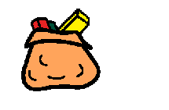
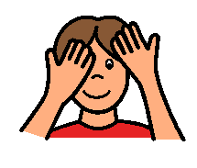

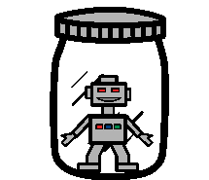

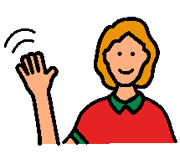
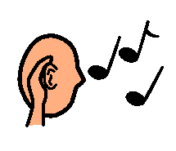

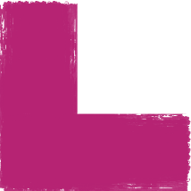

Hello, goodbye

Aim: to develop the use of early gestures

you will need: teddy, dolly, toy people or animals and a bag

how to play:

- sit opposite the child, at their level
- put two or three of the objects in the bag, for example three people
- slowly start to pull the first person out of the bag
- when they pop out say ‘hello’ and wave. Get the child to wave
- give the child the person to play with
- then do the same with the other people in the bag
- when all the people are out, get the child to put them back in the bag one at a time. Say ’bye’ and wave to each one as they go in the bag.
- get the child to wave

helpful hint:

once the child has started to wave, just hold the person a bit longer and wait to see if they will start to wave before you do it

NHS Blackburn with Darwen Speech and Language Therapy Department September 2008

This is the way

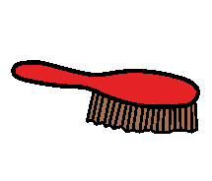

Aim: to develop listening

you will need: a bag and some everyday objects
e.g. brush, cup, ball, flannel, key, book, etc

how to play:

- sit opposite the child, at their level
- choose two or three objects to put in the bag
- help the child to take an object out of the bag and use it as you sing the part of the song which has the object in
- move onto the next object and the next part of the song

helpful hint:

ideas:

‘This is the way we…. drink our juice
…. brush our hair
…. bounce the ball
…. open the door
…. wash our face
…. read the book
…. put on our socks

on a cold and frosty morning’

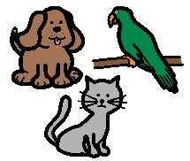

Animal sounds

Aim: to develop an awareness of symbolic sounds

you will need: a bag with some animal toys/puppets inside

how to play:

- sit opposite the child, at their level
- help the child to take an animal out of the bag. Make the animal sound e.g. ‘miaow’ for cat
- put the bag behind your back as you give the child time to play with the animal. Keep making the animal sound
- then, bring the bag back and do it again with the next animal

you can use animal picture books to help this activity

helpful hints:

- you might need to hold the animal up near your face as you say the sound, to help the child to listen
- it doesn’t matter if the child does not try to make the sounds

NHS Blackburn with Darwen Speech and Language Therapy Department September 20

Time to sleep
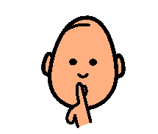

Aim: to listen to symbolic sounds and early words

you will need: 2 teddies, dollies or animal toys

how to play:

- sit opposite the child, at their level
- you take one teddy and give the child the other
- lie your teddy down to sleep, saying ‘sshhhhhh’. Help the child to do the same
- then say ‘wake up’ loudly, as you stand your teddy up. Help the child to do the same
- do this again and again. Remember you can also play this game with the dolls and the toy animals

helpful hint:

as the child starts to listen for ‘sshhhh’ and ‘wake up’, don’t move your teddy until the child has moved theirs

NHS Blackburn with Darwen Speech and Language Therapy Department September 2008

Music game
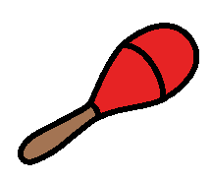

Aim: to listen to symbolic sounds and early words

you will need:2 hand held musical instruments or plastic bottles with rice inside

how to play:

- sit opposite the child, at their level
- hold one of the instruments and give the other one to the child
- shake/bang the instruments as you say ‘go’ loudly
- after about 10 seconds say ‘sshhhhh’ and put your instrument down and place your hand over the child’s instrument
- help them to wait until you say ‘go’ again
- keep repeating this routine

helpful hints:

- gradually increase the amount of time you wait before saying ‘go’
- as the child starts listening for ‘go’ and ‘sshhhh’, you can stop putting your hand over their instrument

NHS Blackburn with Darwen Speech and Language Therapy Department September 2008

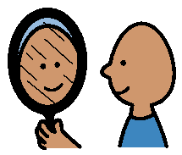
Mirror fun

Aim: to develop copying mouth shapes and sounds

you will need: a big mirror

how to play:

- sit next to the child in front of the mirror
- make silly faces and head movements in the mirror. Help the child to watch and copy your actions
- make funny sounds that mean your mouth has to move:
e.g. mouth wide open for ‘aaah’
mouth round for ‘oo’
mouth open and closed for ‘ma,ma,ma’

helpful hints:

- it may take some time for the child to start copying your faces and sounds
- you can help the child to try making some movements
e.g. head movements

NHS Blackburn with Darwen Speech and Language Therapy Department September 2008

Object matching
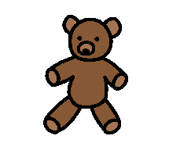

Aim: to develop object to object matching

you will need: a bag and pairs of objects

how to play:

- sit opposite the child, at their level
- put two objects in the bag and their matching pairs in front of the child
- pull one of the objects out of the bag and name it
- put your other hand out over the matching object for the child to give you
- hold both objects together and name them, before giving them to the child to play with
- put the objects back and this time take the other object out of the bag
- do this with different pairs of objects

helpful hints:

- as the child begins to match the objects, just hold your hand out towards the child and not over the object you want
- if the child can do this, try using three pairs of objects at a time

NHS Blackburn with Darwen Speech and Language Therapy Department September 2008
Object picture matching
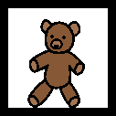

Aim: to develop object to picture matching

you will need: a large box with a hole cut out of it, make a post box
and a set of objects with matching pictures

how to play:

- sit opposite the child, at their level with the box next to you
- put two objects behind your back and their matching pictures in front of the child
- hold up one of the objects and name it
- put your other hand out over the matching picture for the child to give you
- hold the object and the picture together and name them, before giving them to the child to post in the box
- change the object and the picture with another pair and do it again

helpful hints:

- as the child begins to match the items, just hold your hand out
towards the child and not over the picture you want
- if the child can do this, try using three pairs of objects and pictures at a time

NHS Blackburn with Darwen Speech and Language Therapy Department September 2008

Picture matching
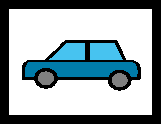

Aim: to develop picture to picture matching

you will need: a set of picture pairs and a bag

how to play:

- choose two pairs of pictures. Put one set of the pictures in the bag and their matching pairs in front of you
- sit opposite the child, at their level with the bag next to you
- help the child to take one picture out of the bag
- hold up the matching picture next to the child’s picture and name it
- change them for another pair and do it again

helpful hint:

if the child can do this, try using three pairs of pictures at a time

NHS Blackburn with Darwen Speech and Language Therapy Department September 2008

