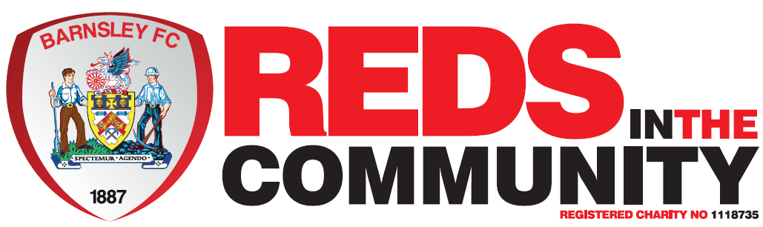 

Barnsley FC EyUp! Charity Cup

**Sunday 19 January, 2:30 – 5:30pm**

**Barnsley Football Club**

**Grove Street, Barnsley S71 1ET**

Lace up your boots and join us for our EyUp! Charity Cup in partnership with Barnsley Football Club:

* Five-a-side
* Age 18+ only
* Minimum donation of £80 per team (Only £10 per player for a team of five and three subs)
* Trophies for winners and runners-up
* Raffle prizes, market stalls and goody bags for all attendees!

**Register at:** [**www.southwestyorkshire.nhs.uk/eyup-charity-cup**](http://www.southwestyorkshire.nhs.uk/eyup-charity-cup)