**I am going to see my Speech and Language Therapist in a Health Centre**

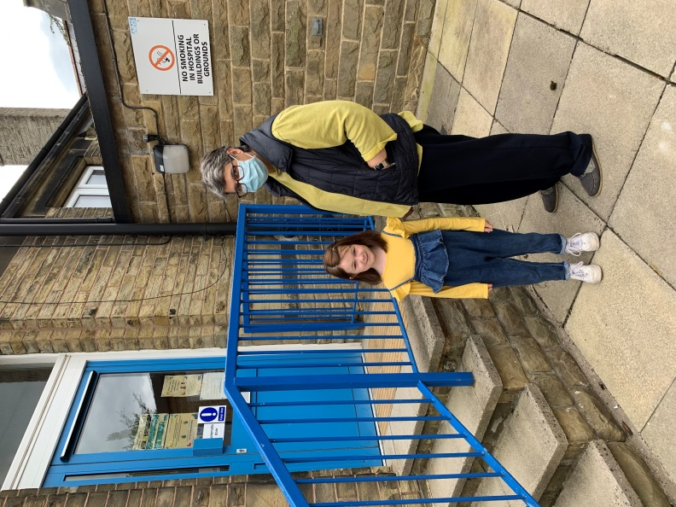

I’m going to the clinic to see my speech therapist

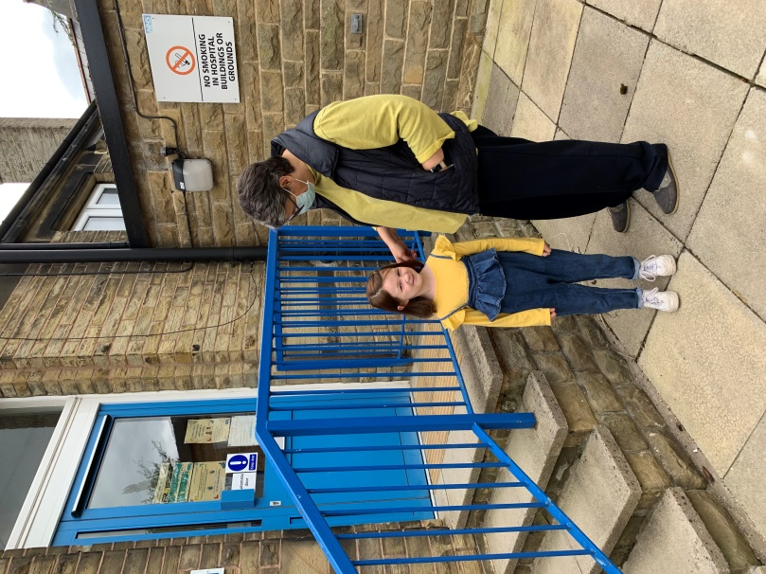

My grown-up will wear a mask.

I don’t have to wear a mask.

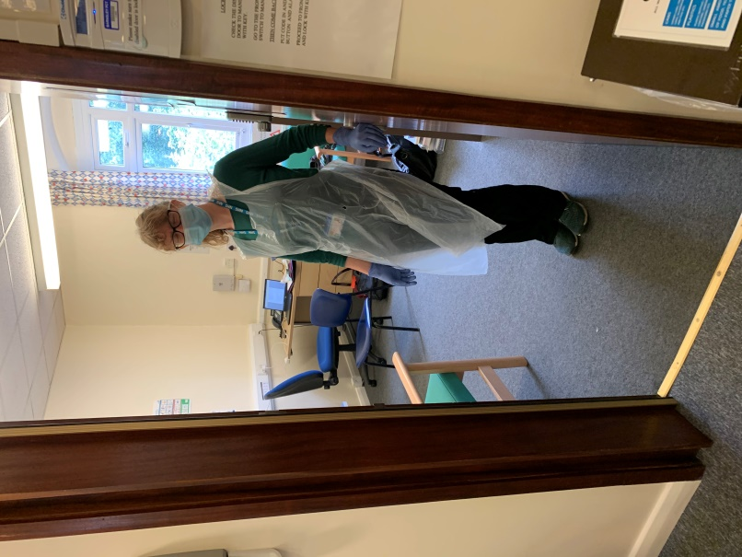

My therapist will be wearing a mask, an apron, and gloves.

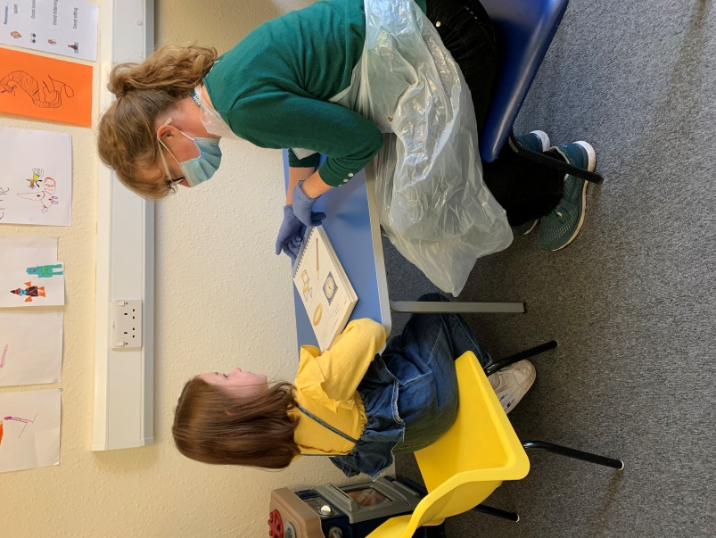

I might look at some pictures with my therapist

Then my therapist might have a chat with my grown-up.



Then it will be time for me to leave.

My speech therapist says “see you soon”

☺