**My Speech and Language Therapist is coming to see me in my school**

**My speech therapist is coming to see me in school.**

**There’s a bug around at the moment. This means that my speech therapist will be wearing some different clothes to help keep me safe.**

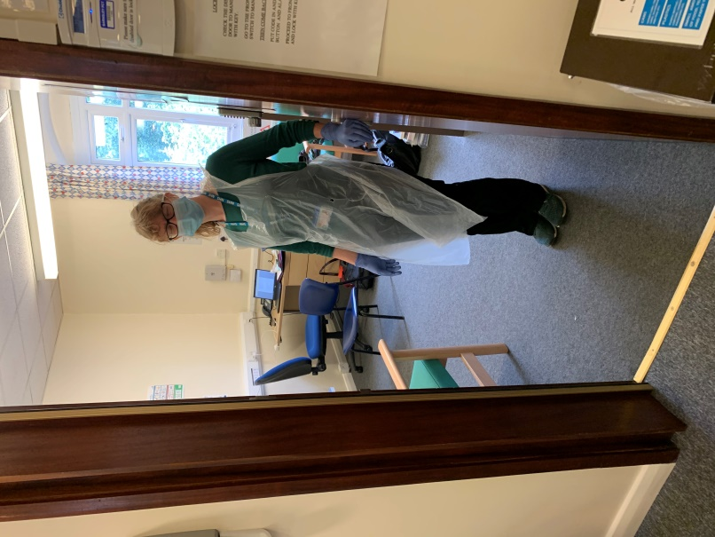

**My therapist will be wearing a mask, an apron, and gloves.**

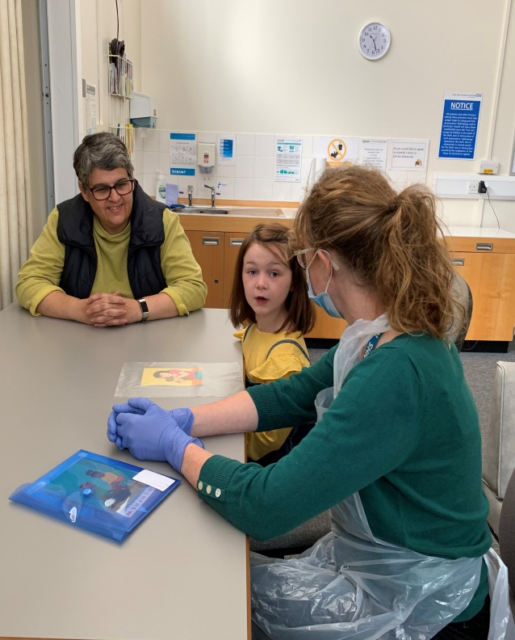

**I will go and sit at a table with my speech therapist.**

**One of my teachers will sit with me as well.**

**My teacher doesn’t have to wear a mask.**

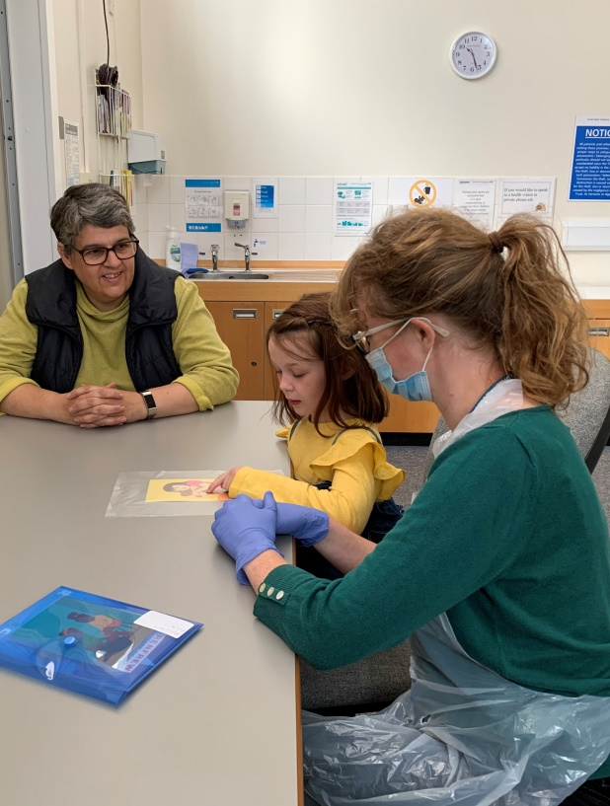

**My therapist might have some pictures for me to look at.**

**I can touch the plastic covering on the pictures**

**After I’ve finished looking at the pictures, my teacher will tell me when I can go back to my classroom.**

**My speech therapist says “see you soon”.**

**☺**