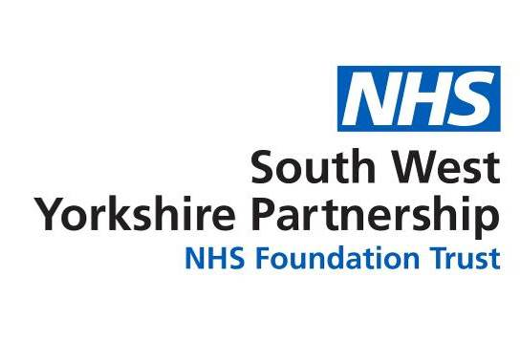
Mental health support for new and expectant mums in
Barnsley, Calderdale, Kirklees and Wakefield
Support available…
- Lost, worried or alone  - Sad and down but don’t know why  - Anxious, worried or stressed  - That no matter how much you do it’s never good enough  - Loss of confidence  - Feelings of guilt | We all need support, especially during big life events such as pregnancy. There is support available through community groups and charities:  - Home-Start: www.home-start.org.uk  - Family Lives: www.familylives.org.uk or 0808 800 2222  - PANDAS: https://pandasfoundation.org.uk or 0808 1961 776  - Auntie Pam’s (Kirklees only): www.kirklees.gov.uk/auntiepams  You can also self-refer into talking therapies (also known as IAPT or psychological therapies) who provide one-to-one support alongside group work. Find your nearest talking therapies: www.nhs.uk/find-a-psychological-therapies-service
How I might be feeling…

- Unsure about taking medication for your mental health during pregnancy | For medication and queries you can speak to your GP, midwife or health visitor. For more specialist medication queries they can contact the perinatal mental health team on your behalf for advice too.  The Choice and Medication website provides information about mental health conditions, treatments and medications also. Visit: www.choiceandmedication.org/swyp

- Scared that your diagnosed mental health illness may impact on your pregnancy or life as a parent  - Struggling to bond or care for your baby  - Anxious about anything and everything, especially about the baby  - Getting bad images and thoughts in your head (intrusive thoughts/memories)  - Dealing with traumatic birth experiences or fear of childbirth  - Feeling very low in mood or depressed, being tearful, irritable, unable to sleep, lacking energy, withdrawn and unable to do everyday tasks  - Wanting to run away or feeling that you aren’t a good mother, and the baby would be better off with someone else  - Loosing contact with reality e.g. seeing or hearing things that other people don’t (hallucinations), behaving out of character, having manic changes in mood or thoughts and beliefs that are likely to be untrue  - Fearing for your or your baby’s future and safety – including having thoughts of suicide or self-harm. | It’s very important that you speak to your GP, midwife or healthcare visitor as soon as possible if you’re experiencing any of these thoughts or feelings. The earlier you seek support, the less likely that things will worsen.  They can refer you into the perinatal mental health team at South West Yorkshire Partnership NHS Foundation Trust. This is a specialist team who provide care and treatment for women with complex mental health needs during and after pregnancy. The team also offer advice for women planning pregnancy who have concerns about their mental health. The team are available Monday to Friday, 9am to 5pm and can be contacted directly also on 01924 316009.  For support outside of these hours, please ring the 24-hour mental health helpline on 0800183 0558, or the Samaritans on 116 123.  You can also call the following telephone numbers for out of hours help:  Barnsley – NHS 111  Calderdale - 01924 316830  Kirklees - 01924 316830

