**My Speech and Language Therapist is coming to see me in my school**

**My speech therapist is coming to see me in school.**

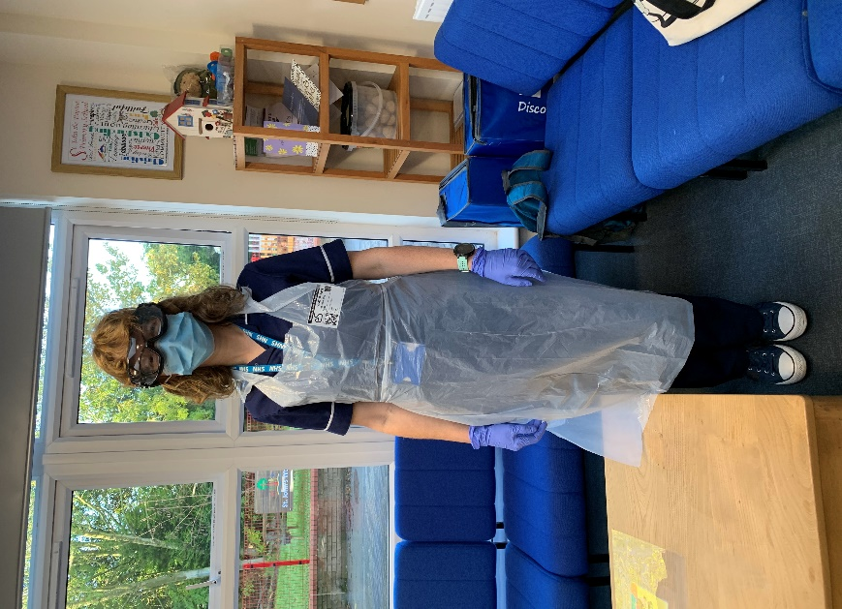

**There’s a bug around at the moment. This means that my speech therapist will be wearing some different clothes to help keep me safe.**

**My therapist will be wearing a mask, an apron, and gloves.**

**One of my teachers will take me to see the speech therapist.**

**I might see the speech therapist in another classroom or an office in my school**

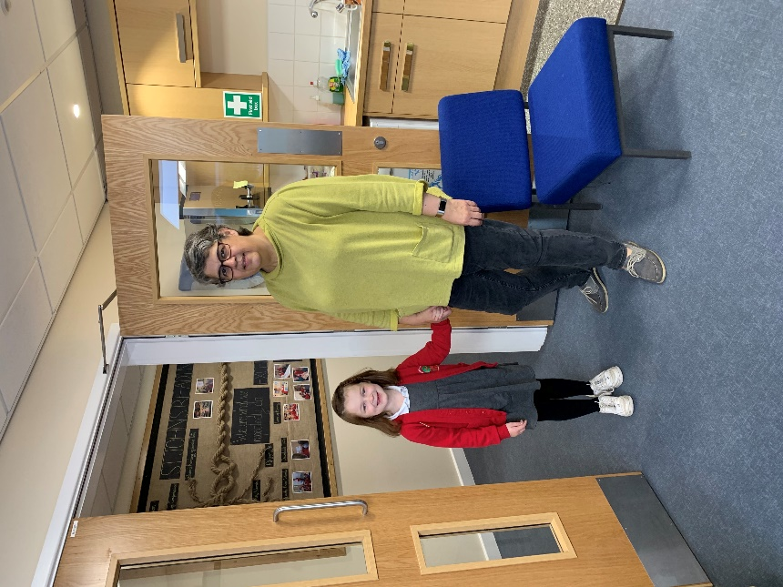

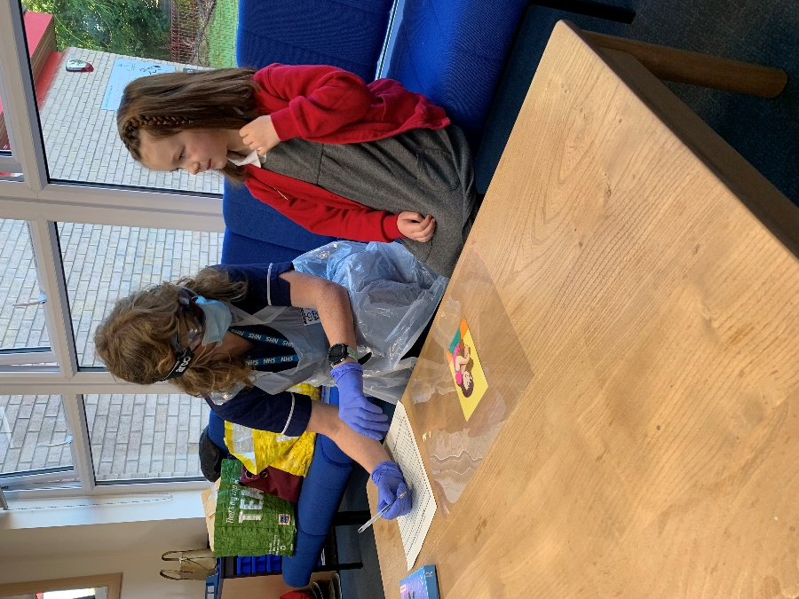

**I will go and sit at a table with my speech therapist.**

**I don’t need to wear a mask**

**One of my teachers will stay in the room with me**

**My teacher doesn’t have to wear a mask.**

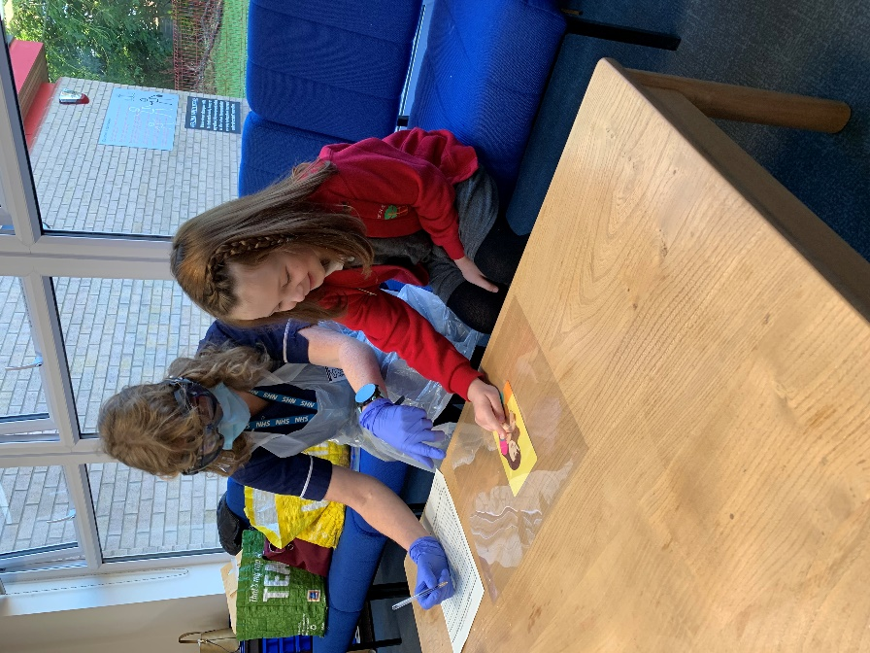

**My therapist might have some pictures for me to look at.**

**I can touch the plastic covering on the pictures**

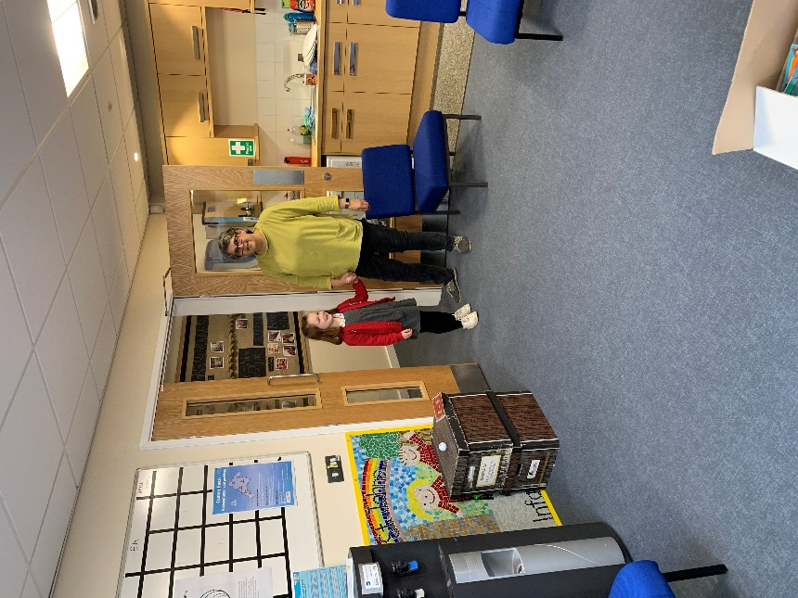

**After I’ve finished looking at the pictures, my teacher will tell me when I can go back to my classroom.**

My speech therapist says

‘see you soon’

☺