Cath’s Covid Vaccine Story
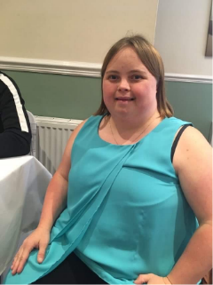 | Hello my name is  Catherine Horbury and I am extremely vulnerable as I have got a learning disability and a condition of Down Syndrome.  I am the Co-lead for Yorkshire and Humber ODN.
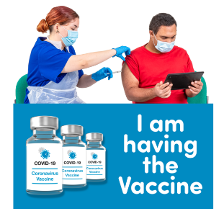 | What I think of the vaccine  I would like to say that it is very important for people who are vulnerable or the elderly and for people who have a learning disability to have the Covid vaccines if you are invited for one please do so as it may just save your life for you
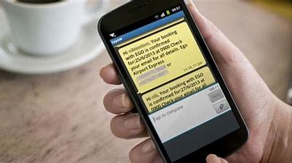 | How did you get an invite?  I got a booking confirmation through a text message asking me to go down for a Covid vaccine as I am extremely vulnerable myself. The text came from my GP.
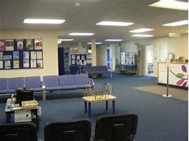 | How did you enter  I put a face mask on before I entered the building and went to the receptionist desk. The receptionist told me to enter the waiting room ready to be called in for my Covid vaccine.
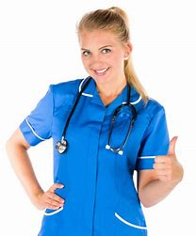 | How was the nurse / staff?  The nurse and the staff were ok. They did ask me questions which I didn’t fully understand but I had some support from a family member.  But I think they should have had easy read information to help me understand the questions they were asking me to answer.
How did you find the Vaccine?
I was nervous about having a Covid vaccine at first, I had the vaccine, but I was ok as I had support from a family member which was good, she told me don’t worry about anything I am here.
The nurse who did the vaccine was lovely and I didn’t feel a thing, everything was good.

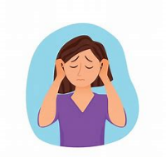 | How did you feel after?  I was having headaches and felt sick for a couple of days. However, after a couple of days I felt ok.

