Choose well for your mental health

to keep you happy and healthy

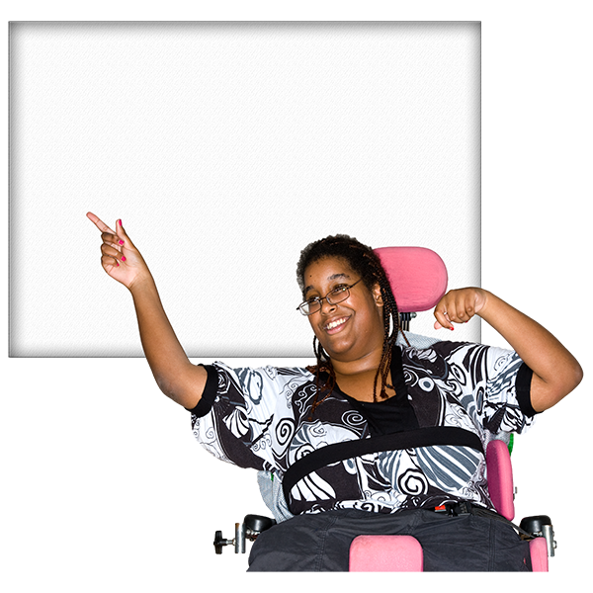

You should look after your mental health as much as the health of your body

This will keep you happy and healthy

How will I know if my mental health is not good?

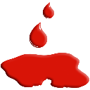
You may feel sad and cry all the time
You may want to hurt yourself

You may start to forget things

You may feel upset because:
You are lonely
Someone has died

You are worried
You feel angry
You feel sad
You cannot sleep

This booklet can help you choose the help you need

Getting the help you need

What can I do?

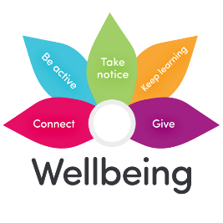
How to help yourself or self-care

Do things to stay happy and healthy

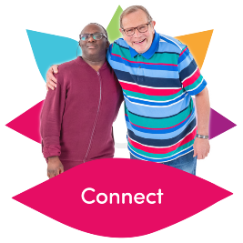
- Spend time with other people around you such as your:
Family, friends, work colleagues and neighbours
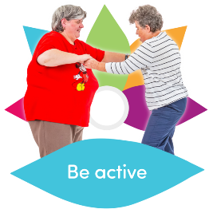
2. Be active - do something you enjoy such as:
Go for a walk
Go cycling
Play a game of football
3. Keep learning
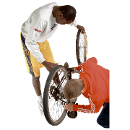
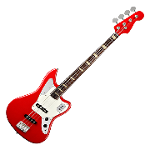
Do a cookery course
Learn to play a musical instrument
Learn how to fix your bike

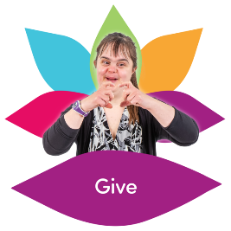
4. Give to other people – or do Something nice
Small things like:
Saying thank you
Or
Smiling at someone

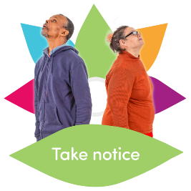
5. Take notice – stop and look at the things around you
Think about what you can see and smell

For more information on the 5 things
Go to : www.nhs.uk/conditions/stress-anxiety.depression/improve-mental-wellbeing
What else can I do?

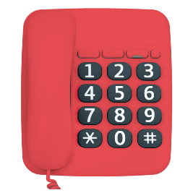
Ring the 24 hour mental health helpline

Ring on 0800 183 0558
Someone can talk to you about your worries and feelings
0800 183 0558
And help you to stay happy and healthy

Talking therapies
You can ring talking therapies
And talk to a trained therapist about how to change the way you feel
To find your nearest Talking therapies go to:
www.nhs.uk/talk

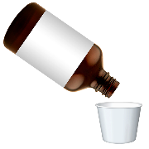
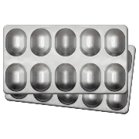
Go and see your doctor
They may give you some medicine
But if the medicine does not help

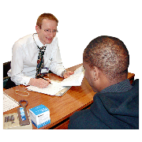
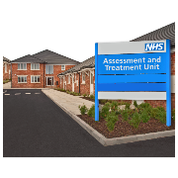
Speak to your doctor who may send you to a secondary mental health service

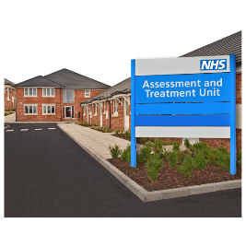
Secondary mental health service
South West Yorkshire Partnership Foundation NHS Trust (SWYPFT) is a secondary mental health service
SWYPFT can help and support people to stay happy and healthy

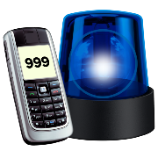
Sometimes you may need help quickly
If you have hurt or harmed yourself
You can ring 999

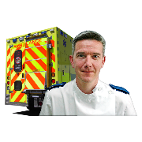
Or go to your nearest A&E
hospital

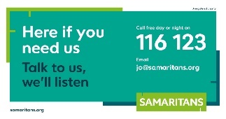
If you want to hurt or harm yourself
Ring the Samaritans (anytime)
On 116 123

Or

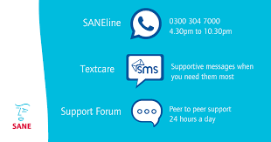
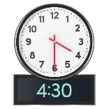
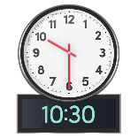
SANEline
on 0300 304 7000
(between 4:30pm – 10:30pm)

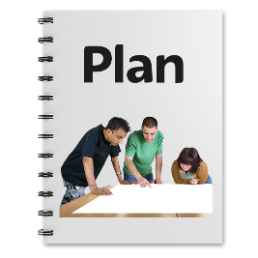
What else can I do?
It is good idea to have a plan
So when you know your mental health is not good
You and other people know who to ring or speak to for help

Write down 3 numbers to ring
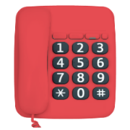
1…………………………………..

2…………………………………..

3…………………………………..
Keep this page in a safe place
Where people can find it
Such as in your wallet or purse

