Equality Workforce

Monitoring Annual Report

2021

Report commissioned by:

Claire Hartland – HR Business Manager

**March 2021**

Report produced by:

Gill Roberts - Information Analyst

**CONTENTS**

EXECUTIVE SUMMARY 1

BACKGROUND 3

1 INTRODUCTION 4

1.1 Aim 4

1.2 Objectives 4

1.3 Methodology 4

1.4 Population 4

1.5 Staff involved 4

2 RESULTS 5

2.1 General information 5

2.1.1 Disciplinaries 5

2.1.2 Non-Mandatory Training 6

2.1.3 Applicants and Shortlisted Candidates 6

2.1.4 Promotions 6

2.1.5 Starters and leavers 6

2.2 Age Band 7

2.2.1 Staff in post 7

2.2.2 Starters and leavers 8

2.2.3 Applicants and shortlisted candidates 10

2.2.4 Promotions 11

2.2.5 Training 12

2.2.6 Disciplinary investigations 13

2.3 Disability 14

2.3.1 Staff in post 14

2.3.2 Starters and leavers 15

2.3.3 Applicants and shortlisted candidates 15

2.3.4 Employment status 16

2.3.5 Non-medical pay band 17

2.3.6 Promotions 18

2.3.7 Training 18

2.3.8 Disciplinary investigations 18

2.4 Gender 19

2.4.1 Staff in post 19

2.4.1.1 Staff in post, pay bands 20

2.4.2 Starters and leavers 21

2.4.2.1 Leavers by pay band 24

2.4.3 Staff in post by employment status 25

2.4.4 Starters and leavers by employment status 27

2.4.5 Promotions 28

2.4.6 Promotions by pay band 29

2.4.7 Training 30

2.4.8 Disciplinary investigations 30

2.5 Religious belief 31

2.5.1 Staff in post 31

2.5.2 Starters and leavers 32

2.5.3 Applicants and shortlisted candidates 32

2.5.4 Promotions 33

2.5.5 Training 34

2.5.6 Disciplinary investigations 35

2.6 Sexual Orientation 35

2.6.1 Staff in post 35

2.6.2 Starters and leavers 36

2.6.3 Applicants and shortlisted candidates 36

2.6.4 Promotions 37

2.6.5 Training 38

2.6.6 Disciplinary investigations 38

2.7 Marital Status 39

2.7.1 Staff in post 39

2.7.2 Starters and leavers 39

2.7.3 Promotions 40

2.7.4 Training 40

2.7.5 Disciplinary investigations 41

2.8 Ethnicity 41

2.8.1 Staff in post 41

2.8.1.1 Staff in post by non-medical pay band 44

2.8.1.2 Staff in post by employment status 45

2.8.2 Starters and leavers 47

2.8.2.1 Starters and leavers by employment status 51

2.8.3 Applicants and shortlisted candidates 52

2.8.4 Training 54

2.8.5 Disciplinary investigations 55

2.9 Grievances and Harassment/Bullying 55

3. ACTIONS……………………………………………………………………………………56

EXECUTIVE SUMMARY

This report aims to provide an overview of the demographics of the workforce within the Trust as at the end of 2020 and will be used to inform our priorities and actions aligned to our Workforce Strategy and our organisational priority to make South West Yorkshire Partnership NHS Foundation Trust a great place to work. The report’s findings in summary are stated below with reference being made to the integrated EDS2 and WRES workforce action plan 2020, the WDES and related data from the 2020 National NHS staff survey.

* The Trust currently employs 4,530 staff delivering a range of services including mental health, learning disability, forensic, some physical health and an extensive range of community services.
* During 2020 in response to the Covid 19 pandemic the Trust had to pause and re-prioritise a number of actions and priorities to ensure the safety. wellbeing and inclusion of staff and services.
* There is no requirement to publish Gender pay audits/reports during 2020 and therefore this information is not included in this report.
* The Trust has seen an increase in new starters compared to the previous year (664 compared with 598) some of these staff supporting the Covid effort through the NHS bring back scheme. This year out of the 543 leavers, 59.9% chose to voluntarily resign/leave the Trust and 25.2% chose to retire.   Of those who resigned, 36.6% went to work for another NHS.  Also, turnover across the Trust, has remained relatively stable at 12.25% compared to the previous year.
* The data shows that 6.4% of our staff consider themselves to have a disability, which is not significantly different to the previous year (6.1%). The total number of disabled staff is 292, this is an increase of 26 since last year. Staff survey data shows that disabled staff generally report a worse experience of violence, bullying and harassment at work than non-disabled colleagues however, improvements have been seen across most areas (except regarding from patients, relatives or the public where there is no significant difference from the previous year).
* Across the whole of the workforce the staff survey shows a reduction in bullying/harassment from service users, managers and colleagues in 2020 and we are below average for colleague on colleague bullying/harassment compared to similar providers.
* The Trusts staff profile has a comparable White British representation to the local demographic of the people that it serves collectively at just over 89%. Mixed race staff are under-represented by 0.15%, Black staff are over-represented by 2.19% and South Asian staff are under-represented by 2.49%. However, the Trust’s local demographic has large variation in BAME representation and there is a significant under-representation of South Asian staff in Kirklees/Calderdale *(exact figures not available due to mixed teams)*
* There continues to be improvements in the number of staff reporting their religion and sexual orientation. Currently 80.5% of staff have provided data regarding their religion and 85% of staff have provided data indicating their sexual orientation.
* Gender – stable at 21.5% male 78.5% female – this is indicative of all NHS bodies.
* The data shows that 38.7% of staff are aged 50 or over. The Trust is mindful that staff are choosing to work longer, and an older workforce may require consideration from a health and wellbeing perspective regarding initiatives and support to maintain them in employment.
* The Trust sees no adverse barriers to training access for any of its staff regardless of their ethnicity, disability or sexuality. The number of courses accessed exceeds the Trust population for BAME and is not significantly different for disabled and LGBT+ staff. The Trust will ensure that all training is recorded and monitored, study leave forms are completed and that training outcomes are identified through formal learning needs analyses.

**Making SWYPFT a great place to work and our staff pledges**

The Trust engaged with more than half the workforce during 2019/20, including Staff Side organisations, to gain their insight in what they believe makes a great place to work. There were 5 key themes identified from the staff engagement and listening exercise on what people believe were the essentials of a Great Place to Work. These are set out below along with our work pledges and these are the foundations of the Workforce Strategy for 2021-2023/24.

|  |  |
| --- | --- |
| **Great Place to Work essentials** | **Great place to work pledges** |
| Feeling Safe | We will tackle violence and bullying and harassment and ensure we have enough staff |
| Supportive Teams | We will develop team leaders at all levels, promote effective team working and ensure high quality supervision and appraisal |
| Keeping fit and well | We will provide support to keep staff physically and psychologically well, enabling them to work flexibly and ensure they have manageable workloads |
| Developing Potential | We will provide flexible career pathways, support personal and professional development plans and develop the talent and potential of all staff |
| My voice counts | We will effectively engage staff in service developments and improvements and ensure change is effectively managed |

**Priorities for 2021/22**

We have used the data in this equality report along with insight, and feedback from staff to develop the following priorities aligned to the five essentials of making the Trust a Great Place to work:

**Feeling Safe:**

* Building on our existingframework for preventing Harassment and Bullying in early 2021 we are establishing and developing civility and respect guardians across services and teams to support local action plans and improve team cultures.
* The RACE Forward network has been re-established to review the approach to harassment and bullying from service users, carers, and visitors.
* Review our recruitment practices and work with partners to increase access to employment for young people and in local communities.

**Supportive team:**

* The Trust continues with its Building Leadership for Inclusion Leadership Programme and is supporting the BAME Fellowship Programme and will be relaunching the senior Leadership forum basedon the Great Place to work essentials.
* The Trust is continuing with its participation in the Insight programme which seeks to increase Trust Board BAME representation.

**Keeping fit and well:**

* During 2021 we will be developing a flexible workforce model to support work life balance and create more inclusive job opportunities.
* We continue to provide an enhanced inclusive health and wellbeing offer for all our staff which provides emotional, social, physical, and psychological support.

**Developing Potential:**

* In partnership with our BAME staff network we are offering both ‘Stepping Up’ and ‘Ready Now’ and in collaboration with partners our ‘Moving Forward’ inclusive leadership programmes as well as supporting managers to have ‘maximising my potential career conversations’ as part of appraisal and supervision.

**My voice counts:**

* we have established BAME and LGBT+ staff networks and are developing our disability and carers staff networks.
* We will be implementing our WRES and WDES action plans and launching a new staff disability and reasonable adjustments policy.
* Also ensuring that wellbeing conversations take place regularly between line managers and staff.

# 

BACKGROUND

The Trust will also use the information in this report to inform discussions and for the development of future equality objectives as part of the Trust’s legal obligation on the Equality Act.

The information in *Table 46* is taken from the 2011 census.

1. INTRODUCTION

South West Yorkshire Partnership NHS Foundation Trust is committed to undertake an annual audit programme

* 1. Aim

The aim is to provide an overview of the workforce within the Trust.

* 1. Objectives

The main objectives of the audit are:

To meet the requirements of the Equality act.

To monitor legal compliance with the Equality act.

To determine the level of workforce equality.

To establish a baseline for future audits.

To highlight any areas of concern and make recommendations.

* 1. Methodology

The data was collected through the electronic staff record as at 31st December 2020.

* 1. Population

The number of Staff in Post (SIP) as at 31st December 2020 was 4,530.

All other information is based on the relevant date falling between 1st January 2020 and 31st December 2020.

Training information is based on staff employed at any point during the calendar year who also accessed non-mandatory training during 2020.

Staff who work solely on bank were not included in the data except for applicants and shortlists where all records dated within the audit period were included.

* 1. Staff involved

Claire Hartland Human Resources Business Manager

Gillian Roberts Information Analyst

Paul Brown Human Resources Business Manager

Lindsay Jensen Deputy Director of HR & OD

Cherill Watterston WRES OD Lead

1. RESULTS

The results have been categorised in the report into the protected characteristics.

In some instances, the information has been split into non-medical and medical staff.

* 1. General information

Section 2.1 includes information that does not fit into the protected characteristic categories but which complements the information in the other sections of the report.

In all cases, where comparisons have been made with staff in post, the figures are based on the SIP as at 31st December 2020.

* + 1. Disciplinaries

There were 26 disciplinaries that started during the audit period. As the numbers are low, the protected characteristic information is shown at Trust level.

The very low number of disciplinary investigations can skew the figures and may make comparisons of little value.

As no medical staff or CAMHS staff were involved in any investigation, the figures for those areas have been excluded from *Table 1*.

*Table 1* *Disciplinaries**by area*



* The area with the highest number of disciplinary investigations is Barnsley, however, as Barnsley also have the highest number of staff, the percentage of its SIP is 0.8%.
* The area with the highest percentage of investigations is Support Services with 1.1%.
* Overall, disciplinary investigations affected 0.6% of staff in post (SIP is of the areas with investigations).
  + 1. Non-Mandatory Training

The Training information covered in the other sections includes only non-mandatory training sessions which took place during the calendar year 2020. This information is for staff employed at any point during the period even where they have subsequently left the Trust before the end of the year. The data includes medical staff but excludes bank staff.

There was a total of 6,179 training sessions completed by 3,007 staff, this gives an average number of 2.1 for the Trust overall.

*Table 2* below shows these training sessions split by area. The difference in the staff figure is explained by staff accessing training in different areas.

*Table 2* *Number of training courses and staff involved by area*



As in previous years, on average, medical staff attend most courses and Support Services the least.

* + 1. Applicants and Shortlisted Candidates

There were 17,056 applicants during the audit period; this includes medical staff. Of these 5,335 were shortlisted.

Unlike the groups in this report, the figures include applications/shortlists for bank positions.

* + 1. Promotions

During the audit period, a total of 391 staff, including medical staff, were promoted within the Trust during the audit period.

* + 1. Starters and leavers

There were 664 new starters during the audit period and 543 leavers. These figures include medical staff.

* 1. Age Band

The current number of staff in post is 4,530; this has been broken down by area as in the table below.

* + 1. Staff in post

*Table 3 Staff in post, split by age and area*





*Figure 1* *Staff in post, Non-Medical compared with Medical staff*

The results in Table 3 and *Figure 1* show that:

* As in previous years, the highest number of Trust staff fall in the age bands 40-49 and 50-59 with over 53% of total staff being between 40 and 59.
* Just under 70% of medical staff are between 40 and 59.
* Support Services have the highest proportion of staff in the 60 and over age bands at 16% (118).
* The slight increase in the overall number of staff aged 60 and over could be due to the Covid crisis.
  + 1. Starters and leavers

*Table 4 Starters, split by age band and area*



* The Trust has seen an increase in new starters compared to the previous year (664 compared with 598).
* As could be expected, most new starters (530) fall into the 20-49 age bands.
* The average age for starters is 36.
* For medical staff, the number of starters in the 20-29 age band has increased the most, with 21 starters compared with 6 in 2019; these were all temporary posts. This maps with the number of leavers in this age group for 2020 (see *Table 5*) which shows 19 leavers in the same age group and assignment category.

*Table 5 Leavers split by age band and area*



* Compared with the previous year, the number of leavers has decreased (543 compared with 574 in 2019).
* For medical staff, the number of leavers has increased from 29 to 44.
* Of the 44 medical leavers, 19 were 20-29 age band and all had been on temporary contracts.
* For non-medical staff, the majority falls into the 50-59 category with 113 (22.6%) leaving during 2020, however, this is still a decrease from 2019 when 134 (24.5%) of staff in that age band left the Trust.
* The average age for leavers is 44.
* Despite the overall number falling, non-medical leavers in the 60-69 category have increased from the previous year (2020 – 101, 20.2%; 2019 – 80, 14.6%).

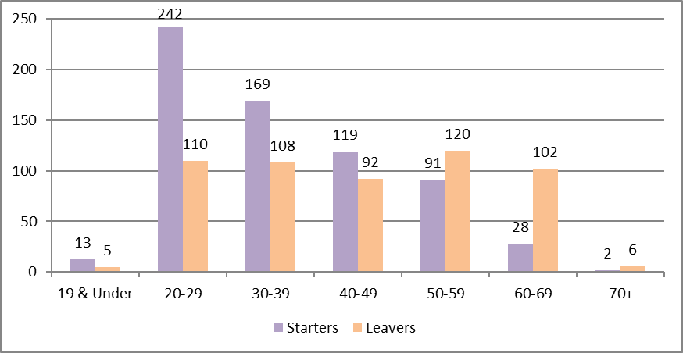

*Figure 2 Number of starters and leavers by age band*

* In 2019, leavers had outweighed starters for staff aged 40 and above.
* In 2020, this has changed and only staff aged 50 and above had the number of leavers been greater than that of new starters.
  + 1. Applicants and shortlisted candidates

*Table 6 Applicants/shortlist by age band*



* The highest percentage of both applicants and shortlisted candidates falls in the 20-29 age band.
* As could be expected, the lowest numbers are in the 19&Under and the 60 and over age groups.
* + 1. Promotions

*Table 7 Promotions by age band*



Most staff who have been promoted during 2020 are aged between 20 and 49 with almost 89% of promoted staff being in that age range.

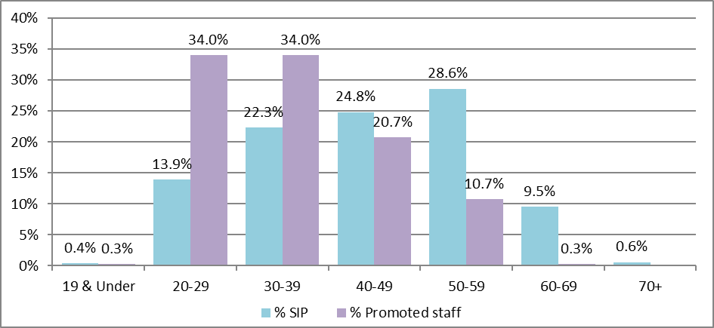

*Figure 3 Percentage of staff in post and promoted by age band*

The chart above shows that a higher percentage of staff in age bands 20-29 and 30-39 were promoted than the staff in post age profile percentages.

For ages 40 and up, this position inverts and a lower percentage are promoted than the Trust age profile percentages.

* + 1. Training

*Table 8 Number of courses by age band and area*



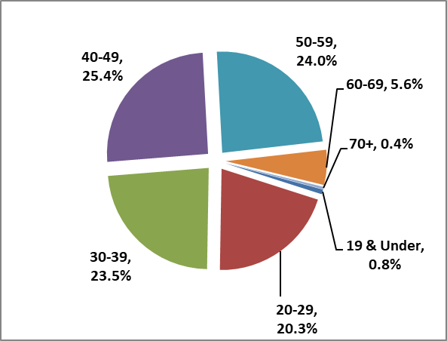

*Figure 4 Percentage courses by age band*

*Figure 5 Percentage SIP by age band*

Based on the age band percentages in *Figure 4*, the proportion of staff accessing training is similar to the Trust age profile with the exception of the 20-29 age band where staff access 20.3% of courses compared with making up 13.9% of staff in post.

* + 1. Disciplinary investigations

*Table 9 Disciplinaries split by age band*



Of the 26 staff who were part of an investigation:

* The largest number of disciplinary investigations were in the 30-39 and 40-49 age bands (8 staff, 30.8% and 10 staff, 38.5% respectively).
* The Trust percentage for staff in those age groups is 22.3% and 24.8% (these figures include all Trust staff).



*Figure 6 Percentage of disciplinaries v SIP by age band*

*Figure 6* shows that:

* Two age groups have a higher percentage of disciplinary investigations than their percentage in the Trust profile.
* Staff in the 19&Under and 70+ age bands have not been involved in any disciplinary investigations.
  1. Disability

* + 1. Staff in post

The following table shows the staff in post who consider they have a disability.

*Table 10 Staff in post by disability and area*



The results show that:

* 6.4% of all Trust staff consider themselves to have a disability. This is similar to the 2019 figure of 6.1%.
* Although the percentage of staff with a disability has not changed significantly, the actual number (292) has increased from the 2019 figure of 266.
* Support Services and Medical Staff have the lowest percentage of staff who consider themselves disabled.
  + 1. Starters and leavers

*Table 11* *Starters and leavers by pay band and disability*



*Table 11* shows the number and percentage of starters and leavers who have stated they consider themselves disabled.

Overall, the starter and leaver profiles match the Trust profile for the pay bands for staff who consider themselves disabled. The exceptions are where small numbers skew the figures.

* + 1. Applicants and shortlisted candidates

*Table 12 Applicants/shortlist by disability*



* Of the 17,056 applicants, 1,004 considered themselves to have a disability.
* For the shortlisted candidates, 347 stated they had a disability.
* The percentage of staff in post who consider they have a disability is 6.4%.

## 

* + 1. Employment status

Non-medical staff

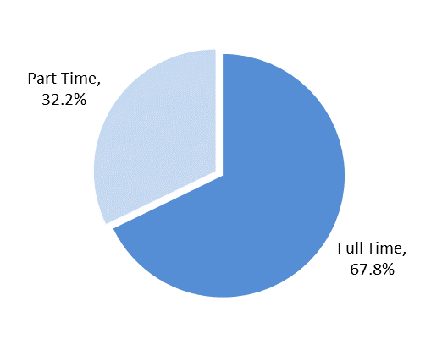



*Table 13 Full/part-time staff with disability*

*Figure 7 Percentage FT/PT with disability*

The results from Table *13* show that for non-medical staff:

* 196 (7%) full time staff consider themselves to be disabled.
* 93 (6%) part time staff consider themselves to be disabled.
* Looking only at the staff who consider themselves to be disabled (*Figure 7*), just over 32% work part time.

Medical staff



*Table 14* *Full/part-time medical staff with disability*

The results in *Table 14* show that for medical staff:

* Three (2.2%) full time staff consider themselves to be disabled.
* No part time medical staff have stated that they consider themselves to be disabled.
  + 1. Non-medical pay band

*Table 15* *Pay bands by disability*



* The number of staff with a disability has increased in line with the increase in total staff numbers.
* The percentage of staff remains relatively stable (2019 – 6.3%).

* + 1. Promotions

*Table 16* *Promotions by disability*



*Table 16* shows the number and percentage of staff who consider they have a disability and who were promoted during the audit period.

The results show that 6.4% of promoted staff have stated that they are disabled which reflects the Trust staff in post figure.

* + 1. Training

*Table 17* *Number of courses by disability and area*



Of the 6,179 courses, 387 were attended by staff who consider themselves to have a disability. This represents 6.3% of all courses taken and is slightly lower than the total percentage of Trust staff who have stated they are disabled (6.4%).

* + 1. Disciplinary investigations

Out of 26 disciplinaries, 1 member of staff stated that they considered themselves to have a disability. This is 3.8% of the total.

* 1. Gender
     1. Staff in post

*Table 18* and *Figure 8* below show the gender split for all Trust staff. The split across all staff is 78.5%/21.5%, female to male staff.

*Table 18 Staff in post by gender* *and area*



The following chart shows the gender split by percentage of the total for each area:



*Figure 8 Gender and area*

The results show that:

* The Trust female to male spilt of 78.5%/21.5% is not significantly different to that of the individual areas although the percentage of male staff in both Barnsley and CAMHS BDUs remains lower than other areas.
* As in previous years, female staff make up over three quarters of Trust staff.
  + - 1. Staff in post, pay bands

*Table 19* *Pay band by gender*



The results in *Table 19* above show the following:

* The Trust total gender split is 80%/20% female to male.
* Bands 2, 3 and 5 have a higher proportion of female to male staff than the Trust overall figure but are not significantly different to the overall population.
* However, as the pay band increases, this split changes and female staff are under-represented in the higher bands compared with the Trust profile.
* This picture has not changed substantially from 2019.

This is better appreciated in *Figure 9* below. The number of staff in the higher bands is small which may artificially skew the figures but, as can be seen from the chart, these bands have a higher percentage of male staff than the overall Trust profile.



*Figure 9 Pay band split by gender*

* + 1. Starters and leavers

*Table 20* *Starters by gender and area*



*Table 21* *Leavers by gender and area*



The tables above show starters and leavers to the Trust by gender and area.

The results show that:

* Both starter and leaver gender splits in non-medical areas are similar to the overall Trust staff in post profile in *Table 18* on Page 19.
* For female medical staff, the number of new starters is higher than leavers while, for male staff, the numbers are the same.

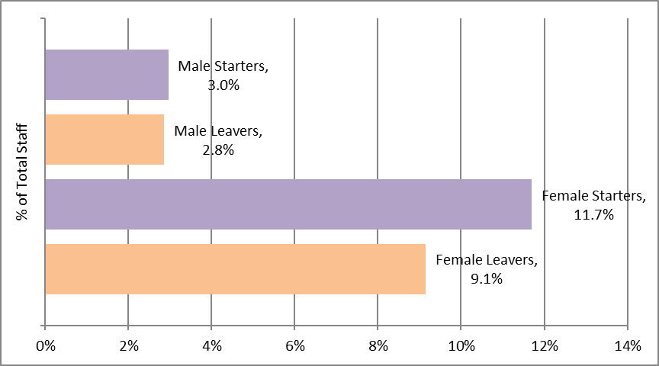

*Figure 10* *Starters and leavers, by gender as a percentage of Trust SIP*

In Figure 10 the starters and leavers are shown as a percentage of the Trust staff in post. If similar numbers are maintained, the future staff in post gender split will not be significantly different from the current one.

**Starters by pay band**

*Table 22* *New starters by pay band and gender*



*Table 22* shows the pay bands for new starters split by gender. There were no starters in Bands 1 or 9.

* The gender split for all non-medical starters is approximately 82%/18% female to male.
* Band 3 has a higher percentage of female new starters than the overall Trust figure.
* While the overall gender split is echoed in most of the lower bands, bands 8b and above tend to have a higher percentage of male staff. However, small numbers can have the effect of skewing the results and may not make comparisons worthwhile.

The following chart in Figure 11 illustrates the differences more clearly



*Figure 11* *New starters split by pay band and gender*

* + - 1. Leavers by pay band

*Table 23* *Leavers by pay band and gender*

*Table 23* shows the split between genders for leavers from the Trust. There were no leavers in Bands 1 or 9.

* The gender split for leavers is 79%/21% female to male.
* The bands showing the most anomalous figure is Band 4 where the proportion of female leavers, at 87%, is high in comparison with the total leaver figure.
* The higher bands do not reflect the Trust gender split for leavers; however, small numbers can mean that comparisons lack meaning.
  + 1. Staff in post by employment status

Non-Medical Staff

Of the total 4,361 non-medical staff, 1,548 work part time.

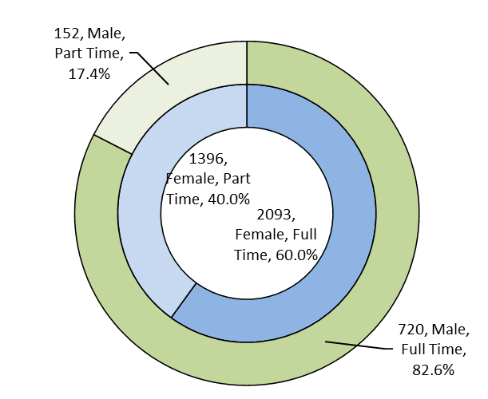

*Figure 12 Full/part time split by gender*

*Figure 12* shows the percentage of non-medical staff split by male/female and full and part time.

The results show that:

* A much higher proportion of female staff (40%) work part time compared to male staff (17.4%).
* The difference between genders is much more marked when comparing just part time staff as in *Figure 13* below.
* Just over 90% of part time staff are female compared with approximately 10% of male staff.

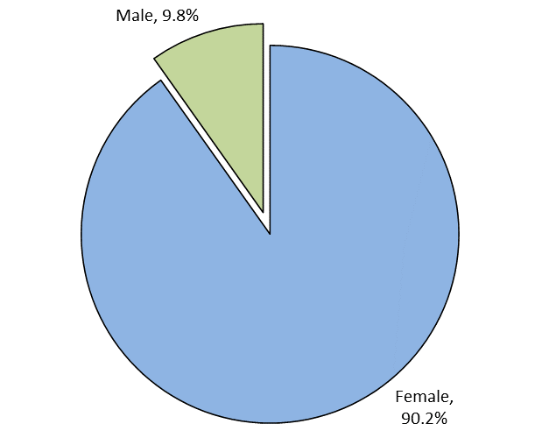

*Figure 13 Part time staff split by gender*

Medical Staff

Of the total 169 medical staff, 30 work part time.

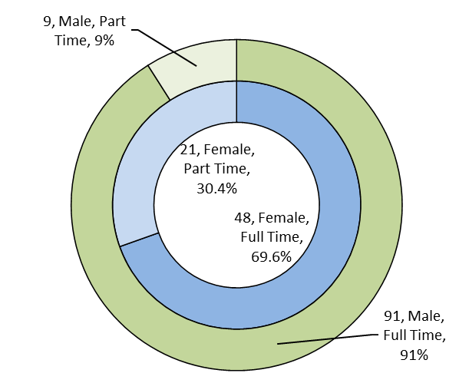

*Figure 14 Full/part-time split by gender (medical staff)*

* There is a significant difference between the genders when looking the full/part time split. Just over 30% of female medical staff work part time compared with 9% of male staff.
* As with non-medical staff, the difference between genders is much more noticeable when comparing only part time staff. Figure 15 shows that 70% of part time medical staff are female.

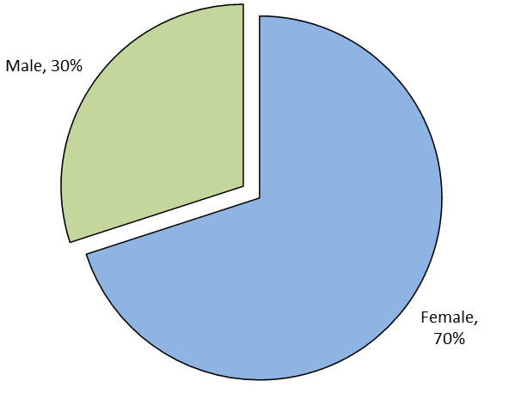

*Figure 15 Part-time staff split by gender (medical staff)*

* + 1. Starters and leavers by employment status

*Figure 16 Part-time starters by gender*

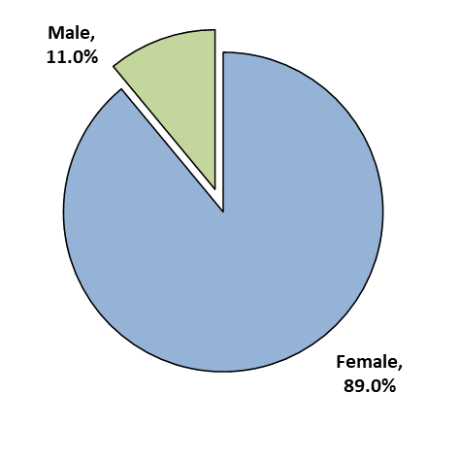

*Figure 17 Starters FT/PT by gender*

The charts above are for all starters by full and part-time posts by gender and show that:

* Female staff take up most part-time positions, making up 89% of part-time new starters.



*Figure 18 Leavers FT/PT by gender*

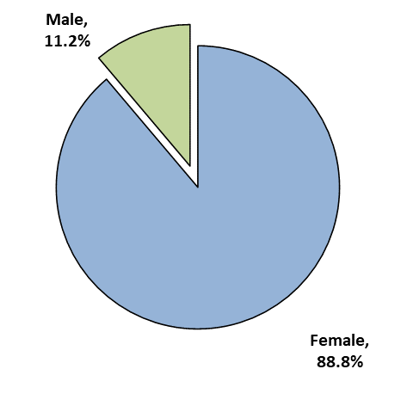

*Figure 19 Leavers PT by gender*

The charts above show all leavers by full and part-time posts by gender, these show that:

* The percentage of full and part-time staff leaving the Trust reflect both the overall Trust and the new starter profiles.
  + 1. Promotions

*Table 24 Promotions by gender*



*Table 24* shows that:

* Of the 391 promotions, 321 (82.1%) were of female staff while 70 (17.9%) were male.
* The Trust percentage gender split at the end of the audit period was 78.5% to 21.5%.
  + 1. Promotions by pay band

The following table and charts show promotions by band and compares the figures to the staff in post.

The assumption is that all promotions are from the previous pay band.

The staff in post (SIP) figures are the percentages for staff in post in each band at the end of the audit period.

Promotions figures are the percentage of staff who have been promoted from the starting band and the band to which they were promoted.

Table 25 shows the information for staff in post pay bands 2 to 8c; there were no promotions to Bands 8d or 9 and medical staff have been excluded for this purpose.

*Table 25* *Promotions split by gender and pay band*





*Figure 20 Percentage of female staff in post and promotions*



*Figure 21 Percentage of male staff in post and promotions*

The results show that:

* In general, a higher percentage of female staff were promoted than the percentage of female staff in the band.
* The small numbers in the higher bands can skew the figures.
  + 1. Training

*Table 26* *Number of courses by gender and area*



Overall, just over 78% of courses were attended by female staff, this reflects the Trust staff in post figure of 78.5%.

The Trust gender profile is also reflected in the training figures in the individual areas except for Support Services where 81.7% of courses are attended by female staff in comparison with the area’s 72% female profile.

* + 1. Disciplinary investigations

*Table 27*  *Disciplinaries by gender*



Of the 26 staff involved, over 34% were male. The gender split for all Trust staff is approximately 78.5%/21.5%. There is a much higher incidence, compared with the Trust profile, of men being involved in disciplinary investigations.

* 1. Religious belief
     1. Staff in post

*Table 28* *Staff in post, split by religion and area*



* Other includes: Buddhism, Hinduism, Judaism, Jainism, and Sikhism



*Figure 22 Trust wide staff in post by religious belief*

* The number of staff who have not stated their religious belief (Unknown) has decreased slightly from 2019 (21%) to just over 19% for 2020.
* The spread of religious belief across Trust staff has remained constant over recent years.
  + 1. Starters and leavers

*Table 29 Starts and leavers by religion and belief*



* The number of staff starting employment with the Trust who did not disclose a religious belief is around 10%. This is much lower than the figure for staff in post which is 19.5%.
* A noticeably higher percentage of new starters state that they have no religion (Atheism) than the staff in post figure.
  + 1. Applicants and shortlisted candidates

*Table 30 Applicants/shortlist by religious belief*





*Figure 23 Applicants/shortlist by religion*

* The figures in *Table 30* and *Figure 23* shows that the number of people who did not disclose a religious belief is around 10% for both applications and shortlisted candidates. This is much lower than the figure for staff in post which is 19.5%.
* The percentage of shortlisted candidates in the Atheism and Christian groups is slightly higher that of the initial applicants but the differences are insignificant.
  + 1. Promotions

*Table 31* *Promotions by religious belief*



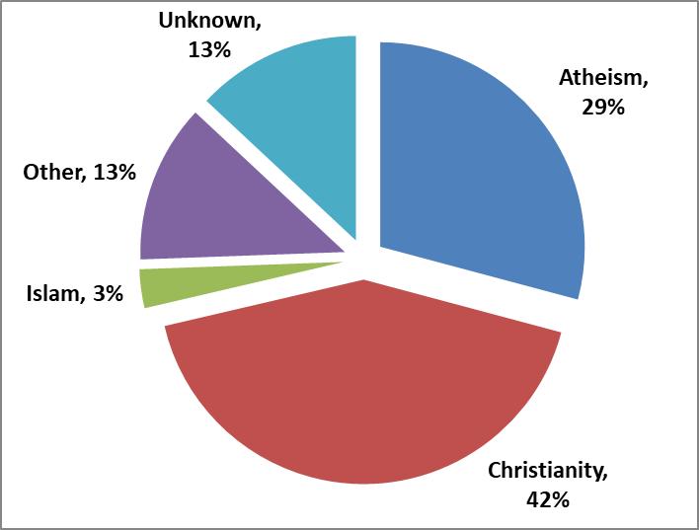

*Figure 24 Trust religion/belief profile*

*Figure 25 Promotions by religion/belief*

Comparing *Figure 24* with *Figure 25* shows that:

* Staff in the Atheism group have a higher percentage of promotions compared with the Trust profile.
* Proportionally, staff in the Christianity and Unknown groups have fewer promotions while the Other and Islam groups reflect the Trust profile.

* + 1. Training

*Table 32 Number of* *courses by religious belief and area*



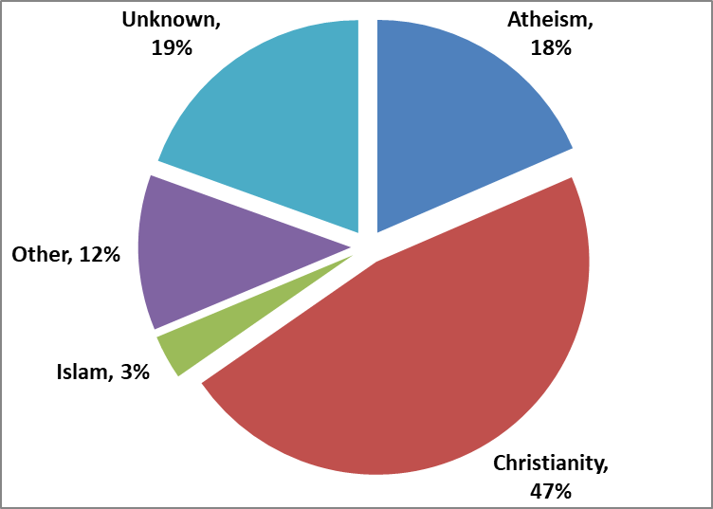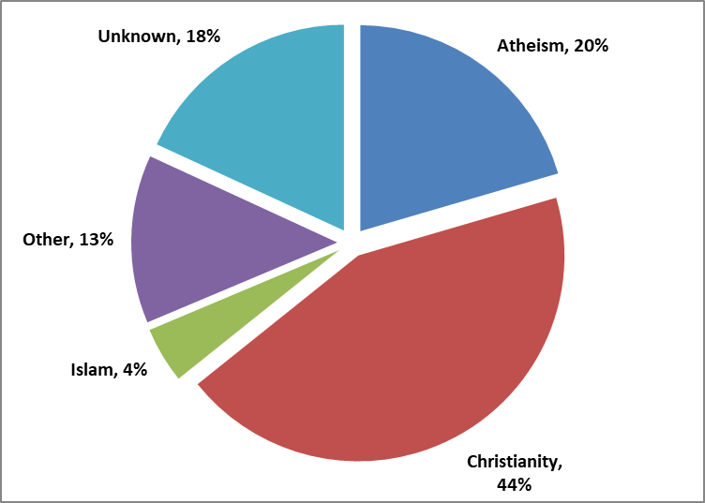

*Figure 26 % courses by religious belief*

*Figure 27 % SIP by religious belief*

The table and charts above show that:

* The proportion of courses accessed is not significantly different to the Trust religious profile.
  + 1. Disciplinary investigations

*Table 33* *Disciplinaries by religious belief*



* Proportionally, fewer staff who have stated they are Christian or have no religious belief have been involved in investigations compared with the Trust profile (46.8% and 18.5% respectively).
* Staff in the Other religious group have a higher incidence compared with the Trust (11.8%).
  1. Sexual Orientation
     1. Staff in post

*Table 34* *Staff in post by sexual orientation and area*



* The Unknown figure (staff declining to answer) has been reducing over recent years. In 2019 it was 16.4% and is now at 15% of all staff.
* The number of LGBT staff has increased only slight to 3.5% (158) from 3.2% (138) in 2019.
  + 1. Starters and leavers

*Table 35 Starters and leavers*



* The Unknown figure (staff declining to answer) is much lower for new starters than for both SIP and staff leaving the Trust.
* The percentage of LGBT starters is slightly higher that the SIP, but this difference could be down to more staff being willing to state their sexual orientation.
  + 1. Applicants and shortlisted candidates

*Table 36 Applicants/shortlist by sexual orientation*



* While only 3.2% of applicants and 4% of shortlisted candidates declined to answer, 15% of Trust staff in post fall into the Unknown category.

There does not appear to be a significant difference between the applicants and shortlist in terms of sexual orientation.

* + 1. Promotions

*Table 37* *Promotions by sexual orientation*



Of the 391 promotions:

* 88.2% of staff were heterosexual compared with 81.5% of staff in post.
* A lower percentage of staff who did not declare their sexual orientation were promoted compared the figure for staff in post (8.2% and 15% respectively).

* + 1. Training

T*able 38* *Number of courses by sexual orientation and area*



There are no significant differences between the percentage of courses taken up and the Trust profile for sexual orientation.

* + 1. Disciplinary investigations

*Table 39* *Disciplinaries by sexual orientation*



* The figure for heterosexual staff is slightly higher than the Trust profile (81.5%) while the figure for those who have not stated a sexual orientation is less than the Trust (15%).
* The percentage of gay/lesbian staff involved mirrors the Trust profile.
  1. Marital Status
     1. Staff in post

*Table 40 Staff in post by marital status and area*



The spread of the marital status of staff across the Trust is relatively unchanged from previous years and shows only slight variations in each category.

* + 1. Starters and leavers

*Table 41 Starters and leavers by marital status*



The results across the Trust show that:

* New starters - while the percentages for marital status is not dissimilar to the Trust SIP curve with the majority of staff falling into the married/single categories, the percentage of new starters who are single is significantly higher at just under 55% (Trust profile 36.6%) - this higher percentage is likely due to the number of new starters who fall into the 20-29 age band.
* Leavers – these percentages reflect the Trust marital status profile.

* + 1. Promotions

*Table 42* *Promotions by marital status*



*Table 42* shows that:

* Proportionally more staff who were single were promoted compared with the overall Trust figure (36.6%).
* Married staff have generally been promoted less than other categories when compared to Trust staff in post (53.3% married).

* + 1. Training

*Table* *43* *Number of courses by marital status and area*



The results show, compared with the Trust profile percentage, that single staff take up a slightly higher proportion of training courses but none of the difference are significant.

* + 1. Disciplinary investigations

*Table 44* *Disciplinaries split by marital status*



Of the 26 staff:

* 53.8% were married compared with 50.8% of Trust staff in post who are married.
* The Divorced/Legally Separated group had a slightly higher percentage of staff involved than in the Trust staff in post figure (9.6%) while staff in the Single group has slightly lower percentage than staff in post (36.6%).
  1. Ethnicity

The following tables and charts show the ethnicity of Trust staff by area and the comparison with the populations of local councils

* + 1. Staff in post

*Table 45 Staff in post by ethnic origin and area*





*Figure 28 Ethnic origin for all staff in post*

The results show that:

* Just under 90% of all staff consider themselves as White.
* Of the remaining 10%, the largest group (5.3%) consider themselves of Asian origin.
* The figure for Unknown, where staff refused to state their ethnicity, has been decreasing in recent years and is at 0.4% of Trust staff.

**Local Population Figures**

The following information compares the percentages for ethnic groups within the Trust with the local council populations for Barnsley, Calderdale, Kirklees, and Wakefield. The Yorkshire and Humber population figure is used for Forensic Services. The combined figure is the total of Wakefield, Barnsley, and Calderdale & Huddersfield council figures.

*Table 46 Percentage staff in post compared with local population*



NB the total Trust figure includes medical staff; the individual areas exclude medical staff



*Table 46* shows the percentage ethnicity of staff in post across the Trust compared with the relevant population figures. The results show that:

* Just over 89% of all Trust staff are white, this is not significantly different from the combined local populations.
* Excluding medical staff, however, the Trust figure increases to 91.4% (see sub-total figure in *Table 45*).
* The Black ethnic group is over-represented in the Trust in all areas and in total except for Support Services.
* In general, the other minorities are under-represented in Trust staff.

* + - 1. Staff in post by non-medical pay band

*Table 47 Pay band by ethnicity*



* The results in *Table 47* show that the ethnic mix of the Trust is not reflected in the higher bandings.
* In general, the lower and middle bandings mirror the diverse ethnic mix of the Trust.
* Again, small numbers can skew the figures.
  + - 1. Staff in post by employment status

The following tables and charts show the part-time and full-time staff by ethnicity for both

medical and non-medical staff.

Non-Medical Staff

*Table 48 Full/part-time split by ethnicity*



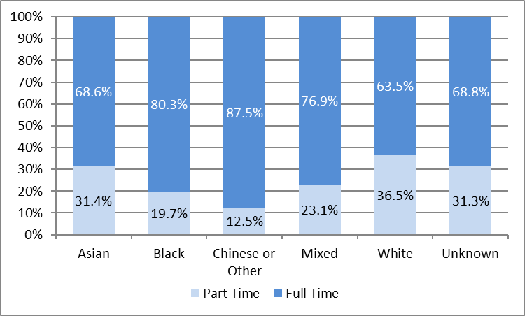

*Figure 29 Ethnicity of full/part-time staff*

*Table 48* shows the ethnicity of full and part time non-medical staff as a percentage of the Trust total.

*Figure 29* shows the same figures but as a percentage of each ethnic group.

* Ethnicity does not appear to be a significant factor in whether staff work full or part time as the figures mirror the Trust’s overall ethnic mix.
* The exceptions are for the Black, Chinese/Other, and Mixed groups which all have a higher proportion of full-time staff. The small numbers of staff in the Chinese/Other group could account for the skew in those figures.

**Medical Staff**

*Table 49 Full/part-time split by ethnicity*



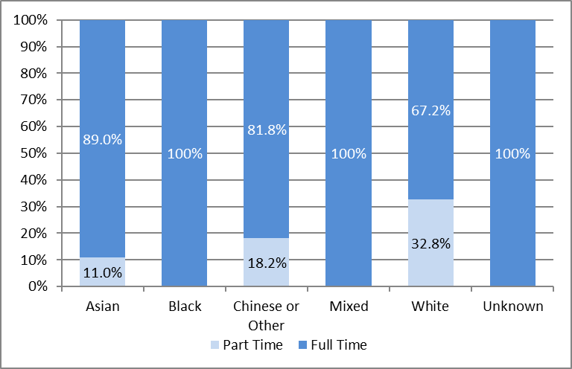

*Figure 30 Ethnicity of full/part-time staff*

*Table 49* shows the ethnicity of full and part-time staff as a percentage of Trust medical staff.

*Figure 30* shows the same figures but as a percentage of the ethnic group.

While it should be remembered that small numbers can skew the results, the figures show that:

* Over 63% of all part-time medical staff are in the White group.
* All medical staff in the Black and Mixed groups work full time.
  + 1. Starters and leavers

The tables below show the ethnic mix of new starters and leavers from the Trust.

*Table 50 Starters by ethnicity and area*



Table 51 Extract from comparison with local populations



* Table 50 shows that the ethnic mix of non-medical new starters improves on the Trust staff in post profile position (see the extract in Table 51) across all the minority ethnic groups.
* When including medical staff, this position improves even more.
* Comparing *Table 50* to Table 51, the figures for non-medical new starters in the Black, Other, and Mixed ethnic groups are higher than they are in the local populations.
* Non-medical new starters from an Asian background are still under-represented compared with the combined local populations but show improvement compared with the Trust staff in post profile.

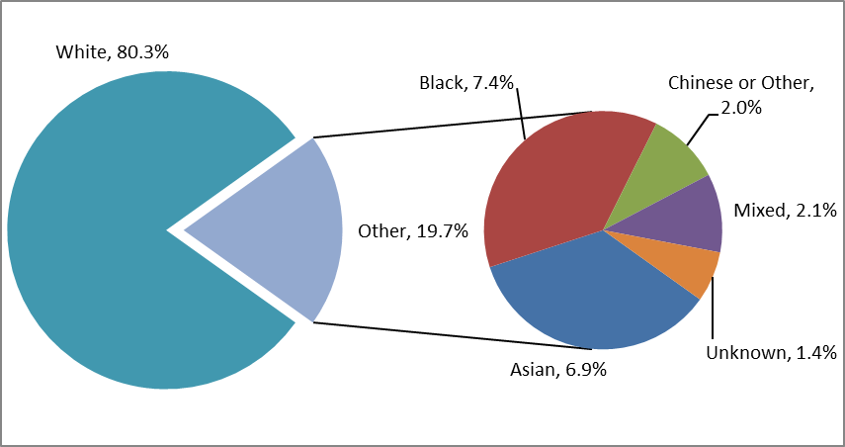

*Figure 31 Ethnicity of all starters including medical staff*

* From *Figure 31*, we can see that just over 80% of new starters consider themselves of white origin. This is a decrease from 2019 figures when just over 86% of starters were White.
* Just over 18% of starters consider themselves from an ethnic minority background compared with just under 13% in 2019.
* The staff in post figure for ethnic minority groups is approximately 10%.

*Table 52 Leavers by ethnicity and area*



* The percentage for all ethnic minority staff leaving (13.6%) during this period is slightly higher than the staff in post figure (10.4%).
* For leavers excluding medical staff, the ethnic group figure is 11%.
* The pie chart in *Figure 32* below better illustrates the leaver figures – this chart includes medical staff.

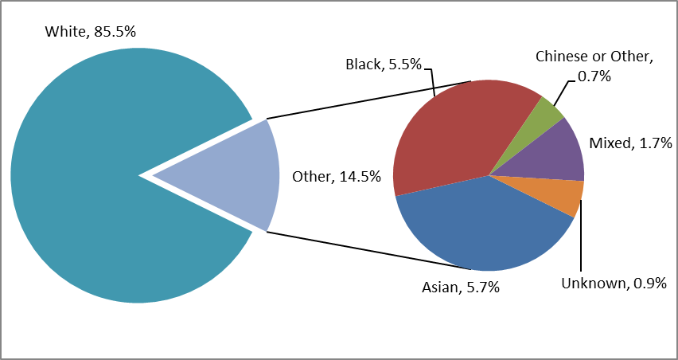

*Figure 32* *Ethnicity of all leavers*

In comparison, slightly over 18% of new starters consider themselves to be part of an ethnic minority group while just over 13% of leavers do so.

Starters by pay band

*Table 53* *Starters by pay band and ethnicity*



*Table 53* shows the split for ethnicity by pay band for new starters to the Trust.

* The white to minority ethnic groups ratio for new starters is approximately 84%/16%. This figure includes Unknown in the ethnic minority grouping.
* Even though the Trust is employing more starters who belong to the ethnic minority groups, with one exception, all new starters in Bands 8a and above are in the White ethnic group.

Leavers by pay band

*Table 54* *Leavers by pay band and ethnicity*



*Table 54*shows the split for ethnicity by pay band for leavers from the Trust.

* The white to ethnic minority groups ratio for leavers from the Trust is approximately 88%/12%. This figure includes Unknown in the ethnic minority grouping.
* While there are some slight anomalies in the figures, most bands reflect the overall split, with leavers coming from all groups. The exceptions to this are Bands 8a and above.
* The large number of White staff in the staff in post population explains the variation in the proportion of leavers across the ethnic groups for Bands 8a and over. At the beginning of 2020, the total number of staff belonging to any ethnic minority and who were in Bands 8a and above, was 14 out of a total staff in post figure of 306.
  + - 1. Starters and leavers by employment status

*Table 55 Starters by employment status and ethnicity*



* Looking at new starters in *Table 55* and comparing with the previous year, in 2020 more staff in the ethnic minority groups have taken up part-time employment with the Trust.
* Just under 75% of part-time posts were taken up by people in the White ethnic group while over 91% of staff appointed to full-time posts were White.

*Table 56 Leavers by employment status and ethnicity*



* For leavers, in all ethnic groups, more were in part-time positions than were full time.

**Promotions**

*Table 57* *Promotions by ethnicity and area*





*Figure 33 Promotions by ethnicity*

*Table 57* and *Figure 33* show that:

* Proportionally, slightly more staff in the minority ethnic groups were promoted than in the Trust staff ethnic profile.
* Of those, staff who consider themselves of Black ethnic origin were promoted at a higher rate than the other groups (6.9% compared with 3.2% Trust profile figure).
  + 1. Applicants and shortlisted candidates

*Table 58 Applicants/shortlist by ethnic group*



The table above shows that:

* Most of the ethnic groups do not have a significantly different percentage of applicants compared with shortlisted candidates.
* The exception is for those in the Asian group who had 13% of applicants compared with 9.3% who were shortlisted.

This is better seen in *Figure 34* below.



*Figure 34 Percentage of applicants/shortlisted by ethnicity*

*Table 59* below shows the ratio of applicants to shortlisted candidates from highest to lowest. The higher the ratio (worst), the fewer applicants from that ethnic group have been successfully shortlisted.

*Table 59 Ratio applicants to shortlist*



* The least successful group was Chinese or Other with those who did not state an ethnicity being the most successful.
  + 1. Training

*Table 60 Courses by ethnicity and area*





*Figure 35 Courses by ethnicity*

*Figure 36 Trust SIP by ethnicity*



*Figure 36* and *Figure 35* show the ethnic mix of the staff in post at the end of the period and the ethnicity of staff who have completed courses during the audit period and. This is for all staff including medical. The results show that:

* Fewer courses were attended by staff who consider themselves white in comparison to the overall Trust figure.
* Staff from BAME backgrounds undertook a significantly higher percentage of courses overall. 15.7 % of courses were attended by staff from groups other than white compared with 10.4% of staff in post who consider themselves to be from a minority ethnic background (excluding Unknown).
  + 1. Disciplinary investigations

*Table 61* *Disciplinaries by ethnicity*



* Only staff in the Black and White ethnic groups were involved in any investigations during the audit period.
* Of these, the White ethnic group had a higher proportion of staff involved than the percentage in the staff ethnic profile (89.2%).
  1. Grievances and Harassment/Bullying

Due to the low numbers, the following figures are not split by the protected characteristics.

There were 6 grievances recorded which started at some point during the audit period, January to December 2020.

There were 5 claims of harassment or bullying during the same period.

**Detailed ACTION plan for 2021**

|  |  |
| --- | --- |
|  |  |
| **Inclusive Recruitment and Retention** | Review recruitment practices in consultation with our staff networks  Continue to provide online information sessions to under-represented communities.  Collaborate on a Virtual Recruitment programme with partners  Lead on a collaborative International Recruitment of Nurses programme  Develop a more inclusive recruitment programme.  Refresh our retention strategy |
| **Creating a focus on disability, supporting the development of a disability network and implementing the WDES** | Continue to support the ongoing development of the staff disability network. A new steering group is being established and will build on the network’s previous positive achievements. Members of the network have been key stakeholders in the development of the staff disability and reasonable adjustments policy which will be launched in 2021. The network will continue to play a key role in the WDES. |
| **Redesign our approach to bullying and harassment based on developing cultures of civility and respect.** | Continue to develop and improve the framework for the prevention and harassment and bullying. In 2021 we will redesign our approach to bullying and harassment to focus on developing cultures of civility and respect, encouraging colleagues to speak up as early as possible if they are concerned about behaviours in the workplace. |
| **Develop an approach to manage issues of harassment, bullying and abuse from service users, carers and visitors** | The Equity Guardian model has been developed with clinical staff and has a support element for staff experiencing racial abuse and a clinical pathway to support the care needs of service users. There are 2 Equity Guardian’s in place with a comms campaign pending to recruit more and increase awareness of the rationale for the role. The Race Forward network will be relaunched with more involvement from clinical staff. There is a Dare to Change regional meeting including SWYPFT, BDCT, Leeds & York PFT, Calderdale CCG and RDaSH looking at areas such as data recording, training and protocols. |
| **Develop initiatives to support an older workforce to maintain employment** | Develop a flexible working model building on learning from the way we have worked during the pandemic. Work is progressing looking at areas such as 12-hour hybrid shift options, enhancing our Occupational Health and wellbeing offer, menopause support, flexible retirement and reviewing approaches to retention |
| **Ensure the Leadership and Management development strategy includes diverse initiatives such as the Stepping Up and Moving Forward programmes for BAME staff** | Stepping Up and Ready Now programmes are embedded into our Leader & Manager Pathway. Access for staff will continue when NHS Leadership Academy programmes resume these programmes, post pandemic. Moving Forward is led by us here at SWYPFT and delivered in partnership with BDCT, LYPFT, Mid Yorkshire and Wakefield CCG. The next programme commences in May 2021. A Moving Forward Plus pilot programme is currently underway as part of our inaugural Talent Programme. As a Trust, we piloted a Reciprocal Mentoring programme in 2019/20, consequently being incorporated into our refreshed L&M pathway with two further cohorts commencing in May 2021, access to which has also been extended to staff from other marginalised groups. As part of our Trust-wide Coaching and Mentoring framework, 1:1 coaching, executive coaching and mentoring is also available with Coaching for Inclusion currently being developed/added. Our next Shadow Board programme is planned for summer to autumn 2021.  The redesign of our middle management programme is underway, and a revised programme is planned from June 2021. This is based on the 5 essentials of a ‘Great Place to Work’. |
| **Continue with HCSW/band 2 apprenticeship values-based assessment centres** | The Trust continues to recruit through a values-based interview selection process, delivered virtually in cohorts throughout the year. We are hoping to return to assessment centres when Covid restrictions allow. |
| **Explore actions to reduce the gender pay gap** | The reporting requirement was removed in 2020 and our last audits were published in 2019. Further audits will be undertaken in 2021. |