Cath’s annual health check story
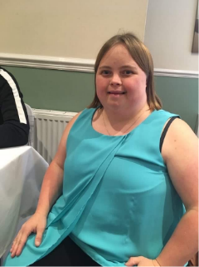 | Catherine Horbury and I am sharing my annual health check story with you all. As I have got a learning disability and a condition of Down Syndrome.  I am the co-lead for Yorkshire and Humber Operational Delivery Network (ODN)
What has changed when you go to your annual health check with COVID?
I went into the GP surgery with a face covering on.
The nurse who did my annual health check wore a face covering too.
Sometimes I was struggling to hear what the nurse was saying to me. I asked the nurse to repeat back to me what she said.
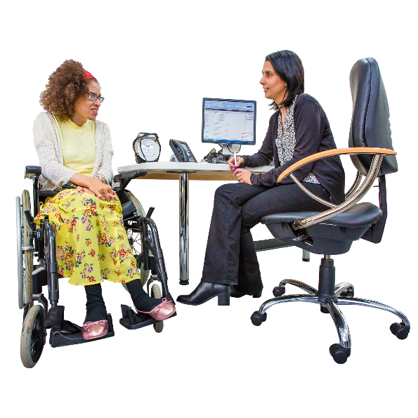  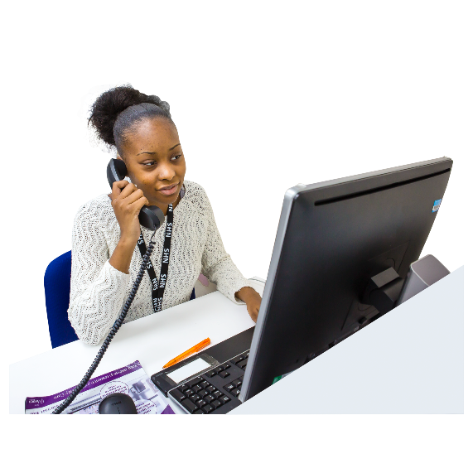 | How did I get an invite for an annual health check?  Went to the reception to book my annual health check with the receptionist for the new year.  What did I think of the annual health check?  Overall, my annual health check went very well. The nurse asked me some questions relating to my health and then gave me some suggestions on how I can improve my health if needed.  I am glad that my annual health check turned out to be a good one.
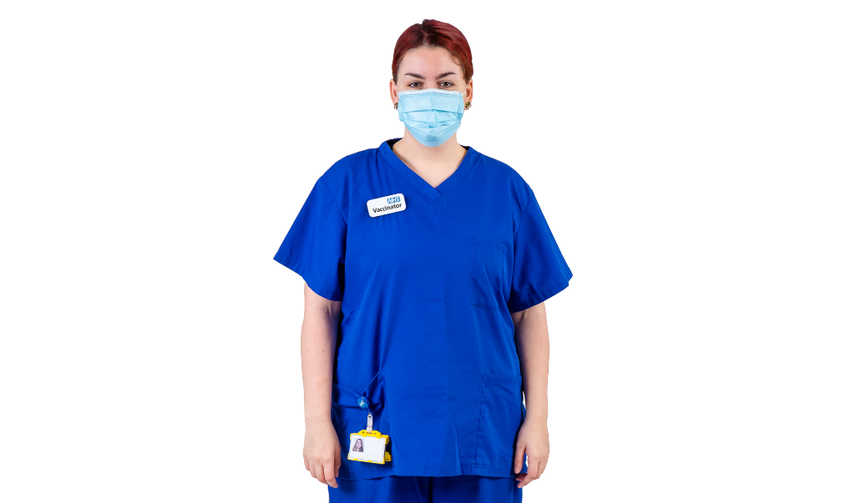 | How was the nurse and staff at your annual health check?  The nurse who carried out my annual health check was very lovely kind lady and she greeted me with a smile and I smiled back at her too.  I felt at ease with the nurse and if I had any questions, I felt comfortable enough to ask them.
Did you leave your annual health check with a health action plan and goals?
Yes, I did leave my annual health check with a health action plan and she gave me some goals, I will also have a copy of my goals too and the notes of was said at the annual health check.

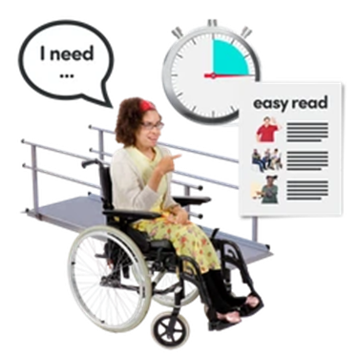
Were there any reasonable adjustments in place during your annual health check?
Yes, there was plenty of space around. The nurse made sure that there was a chair for me to sit on and she greeted me with a smile, and she spoke to me rather than my support which was good. I even had the chance to talk to the nurse too on my own.
Everything went great. A perfect annual health check.

How did you feel after your annual health check had finished?
I felt great and glad that all my health is good. I will take the nurse’s advice of what I need to do next for my health.
So, I can say it was a positive annual health check in the end.
