Making better choices for local people, communities, and the environment.
A 6-year plan

Easy Read Booklet
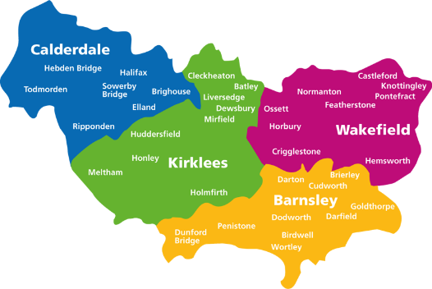
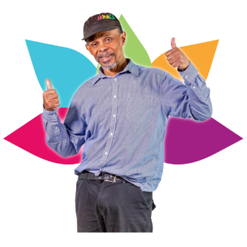
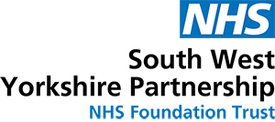
We are SWYPFT, which is short for
South West Yorkshire Partnership NHS Foundation Trust.
We are a specialist NHS Foundation Trust that provides community, mental health, learning disability and autism services.
Our services help to support people to be happy, healthy and to live well in their community. We help people who live in Barnsley, Calderdale, Kirklees and Wakefield.
We know the wellbeing of local people; communities and the environment can be affected by the choices organisations make.
Who we are
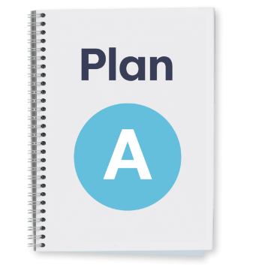
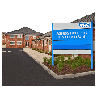
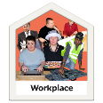
We want to make better choices for the future. Choices like, where to buy our goods and services from, how to look after our buildings, and how to support local people to come and work for us.
This is called being socially responsible and sustainable.
Over the last few months, we have listened to our staff and local people. They gave us lots of ideas about the better choices we could make. Their ideas helped us to write our plan.
In this document we will tell you about our plan and how it will help the local people, local communities, and the environment.

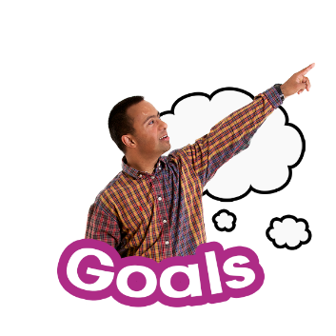
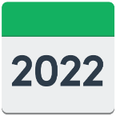
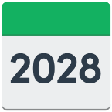
Over the next 6 years, we will focus on 5 goals, which are:
Our 5 goals (better choices)
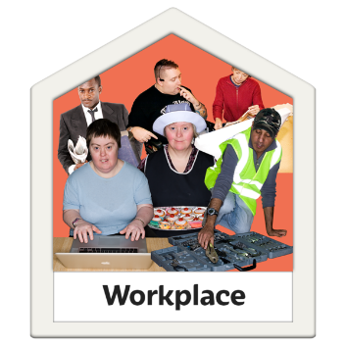
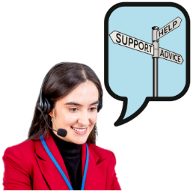
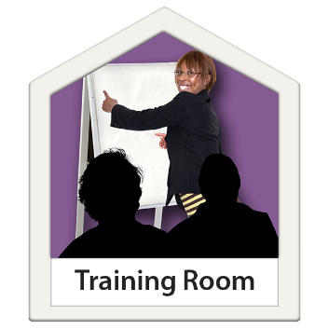
- The people who work for us
We want to encourage and make it easier for people from diverse backgrounds to come and work for us.
Diverse means people of different social and ethnic backgrounds, age, sex, religion, disability, and life experiences.
To do this we will:
Offer more help and support to apply for jobs in SWYPFT.
Offer more training. Training can help and support staff to improve their skills and get a better paid job.
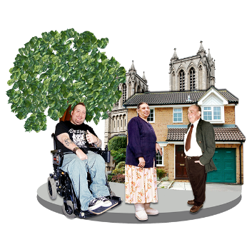
- The goods and services we buy
We can make a big difference by buying goods and services from our local communities.
To do this we will:
Buy more local goods and services in Barnsley, Calderdale, Kirklees, and Wakefield.
This means money is reinvested or put back into the local communities.
When money is reinvested, local businesses get bigger. This makes more local jobs for the community and the local community gets richer.
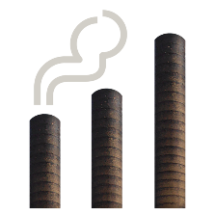
- Reduce our carbon dioxide (CO²) emissions
CO² is short for carbon dioxide. CO² is a greenhouse gas, and over the last 100 years it has been put into the atmosphere more quickly than it has been used.
The extra CO² causes global warming, which leads to climate change, such as stronger storms and floods.
By 2040 we will aim to reduce our CO² emissions to 0.
To do this we will:
Use less energy or power across our estate.
Use more renewable energy such as, wind or solar power.
Improve and add to our green spaces.
Support our staff to walk, cycle, drive an electric car or use public transport to come to work.
0
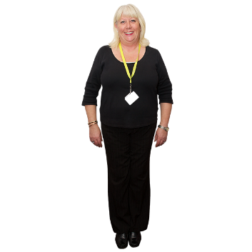
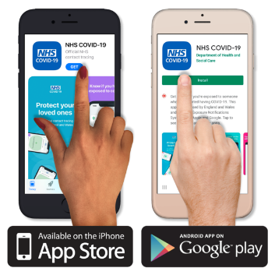
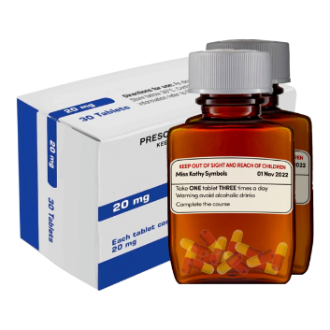
- Cultural and creative partnerships
We know more and more people are needing our help and support.
We want to offer people more choice on the support they can get, to make them happy and healthy.
To do this we will:
Increase the number of cultural and creative services we work with.
We know cultural and creative activities such as art, music, sport, and dance can help people to be happy, healthy and live well in their community.
Employ a health and wellbeing practitioner to work with our busy staff and help support them to be happy and healthy at work.
Look at different ways people can take part in creative activities. Such as joining online with an app.
An app is short for an ‘application’. It is a computer programme that you can add to your computer or phone.
5. Reducing medication and connecting people to local community services and activities
Medication may help to support some people to be happy and healthy. Medication is things like tablets and medicine.
There are other things which may support people to be happy and healthy.
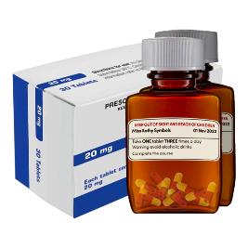
To do this we will:
Help and support people to reduce their medication.

Connect people to more art, music and craft activities within the community.
More information

For more information on the
6-year plan you can:

Email: customerservices@swyt.nhs.uk
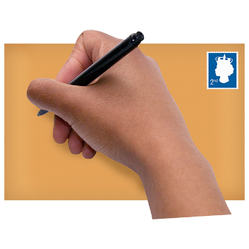
Write:
Customer Services
SWYPFT
Block 10, Fieldhead, Ouchthorpe Lane,
Wakefield,
WF1 3SP
Telephone:
01924 316060 or
0800 587 2108

