Non-executive director

Candidate information pack

2022

Contents

Welcome letter from the Chair 3

About us 4

Advertisement 7

Job description 9

Recruitment timetable 11

How to apply 12

Welcome from Marie Burnham, Chair

Dear candidate,

Thank you for your interest in joining the Board of our Trust as a Non-executive Director in South West Yorkshire NHS Foundation Trust. I hope that the demanding, but very rewarding, opportunity catches your imagination and that you are encouraged to apply. This crucial role provides an excellent opportunity and comes at an exciting time for our Trust. Our ambitious programme of transformation reflects the challenging times in which we operate, will transform the lives of those who use our services and bring benefits to the communities we serve. I have very recently joined the Trust as the new Chair, and I am looking forward to working with you and the rest of the team in delivering our vision, mission, culture and values.
As a Trust, we are in a strong position as a specialist provider of community, mental health and learning disability services to the 1.22m people of Barnsley, Calderdale, Kirklees and Wakefield. Most of the care we provide is delivered in local communities by our 4,600 staff and annual income of £290m. We also are the lead provider for low and medium secure forensic mental health care to people across West Yorkshire and deliver specialist mental health support into Wetherby Young Offenders’ Institution.
We are a high performing organisation with over 87% of services assessed by the CQC rated as ‘Good’ or ‘Outstanding’. We have a significant role to play in both the West Yorkshire and South Yorkshire Integrated Care Systems (ICS) working with partners to integrate health and care services to meet the needs of our diverse populations
Further information is available on their website: Care Quality Commission (http://www.cqc.org.uk/provider/RXG/reports).

The Trust is seeking to appoint an outstanding individual, who is both a qualified accountant and has senior-level financial management experience, to join our strong Board.

The successful candidate will bring the capability and enthusiasm to support our ambitious vision within the context of significant change, transformation and opportunity, both within the organisation, the region and the wider NHS. The successful candidate must also be able to demonstrate experience of working in or with large, complex organisations, an ability to engage positively and collaboratively in Board discussions, and the potential to act as an ambassador for the Trust. They will also bring strong relationship management and influencing skills, have experience of making autonomous decisions, have a passion for delivering quality and excellence, and, importantly, support the values of the Trust.

Interested applicants must live within the regions of Yorkshire, the Humber, Cumbria, Durham, Lancashire, Greater Manchester, Derbyshire, Nottinghamshire and Lincolnshire and we welcome applications from all aspects of society, including people from BAME and LGBT+ communities, people with disabilities, younger people, service users and carers.

I trust the information in this pack will give you a flavour of our organisation, our values and priorities. If you share our ambition for success and can offer the commitment needed, please see details within this pack regarding how to apply for the role and our drop-in recruitment/information event, where you can meet members of our Trust Board. Prospective candidates wishing to discuss the role informally may speak to either myself, the Chief Executive or Deputy Chair.

I wish you the very best in your application.

Marie Burnham
Chair

Background

We are an NHS foundation trust that provides community, mental health and learning disability services to the people of Barnsley, Calderdale, Kirklees and Wakefield. We also provide medium secure (forensic) services to the whole of West Yorkshire.

Over 1.22 million people live in the communities of Barnsley, Calderdale, Kirklees and Wakefield from a range of diverse backgrounds. We aim to match the community’s needs by providing personalised care that puts the person first and in the centre.

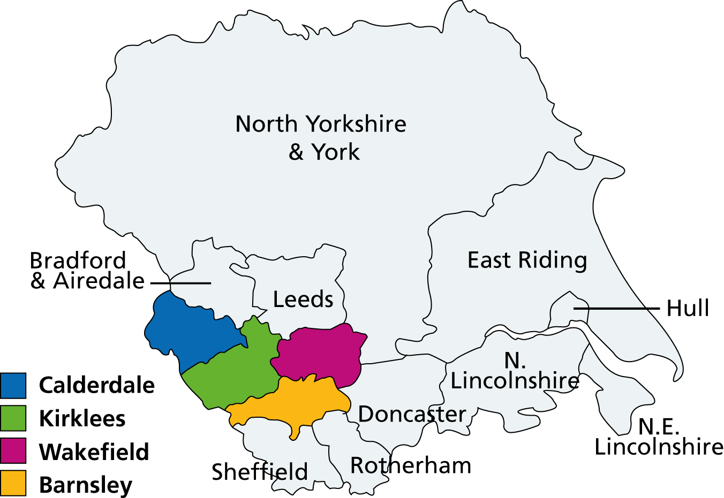

We work with other local NHS organisations, local authorities, government departments and voluntary organisations to provide high quality health care to people in our area. Working in partnership is very important to us as it enables us and our partners to provide more efficient, streamlined care that truly meets the needs of local people.

Working in partnership also means working with the members of our foundation trust, who can have a say in how we run the Trust and how they wish our services to be developed. Over 9,000 local people have joined us as members, and our staff are members too.

We are committed to helping join up care wherever possible. We are an integral partner in the West Yorkshire Integrated Care System, and a leading partner in the West Yorkshire Mental Health, Learning Disability and Autism Collaborative. We are also members of the South Yorkshire and Bassetlaw Integrated Care System, driving forward collaborative working in areas such as stroke services, ASD/ADHD, CAMHS and employment.

We’re involved in provider alliances across Kirklees and Wakefield, the Wakefield Integrated Care Partnership, the Wakefield Mental Health Alliance, and with Calderdale Cares. In South Yorkshire we are also leading members of the provider alliance and integrated care partnership, committed to joining up care for the people of Barnsley.

To provide the flexible, individually tailored care that local people have told us they want, we work from a variety of sites as well as with people in their own homes. 98% of our services are community-based and are well supported by inpatient services for when people need care or assessment in a hospital setting.

The Trust, which was first established in 2002, now employs around 4,600 staff, in both clinical and non-clinical support services, and has a turnover of over £290 million.
Our mission

We help people reach their potential and live well in their community.

Our values

- We put the person first and in the centre.
- We know that families and carers matter.
- We are respectful, honest, open and transparent.
- We improve and aim to be outstanding.
- We are relevant today and ready for tomorrow.

Our proposed strategic priorities for 2021/22
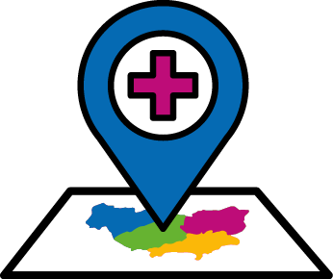
- Improve health
- Play a full role in our Integrated Care Systems and associated places to outcomes in their 5 year plans.
- Improve outcomes through our wellbeing services, physical health and services for people with mental health and learning disabilities.
- Enhance creative, cultural and digital offers through Creative Minds and our recovery colleges.

- Improve care
- Continually improve patient safety
- Safely deliver and restore inclusive services locking in innovation.
- Provide care as close to home as possible.
- Deliver improvements, particularly in CAMHS and forensic services.

- Improve resources
- Integrate digital approaches to the way we work.
- Spend money wisely and reduce waste.

- Making SWYPFT A Great Place to Work
- Support the provision of a health, resilient and safe workforce.
- Refresh and deliver our sustainability strategy and action plan.

Our services

In Barnsley, Calderdale, Kirklees and Wakefield we provide care to:

- adults of working age (aged 18 to 65) with a mental health problem;
- services to people as young as 14 experiencing the first signs of psychosis;
- child and adolescent mental health services;
- older people (over 65) with a mental health problem;
- people (mainly adults) with a learning disability whose behaviour challenges services, with intensive support needs and/or a mental health problem; and
- medium secure forensic services for people with a mental health problem and/or learning disability.

In Barnsley we also provide:
- inpatient services;
- partnership services;
- children's services;
- community rehabilitation;
- services for people with long-term conditions; and
- primary care and preventative services.

We are active partners in two Integrated Care Systems (ICSs):
- West Yorkshire ICS; and
- South Yorkshire and Bassetlaw ICS
and we play a key role in the place-based health and care partnerships in Barnsley, Calderdale, Kirklees and Wakefield.

A fuller description of our services can be found on our website at: http://www.southwestyorkshire.nhs.uk/our-services/.

Links to further information

How we’re run

Further information on how our organisation runs, including members, Members’ Council, and the Trust Board, can be found on our website at: http://www.southwestyorkshire.nhs.uk/about-us/how-we-are-run/.

Our Constitution

Our Constitution can be found on our website at:
http://www.southwestyorkshire.nhs.uk/about-us/how-we-are-run/trust-board/constitution-self-certification/

Annual report and accounts

Our Annual Report and accounts can be found on our website at: http://www.southwestyorkshire.nhs.uk/about-us/performance/annual-report/.

Quality account

Our Quality Accounts can be found on our website at: http://www.southwestyorkshire.nhs.uk/quality-innovation/quality-account/.

Creative Minds

Information on our Creative Minds approach can be found on our website at: http://www.southwestyorkshire.nhs.uk/quality-innovation/creative-minds/.

Regulators (NHS Improvement and Care Quality Commission (CQC))

Further information on the Trust can be found on the NHS England website at: https://www.gov.uk/government/groups/south-west-yorkshire-partnership-nhs-foundation-trust and
Care Quality Commission (CQC) website (http://www.cqc.org.uk/provider/RXG/reports).
Advertisement

Non-Executive Director

South West Yorkshire – £13,584 (3 days per month)

South West Yorkshire Partnership NHS Foundation Trust is an award winning organisation which exists to help people reach their potential and live well in their communities.

Our compassionate, dedicated and enthusiastic staff are committed to living our values every day:

- We put the person first and in the centre
- We know that families and carers matter
- We are respectful, honest, open and transparent
- We improve and aim to be outstanding
- We are relevant today and ready for tomorrow

Our values guide us in providing a range of community, mental health and learning disability services to more than a million people across Barnsley, Calderdale, Kirklees and Wakefield. We also provide some medium secure (forensic) services to the whole of Yorkshire and the Humber and some wellbeing services in other parts of Yorkshire.

We’re looking for a Non-executive director who is financially qualified (CCAB registered accountant), with senior-level financial management experience, to join our strong, unitary Board in guiding our workforce to deliver the highest quality care for local people. You’ll have the ability to build strong relationships, provide support and constructive challenge to the Executive team, and help us to continue to improve the services we deliver. You will bring the capability and enthusiasm to support our ambitious vision and goals within the context of significant change, transformation and opportunity, both within the organisation and in the wider NHS.

You will demonstrate an ability to engage positively and collaboratively in Board discussions and act as an ambassador for the Trust. You should also bring strong relationship management skills and have a passion for delivering excellence. Able to champion our drive for service excellence, you will demonstrate experience of working, ideally at Board level, in large, complex, customer-focused organisations.

You must live within the regions of Yorkshire, the Humber, Cumbria, Durham, Lancashire, Greater Manchester, Derbyshire, Nottinghamshire and Lincolnshire and we welcome applications from all aspects of society, including people from BAME and LGBT+ communities, people with disabilities, younger people, service users and carers.

If you share our ambition for success and can offer the commitment needed, please contact us to arrange to have an informal discussion about this role with our Chair, Chief Executive or Deputy Chair by emailing gemma.lockwood@swyt.nhs.uk marked as “Non-Executive Director appointment”.

For further information on how to apply and to download a copy of the information pack, please visit our website: http://www.southwestyorkshire.nhs.uk/beourNED.

Closing date is Friday 25th March 2022 (12noon).

Job description

Non-Executive Director outline job description

The Non-Executive Directors of our Board bring their expertise and experience, as well as their particular knowledge as a member of the community to the work of the Board.

Your role will be to use your skills and your personal experience as a member of your community to:

- promote the success of the Trust to maximise the benefits for members and for the public;
- commit to working to, and encouraging within the Trust, the highest standards of probity, integrity and governance, and contribute to ensuring that the Trust’s internal governance arrangements conform to best practice and statutory requirements;
- provide independent judgement and advice on issues of strategy, vision, performance, resources and standards of conduct and constructively challenge, influence and help the Executive Management Team develop proposals on such strategies;
- assist fellow Directors in setting the Trust’s strategic aims, ensuring that the necessary financial and human resources are in place for the Trust to meet its objectives, and that performance is effectively monitored and reviewed;
- assist fellow Directors in providing entrepreneurial leadership to the Trust within a framework of prudent and effective controls, which enable risk to be assessed and managed;
- assist fellow Directors in setting the Trust’s values and standards and ensure that its obligations to its stakeholders and the wider community are understood and fairly balanced at all times;
- engage positively and collaboratively in board discussion of agenda items and act as an ambassador for the Trust in engagement with stakeholders including the local community, dealing with the media when appropriate;
- monitor the performance and conduct of management in meeting agreed goals and objectives and statutory responsibilities, including the preparation of annual reports and annual accounts and other statutory duties;
- obtain comfort that financial information is accurate and that financial controls and risk management systems are robust and defensible;
- contribute to the determination of appropriate levels of remuneration for executive directors;
- participate in and in some cases Chair Committees as required;
- attend and contribute to Members' Council meetings;
- bring independent judgement and experience based on commercial, financial, legal or governance expertise from outside the Trust and apply this to the benefit of the trust, its stakeholders and its wider community;
- undertake responsibilities and duties under the Mental Health Act; and
- on occasion participate as Chair of the interview panel in the selection of medical consultant staff and Chair appeals.
- Must be able to demonstrate a commitment to, and significant knowledge of, the communities the Trust serves.

Person specification

The Trust has identified the following skills/expertise for this appointment:
- A financial qualification (CCAB registered accountant), with senior level financial management experience is essential.

Plus:
- Experience of working in or with large complex organisations
- Strong relationship management and influencing skills
- Committed to quality and delivering excellence
- Ability to engage positively and collaboratively in Board discussions
- Ability to act as an ambassador for the Trust
- Strong commitment to promoting equality, inclusion and diversity

In addition to the expertise detailed above, all candidates selected for interview will need to show that they have the competencies required to be effective in a board level role. They are:

Patient and community focus | A high level of commitment to patients, carers and the community, especially to disadvantaged groups, and the values of the Trust
Strategic direction | The ability to think and plan ahead, balancing needs and constraints.
Holding to account | The ability to accept accountability and probe and challenge constructively.
Effective influencing and communication | Be able to influence and persuade others.
Team working | Be committed to working as a team member.
Self-belief and drive | The motivation to improve NHS performance and confidence to take on challenges.
Intellectual flexibility | The ability to think clearly and creatively.

Recruitment timetable

Action | Date
Candidate information pack to be signed off | Wednesday 12th January 2022
Advert goes live: | w/c 28th February
Informal discussions about the role with:  Chair  Deputy Chair  Chief Executive | Flexible dates between advert going live up to Friday 25th March (where possible) to be agreed through Gemma Lockwood
Closing date for applications (submitted to: nedrecruitment@swyt.nhs.uk) | Friday 25th March 2022
Shortlisting meeting | w/c 28th March 2022
Nominations Committee (to agree shortlist) | w/c 28th March 2022
Final interviews: | Stakeholder engagement events: Tuesday 12th April  Formal Panel Interviews: Wednesday 13th April
Nominations Committee (to agree recommendation on preferred candidate) | ASAP after interviews
Members’ Council (approval) | ASAP after Nominations Committee
Appointment start date, subject to completing of pre-employment checks | TBC

How to apply

Closing date: Friday 25th March 2022 (12 noon)

Interested applicants must live within Yorkshire, the Humber, Cumbria, Durham, Lancashire, Greater Manchester, Derbyshire, Nottinghamshire and Lincolnshire as set out in Annex 1 of our Constitution and meet the provisions covering the appointment and removal of Non-Executive Directors of the Trust Board set out in paragraphs 25, 29 and Annex 6 of our Constitution. Our Constitution can be found on our website at:
http://www.southwestyorkshire.nhs.uk/about-us/how-we-are-run/trust-board/constitution-self-certification/

Before you apply, please ensure that you have read the Job Description in detail. Your supporting statement must be aligned to the criteria outlined in the Person Specification.

To apply for this role, please send the following to email address: nedrecruitment@swyt.nhs.uk clearly marked “Application for Non-Executive Director”:

- Your current CV (including email address and daytime telephone number)
- Supporting statement aligned to the person specification (maximum 2 pages)
- Your current remuneration package
- Contact details of at least TWO referees, one of whom should be your current or most recent employer. (We will not make contact with referees before speaking with you and gaining your permission to do so. References will not be sought prior to shortlisting.)

Informal Discussion

If you would like to discuss the role informally and confidentially with the Chair, Chief Executive or Deputy Chair please email gemma.lockwood@swyt.nhs.uk marked as “Non-Executive Director appointment”.

