Children’s Speech and Language Therapy
Pre feeding skills - Helping children with touch on the face

What is it?
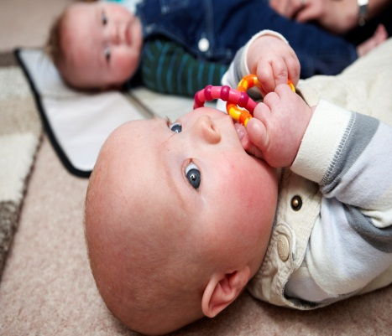
This advice helps young children to be relaxed about touch on their face and in their mouth. It can help them get ready for eating and drinking in future. It can also help with mouth care and toothbrushing.

Why does my child need to practice this?

This advice can help children:
- Who have had lots of medical procedures like tubes around their face and mouth.
- Who have had a long time without feeding, eating or drinking.

These children may feel worried about people touching their face. They may not want to have things near their face and their mouth. These children are described as having ‘face sensitivity’ or ‘oral aversion.’

Children need to be relaxed about things near their face before they are happy to eat and drink. Speech and language therapists recommend working to help them accept touch on their face.

Signs that your child is sensitive

Eating, drinking and mouth sensitivity | Sensitivity in other places
- Turns head away if lips are touched  - Faster breathing or colour change when face is touched  - Gagging  - A ‘pained’ look on their face  - Crying when fed or if their face is touched  - Vomiting  - Blinking, eye rolling or staring when their face is touched  - Does not like teeth being cleaned  - Only likes certain textures of food | - Avoids having their hair brushed  - Avoids having their face washed or wiped  - Does not like being touched by other people  - Does not like clothes pulled over their head  - Gags when touching certain foods or textures  - Dislikes mess on hands or seeing things that are messy

Touch on face programme

This plan will help your child to relax about touch. The plan works to help your child accept:
- Body touch
- Touch to their face
- Touch around and inside their mouth

Complete the practice in this order. Your child needs to be happy with touch before they are ready to have mouth care or to eat and drink.

Before you start  Children’s speech and language therapy  New Street Health Centre, Upper New Street, Barnsley, S70 1LP Telephone: 01226 433119/433115  Email: childrensspeech.therapy@swyt.nhs.uk Web: www.barnsleyspeechtherapy.co.uk | Things to remember
- Allow lots of time. Do not rush  - Practice can be short.  - It help to do this 2-3 times a day.  - Make sure your child is sitting or lying in a balanced, supported and relaxed way. Your physiotherapist or occupational therapist can give advice to help with this.  - Only touch your child with your hands. Keep clothing like sleeves out of the way  - Keep your finger nails short and clean  - Other people such as care staff will need to wear gloves for step 3.  - Parents can use a clean finger | - Use a firm touch. It should not leave a mark or a colour change to your child’s skin.  - Do not use a light or ‘tickle’ touch. This is not relaxing.  - Keep the practice relaxed and fun  - STOP if your child shows signs of discomfort or upset.  - You do not have to do all the steps if your child cannot manage them  - Do the practice in the same order  - Try playing music. This can help your child to relax  - Keep your voice calm and soothing.  - End each practice on a positive note.

Step 1 – Body Touch or Body Massage

- Help to relax your child by putting your hands on the middle of their chest.
- Your touch needs to be firm but gentle
- Do slow strokes on your child’s legs. Keep the movements at the same speed. Do both legs at the same time
- Move back to your child’s chest.
- Do slow firm strokes of your child’s arms and hands. Keep the movements at the same speed. Do both arms at the same time
- Older children. Use a calm and soothing voice. Tell your child the body part at each point of the massage
- Younger children. Sing a song to help them relax. This can also help you remember the order. Try the tune to Tommy Thumb (e.g. Bobby’s arms, Bobby’s arms, where are you…?)

Step 2 – Face Touch

- Practice this away from feeding or mealtimes to start with
- Help your child get ready for face touch by touching/kissing their arms. Move their arms towards their face as you do this
- Try firm kisses on child’s face
- Keep movements slow and at the same speed.
- Do both sides of the face at the same time
- Start by touching your child’s forehead. Start in the middle. Do 3 strokes from the middle to the side, near the hairline.
- Do 3 strokes on both cheeks. Start in the middle near the nose. In a circle move along the cheekbone to the outside and down towards the corner of the mouth
- Do 3 strokes on both sides of the nose from the bridge of the nose to the nostrils
- Do 3 strokes from the bottom of your child’s chin up to their mouth
- Move to step 3 (see the next page) if your child is happy and relaxed
Step 3 – Touch around and inside the mouth

Parents can use a clean finger. Other people helping should wear a glove.
 | Do 3 strokes on your child’s top lip | 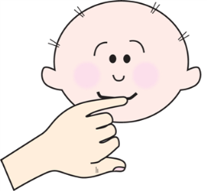
Do 3 strokes on your child’s bottom lip

Use your little finger if your child is under 5 and an index finger if your child is older.
You can encourage older children to do this part
 | Place your finger on the bottom gums, just to one side of the middle. | 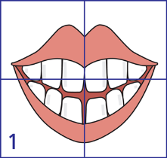
Slide your finger along the gum line towards the back of the mouth and back again.
Only go as far back as your child will allow. Repeat this 3 times.
 | Keeping your finger on the gum.  Turn it so that the padded part faces your child’s cheek.  Push out the middle of the cheek. Massage in a circular motion. | 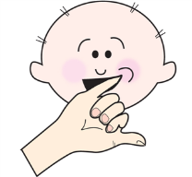
 | Return your finger to the middle of your child’s mouth. Repeat the same on the other side of the lower gum and cheek | 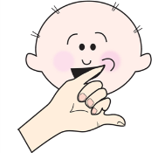  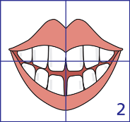
 | Now do the same on your top gum | 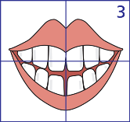
 | Slide your finger along the gum line and back again. Repeat this 3 times
 | Return your finger to the middle of the gums and repeat on the other side | 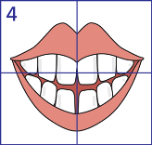
 | Place your finger on the tip of your child’s tongue | 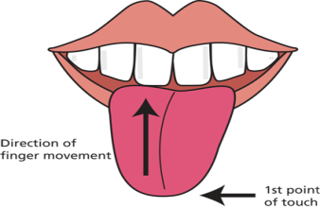
 | Using a firm touch, slowly stroke your finger to the middle of your child’s tongue 3 times

If your child is able to manage the step 3 sequence try it with your finger dipped in water or milk.
Practice each day with your child.

Stop if you notice any signs your child is not relaxed. If your child is managing the practice, do it in everyday routines like face washing and tooth brushing.

