- Learning from Healthcare Deaths Report
Annual Cumulative Report 2022/23 (covering the period 1/4/2022 – 31/12/2022)
  - Background context

    - Introduction

Scrutiny of healthcare deaths remains high on the Government’s agenda. In line with the National Quality Board report published in 2017, the Trust has had Learning from Healthcare Deaths policy which sets out how we identify, report, investigate and learn from a patient’s death. The Trust has been reporting and publishing our data on our website since October 2017.

Most people will be in receipt of care from the NHS at the time of their death and experience excellent care from the NHS for the weeks, months and years leading up to their death. However, for some people, their experience is different, and they receive poor quality care for a number of reasons including system failure.

The Five Year Forward View for Mental Health identified that people with severe and prolonged mental illness are at risk of dying on average 15 to 20 years earlier than other people. Therefore, it is important that organisations widen the scope of deaths which are reviewed in order to maximise learning.

The Confidential Inquiry into premature deaths of people with learning disabilities showed a very similar picture in terms of early deaths.

The Trust worked collaboratively with other providers in the North of England to develop our approach. The Trust will review/investigate reportable deaths in line with the policy. We aim to work with families/carers of patients who have died as they offer an invaluable source of insight to learn lessons and improve services.

The Trust has a representative from the Patient Safety Support Team who attends the Regional Mortality Meeting which are held quarterly. This meeting facilitates the dissemination of good practice around learning from deaths with sharing of processes that other trusts have in place to review deaths and improve care.

    - Scope

The Trust has systems that identify and capture the known deaths of its service users on its electronic clinical information system and on its Datix system where the death requires reporting.

The Trust Learning from Deaths policy sets out how deaths should be responded to, which deaths are reportable, how we should engage families and how reportable deaths will be reviewed. Each reported death that meets the scope criteria is reviewed in line with the three levels of scrutiny the Trust has adopted in line with the National Quality Board guidance:

In scope deaths should be reviewed using one of the 3 levels of scrutiny:
1 | Death Certification | Details of the cause of death as certified by the attending doctor.
2 | Case record review | Includes:  (1) Managers 48-hour review  (2) Structured Judgement Review
3 | Investigation | Includes:  Service Level Investigation  Serious Incident Investigation (reported on STEIS)  Other reviews e.g. LeDeR, safeguarding.

    - Next Steps

Our work to support learning from deaths continues, and includes:

- We will have a Family Liaison Professional post advertised shortly.
- Regional Mortality Meetings have been re-established hosted by the Improvement Academy to share best practice in relation to the scrutiny/review/learning from deaths
- The Northern Alliance of mental health trusts has recently been re-established and we provided representation.
- We continue to review best practice and national guidance for inclusion in future iterations of the Trust’s Learning from Deaths policy and being open policy alongside national developments with the Patient Safety Incident Response Framework.

  - Annual Cumulative Dashboard Report 2022/2023 covering the period 1/4/2022 – 31/12/2022
Figure 1 Summary of 2022/32 Annual Death reporting by financial quarter to 31/12/2022*
Reporting criteria |  | 2021/22 total | 22/23 Q1 | 22/23 Q2 | 22/23 Q3 | 22/23 Q4 | 2022/23 Total
1 | Total number of deaths reported on SWYPFT clinical systems where there has been system activity within 180 days of date of death** | 3609 | 800 | 657 | 669 |  | 2166
2 | Total number of deaths reported on Datix by staff (by reported date, not date of death) and reviewed | 405 | 96 | 89 | 101 |  | 286
3 | Total Number of deaths which were in scope | 308 | 68 | 57 | 60 |  | 185
4 | Total Number of deaths reported on Datix that were not in the Trust's scope | 97 | 27 | 32 | 41 |  | 100
*Dashboard format and content as agreed by Northern Alliance group
**Data extracted from Business Intelligence Dashboards. Data is refreshed each quarter so figures may differ from previous reports. Data changes where records may have been amended or added within live systems
As shown in Figure 1, row 2 shows that 101 deaths were reported on Datix during Q3. Deaths reported are mainly deaths of those who have died in the community. All reported deaths are reviewed to understand if the death meets the critieria for being in scope for mortality review using the 3 levels as described earlier.
Figure 2 below shows a Statistical Process Control chart of all reported deaths (by reported date) between 1/1/2021-31/12/2022. There is natural variation in the data as you would expect. There are no areas of special cause variation that require further exploration.
Figure 2 Statistical Process Control Report of all deaths reported 1/1/2021 – 31/12/2022 by date reported

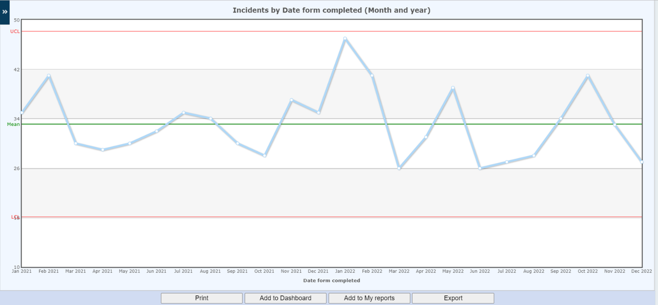
Figure 3 Breakdown of the total number of in scope deaths reviewed in 2022/23 by service area by financial quarter
Financial quarter - date reported | Barnsley General Community Services | Barnsley Community Mental Health Services | Calderdale Community Mental Health Services | Kirklees Community Mental Health Services | Wakefield Community Mental Health Services | Mental Health Inpatient Services | Forensic Services | Learning Disability & ADHD/Autism services | CAMHS Specialist Services | Total
22/23 Q1 | 1 | 10 | 10 | 13 | 19 | 7 | 0 | 8 | 0 | 68
22/23 Q2 | 5 | 7 | 9 | 10 | 18 | 4 | 0 | 3 | 1 | 57
22/23 Q3 | 5 | 5 | 5 | 16 | 19 | 2 | 0 | 8 | 0 | 60
22/23 Q4
Total | 11 | 22 | 24 | 39 | 56 | 13 | 0 | 19 | 1 | 185

The death of any patient with a Learning Disability has to be reported to the Learning Disability Mortality Review Programme (LeDeR). It should be noted that the figures may not tally with the figures above. This is because we identify Learning Disability not just through the reporting team, but by a field on Datix to determine if any patient who died had a learning disability irrespective of where they were cared for. Figure 3 above shows there were 11 deaths reported by Learning Disability teams (all community).

Figure 4 Summary of total number of all in scope deaths in 2022/23 by the mortality review process
Financial quarter - date reported | Level 1:  Certified | Level 2:  Case note review |  | Level 3:  Investigation
 | Death certified | Manager's 48-hour review | Structured Judgement Review | Learning Disability Mortality Review (LeDeR) | Serious Incident Investigation | Service Level Investigation | Significant Event Analysis (SEA) | Specialist Root Cause Analysis | Safeguarding review | Total
22/23 Q1 | 11 | 40 | 6 | 8 | 2 | 1 | 0 | 0 | 0 | 68
22/23 Q2 | 3 | 37 | 8 | 2 | 4 | 2 | 0 | 0 | 1 | 57
22/23 Q3 | 0 | 49 | 6 | 2 | 0 | 1 | 0 | 0 | 2 | 60
22/23 Q4
Total | 14 | 126 | 20 | 12 | 6 | 4 | 0 | 0 | 3 | 185
Figure 4 above shows the total number of all in scope deaths in 2022/23 to date. The numbers of deaths in scope for Q3 (n=60).
There was one Structured Judgement Review in Q2 which was also reported to LeDeR.
In line with national reporting of deaths, we are required to separate our reporting of in scope deaths into learning disability deaths and all other deaths.
Figure 5 below shows all deaths where the patient is recorded as not have a learning disability and what level of review was completed. All deaths reported have the Manager’s 48 hour review completed to ensure we have considered the care and treatment we have provided leading up to a death, although if there is another review process followed, this will be what is reported on.

Figure 5 does show a higher number of cases where the Manager’s 48 hour Review has been accepted as the Mortality review process than would be expected. On checking the data, a high proportion of the deaths have been Certified but this has not be captued in the data. A piece of work will be undertaken to address this to show those certified.

Figure 5 Summary of total number of in scope deaths in 2022/23 by the Review process (excluding Learning Disability deaths)
Financial quarter - date reported | Level 1:  Certified | Level 2:  Case note review |  | Level 3:  Investigation
 | Death certified | Manager's 48-hour review | Structured Judgment Review | Serious Incident Investigation | Service Level Investigation | Significant Event Analysis (SEA) | Specialist RCA | Safeguarding review | Total
22/23 Q1 | 11 | 40 | 6 | 2 | 1 | 0 | 0 | 0 | 60
22/23 Q2 | 3 | 34 | 7 | 4 | 2 | 0 | 0 | 1 | 51
22/23 Q3 | 0 | 42 | 6 | 0 | 1 | 0 | 0 | 2 | 51
22/23 Q4
Total | 14 | 116 | 19 | 6 | 4 | 0 | 0 | 3 | 162

Figure 6 below shows that the number of learning disability deaths and their status of being reported to the Learning Disability Review Programme (LeDeR). The 9 deaths pending reporting to LeDeR are being addressed, some of which relate to the death of people with a learning disability under the care of General Community services.

Figure 6 Summary of total number of Learning Disability deaths in 2022/23 which were in scope
Financial quarter - date reported | Reported to LeDeR | Reported to LeDeR by another organisation | Decision not to report on LeDeR | Pending reporting on LeDeR | Total
22/23 Q1 | 8 | 0 | 0 | 0 | 8
22/23 Q2 | 2 | 0 | 1 | 3 | 6
22/23 Q3 | 0 | 0 | 0 | 9 | 9
22/23 Q4
Total | 10 | 0 | 1 | 12 | 23

Figure 7 below shows that over the year 2022/23 to date, there were 17 inpatient deaths reported. There were no inpatient deaths relating to Learning Disability Services.

Figure 7 Trust wide Inpatient deaths in 2022/23 by date reported
BDU | Ward | Financial quarter - date reported |  |  |  | Total
 |  | Q1 22/23 | Q2 22/23 | Q3 22/23 | Q4 22/23
Mental Health Inpatient Services | Ashdale Ward | 0 | 0 | 1 |  | 1
 | Poplars Unit, Wakefield | 1 | 0 | 1 |  | 2
 | Beechdale Ward, The Dales Unit | 2 | 1 | 0 |  | 3
 | Crofton Ward (OPS), Wakefield | 2 | 2 | 0 |  | 4
 | Willow Ward - Barnsley | 1 | 0 | 0 |  | 1
 | Ward 19 (OPS) | 1 | 1 | 0 |  | 2
Barnsley General Services | Neuro Rehab Unit | 0 | 0 | 3 |  | 3
 | Stroke Unit | 0 | 0 | 1 |  | 1
Total |  | 7 | 4 | 6 |  | 17

