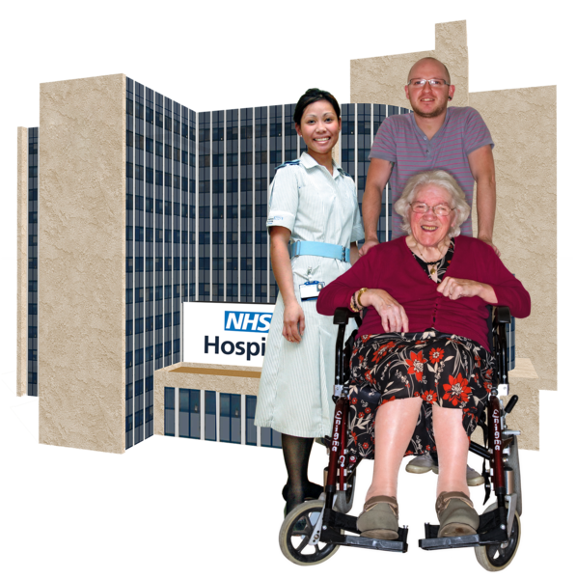

Changes to inpatient services for older people.
Information about our plans for dementia and mental health services.

About our plans
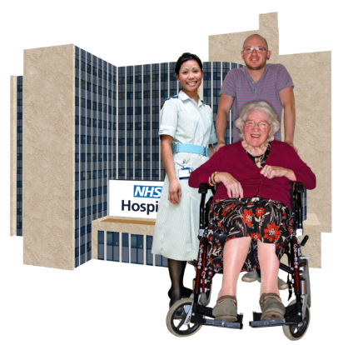
We want to create new specialist wards in hospitals, in Calderdale, Kirklees and Wakefield.

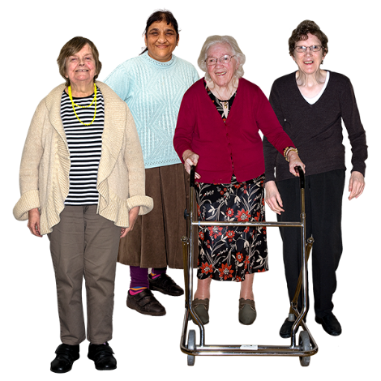
The wards will be for older people with:

- dementia
- mental health needs

How to tell us what you think:
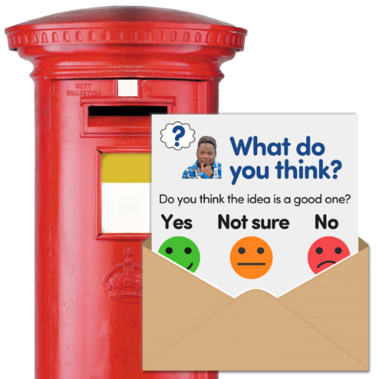
- You will need a survey
- You can get a copy of the survey online at: www.southwestyorkshire.nhs.uk/opsconsultation or by asking a member of staff
- Get help with taking part:
0800 587 2108

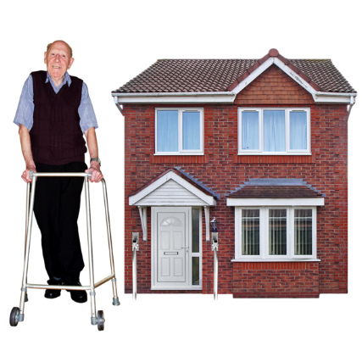
About our services

Most older people with dementia or a mental health need get care and support at home.
Examples of mental health needs include anxiety, depression or psychosis.

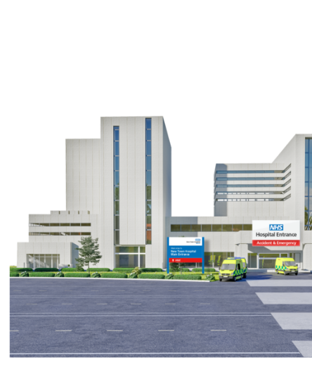
People need to stay in hospital when:
- their mental health gets worse, and they need more help from specialist staff
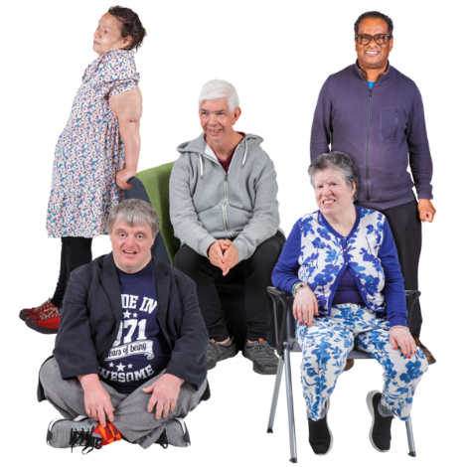
- they might hurt themselves or other people

People with dementia often stay on the same ward as people with mental health needs - mixed needs wards.
We have 5 older people’s mental health inpatient wards, in:
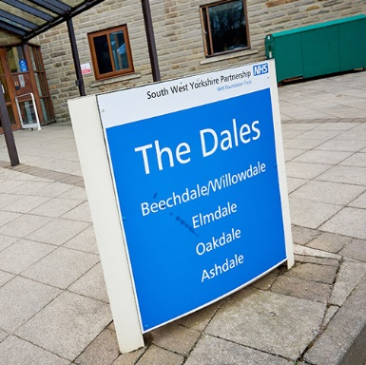
- The Dales, Calderdale Royal Hospital, Halifax
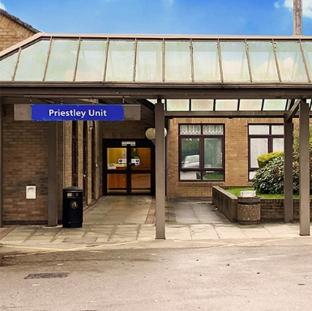

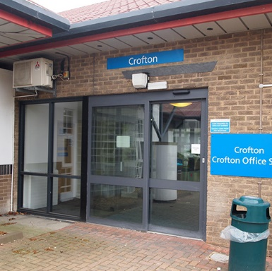
- Priestley Unit, Dewsbury and District Hospital

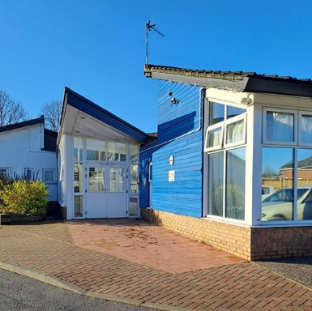
- The Crofton Ward, Fieldhead Hospital, Wakefield
- The Poplars, Hemsworth, Wakefield

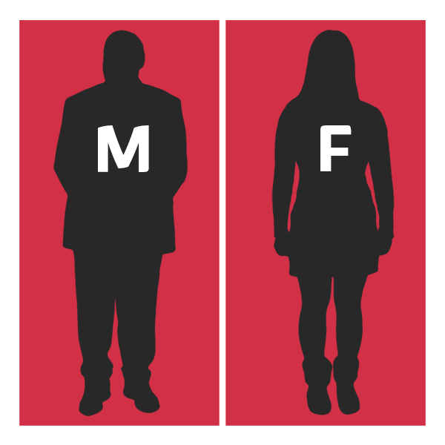

Many of these wards are for people with dementia, people with mental health needs, and both sexes, staying together.

Reasons for change
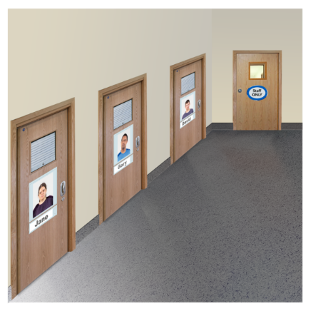
We want to create new, separate wards for people with:
- dementia
- mental health needs

Separate, specialist wards can:
- improve care and wellbeing
- be a better experience for inpatients, carers, families and staff
- create more space for therapies
Mixed needs wards are not ideal because:
- people’s needs can be very different
- activities do not suit all patients
- wards do not help patients to be independent
- accidents, disagreements and other incidents are more likely to happen

Our ideas
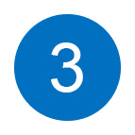
We have 3 options for where older people’s mental health inpatient wards could be.

The options do not include The Poplars Ward, in Hemsworth, Wakefield.

Where services could be
a
Option 1a

Dementia service
30 beds, in 2 separate male and female wards at Dewsbury and district hospital.

Mental health services
42 beds:
- 26 beds, in 2 separate male and female wards, at Fieldhead Hospital, Wakefield

- 16 beds, in a mixed male and female ward, at Calderdale Royal Hospital

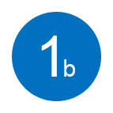
Option 1b
Dementia service
30 beds, in 2 separate male and female wards at Dewsbury and district hospital.

Mental health services
38 beds:
b
b
- 22 beds, in a mixed male and female ward, at Fieldhead Hospital, Wakefield
- 16 beds, in a mixed male and female ward, at Calderdale Royal Hospital

Option 2

Dementia service
26 beds, in 2 separate male and female wards at Fieldhead Hospital, Wakefield

Mental health services

46 beds:
- 30 beds in 2 separate male and female wards at Dewsbury and district hospital
- 16 beds in a mixed male and female ward, at Calderdale Royal Hospital

The cost of our ideas

Option 1a
- 72 beds
- £8.2 million to set up
- £9.1 million each year to run
Option 1b
- 68 beds
- £5.5 million to set up
- £8.2 million each year to run
Option 2:
- 72 beds
- £8.2 million to set up
- £9.3 million to each year to run

Good things about the changes
- Better working conditions for staff: more support, training and time to spend with patients
- Better care, treatment and activities, leading to shorter stays
- People are less likely to have to move from one ward to another during their stay
- We will be able to support people to be more independent

Travelling to and from hospital
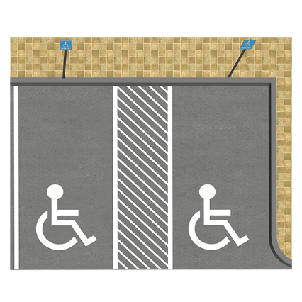
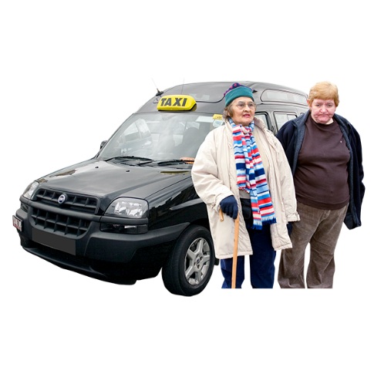
The changes may affect travel, transport and parking.
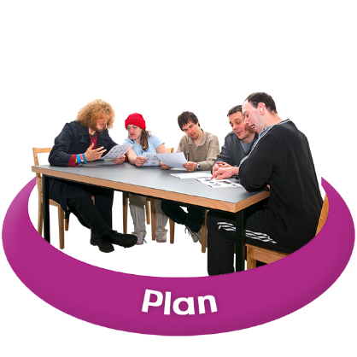
We want to understand more about how people get to and from our services.

This will help us to plan how to support families, carers and visitors.
We think the changes will help the environment, but we know that some people may need to travel further to our wards.

Find out more

Visit our website for:
- a full consultation document
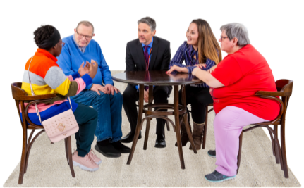
- consultation information in other formats, including video, and text only webpages
- information about how to have your say using events and community groups
www.southwestyorkshire.nhs.uk/
opsconsultation

