



Chief People Officer

Candidate information pack 2026



Contents

Candidate information pack 2026 1
Welcome from Mark Brooks, Chief Executive 3
About us 4
Our purpose 5
Our values 5
Our strategy 5
Our services 6
Vacancy 8
Chief People Officer 8
Job Description 9
Person Specification 13
Recruitment timetable 15
How to apply 15

Welcome from Mark Brooks, Chief Executive

Dear candidate,

Thank you for your interest in the position of Chief People Officer at South West Yorkshire Partnership Teaching NHS Foundation Trust.
As a Trust, we are in a strong position as a specialist provider of mental health and learning disability & autism and community services to the 1.22m people of Barnsley, Calderdale, Kirklees and Wakefield. Most of the care we provide is delivered in local communities by our 5,300 staff and our annual income of £360m. We are the lead provider for low and medium secure forensic mental health care to people across South and West Yorkshire and deliver specialist mental health support into Wetherby Young Offenders’ Institution. We also recently took over management of Cheswold Park Hospital in Doncaster, an adult secure mental health unit.
We are a high performing organisation with over 87% of services assessed by the CQC rated as ‘Good’ or ‘Outstanding’. We have a significant role to play in both the West Yorkshire and South Yorkshire Integrated Care Systems (ICS), working with partners to integrate health and care services to meet the needs of our diverse populations.
At our Trust we are driven by our values, and our aim to help people live well in their communities. We put people first and provide true person-centred care. We have a commitment to continual improvement, with an aim to be outstanding in what we do. Our ambitious programme of transformation and improvement reflects the challenging times in which we operate; will help to transform the lives of those who use our services; and brings real benefits to the communities we serve.

I trust the information in this pack will give you a flavour of our organisation, our values and our priorities. If you share our ambition for success and can offer the commitment needed, please see details within this pack regarding how to apply for the role. Prospective candidates wishing to discuss the role informally may use the details in this pack to arrange a discussion with me.

I wish you the very best in your application.



Mark Brooks
Chief Executive

About us

Background

We are a Teaching NHS Foundation Trust that provides community, mental health, wellbeing and learning disability services to the people of Barnsley, Calderdale, Kirklees and Wakefield. We also provide medium secure (forensic) services to the whole of West Yorkshire, and in South Yorkshire through our management of Cheswold Park Hospital.

Over 1.22 million people live in the communities of Barnsley, Calderdale, Kirklees and Wakefield from a range of diverse backgrounds. We aim to match communities’ needs by providing personalised care that puts the person first and in the centre.

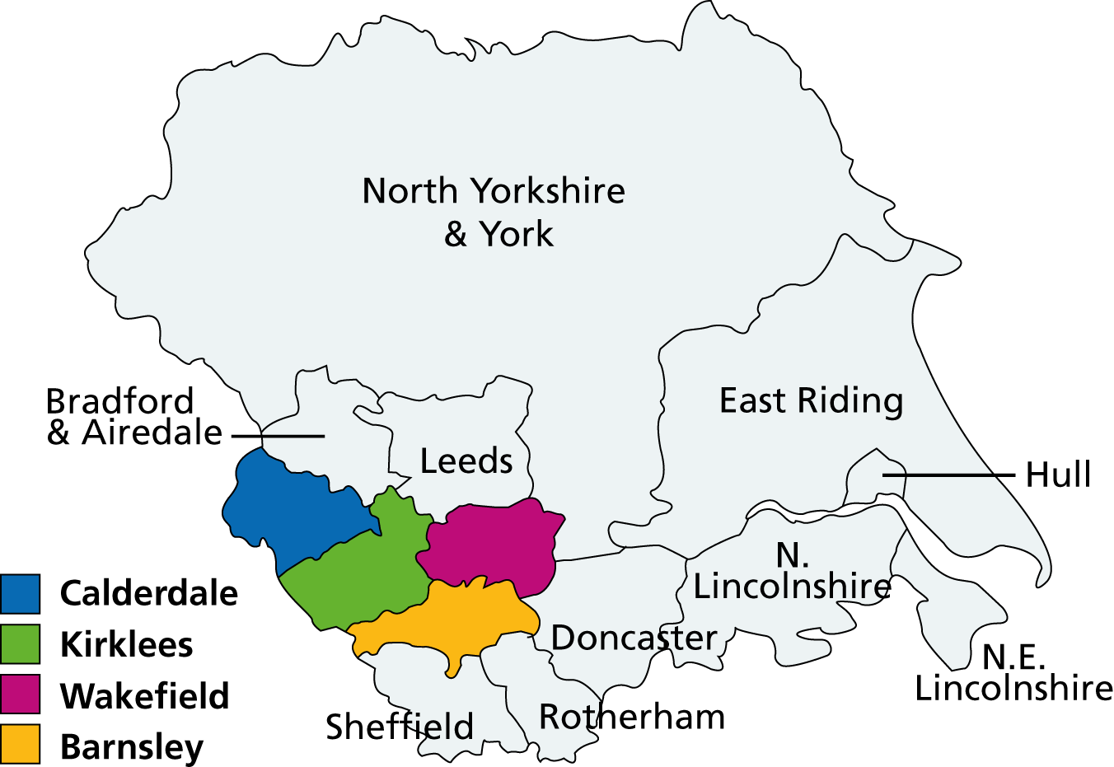

We work with other local NHS organisations, local authorities, government departments and voluntary and community organisations to provide high quality health care to people in our area. Working in partnership is very important to us as it enables us and our partners to provide more efficient, streamlined care that truly meets the needs of local people.

Working in partnership also means working with the members of our foundation trust, who can have a say in how we run the Trust and how they wish our services to be developed. Over 9,000 local people have joined us as members and our staff are members too.

We are committed to joining up care wherever possible. We are an integral partner in the West Yorkshire Integrated Care System, and a leading partner in the West Yorkshire Mental Health, Learning Disability and Autism Collaborative. We are also an active member of the South Yorkshire Integrated Care System, driving forward collaborative working with our partners.

We’re fully involved in alliances in each place we work across Barnsley, Calderdale, Kirklees and Wakefield, working with colleagues in a whole range of partner organisations.

To provide the flexible, individually tailored care that local people have told us they want, we work from a variety of sites as well as with people in their own homes. Over 90% of our services are community-based and are well supported by inpatient services for when people need care or assessment in a hospital setting.

The Trust, which was first established in 2002, now employs around 5,300 staff, in both clinical and non-clinical support services, and has a turnover of over £360 million.

Our purpose

We help people reach their potential and live well in their community.

Our values

- We put the person first and in the centre.
- We know that families and carers matter.
- We are respectful, honest, open and transparent.
- We improve and aim to be outstanding.
- We are relevant today and ready for tomorrow.

Our strategy

Our strategy is our medium to long term plan that describes what we are going to do in the future, and helps all of us, collectively, to understand what we want to achieve and how we will do it. It focuses on our purpose, ambitions and goals, always led by our values and behaviours.

We recently updated our Trust strategy, following an extensive engagement process with our staff, service users, carers, partners and local communities. We called this our ‘All of us conversation’, linked to our Trust moto – ‘with all of us in mind’. We heard from over 1,500 people from our local communities, almost a quarter of our workforce, and all our partners were involved. This ensured everyone had a voice, that they could be heard and responded to, and that their views were incorporated into the final strategy we developed.

As a result of the strategy review, we developed the following strategic aims:
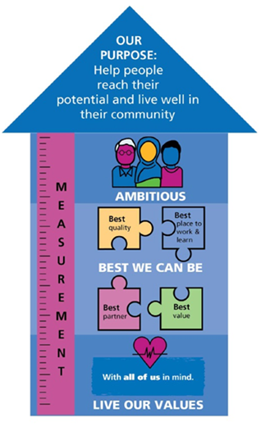
- We will live our values.

- We will be the best we can be:
  - Best quality
  - Best place to work and learn
  - Best partner
  - Best value

- We will be ambitious for our service users and local communities.
Our strategy is our clear plan of what we want to achieve, and how we will know if we have achieved what we set out to. We will review our impact and progress with our colleagues and those we serve. This means that year on year we will understand what we are getting right and where we can improve.

We are really clear that we are here to help people reach their potential and live well in their community. We will do this by living our values, being the best, we can be every day and being ambitious for our service users and colleagues on our journey to be outstanding for the people we serve. With all of us in mind.

You can read our strategy on our website, with a strategy on a page and an Easy Read version available too.

Our services

In Barnsley, Calderdale, Kirklees and Wakefield we provide care to:

- adults of working age (aged 18 to 65) with a mental health need;
- services to people as young as 14 experiencing the first signs of psychosis;
- child and adolescents who need mental health services;
- older people (over 65) with a mental health need;
- people (mainly adults) with a learning disability whose behaviour challenges services, with intensive support needs and/or a mental health need; and

In Barnsley we also provide:
- community physical health services;
- children's services;
- community rehabilitation;
- services for people with long-term conditions; and
- primary care and preventative services.

Across other areas:
- Yorkshire Smokefree services in Calderdale, Wakefield, Barnsley, Doncaster and Sheffield
- Adult medium and low secure services in West and South Yorkshire
- Specialist mental health support into Wetherby Young Offenders’ Institution
- Health support at Urban House in Wakefield

We are active partners in two Integrated Care Systems (ICSs):

- West Yorkshire ICS; and
- South Yorkshire ICS

and we play a key role in the place-based health and care partnerships in Barnsley, Calderdale, Kirklees and Wakefield.

A fuller description of our services can be found on our website at: http://www.southwestyorkshire.nhs.uk/our-services/.
Links to further information

How we’re run
Further information on how our organisation runs, including members, Members’ Council, and the Trust Board, can be found on our website at: How we're run - South West Yorkshire Partnership NHS Foundation Trust

Our constitution
Our constitution can be found on our website at:
Constitution and self-certification - South West Yorkshire Partnership NHS Foundation Trust

Annual report and accounts
Our annual report and accounts can be found on our website at: Annual Report and Quality Account - South West Yorkshire Partnership NHS Foundation Trust

Quality account
Our quality accounts can be found on our website at: Annual Report and Quality Account - South West Yorkshire Partnership NHS Foundation Trust

Creative Minds
Information on our Creative Minds approach can be found on our website at: About Us - South West Yorkshire Partnership NHS Foundation Trust

Care Quality Commission (CQC)
Further information on the Trust can be found on the Care Quality Commission (CQC) website (South West Yorkshire Partnership NHS Foundation Trust - Overview - Care Quality Commission).

Vacancy

Chief People Officer
Very Senior Manager (VSM)
Our purpose is to enable people to reach their potential and live well in their community.
Our people are at the heart of all that we do, as, without them, we will be unable to provide the services to our communities to the standard we aspire.

Our People Strategy is built on listening, learning and acting. We want every colleague to feel valued, supported and empowered, and we strive to achieve this through our three key aims:

1. Best Place to Work – Creating an inclusive, supportive, and empowering environment.
2. Best Place to Learn – Cultivating continuous learning, growth and development.
3. Living Our Values – Embedding our shared values into how we lead and collaborate.

We are seeking to appoint a permanent Chief People Officer to join an ambitious, values driven and well-established board of directors who want to make a difference and deliver our aim of providing outstanding physical, mental and social care in a modern health and social care system.

This vacancy comes at an exciting time for our Trust, having just achieved Teaching Trust status. We have a strong track record on learning and improvement, working with a range of learning providers. This will be strengthened further in our partnership with the University of Leeds to further advance our commitment to providing exceptional education, training and learning opportunities for all staff and students.

The successful candidate will bring with them the capability and enthusiasm to support our ambitious vision within the context of significant change, transformation and opportunity, both within the organisation, the region and the wider NHS. The successful candidate must also be able to demonstrate experience of working in or with large, complex organisations, and an ability to engage positively and collaboratively at all levels. They will also bring strong relationship management and influencing skills, have experience of making autonomous decisions, have a passion for delivering quality and excellence, and, importantly, embrace the values of the Trust.

As an executive director you will make a very significant contribution to the strategic leadership and direction of the Trust overall, whilst being responsible for providing strong professional leadership to the Trust’s People services.

You must have an excellent track record of success at director or at a senior level, together with experience of partnership working across complex systems. Added to this we want an exceptional and inspirational leader with a passion for delivering high quality care, continuous improvement, and a commitment to enhancing our strong reputation.

Reporting directly to the Chief Executive and a key member of the unitary Board, you will provide strategic leadership across all aspects of our People and Organisational Development agenda. You will drive workforce transformation and delivery, ensuring the Trust is future-ready and our people are supported to deliver exceptional care.

The closing date for applications is 12 noon Monday 9 March 2026 and an assessment centre is expected to take place on Monday 20 April 2026.

Job Description

Post: Chief People Officer

Accountable to: Chief Executive

Job summary

As a role model for the Trust’s vision and values, the Chief People Officer is responsible for the design, development and implementation of the Trust’s People Strategy and strategic workforce plans that support the Trust’s purpose, direction and objectives.

The postholder will advise the Trust Board and Chief Executive on complex national and local employment matters, policy decisions, strategies, and targets. This will include advising and ensuring compliance with the Trust’s statutory obligations as an employer and ensuring that the Trust has effective training and education structures and processes to support the delivery of safe, compassionate and modern services.

As an executive member of the unitary Trust Board and the Executive team, the postholder will be expected to support the development of an open, engaging and inclusive culture for service users and staff that encourages excellence in clinical practice, facilitates team working and multi-disciplinary delivery of care.

The Chief People Officer also plays a crucial role as a partner in each place and integrated care system the Trust operates.

Key Result Areas:

Executive Director responsibilities

- Contribute fully to the Trusts overall strategy, Board effectiveness, and achievement of strategic and financial objectives including leadership of wider workstreams to support financial sustainability alongside delivery on year-on-year efficiencies within the workforce function.

- Maintain Board-level oversight and accountability for all workforce, organisational development, and EDI matters.

- Lead executive director for the People and Remuneration Committee.

- Participate in the Executive Director on-call Rota.

- Maintain eligibility with Fit & Proper Persons Requirements.

Strategic HR

- To design and implement a ‘best in class’ People Strategy in collaboration with the Trust’s Board, colleagues and partners that sets ambitious yet deliverable high impact actions for people engagement, wellbeing, development and leadership across the Trust and supports the achievement of the Trust’s strategy.

- Lead delivery of the workforce aspects of the NHS 10-year plan, including the exploration and implementation of transformative and innovative workforce models in partnership with clinical and operational leaders.

- To support the Chief Executive and the Board to increase The Trust’s social value in our local communities, ensuring the Trust is an employer of choice, with a strong employer brand to attract, retain and develop a workforce that reflects the communities it serves and reduces inequalities.

- To provide high level advice and guidance to the Trust Board and Chief Executive on the workforce implications of national and local policies, plans, targets, and standards – for example the Fit and Proper Persons Test and Board competencies arising from the Kark Review

- To provide strategic leadership that enables meaningful staff voice and partnership working, to strengthen satisfaction, inclusion and a sense of belonging through effective social partnership arrangements with Staff Side organisations and staff networks.

- Lead strategic workforce transformation in the context of financial and workforce supply challenges, including responding to service design, digital and technology solutions by developing new workforce models and ways of working.

- Play a lead role in the development and implementation of workforce and people strategies and facilitate effective partnerships with other system providers and locality partners, to influence the people agenda, to contribute the development of joint working and integrated delivery of local NHS and community strategies.

- Play a key role in ensuring the Freedom to Speak Up Process, along with other systems and processes, is an embodied, positive approach that enables colleagues to raise concerns about patient safety or delivery of care.

Workforce Planning

- To lead the development of organisational workforce planning processes including the development of new roles, and service redesign which support the service strategy and link to financial plans and strategies as part of an integrated planning process.

- To ensure that the Trust’s annual and longer-term operational plans are supported by well- developed and consistent workforce plans.

- To work with the Chief Nurse and Medical Director to ensure appropriate pipelines of clinical talent, ensuring safe and effective services and to support future service models.

Talent Management and Succession Planning

- To develop and implement a talent management strategy that supports the Trust’s strategic direction and maximises organisational performance, supported by effective talent management and succession planning frameworks and processes that build organisational capability and promote equality, diversity and inclusion.

- To support the Chief Executive with the development of leadership and management structures, succession plans and talent pipelines for critical roles.

- Support the Chair and Chief Executive by leading the Board and senior leadership team development programmes.

Education and Learning

- Lead the Teaching and Learning strategy, ensuring excellence in clinical, managerial, and professional development.

- Strengthen leadership and management capability at all levels of the Trust through targeted training, development programmes, and interventions.

- To ensure that the Trust has effective plans and processes for the education, development, and training of all staff, including mandatory and statutory training, which supports the delivery of safe and effective services.

- To develop strong links within each place, provider collaborative, integrated care system and other key partner organisations to support the effective training, education, and future planning of a competent workforce.

Human Resource Management

- Provide professional leadership, vision, and direction for the Trust’s HR, EDI, OD, and Learning functions.
- To ensure that the Trust has evidence-based, inclusive Human Resource policies, procedures and guidance which: embody the Trust values and behaviours; embed openness, trust, psychological safety and continuous learning in all aspects of organisational and clinical practice; are trauma- informed; promote equality, inclusion and belonging; and ensure the Trust complies with statutory and regulatory requirements.

- Advise the Board on complex and highly sensitive employee relations issues.

- Support the Chief Medical Officer as lead for the medical Workforce function.

Organisational Development

- Direct the design and delivery of OD strategies and programmes that support the achievement of the Trust’s strategic goals to enable a compassionate, inclusive, culture aligned to NHS values and the People Promise.
- Ensure OD is central to workforce transformation, supports effective organisational change, staff wellbeing and engagement, and outstanding patient care.
Developing an open and transparent culture, focusing on quality improvement

- Champion equality, diversity and inclusion across the Trust, taking the executive lead role in: developing workforce equality and eliminating discrimination in our employment processes; and improving the experiences of colleagues who identify with a protected characteristic.

- Lead the development and implementation of transparent and fair policies and processes that allow staff to raise concerns about quality and safety that result in concerns being resolved.

- Lead the development of interventions and assessments that provide insights into the organisational culture and ensuring remedial action is taken when required.

- Amplify staff voice and involvement and ensure productive partnership working with staff networks and trade unions to enable all staff to play a part in the Trust’s decision-making processes.

- Champion the NHS staff survey and other staff opinion surveys, developing mechanisms for staff involvement and quality improvement.

- Responsible for the delivery of the workforce national equality and diversity requirement i.e. the WRES and WDES

Modern and effective People Services

- Lead the professional development of the Trust’s People professionals ensuring that standards are maintained and demonstrated in their practice.

- To ensure the Trust has effective and modern People Services, which are supported by appropriate policies, systems and processes.

- Ensure data-driven decision-making to identify trends, risks, and opportunities for organisational improvement through effective workforce information and People metrics.

- Ensure that the Trust maximises opportunities for digital transformation, automation, and modernisation of People Services to improve organisational performance and employee experience.
Employee Health and Wellbeing
- Ensure the Trust has a comprehensive and inclusive health and wellbeing offer.
- Ensure that leaders across the organisation role-model a compassionate, person-centred approach to colleague wellbeing, creating the conditions for a healthy, safe and supportive workplace.
- Embed a culture in which wellbeing is viewed as a collective leadership responsibility, with psychologically safe teams, fair and consistent practice, and data-informed actions that improve staff experience, reduce avoidable absence and enhance the overall health of the workforce.

Person Specification

ATTRIBUTES | CRITERIA | METHOD OF ASSESSMENT
QUALIFICATIONS | - Masters degree or further postgraduate professional qualification (or equivalent gained through experience) in a related subject.  - Evidence of continuous and proactive professional, leadership, and personal development.  - Chartered CIPD either as Member or Fellow. | Application Form  Interview  Certificates
EXPERIENCE | Essential  - Previous, successful senior people and organisational development leadership experience at or just below Board level in a highly complex organisation.  - Substantial senior leadership experience in a complex healthcare, public service or other public-facing, regulated organisation.  - Proven experience of successfully leading service development or change management in a complex organisation.  - Experience in the development and delivery of transformational OD interventions.  - Proven track record of successfully building, leading and managing high-performing, multi-disciplinary teams.  - Substantial experience of effective budget management, managing significant size budgets across multiple services.  - Proven experience of successfully working in partnership both internally and with external partners and stakeholders.  - Proven experience of promoting and delivering equality, diversity and inclusion.  Desirable  - Experience of successful system leadership or across multiple or multi-site organisations.  - Experience of working with partners to develop or lead shared service models. | Application Form  Interview
SPECIAL KNOWLEDGE / SKILLS | - Able to successfully lead transformational change and organizational development.  - In depth knowledge and understanding of: the NHS Long Term Plan; oversight and regulatory frameworks; the NHS People Promise; and key national people issues.  - Excellent written and oral communication skills to: articulate their vision clearly and credibly; explain often complex information clearly to a range of audiences; and to successfully engage and influence stakeholders across a range of communication channels.  - Able to create and sustain effective, collaborative partnership relationships with a range of stakeholders.  - Ability to make sound judgements in the face of competing priorities and complex scenarios.  - Robust analytical skills, assimilating and using complex data to make data-driven decisions.  - Able to inspire, motivate, and lead others at all levels.  - Able to work effectively as part of unified executive team and a unitary Board.  - Able to establish and maintain professional credibility amongst peers and with key stakeholders.  Desirable  - Sound knowledge of NHS regulatory frameworks.  - Understanding of different environments in which the Trust operates - ability to assess opportunities for innovation, revenue generation, partnership and enhanced care | Application form  Test  Interview
PERSONAL ATTRIBUTES | - Acts as a role model for NHS and Trust values.  - Compassionate leader  - Acts with integrity, honesty and self-awareness.  - Visible and approachable.  - Demonstrates a commitment to continuous improvement.  - Able to travel to Trust sites as required. | Application form  Interview

If a candidate is concerned that a person specification may prevent or restrict their application for employment on the grounds of their sex, race, age, sexual orientation, religion/belief or disability they should initially contact the Appointing Officer or the Trust’s Human Resources department. The Trust will seek to resolve this issue wherever possible.

Recruitment timetable

Action | Date
Closing date for applications | 12 noon Monday 9 March 2026
Shortlisting meeting (following longlist) | Week commencing 16 March 2026
Notify candidates | By 23 March 2026
Online Psychometric Assessment | In advance of assessment day
Assessment day | Monday 20 April 2026

How to apply

Closing date: 12 noon Monday 9 March 2026

Before you apply, please ensure that you have read the Job Description in detail. Your supporting statements must be aligned to the criteria outlined in the Person Specification.

Informal Discussion

If you would like to discuss the role informally and confidentially with the chief executive, chair or current post holder please email jane.barrett@swyt.nhs.uk.

Please note that candidates must ensure that they meet the essential criteria before arranging an informal discussion.

