

Quality account


2025 – 26

Contents
Part one: Welcome to the quality account iv
1.1. Welcome to the South West Yorkshire Partnership Teaching NHS Foundation Trust quality account for 2025/26 iv
1.2. Chief executive and chair’s welcome v
1.3. Statement of assurance vi
1.4. Patient story 8
1.5. About our Trust 9
1.6. Trust strategy 2024-2030 10
1.7. Clinical strategy 13
1.8. Equality, diversity and inclusion (EDI) strategy 15
1.9. Quality foundations 16
1.10 Achieving recognition and celebrating excellence 20
1.11 Our quality achievement headlines for 2025/26 21
Part Two: Priorities for improvement 23
2.1 Quality improvement 23
2.2 Quality governance and oversight 30
2.3 Best quality – progress against the priority areas 31
Part three: Other information on quality performance 51
3.1. Key national indicators 51
3.2. Statements of assurance from the Board 51
3.3. Participation in clinical audits and national confidential enquiries 51
3.4. Participation in clinical research 54
3.5. Care Quality Commission (CQC) 55
3.6. NHS number and general medical practice code validity 56
3.7. Data security and protection toolkit 56
3.8. Clinical coding accuracy 57
3.9. Quality of data 57
3.10. Learning from deaths 58
3.11. Reporting against core indicators 61
Appendix 1: Glossary 69
Appendix 2: Statements from our stakeholders 71

Part one: Welcome to the quality account

Welcome to the South West Yorkshire Partnership Teaching NHS Foundation Trust quality account for 2025/26
All providers of NHS care are required to produce an annual quality account, showcasing the work undertaken during the year to continuously improve the quality of our services and the care we provide. We are proud to be able to share the excellent work that our staff, patients and carers have achieved throughout the year and our priorities for the coming 12 months.
This document is divided into three sections:
Part one: Includes a welcome from our chief executive, Mark Brooks, and then provides an overview of South West Yorkshire Partnership Teaching NHS Foundation Trust, our Trust strategy and the foundations which underpin quality across our services.
This section also contains a patient story and a showcase of our successes throughout 2025/26.
Part two: Outlines the progress we have made during 2025/26, in relation to our quality priorities. This includes some showcase items where improvements in quality and care have been made. We discuss our achievements and set out our objectives for 2026/27 and beyond.
Part three: Includes a report on key national indicator set out by NHS England and shares our performance in relation to other indicators which are monitored by the Trust Board.
We also share comments from our key stakeholders in relation to the quality account. These can be found within the appendices.

Chief executive and chair’s welcome
Welcome to our 2025/26 quality account. We are pleased to introduce this reflection of our services outlining our performance and priorities for improvement.
Our patients and service users need us to provide the very best services that we can, when they need them, and in a way that makes them feel included. For us to achieve this, it’s essential that we have a clear, coherent strategic direction, and that we have a thorough understanding of our external environment and internal capabilities.
Last year the government introduced a new way to rate NHS trusts using a performance dashboard. Based on a range of performance metrics, each trust is placed into one of four core segments. Segment 1 represents the organisations with the least challenges, while segment 4 contains those with the most. This means that being given a rating of one is the best a trust can achieve.
At the end of the first quarter of 2025, we were in segmentation three. This was because of our financial position at the time. At the end of quarter two our segmentation improved to one, and we remain in segmentation one at the end of quarter four. We are now ranked fourth in the country, out of a total of 61 comparable organisations. This reflects the amazing work we do every day to deliver exceptional services and help the people and communities we serve. It also recognises all we have done to help manage our budgets effectively and provide value for money.
Achieving our rating took drive and determination from everyone, and to retain this rating has taken a continuing effort. This is thanks to our colleagues’ unwavering commitment to our improvement journey.
Over the past two years we have been working more closely to formalise our partnership with the University of Leeds with regards to student education and research and development. Building on our existing Associated Teaching Trust agreement, in 2025 the University of Leeds approved our application to become a Teaching Trust.
We are excited to continue our journey together to further create innovative opportunities in teaching, learning, and research, and to embed evidence-based practice. The partnership is one of the very few nationally where Teaching Trust status has been achieved by a trust that provides not only community services but also mental health, learning disability, and autism services. This demonstrates our collective commitment to parity of esteem for physical and mental health.
We formally launched our new name, South West Yorkshire Partnership Teaching NHS Foundation Trust, at our 2025 annual members’ meeting held on 17 September 2025.
On 1 October 2024, services at Cheswold Park Hospital (CPH) transferred to the Trust. This transition was enabled through external funding provided by NHS England.
In the months leading up to the transfer, the Trust established a dedicated programme team to develop and implement a structured plan to align the hospital with NHS ways of working, including the adoption of NHS systems, governance arrangements, and organisational policies.
In June 2025, NHS England removed Cheswold Park Hospital from enhanced monitoring. This decision reflects NHS England’s assurance that the Trust has the appropriate leadership, workforce, systems, and policies in place to deliver high-quality, safe care for patients.
The NHS is built on a founding principle of equality and social justice. We all share a commitment to fostering an inclusive, respectful and professional environment for colleagues, service users, carers and visitors. Through our equality, diversity and inclusion work, we continue to strengthen our efforts to prevent, challenge and address racism and abuse, ensuring everyone feels heard, valued and supported. Creating a safe and inclusive workplace is essential for the wellbeing of our teams and the quality of care we provide.
As part of our continued commitment to being trauma-informed and responsive, we have an ambition to become a staff-led zero prone restraint organisation. This initiative reflects our shared dedication to enhancing both service user and staff experiences, fostering a culture of safety, dignity, and compassion across all care settings.
In 2025, the Trust was recognised as one of the top five mental health trusts in the country for supporting privacy, dignity and wellbeing in care. The results were published as part of NHS England’s Patient-Led Assessments of the Care Environment (PLACE) programme.
PLACE (Patient-Led Assessments of the Care Environment) assesses a range of non-clinical aspects of healthcare premises that are identified by patients and the public as being important to their experience of care. As part of this assessment, patients and staff score trusts on the extent to which privacy and dignity are supported within care environments.
Our Trust achieved a score of 99%, representing an improvement from 97% in 2023, and demonstrating our continued commitment to providing environments that respect and promote patient privacy and dignity.
The financial position across the NHS remains challenging, and our Trust is not immune to these pressures. However, through the hard work, commitment, and professionalism of our staff, we have successfully delivered our financial plan while continuing to maintain and improve the quality of care we provide.
We are unequivocal that safety will never be compromised. Our values underpin everything we do, and during times of financial challenge they become even more important. Our leadership approach and the decisions we take are firmly grounded in these values.
We remain true to our purpose: to help people reach their potential and live well within their communities. This commitment continues to guide our priorities and actions, even in the most demanding circumstances.

Statement of assurance
This quality report has been prepared in line with the requirements of the NHS Act 2009, regulations of the Health and Social Care Bill 2012 and NHS Improvement, the independent regulator of foundation trusts.
The Board of Directors has reviewed the quality report and to the best of our knowledge, we confirm that the information contained in this report is an accurate account of our performance and represents a balanced view of the quality of services provided by the Trust.

 Chief executive: Mark Brooks
 Chair: Jayne Brown 

Patient story
I have spent most of my life living with constant physical discomfort, exhaustion, sleep deprivation, malnutrition, pain, suicidal thoughts and anxiety. For many years, these symptoms were put down to depression, or I was investigated for physical conditions such as Cushing’s disease or thyroid problems. I knew that I did not have depression but as the physical tests were always clear, doctors insisted that I was depressed and prescribed anxiety medication that I refused to take. Due to a change of jobs I incidentally learnt about autism and my profile seemed to fit. I completed several self assessments; after 2 years of consideration and a period of intense exhaustion, I spoke with my GP, and he referred me to the adult autism service. I was reassured that it formed part of a wider service, which I felt would help reduce the chance of a misdiagnosis.
The diagnostic process was intense and tiring. I worried about the unknown: the chair I would have to sit on (some fabric, for example on buses, is painful to sit on), whether the paperwork (that forced me to engage on a personal level with family) might get lost, the strong smell in the Manygates car park and whether it would follow me into the clinic room. I did not want an autism diagnosis as there is no ‘cure’ and I worried that if I was autistic, how could I possibly manage another forty years living with this level of discomfort and exhaustion. I hoped it would be something else with a cure.
Although the process was challenging for me the professionalism of the team made it accessible, the receptionist was kind and answered my questions with patience, she was empathic without being patronising; this gave me the confidence to attend the first appointment. The service was clear, logical, and structured, which helped me engage. The first clinician I spoke to actively listened with an open mind in a way I had never experienced before. That alone meant more than I can say and was therapeutic in its own right; normally, sharing that type of personal experience results in being dismissed.
The Manygates building comes with physical challenges which were visual, auditory, and scent related. The formal task-based assessment requiring imaginative, storytelling and communication skills was so draining that I felt so tired when driving home. To this day I have no idea how a number of children’s games can be so overwhelming. The wait between the final session and receiving the diagnosis felt very long but enabled processing time.
When I received my diagnosis in a face‑to‑face meeting, it was unsettling but opened the door to support I desperately needed. The clinician took time to explain what help was available, which reassured me. The diagnosis process was detailed and comprehensive, which I needed to enable confidence in the findings; it took a number of months to really believe that I was autistic.
Afterwards, I received communication sessions and home‑based support from an occupational therapist. She supported me with practical strategies at home, helped me understand myself more clearly, and encouraged me to be kinder to myself. These interventions have been truly life‑changing. My sensory assessment was particularly important; I have learned that sensory needs aren’t always obvious and I do not have the ability to identify my needs or emotions independently. Having a formal sensory profile with the sensory diet I follow has genuinely saved my life. I no longer have suicidal thoughts as I am comfortable; over 40 years of constant pain has gone.
The communication course was eye opening helped me understand other people better. The diagnosis gave me confidence to be openly autistic in the workplace and seek formal reasonable adjustments.

My experience of the autism service has transformed my life. From a continuous improvement perspective there are some small changes that could make things even better.
Differences in clinician training can lead to very different experiences, so I strongly encourage wider use of Oliver McGowan training - it is very clear when staff have not completed it.
- Routine sensory profiling with sensory diets designed for autistic adults
- Simple post‑assessment support to help people recover from the exhaustion of appointments
- Specific interventions addressing interoception
- Linking training and service outcomes to national quality assurance processes, so care is consistent everywhere in the country
My life has been difficult at times, but thanks to the support I received, I can ensure that my needs are met, I stay safe and can manage wider family relationships better. I have had less physical accidents, trips and falls, have significantly more energy, an improved diet and rarely feel physical discomfort and pain.
Finally, I wanted to say a massive thank you to the team of professionals that I have met and the staff in the background that have ensured a comprehensive quality service.

About our Trust
We are a specialist Teaching NHS Foundation Trust that provides community, mental health and learning disability services to the people of Barnsley, Calderdale, Kirklees and Wakefield. We also provide some medium secure (forensic) services to the whole of Yorkshire and the Humber.
We exist to help people reach their potential and live well in their community. Our organisation provides services that promote healthier communities and prevention through supported self-care, recovery focused approaches, peer support and community involvement, as well as volunteering and supported engagement. We are proud of our Recovery Colleges, three linked charities of Creative Minds, Spirit in Mind, and the Mental Health Museum, our volunteering services, and Altogether Better (a national organisation that is hosted by the Trust) further contribute to this.
We have almost 5,000 colleagues, in both clinical and non-clinical support services, working hard every day to make a difference to the lives of service users, their families and carers.
According to the latest census data 2021, the Trust serve 1.237 million people living across South and West Yorkshire. The Trust also has services and colleagues in North Leeds, Sheffield, Doncaster, and Rotherham. Most of the care we provide is delivered in local communities. This means we work in all the villages, towns, and cities, from Todmorden and Hebden Bridge in the west, to Castleford and Pontefract in the east, Hoyland and the Dearne Valley to the south of Barnsley.
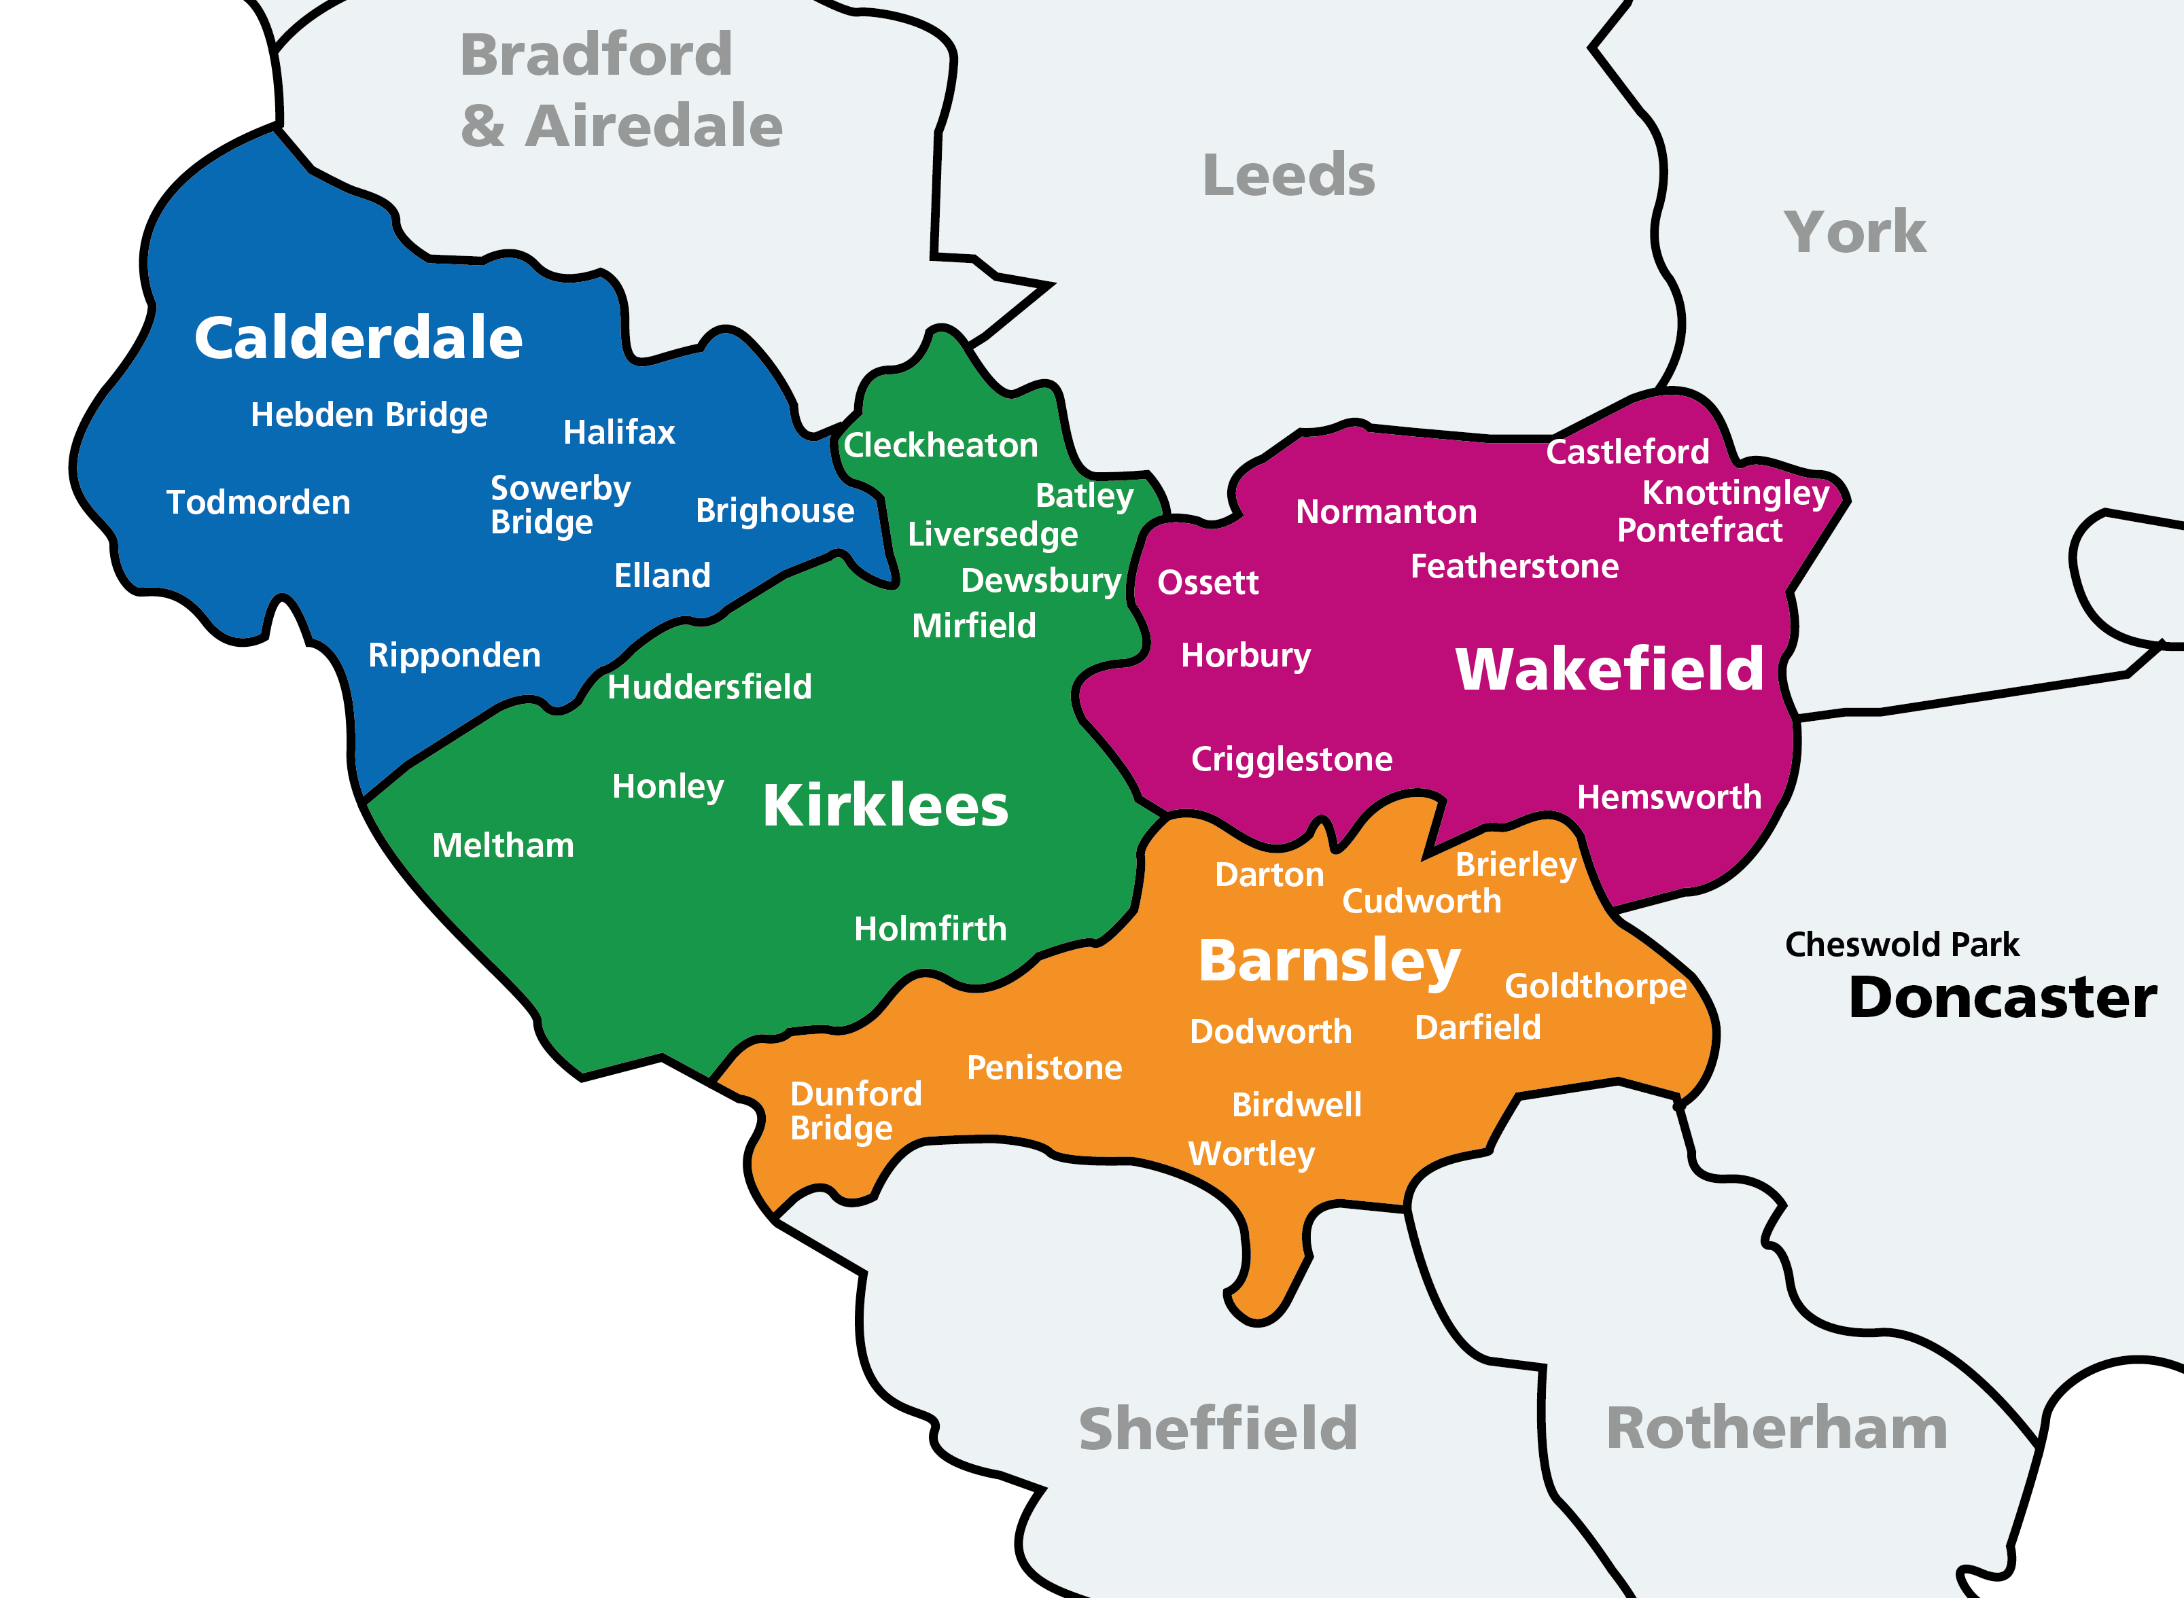
Our Trust provides a wide range of services across several communities. These services are commissioned by two separate ICBs and we work across five place-based partnerships:
- West Yorkshire Health and Care Partnership
  - Kirklees place
  - Calderdale place
  - Wakefield place
- South Yorkshire Integrated Care Partnership
  - Barnsley place
  - Doncaster place
Some of the Trust’s specialist services such as the forensic mental health services are commissioned under specialist commissioning which comes directly from NHS England.

Trust strategy 2024-2030
Our Trust strategy for 2024–2030 was approved by the Trust Board in October 2024. The strategy sets out our clear ambitions and priorities for the period to 2030 and describes how we will deliver our purpose as an organisation.
A summary of the strategy is illustrated in the infographic below.

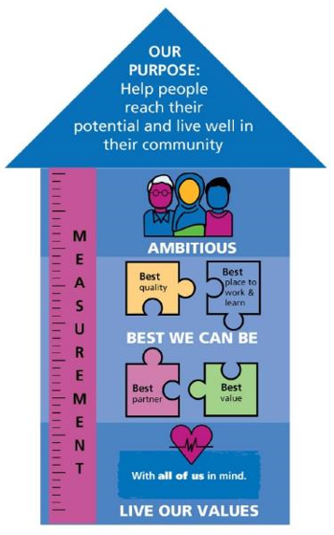
Our strategic aims:
- We will live our values
- We will be the best we can be
- We will be ambitious

Our purpose was developed through extensive co-creation with stakeholders and is to help people reach their potential and live well in their community.
Our strategy describes our role within neighbourhoods, communities, and places, setting out how we will work together and what we aim to achieve. As our overarching Trust strategy, it informs all other strategies and plans, providing clear direction and alignment. It brings clarity to our focus, priorities, and the actions we will take to deliver our purpose.
Our three strategic aims allow us to focus on specific areas where we can collectively make the greatest difference. These are:
- Strategic aim one: We will live our values
- Strategic aim two: We will be the best we can be
- Strategic aim three: We will be ambitious
For each strategic aim, and informed by evidence from our engagement and analysis, we have:
- Set out clear strategic objectives detailing what we will do
- Defined what success will look like and what we will see if we are getting it right
- Identified measurable indicators to track progress
This approach ensures a clear line of sight from our strategy through to delivery, supported by robust measures that enable us to assess progress and determine whether we are achieving what we set out to do.
Strategic aim two is particularly pertinent to this quality account, as it focuses on our commitment to delivering the highest standards of quality, safety, equity, and continuous improvement across all our services. The priorities and achievements set out in this quality account align directly with this strategic aim and demonstrate how we are delivering on our ambition to be the best we can be for the people we serve.

Strategic aim two: We will be the best we can be
Our second strategic aim is to be the best we can possibly be. We aim to do this every day and for every contact we have with those we serve and those colleagues we work with. For this strategic aim we have identified four best statements which we have used to theme our strategic objectives.

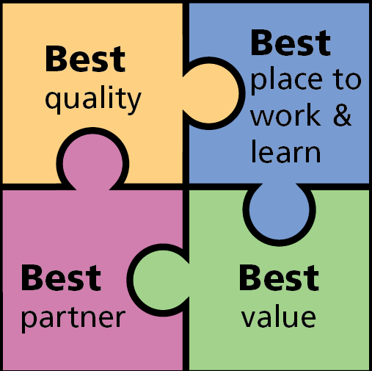

Best quality
To provide the best quality we can we have identified four strategic objectives. These are set out below. Within the strategy there are statements about how we will know if we are getting it right and examples of the measures and metrics we will use:
- We will ensure equitable access, experience and outcomes for all
- We will ensure our services are consistently safe, responsive, personalised and effective
- We will ensure continuous inclusive improvement is integral to developing and delivering creative and innovative services
- We will consistently address health inequalities across our services, ensuring we are inclusive and working to minimise the impact of deprivation

Priorities for 2026/27
We have developed our priorities for 2026/27 through our annual planning processes, aligning them closely to the Trust strategy. Our comprehensive bottom-up and top-down planning process has developed an ‘all of us’ annual plan that sets out what we will do, in line with our strategy. Our priorities for 2026/27 have been developed through our annual planning processes and are closely aligned with the Trust strategy. A comprehensive, integrated planning approach—bringing together both bottom-up and top-down input—has enabled us to develop an ‘all of us’ annual plan.
This plan clearly sets out what we will deliver during 2026/27 and how this will support the achievement of our strategic ambitions.

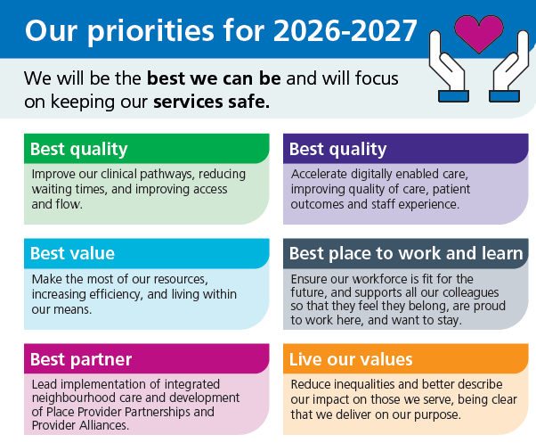
There are specific areas of quality improvement work that sit beneath these strategic improvement priorities. These focus on particular areas of concern identified through our analysis of available data, feedback, and intelligence.
Under the best quality priority, this will include examples such as:
- Responding to clinical demand, capacity, resources, patient flow
- Reducing length of stay in inpatient areas
- Productivity
- Undertaking evidence-based establishment reviews
- Continuing the focus on reducing restrictive practice
- Improving clinical record keeping
- Ensuring we continue to do all we can to provide mental health inpatient care close to a person’s home

Clinical strategy
The Trust’s inaugural clinical strategy was published in 2025 and sets out our ambitions for clinical services, including what we aim to achieve and how we will deliver this.
Since publication, we have worked collaboratively with key stakeholders to co-develop a comprehensive clinical strategy implementation plan. We continue to meet on a quarterly basis to oversee delivery and monitor progress against the agreed clinical priorities.
Strong facilitation with clinical leads has been a key enabler, and we are now building further momentum by strengthening alignment and support from our operational lead colleagues. All priorities remain on track for delivery within the timeframes identified.
Recent updates include, but are not limited to:

Co-production:
- Pharmacy-led pilot delivering seven-day discharge follow-ups in primary care
- Programme underway to strengthen the role and impact of allied health professionals (AHPs) within mental health inpatient units
Equality:
- Psychological professions are engaged in North East and Yorkshire (NEY) reciprocal mentoring scheme for aspiring leaders of the global majority. Continuing professional development (CPD) events aimed at health care support workers (HCSW) who have a psychology degree to ensure equity of access to experience and career progression
- Implementation of the deaf inclusivity project, including clinical tools and a business case for in-house British Sign Language (BSL) interpretation services
- First internationally educated professional nurse advocates (PNA) recruited and trained, with further in training
Learn:
- The research and development team organised a funding and networking seminar on 2nd June 2026
- Student-led placement piloted with higher education institute (HEI) partners to shape future research and leadership placement opportunities
- Bitesize learning sessions embedded into preceptorship forums, with plans for expanded study-day provision
Grow:
- Work has started on new pre-registration placement pathways with advanced practice colleagues
- Our chief allied health professional (AHP) is contributing to national-evidence gathering on safer AHP staffing in mental health wards
- Phase two of the community nursing safer staffing tool implemented in Barnsley neighbourhood rehabilitation service (NRS), with staff training planned
Lead:
- Development of enhanced trauma-informed clinical supervision training is underway
- PNA workforce has expanded to 42, with 21 more in training and plans to secure funding for additional training
Holistic:
- Development of a governed psychological therapies system and complex emotional needs pathway
- Psychological therapists added to older adult crisis teams to embed formulation and trauma-informed practice
- Leadership established for neuropsychological expertise development
- Preceptorship offer now fully multiprofessional, with forums open to assessed and supported year in employment (AYSE) social workers and trainee clinical psychologists

1.8. Equality, diversity and inclusion (EDI) strategy
In April 2025, our Trust Board agreed a new equality, diversity and inclusion (EDI) strategy. This new strategy was developed through extensive engagement, comprehensive analysis and clear alignment to our overall Trust strategy.
Our EDI strategy ensures that EVERYONE is supported to live well in their community. It describes how we will work to actively understand our communities and colleagues so that all of us reach our potential, identity does not predict outcome, and this is the best place to work and learn for everyone. Explicitly, the strategy sets out our EDI approach and plans for both our community of colleagues (our colleagues) and also the communities we serve (our public). An important part of the communities we serve are our service users, patients and carers.
The strategy contains six strategic aims.
1. Strengthen our approach to equality, inclusion and involvement
We will strengthen our approach and weave equality, inclusion and involvement through everything that we do, so it is easier to do the right thing.
2. Embrace equality
We will consistently address health inequalities across our services, ensuring we are inclusive and working to minimise the impact of deprivation and the wider determinants of health.
3. Recognise diversity
We will ensure we recognise and value diversity through the systematic collection and analysis of data (both numbers and voice) according to protected characteristics. We will use this to develop understanding and inform decision-making.
4. Deliver inclusivity
We will ensure inclusive practices with #allofusinmind so that our colleagues feel they belong, are proud to work here and want to stay.
5. Involvement
We will truly listen to all our communities and demonstrate the difference we make to those we serve.
6. Data and insight
We already have a range of metrics and measurement in place around the EDI agenda. Further work had been undertaken to clarify the measures to assess how well we are delivering against our aims and to identify where additional or different effort is required.
Examples of our progress and achievements
- Equality impact assessments (review)
A task and finish group has adopted a quality improvement-led approach to review and streamline the current tools and processes.

Drawing on recognised best practice from across the public sector, the group is identifying and testing solutions designed to strengthen assurance, improve compliance, and enhance equity across services, supporting the organisation to give due regard to its statutory equality duties under the Equality Act 2010.

Implementation activity remains on track, with current efforts focused on gathering and responding to feedback on the proposed tools.

Quality foundations
Alongside the Trust strategy and the supportive and enabling clinical strategy and EDI strategy, the Trust has a number of key areas that provide the foundations for the delivery of high-quality care.
1.9.1 Patient-Led Assessment of the Care Environment (PLACE)
Each year the Trust participates in the Patient-Led Assessment of the Care Environment (PLACE) assessments, which enables NHS patients to be involved reviewing the care environment. These assessments consider how the environment supports the provision of clinical care in areas such as privacy and dignity, food, cleanliness, general building maintenance and the extent to which the environment supports the care of people living with dementia or a disability. The assessments take place annually and help to drive improvements in the care environment.
All Trust wide inpatient wards (with the exception of Lyndhurst unit) are included in the PLACE audit and in 2025, Cheswold Park Hospital was assessed for the first time. In summary, the results for 2025 evidence the commitment and dedication of staff across the Trust and our estates and facilities colleagues working together to continue to achieve and maintain high standards of quality. In most areas the scores remain positive and well-maintained, providing assurance that the Trust represents good practice and is meeting the needs of patients in non-clinical aspects of healthcare. The full PLACE report for 2025 is available separately.
The Trust was revealed as one of the top five mental health trusts in the country for supporting privacy, dignity and wellbeing in care in the PLACE programme.
1.9.2 Infection prevention and control
Infection prevention and control (IPC) is essential to delivering safe, high-quality care. It protects patients, staff, and visitors from avoidable harm by reducing the risk of healthcare-associated infections. As required under the Health and Social Care Act, organisations must have robust IPC systems, policies, and procedures, making IPC a legal responsibility, not an optional activity.
Evidence-based IPC practices support therapeutic, recovery-focused mental health environments, where patients often share communal spaces and may have challenges engaging with their physical health needs. IPC is also a core element of the PLACE assessments, enabling service users to shape safer and cleaner care environments.
By embedding clear routines such as effective environmental cleaning, hand hygiene arrangements, and tailored risk assessment, IPC safeguards vulnerable individuals whose mental or physical health conditions may increase their susceptibility to infection.
IPC also contributes positively to organisational learning through incident review, advice on best practice and support to the physical health agenda, all of which can reduce patient safety incidents. It supports continuity of care by preventing ward closures, minimising service disruption and reducing staff sickness through surveillance of infection and outbreak management all of which directly impact safe delivery of services.
Strong IPC practice fosters trust, dignity, and confidence amongst patients and staff, reinforcing a culture of safety and compassion. In mental health settings, where holistic, person-centred care is essential, IPC is integral to protecting recovery, stability, and the overall high quality care experience.

1.9.3 Freedom to Speak Up (FTSU)
The Trust recognises the importance of creating an organisational culture where staff feel able and safe to raise concerns at work including issues relating to malpractice, patient and staff safety issues, harassment and bullying, and fraud. To support this, the Trust has a full-time Freedom to Speak Up Guardian (FTSUG), who is supported by two part-time guardians.

The FTSUG continues to proactively develop and promote a more open and transparent culture, supporting the organisational priority for staff to feel safe and encouraged to raise concerns appropriately. Freedom to Speak Up is a key element of organisational induction for all new starters and the FTSUG attends the Trust welcome event. FTSU training is available to all staff and line manager training incorporates freedom to speak up principles to support managers in embedding an open culture. A network of civility and respect champions also continues to provide signposting and support to staff.

In 2025/26 the Trust reviewed the NHS England Board-level FTSU reflection and planning tool, which was approved by Trust Board in November 2025. A new Freedom to Speak up action plan was subsequently established and is monitored through the Trust’s audit committee. The FTSU policy was also reviewed in 2025/26 in line with organisational requirements. A FTSU oversight group meets every six weeks to oversee the strategic delivery of FTSU across the Trust, and themes and learning from FTSU cases are shared at care group partnership meetings.

1.9.4 Patient and Carer Race Equality Framework (PCREF)
In our equality, diversity and inclusion (EDI) strategy, PCREF is identified as a key tool for delivery and for measuring a meaningful and sustainable progress towards greater participation and collaboration. This national framework sets the foundations for improvement in our work to actively involve our patients and carers in decision making, and to improve their access, experiences and outcomes. It acts as an anti-racism, race equity and accountability framework, supporting mental health trusts to demonstrate how they are meeting their core legislative requirements and how they can improve organisational cultural competence.
The aim of the PCREF programme is to improve access, experience and outcomes for our racialised and marginalised communities, including our workforce, by:
- Fostering closer working relationships with our racialised and marginalised communities to implement real-time and transparent feedback loops
- Ensuring ethnically and culturally diverse patients and carers are treated as equal partners in decision making on their care and treatment, and are actively involved in the design, development and review of care pathways
We have established this programme of work in the Trust. This includes the development of an external PCREF advisory group made up of members of our communities with lived experience, or those advocating on behalf of others through the voluntary, community and social enterprises (VCSE) sector. The group has rated the NHS England identified competencies from highest to lowest based on their perspectives and lived experience. This has enabled the co-production of our PCREF action plan.
The Trust has an agreed Anti-Racism Statement and aligns this within the aims of the PCREF programme to improve access, experience and outcomes for our racialised and marginalised communities, including our workforce by:
- On a day-to-day basis, we deliver our PCREF commitments through embedded approaches that shape care and culture across the organisation. This includes but isn’t exhaustively having a nominated Executive lead, and operational person with responsibility for driving the commitments within the Organisation
- A Quality Improvement methodology with inbuilt dashboards so that data in the form of both numbers and voice provide insight around focus and impact.
- Working towards person-centred care planning that reflects identity, culture and lived experience
- Learning from staff networks to inform policy and practice
- Adopting a proportionate approach to Equality Impact Assessments (EIA) that routinely consider the impact of decisions on racialised communities; and clear reporting, response and learning processes for racialised incidents, ensuring concerns are addressed and drive improvement.
We have also ensured that the work is aligned with other existing programmes, including Culture of Care, Mental Health Act, the Triangle of Care, and our anti-racism work.
1.9.5 Trauma-informed care
“Being trauma-informed is a duty of care for the whole organisation and requires a whole cultural change in how we operate. A trauma informed approach must be embraced in all aspects; as well as in direct therapeutic interventions, it should be integrated into leadership, estates services, human resources, research and strategic priorities.” (www.candi.nhs.uk, 2023)
Becoming a trauma-informed (TI) organisation is included in the Trust strategy and clinical strategy and we have ensured it is considered as part of annual planning processes. Employment policy reviews continue to be undertaken through a trauma-informed lens, alongside a focus on staff support and wellbeing, and alignment with the newly developed people plan.
The work continues in collaboration with partners across the system. For example, trauma-informed principles underpin the Wakefield district plan and the Trust’s clinical lead has contributed to the complex lives workstream.
Other examples of improving quality though engaging TI principles include:
- Colleagues in physical health have adapted ROOTS (a tool for assessing trauma informed maturity) to better meet service needs following feedback from colleagues in the neurological rehabilitation unit (NRU). This adapted version is about to be piloted by podiatry colleagues in Barnsley
- Ongoing delivery of trauma-informed training in response to service-specific requests, including child and adolescent mental health services (CAMHS) and older people’s services (OPS)
- Following review, trauma-informed training will continue to be introduced through staff induction and service-specific learning days using case-based examples, rather than as a standalone mandatory training module. This approach will be implemented as part of the wider mandatory training and learning reviews
- The principles have been thoughtfully considered as part of recent work on sexual safety across the Trust and will underpin evolving development around work focused on a women’s pathway
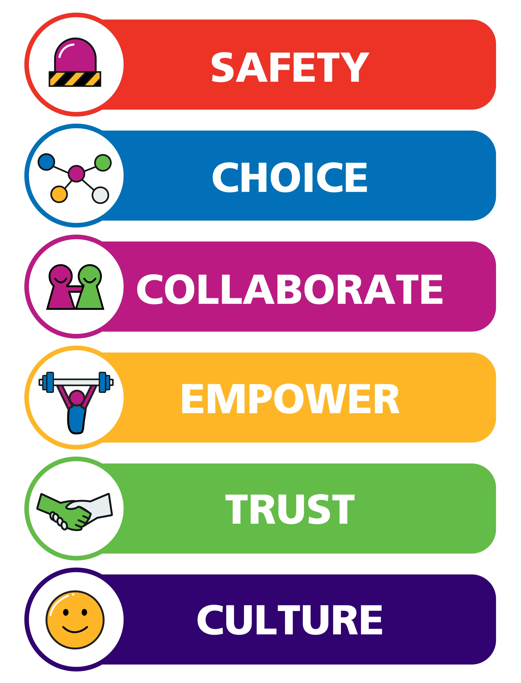
The drive to embed and connect TI practice with different agendas continues, with good progress to improve quality of service delivery for service users, carers and staff.
1.9.6 Quality assurance system (QAS) and quality walkarounds
The Trust quality assurance system (QAS) was launched formally in early 2025. This framework triangulates data, information and feedback to provide oversight of quality and culture across Trust services. It has been designed to provide the Trust with a robust system for monitoring and assuring the quality of services, and to identify risks early so that actions can be put in place.
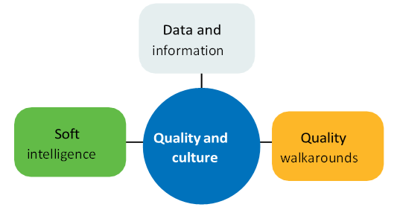
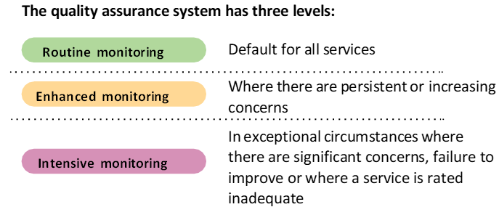
A key element of the QAS is a quality walkaround. This is a quality intervention that focuses on open and transparent communication. It enables service users, staff and others to work together to identify areas of excellent practice, where improvements are needed and overcome any barriers to these.
In 2025/26 there have been:

1.10 Achieving recognition and celebrating excellence
1.10.1 Teaching Trust status
In May 2025 the University of Leeds approved the Trust’s application to become a Teaching Trust.
The Trust and the University of Leeds already had a strong history of partnership working in relation to student education and research and development, and over the last two years have worked together to formalise the partnership.
This partnership is one of very few nationally in which Teaching Trust status has been achieved by a trust that provides not only community services but also mental health, learning disability and autism services.
Teaching Trust status enables the Trust to create innovative opportunities for teaching, learning, and research, and to embed evidence-based practice. The partnership with the University of Leeds will further enhance education, training, and learning opportunities for all staff and students.
1.10.2 Older people mental health team in Barnsley
The team has been re-accredited for a second consecutive cycle by the Royal College of Psychiatrists through the Accreditation for Community Mental Health Services (ACOMHS) programme, with accredited status confirmed until July 2028.
This re-accreditation provides independent assurance that the service continues to meet nationally recognised standards for quality, safety, multidisciplinary working, and patient-centred care.
1.10.3 Safety Incident Response Accreditation Network (SIRAN)
The Trust was awarded SIRAN accreditation by the Royal College of Psychiatrists. This accreditation demonstrates that robust processes and governance arrangements are in place to review safety incidents, identify learning, and implement improvements that reduce risk and enhance outcomes for patients and staff.
This is important because it provides independent assurance that patient safety is actively prioritised, learning from incidents is embedded into practice, and continuous improvement is central to how we deliver care.
1.10.4 British Journal of Learning Disabilities
As part of the national review of mental health legislation, the government commissioned NHS England to deliver a national quality improvement programme focused on improving equity of experience for people from ethnically diverse backgrounds, and for people with learning disabilities and autism.
With the support of our chief medical officer, Professor Subha Thiyagesh, alongside the senior leadership team at the Horizon assessment and treatment unit and colleagues from legal services, the Trust undertook a significant piece of work exploring the use of advance choice documents (ACDs) for people with learning disabilities admitted to Horizon under the Mental Health Act.
This work examined how ACDs can support greater involvement, autonomy, and person-centred decision-making for this population. The findings have been peer-reviewed and published in the British Journal of Learning Disabilities, demonstrating the Trust’s contribution to national learning and evidence-based improvement in mental health care.
1.10.5 Care and commitment to staff
On Thursday 1 May 2025, the Trust celebrated the care, dedication, and commitment of its staff through a special day of recognition. This included our learner and long service presentations, as well as our annual Excellence awards, recognising the outstanding contributions of colleagues across the organisation.
1.10.6 Research fellowship
Dr Estelle Verdi, principal counselling psychologist and service lead of the West Yorkshire Maternal Mental Health Service – Paths, was awarded a Medical Humanities in Practice Research Fellowship with the Institute for Medical Humanities (IMH) at Durham University.

1.11 Our quality achievement headlines for 2025/26
April | - Launch of the Patient and Carer Race Equality Framework  - SystmOne (patient record system) went live at Cheswold Park Hospital  - Quality assurance system (QAS) was launched across the Trust
May | - Trauma-informed celebration and learning event held, attended by 130 people  - Application to become a Teaching Trust was approved  - The Trust was revealed as one of the top five mental health providers in the country for supporting privacy, dignity and wellbeing in care  - Our first clinical audit showcase event was held, with a range of presentations and guest speakers
June | - Our third annual research, discovery and innovation conference was held  - Marked Clinical Audit Awareness Week (2-6 June), celebrating the benefits and impact of clinical audit and quality improvement work in healthcare  - Trust simulation suite opened in Barnsley, designed to enhance the skills of community-based NHS staff  - Celebrated Learning Disability Week with the theme ‘do you see me?’, which focused on challenging the barriers people with a learning disability face and celebrating the things they bring to society
July | - Celebrated 25 years of delivering smoking cessation services  - The all-age forensic community services hosted a stakeholder event which promoted the innovative forensic community offer  - Two catering managers represented the Trust in the NHS Chef of the Year regional heats  - Patients Know Best (PKB), a secure personal health record system, went live in the integrated neighbourhood teams SystmOne unit in early July
August | - A new wound care drop-in clinic opened in Barnsley  - The Trust engaged with the final two stages of the Culture of Care programme  - The caring garden at Fieldhead Hospital was shortlisted for an NHS Forest award
September | - Team members from Paths, our West Yorkshire maternal mental health service, attended an event at the Houses of Parliament to mark Black Maternal Mental Health week  - Our South Kirklees early intervention in psychosis team successfully delivered clozapine treatment in a community setting for the first time  - A caseload management tool for community mental health services was established to support services to deliver effective caseload management  - Barnsley musculoskeletal (MSK) community service successfully held their first community appointment day on 4 September, offering patients on the MSK waiting list faster access to personalised and holistic care  - We hosted our 2025 annual members meeting on 17 September, reflecting on our achievements from the year and looking ahead at our plans for the future
October | - Held our annual safeguarding conference, with a theme of sexual abuse and intrafamilial harm  - Opened a new Kirklees sensory integration assessment and therapy room at the learning disability resource centre in Fox View in Dewsbury  - Our Trustwide volunteer service created a co-production group for the lived experience community  - To mark Diwali, the Trust held a celebration in the wellbeing and learning centre at Fieldhead on Thursday 23 October. The event gave the opportunity for colleagues from all backgrounds to connect with each other and learn more about the festival of light
November | - On Carers Rights Day (20 November) we launched our new commitment to family, friends and carers  - Electronic prescribing and medication administration (EPMA) was successfully rolled out across all our intensive home-based treatment teams (IHBTT)  - We marked Occupational Therapy Week, celebrating colleagues and sharing stories, highlighting the impact and difference they make  - From 10-14 November, we recognised Psychological Professions Week by celebrating more than 400 psychological professions staff across our services and holding a continuing professional development event  - We launched the re-designed Trustwide clinical record keeping audit
December | - Held our annual connecting people celebration event, highlighting the importance of the diverse and reflective voice from our communities  - Launched our sexual safety programme for staff  - On 5 December, we held an event to celebrate the dedication and hard work of our staff taking part in a registered nurse degree apprenticeship in partnership with The Open University
January | - Reviewed our inpatient falls management flowchart to reflect recently updated NICE guidelines  - Our recovery colleges welcomed a delegation of guests from Hong Kong to support co-production, lived experience and peer support  - Colleagues from early intervention in psychosis services completed Maastricht interviewing to enable them to explore and understand service users’ voice-hearing experiences
February | - Supported Race Equality Week (2-8 February), with the theme #ChangeNeedsAllofUs emphasising that progress requires participation from everyone  - Marked National Apprenticeship Week and reflected that 434 colleagues have successfully completed programmes across 28 different apprenticeship standards since we began offering apprenticeships  - We became the lead NHS partner of a new mental health research centre with the University of Huddersfield to improve mental health research capacity
March | - Trust dietitians supported Nutrition and Hydration Week by attending the Glassworks in Barnsley to share tips and advice on good nutrition and hydration and resources for older adults on nourishing meal and drink ideas  - Child and adolescent services and early intervention in psychosis teams in Calderdale were recognised for their involvement in a recent special educational needs and disabilities (SEND) inspection, in which they showcased partnership working and clinical expertise  - Work continues to strengthen our deaf inclusivity, including rolling our deaf champions training  - Held our third annual suicide prevention conference joined by guest speakers and colleagues from across the region

Part Two: Priorities for improvement

2.1 Quality improvement
To deliver the quality improvements set out in our priorities, the Trust uses an evidence-based quality improvement (QI) approach. This consistent and systematic method for improvement across the organisation is known as #allofusimprove.
Quality improvement is embedded throughout the Trust’s new strategy, aligned to our shared vision and purpose of being the best we can be. This ensures that improvement activity is systematic, sustained, and focused on achieving meaningful benefits for the people who use our services.

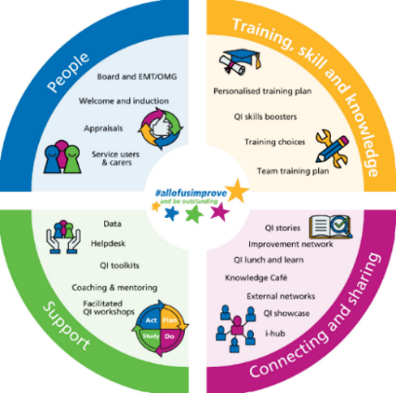
A strong and consistent narrative across the Trust is that quality improvement is everyone’s business. Regardless of role, profession, or work setting, every colleague has a part to play and a responsibility to contribute to continual improvement.

The Trust is supported by a dedicated quality improvement team, made up of colleagues with specialist QI skills and expertise. The team provides support, advice, and guidance to individuals, teams, and care groups, enabling them to develop, deliver, and sustain improvements within their local areas.

All individuals and teams across the Trust have access to a wide range of quality improvement tools to support improvement in their areas of practice. This includes the model for improvement toolkit, which is used to design, test, and implement small-scale or incremental improvements, as well as the six-step quality improvement project toolkit, which is used to support larger-scale and more complex improvement work.

The six-step quality improvement project toolkit guides teams through our bespoke improvement methodology, covering each stage of the process. This includes identifying the challenge, using quality improvement tools to understand the underlying issues, generating and testing ideas for change, implementing improvements, and evaluating and sharing learning and improvement stories to support spread and sustainability.
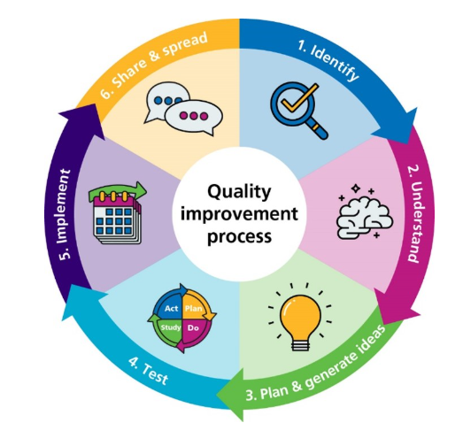

Our quality improvement model aligns to the five pillars of NHS Impact and our offer to all colleagues across the organisation spans the four quadrants of:
- People
- Training, skills and knowledge
- Support
- Connecting and sharing

Our people are at the heart of the model, and it is important to us that we have effective leadership for improvement.
This year we have continued to ensure we have an organisational focus on data and measurement to ensure the work we do is making a difference.
Creating a workplace culture that supports quality improvement is vital to ensuring our systematic approach to improvement is embedded across the Trust.
The team work alongside colleagues within the Trust’s learning and development team to ensure that quality improvement is built into the fabric of colleagues one to one discussions, supervision sessions and appraisals.
The Trust offers a variety of mechanisms to build improvement skills from senior leaders through to frontline staff as our training offer is open to anyone who has an interest in quality improvement.

Quality improvement example – inpatient food waste, quality and cost improvement
During 2025/26, the catering and facilities team, alongside ward staff, undertook a project which focused on monitoring, managing and actively reducing food waste. This looked at production waste, plate waste and unserved meals. Reducing food waste is an effective strategy for lowering environmental impact and is in line with the Trust’s food and drink strategy and social responsibility and sustainability strategy.
The Trust facilities team started by auditing the number of food portions served, portions remaining unserved, and associated weight of food waste (in tonnes) across a 10-month period at Fieldhead Hospital. This work built on learning from the impact of individual food ordering at Kendray Hospital on food wastage.
The findings from this audit informed the catering team’s work plan for individual meal and food ordering as a means to reduce food waste. This involved patient engagement in ward catering orders and a move away from historical bulk ordering towards tailored, individual meals. Horizon unit and Walton ward commenced individual ordering in April 2025, with all other wards at Fieldhead following in July 2025.
Results and improvements
Food waste in hospitals remains a significant sustainability challenge. Since 2022, all food waste has been segregated and repurposed as a valuable resource for the generation of green energy.
The results of the changes over a 10-month period for Newton Lodge and Fieldhead Hospital wards demonstrate an overall reduction in food waste of 47%, decreasing from 2.515 tonnes in May 2024 to 1.325 tonnes in August 2025.
In addition, the initial audit results informed several quality and cost saving improvements including:
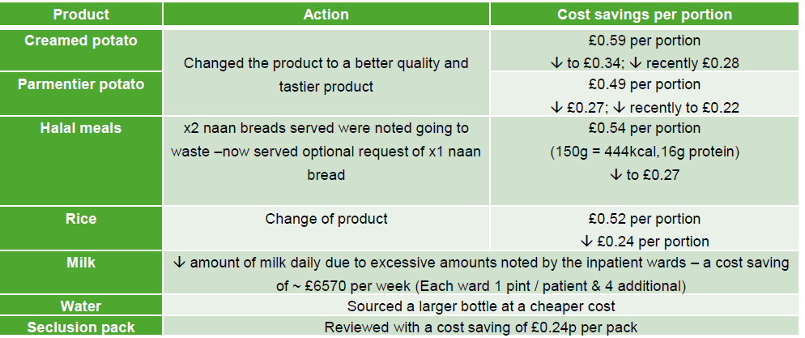
The next steps are to replace traditional paper-based ordering with digital technology, in line with National Standards for Healthcare Food and Drink. Digital solutions reduce paper and printing costs, enable real-time adjustments to meet individual patient needs, and improve efficiency and sustainability. This supports the delivery of more personalised mealtimes and helps optimise nutrition and recovery for patients.
Quality improvement example – falls improvement
Throughout 2025/26, the Trust has maintained a strong focus on patient safety and reducing harm related to falls. This work has been focused not only on preventing falls, but on minimising associated harm and protecting patients’ health, wellbeing, and independence. Improving understanding of falls risk among patients, families, and staff has been a key driver of these improvements and has supported more proactive and preventative care.
A range of quality improvement initiatives have been delivered during the year, which have strengthened consistency, reliability, and effectiveness in falls prevention and management, including:
- Using the NICE quality standard for falls to improve the quality and completeness of multi-factorial risk assessments, resulting in more individualised care planning, targeted therapeutic interventions, and clearer mobility plans
- Embedding safety huddles within inpatient wards to improve communication and shared situational awareness of risk, contributing to earlier identification of deterioration and improved management of patients at higher risk of falling
- Updating the Trust’s falls and bone health policy and the inpatient falls management pathway to strengthen clinical decision making, escalation processes and governance oversight
- Ongoing collaboration with the research and development team on electronic falls (eFalls) monitoring, which has identified higher rates of falls among younger adults and links with gender, polypharmacy and diagnosis; a draft clinical validation study has been submitted for publication
- Measurable improvements in patient education relating to falls risk, as demonstrated in the graph below, supporting safer behaviours and contributing to a reduction in avoidable falls through increased awareness and engagement

Looking ahead to 2026/27, the Trust will continue to build on this progress to further reduce the frequency and impact of falls across services. This will include strengthened review of patient safety events to ensure learning is consistently identified and translated into practice; thematic reviews of patients experiencing frequent falls to identify best practice and address potential missed opportunities; continued alignment with NICE quality standards; and the systematic sharing of learning and outcomes across services to support sustained improvement and harm reduction.
Quality improvement example – reducing the use of prone restraint
Across our services, we have a clear and sustained ambition to become a zero prone restraint organisation. Prone restraint refers to the use of physical restraint where a person is held or placed face down. This position is associated with a significantly increased risk of physical harm, including respiratory compromise, positional asphyxia, and increased psychological distress. For these reasons, prone restraint is widely recognised as a restrictive practice that should be avoided wherever possible and used only as a last resort.
Throughout 2025/26, work has continued to support staff to use safer, alternative approaches when supporting patients. Improvement activity has been informed by enhanced use of data, with a particular focus on reducing staff-led prone restraint, including during seclusion exits and for the administration of intramuscular medication. This has strengthened our understanding of risk and enabled targeted action in areas where prone restraint has been most frequently used.
Every incident of staff-led prone restraint is subject to structured review involving specialist advisors and relevant clinical teams and is considered through the Trust’s reducing restrictive practice (RRP) action group. This process enables learning to be identified, supports staff to reflect on decision-making, and promotes safer, less restrictive approaches, contributing to a sustained reduction in the use of prone restraint.
Communication and reporting processes have been further strengthened to improve the accuracy, consistency, and reliability of prone restraint data. This has enhanced organisational oversight and reinforced our focus on reducing harm and improving patient safety.
More recently, a dedicated dashboard has been developed to clearly distinguish between staff-led prone restraint and service user-initiated prone positioning. This improved clarity supports more meaningful analysis of practice, enables identification of both good practice and areas requiring improvement, and ensures trauma-informed principles remain central to learning and service development.
In addition, a clinical decision making flowchart is being developed to support clinicians in consistently distinguishing between staff-led prone restraint and service user-led positioning. This will further strengthen shared understanding, improve reporting accuracy, and support safer clinical practice across inpatient services.
The table below illustrates the number of occasions on which staff-led prone restraint has been used within inpatient services. Any increase in usage is subject to detailed review through the Trust patient safety oversight group. It is also reported to the quality and safety committee and Trust Board, ensuring robust governance, transparency, and accountability.
Mar 25 | Apr 25 | May 25 | Jun 25 | Jul 25 | Aug 25 | Sep 25 | Oct 25 | Nov 25 | Dec 25 | Jan  26 | Feb  26 | Mar  26
6 | 9 | 11 | 12 | 7 | 13 | 5 | 14 | 4 | 7 | 3 | 3 | 5

Quality improvement example – reducing the use of seclusion in inpatient settings
In line with our commitment to promoting and embedding a least-restrictive approach, a focused programme of quality improvement is underway to reduce the use of seclusion across inpatient services. Seclusion is only used when absolutely necessary, and practice is underpinned by continuous assessment to support termination at the earliest safe opportunity, in accordance with the Mental Health Act Code of Practice. Preventative strategies are further strengthened through Restraint Reduction Network (RRN) accredited training.
Following an internal audit, additional quality improvement work has been undertaken to review and refine electronic seclusion documentation. This work aims to ensure information is captured accurately and consistently, while continuing to embed the principles of a compassionate, therapeutic culture of care. Although this work is ongoing, early data from mental health inpatient services, as shown in the figure below, demonstrates sustained improvement in the completion of timely multidisciplinary team (MDT) independent reviews. This supports safer decision making, stronger oversight, and more effective planning to resolve seclusion episodes promptly.
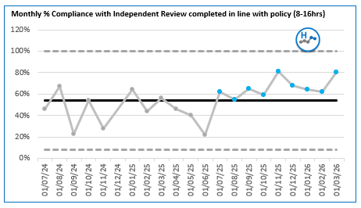
A seclusion working group has also been established, providing a forum for clinicians and specialist advisors to share learning, explore challenges, identify what is working well, and promote consistent good practice across services. Seclusion review breaches and emerging themes are reviewed through the Trust’s reducing restrictive practice (RRP) Trust action group, ensuring appropriate challenge, escalation, and governance.
Data on the use of seclusion is routinely reviewed to monitor trends, identify variation, and assess the impact of improvement actions. This enables the Trust to understand where progress is being made and where further targeted interventions are required. Learning from this data is used to inform practice, training, and service development.
The perspectives of people with lived experience have been incorporated into current training programmes, supporting reflective practice and professional learning. While this represents an important foundation, further quality improvement work has been identified to strengthen co-production, ensuring lived experience perspectives are meaningfully embedded, sustained, and influential in shaping future practice and service improvement.

2.2 Quality governance and oversight
Our executive lead for quality improvement and quality governance is the chief nurse / director of quality and professions, providing clear senior leadership and accountability for quality across the Trust.
Central to our approach to quality governance and assurance is the quality and safety committee (QSC), a formal sub-committee of the Trust Board. The QSC provides oversight and assurance on the quality and safety of care delivered by the Trust. Reporting into the QSC is the clinical governance group, which ensures assurance on quality through close working with care group quality and governance colleagues.
During 2025/26, focused work was undertaken to strengthen governance arrangements and reporting pathways. This included enhancing the flow of information from key Trust action groups and care group governance groups, and strengthening escalation routes for emerging concerns to the clinical governance group and onward to the quality and safety committee.
The clinical governance group plays a key role in horizon scanning and risk identification, the interpretation and assurance of national and local quality and safety directives, and the critical review of organisational quality and safety improvements. It also supports information sharing, planning, and the monitoring of implementation of improvement actions across the Trust. Oversight is further strengthened through the members’ council quality group, which supports and oversees the Trust’s approach to quality governance.
Governance and quality assurance are integral to how we manage and improve quality across the organisation. At executive, care group, and service levels, the Trust operates a trio model of leadership, bringing together clinical, operational, and governance roles to provide coordinated leadership and accountability for quality.
We routinely monitor a range of quality indicators through our integrated performance report (IPR). This can be accessed at team, service, and Trustwide levels, and selected information is published externally on the Trust’s website. Quality indicators include, but are not limited to, the NHS Friends and Family Test (FFT), infection prevention and control performance, Patient Safety Incident Response Framework (PSIRF) activity, safer staffing, pressure ulcers, restrictive interventions, and complaints. Each indicator has defined measures and targets that reflect our ambition for continuous improvement. The IPR is routinely reviewed by the executive management team (EMT), the Trust Board and its committees, and the members’ council quality group.
Learning and improvement are supported through a comprehensive clinical audit programme, alongside active engagement in research and development, including partnerships with universities and the Academic Health Science Network (AHSN). The Trust also contributes to and learns from external benchmarking and assurance programmes, including the National Confidential Inquiry into Suicide and Homicide (NCISH), mental health benchmarking initiatives, and workforce capacity and demand reporting.
To maintain a strong operational focus on quality, an enhanced clinical risk and performance report is presented to the operational management group (OMG). This, alongside the wider quality assurance framework, supports the identification of good practice, highlights areas requiring improvement, and maintains oversight of quality and risk across services.
Quality oversight is also embedded within routine governance meetings at care group level, with clear routes for escalation to the clinical governance group, the executive management team, and the quality and safety committee where required. This ensures a robust, transparent, and responsive system for managing quality and safety across the Trust.

2.3 Best quality – progress against the priority areas
In line with our best quality aim, the following information outlines our progress with meeting the four priorities.
- We will ensure equitable access, experience and outcomes for all
- We will ensure our services are consistently safe, responsive, personalised and effective
- We will ensure continuous inclusive improvement is integral to developing and delivering creative and innovative services
- We will consistently address health inequalities across our services, ensuring we are inclusive and working to minimise the impact of deprivation
2.3.1 We will ensure equitable access, experience and outcomes for all
2.3.1.1 Capturing patient experience
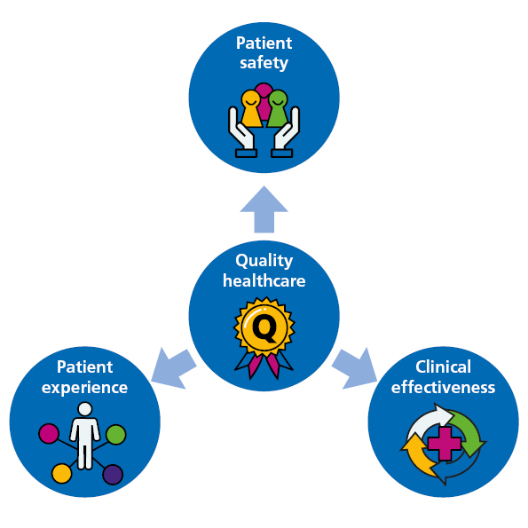
Patient experience is central to all Trust activity, ensuring care is person-centred and that the voices of patients, families, and carers are heard. Understanding these experiences helps us identify opportunities for improvement and supports our ambition to deliver outstanding care and outcomes.
Patient experience is captured across the Trust using a range of methods. Feedback is triangulated to provide a comprehensive view of the experiences of patients, families, and carers, and to demonstrate how this insight is used to drive improvements in the quality of care.
Our annual patient experience report brings together key feedback to support understanding, learning, and ongoing improvement.
During 2025/26, the Trust strengthened how patient experience is measured and used to drive improvement. Service-specific patient experience surveys were developed, in line with the Care Quality Commission’s (CQC) five key domains, ensuring feedback was relevant and directly linked to quality and regulatory expectations.
Feedback from 635 service users across a wide range of services demonstrated high levels of satisfaction, with scores ranging from 91% to 98%. Actions are underway to address slightly lower scores, which primarily related to awareness of how to raise concerns.
Surveys were also piloted within child and adolescent mental health services (CAMHS), generating positive feedback and informing plans to increase participation from children and young people, strengthening how their views shape service development.
The Trust continued to support delivery of the Patient and Carer Race Equality Framework (PCREF) by using Friends and Family Test (FFT) data to monitor experience across ethnic groups. Quarterly reporting, volunteer engagement, and plans for new equality dashboards aim to ensure feedback highlights inequalities and supports culturally responsive improvement.
Friends and Family Test (FFT) response rates increased by 5% compared with the previous year, supported by improved collection methods, the introduction of QR code posters and preparation for future integration with Patients Know Best and the NHS App. In total, 9,030 FFT responses were received in 2025/26.
Overall, FFT results remained strong, with mental health services achieving 92% positive ratings against an 85% target, and community services achieving 97%, slightly below their 98% target.
Staff, communication and patient care featured as the most common positive themes, while access, waiting times and admission and discharge processes were identified as key areas for improvement. This feedback is shared with services and used to inform targeted quality improvement activity.
Looking ahead to 2026/27, the Trust plans to expand feedback opportunities, implement the Experience of Care Framework, enhance patient experience dashboards, and develop a local community mental health survey to generate more detailed, locally relevant insight.
2.3.1.2 Cheswold Park Hospital integration
In October 2024, the Trust assumed responsibility for delivering services at Cheswold Park Hospital, a secure hospital in Doncaster providing medium and low secure forensic inpatient services. Throughout 2025/26, a comprehensive integration programme has been delivered to embed the hospital within the wider Trust.
This programme comprised 20 priority areas, focusing on operational delivery, quality and safety, and people and workforce, and has supported the safe, effective, and sustainable integration of services.
Quality and safety improvements integrated into the wider Trust include:
- Mandatory training, achieving high levels of compliance across the hospital
- Introduction of physical health plans to support service users with physical health needs
- Establishment of processes to ensure medical devices meet Care Quality Commission (CQC) standards
- Implementation of the Trust’s reducing restrictive practice training and processes
- Introduction of Datix and the Patient Safety Incident Response Framework (PSIRF)
- Review of food provision against British dietetic standards, with regular input from the Trust’s senior catering dietitian to promote healthy lifestyle choices
- Introduction of infection prevention and control (IPC) standards across the hospital, supported by regular walkarounds
- Implementation of Trust customer services, safeguarding and Freedom to Speak Up processes
- Review of the advocacy contract to ensure access to a positive and effective patient experience
- Introduction and implementation of the Trust’s falls risk assessment
Monitoring and reporting are now embedded within wider forensic services and incorporated into Trustwide integrated performance reporting. All CQC actions issued to the previous provider have been completed, providing additional assurance regarding the improvement work undertaken and the delivery of improved standards of care.
2.3.1.3 Making data count
The Trust has continued to embed making data count through strong collaboration, ensuring that data and visualisations are co-designed with end users and presented in formats that enable timely, informed and effective decision-making.
Colleagues across intelligence and change (integrated change team), performance and business intelligence, research and development, equality, inclusion and involvement, and operational services have worked collaboratively to ensure data is used effectively to support quality improvement, assurance and decision-making. This includes identifying the most meaningful measures for specific areas of work and applying making data count principles to distinguish between normal variation and genuine change over time.
A key focus has been ensuring that data insights are actionable and clearly linked to improvement activity. This enables leaders and teams to understand whether changes in performance represent sustained improvement, emerging risk or expected variation. Data is increasingly presented in ways that support both local improvement efforts and organisational assurance.
Key achievements during 2025/26 include:
- Embedding making data count principles within the customer services team’s complaints monitoring, with statistical process control (SPC) charts used to track monthly complaint levels, strengthening the Trust’s ability to identify signals, respond proportionately, and provide assurance on patient experience trends
- Use of SPC charts to evidence improvement activity against CQC actions, ensuring improvement can be confidently demonstrated through data and supporting the closure of outstanding CQC actions
Building on these successes, a key component of our commitment to the strategy refresh is to further define how we measure progress. Understanding what success looks like - and what will be different if we are “getting it right” - will remain critical. This will involve not only consideration of Trust performance and risk information, but also a continued focus on improvement data and measures. This includes triangulating information from multiple sources and recognising the equal importance of quantitative data and experiential data (voice).
We will continue to develop our understanding of how outcomes change over time, enabling us to clearly articulate whether improvement is occurring as a direct result of our actions. This is essential to providing assurance of impact, and we will maintain a collaborative approach to reporting data in ways that support this aim.

2.3.1.4 Culture of Care
The Culture of Care programme is an NHS England quality transformation initiative aimed at improving the culture of inpatient mental health, learning disability and autism wards, ensuring they are safe, therapeutic and equitable for patients, and fulfilling places to work for staff. The programme is built on 12 co-produced core commitments, supported by 76 standards, alongside three cross-cutting equity principles.
Simply put, a Culture of Care is one in which care is at the centre: patients, their loved ones and staff feel cared for, and staff are enabled to provide the care they want to deliver to others. In 2023, NHS England convened a sector-wide group with strong representation from lived experience leadership, involvement partners, and people who experience inequality in accessing and using mental health services. This collaboration led to the development of detailed Culture of Care standards that clearly describe what good looks like in practice.
The Trust set out to embed the Culture of Care standards on every inpatient ward. This ambition aligns directly with our people, clinical and equality strategies and commitments, supported by clear governance arrangements from ward to Board.
Our operating model included:
- Ward-level quality improvement, with four pilot wards using a six-step quality improvement methodology co-produced with service users and carers
- Ward-level staff care and development, focusing on anti-racism, psychological safety and relational safety
- Staff care and development, including protected time for reflective practice, skill-based training, routine coaching and supervision, and lived-experience-led development support
- Leadership and management development, with targeted support for ward managers to create person-centred cultures, alongside executive coaching
- Insight, using Culture of Care lived-experience resources to inform improvement
- Organisational reflection, focusing on how internal teams and services can best support ward staff and managers
- Executive sponsorship, including direct coaching and monitoring from the chief nurse and chief medical officer
Key themes emerging from the Culture of Care work included:
- Lived experience and involvement at every level
- Relational safety and the therapeutic day
- Staff support as an enabler of quality care
- Equity by design, rather than as an add-on
- Evidence-informed measurement
A defining success of the Culture of Care programme has been its ability to connect and align major Trust improvement priorities, creating a more coherent, values-driven approach across inpatient services. By embedding the 12 Culture of Care commitments and equity principles into existing programmes, the Trust has developed a shared language, shared expectations and shared momentum for change.
This integration is most clearly visible within the acute pathways and inpatient improvement priority programme, where Culture of Care insights directly inform quality, safety and experience workstreams. It is also evident within the Trust’s Triangle of Care developments, where relational practice and meaningful carer involvement strongly reflect core Culture of Care principles.
The Trust remains committed to ensuring that the equity principles at the heart of the Culture of Care - including anti-racism practice, trauma-informed care and autism-informed care - are protected, strengthened and fully embedded at every level of the organisation. This commitment is enacted and safeguarded through the implementation of the EDI strategy and associated governance structures, ensuring that equity is a core organisational expectation rather than an add-on.
2.3.1.5 Caseload complexity tool
A complexity tool is being developed to support more effective caseload allocation and prioritisation, by indicating the level of clinical input and support required for each service user. Rather than relying solely on caseload numbers, this approach recognises the varying levels of time, complexity, and professional input needed to manage cases safely and effectively.
Ultimately, the tool aims to:
- Support practitioners and managers to better understand capacity and demand
- Inform establishment reviews for community services
- Provide a foundation for future enhancements, including discharge prediction and crisis likelihood modelling, subject to clinical validation and robust governance arrangements
It will also help to:
- Enable caseloads to be sorted by complexity
- Highlight service users requiring higher levels of intervention
- Support decision making without replacing clinical judgement

Our approach to implementation
Clinician-led and clinically validated
- The tool will not replace clinical judgement
- Clinicians will retain the ability to challenge, confirm or override algorithm-generated scores
- Clinical expertise will guide both the initial rollout and ongoing refinement of the tool
Phased development
Phase 1 (immediate):
The caseload management tool will be launched without complexity scoring. This phase is progressing well, with a number of practitioners already using the tool. Guidance materials and a crib sheet have been developed, and workshops have been delivered. Initial feedback suggests that the tool is effective, intuitive and well received by practitioners.
Phase 2 (future):
Complexity scoring will be introduced, initially with a strong manual component. An algorithm-led approach will only be implemented once the tool has been fully validated. This phase will include:
Collaboration and governance
- Development will be clinically led, with support from colleagues in research and development
Data quality and integration
- The accuracy of any future algorithm-led approach will depend on the quality of data recorded in SystmOne; focus will be required on improving data capture and exploring integration with FACT (Framework for Assessing Clinical Thinking) and FIRM risk assessment.
- Complexity scoring will draw on historical data and validated measures, with clinicians remaining central to interpretation
Sensitivity and engagement
- We recognise staff concerns regarding administrative burden and will ensure the tool is positioned as supportive rather than punitive
- Pilot testing will be undertaken with selected teams prior to wider rollout
Key principles
- Clinician-led development first, with automation introduced later
- Algorithm development undertaken in the background and not visible to teams until clinically validated
- Clinical override always available
- R&D involvement to support evidence-based design
- Clinical validation required prior to full implementation

2.3.1.6 Triangle of Care
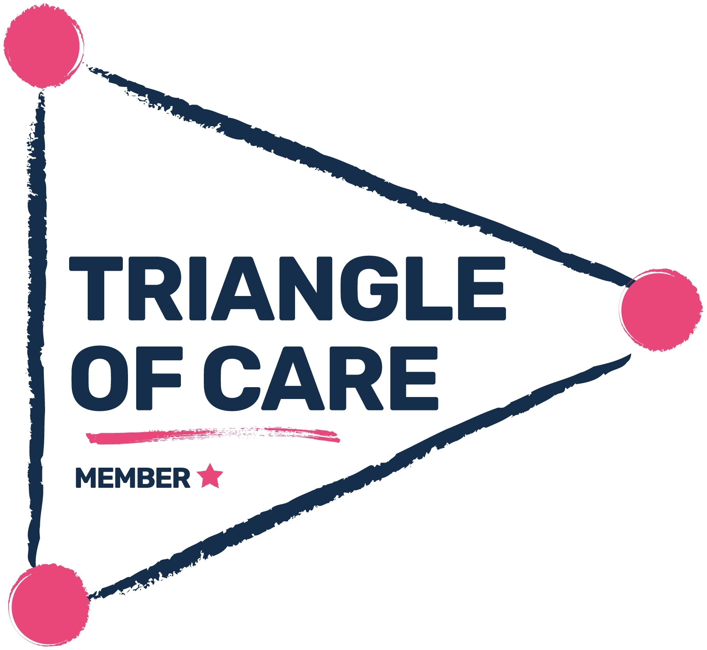
During 2024/25, the Trust achieved its first star under the Triangle of Care (ToC) programme from the Carers Trust. Throughout 2025/26, the Trust has continued to strengthen its organisational approach to recognising, involving and supporting carers by maintaining Star 1 and progressing towards Star 2. This has involved ensuring that both community and inpatient services consistently embed carer-inclusive practice.
We have also prioritised improving the visibility of carers and young carers, strengthening support pathways, and ensuring that our commitments - such as the carers’ charter and carers’ passport - are meaningful and actively used in practice. This work is aligned with the Patient and Carer Race Equality Framework (PCREF), supporting equity, inclusion and culturally responsible engagement with carers and families.
Community mental health teams have completed self-assessments against the ToC standards, helping to identify areas of strong practice and where improvement actions are required. This has frequently highlighted the need for more consistent involvement of carers in care planning. Cheswold Park Hospital wards have also completed self-assessments to align practice with the rest of the Trust.
Throughout our ToC journey, we have seen a sustained improvement in support for carers through increased use of carers’ passports. Experience data indicates that carers consistently report feeling more involved in the care of their loved ones. In addition, carers awareness training for staff has been developed into an electronic learning package, making it accessible to all staff, with consistently good uptake.
Looking ahead, we will continue to deepen inclusion, strengthen pathways to support carers, and better understand the real-world impact of the improvements made - both for carers and for the people they care for. A key priority will be to enhance engagement with carers from minority groups, ensuring that our approach is culturally responsible, accessible and aligned with PCREF principles.
We will continue to develop the young carers pathway, ensuring alignment with the ‘no wrong door’ approach. In addition, we will regularly review and analyse data and intelligence from staff feedback, carers’ stories and insights from carers champions to evaluate impact, identify gaps and refine our approach.
2.3.2 We will ensure our services are consistently safe, responsive, personalised and effective

2.3.2.1 Learning disability services

The Trust delivers community services to people with a learning disability in four different geographical areas and runs a specialist in-patient assessment and treatment unit called the Horizon Centre. Each community service has a multidisciplinary model for routine care, and intensive support and psychiatry, which offers an immediate response to people who are experiencing a crisis. The service also operates an out-of-hours provision which ensures people in crisis have access to specialist learning disability advice and support.
During 2025/26, learning disability (LD) services focused on reducing unwarranted variation in access, improving quality and safety of care, and addressing health inequalities for people with a learning disability and/or autism.
Key priorities included:
- Maintaining referral to treatment times within 18 weeks across all four community teams
- Improving the uptake and quality of annual health checks (AHCs) and health action plans (HAPs)
- Embedding improvements from the community and Horizon inpatient improvement programmes
- Improving clinical pathways (including behaviour, dementia, transitions, weight management and STOMP (stop over medication of people with a learning disability and autistic people)
- Implementing the Keep My Chest Healthy respiratory pathway
- Reviewing intensive support and access processes
- Improving communication and accessible information
- Embedding the greenlight toolkit principles
- Sharing learning from LeDeR (reviews of deaths of people with a learning disability and autistic people)
- Strengthening admission and discharge processes in the Horizon Assessment and Treatment Unit (ATU)

During 2025/26, waiting list management was further strengthened and the waiting well pathway was implemented. This significantly reduced waiting times, with the majority of people now seen within 18 weeks. Reduced waiting times have improved the experience of people using services, supported earlier intervention and enabled clinicians to manage caseloads more safely and effectively.

Annual health check delivery continued to exceed national targets, with all four localities achieving higher completion rates than the previous year. Strategic health facilitators worked closely with GP practices to improve the quality of AHCs and HAPs and to embed reasonable adjustments, supporting improved access to flu vaccinations and screening programmes.

The community improvement plan was completed and embedded, delivering tangible improvements, including revised referral forms, clearer duty arrangements, strengthened MDT clinical pathways, and locality and Trustwide safety huddles. These huddles have improved communication across services, supported proactive crisis management and improved coordination with the Horizon ATU for admissions and discharge planning.

The Keeping My Chest Healthy pathway was embedded in Kirklees and Wakefield and roll out has started in Calderdale. This helps to support early identification of respiratory issues.

Communication has also improved through the development of an Easy Read library.

Greenlight champions have driven improvements in Trustwide understanding of how services support people with a learning disability and/or autism, leading to better joint working and reduced inappropriate referrals.

Looking forwards to 2026/27, we will continue to sustain waiting times under 18 weeks and further embed greenlight toolkit principles. A focus will remain on improving uptake of AHCs, reduce delayed discharges from Horizon ATU and participating in research to support quality of life outcomes.

2.3.2.2 Safer staffing
The Trust is working towards full alignment with national safer staffing policy, strengthening safeguards and governance systems to support the delivery of safe, sustainable, high-quality care. This work also ensures that workforce risks are effectively identified, mitigated and escalated.
Progress is being delivered through a number of key actions, including:
- Twice-yearly establishment reviews for inpatient services
- Monthly safer staffing reports to the Trust Board
- Development of an automated dashboard presenting key safer staffing indicators
- Implementation of training for the evidence-based Mental Health Optimal Staffing Tool (MHOST)
- Completion of the NHS England safer staffing fellowship programme by the assistant director of nursing (aligning with the national aim for each NHS organisation to have a safer staffing fellow to provide guidance, oversight and leadership)
Throughout 2025/26, the Trust made good progress in strengthening its approach to safer staffing. Establishment reviews, undertaken using NHS-approved staffing tools, have enabled the Trust to make evidence-based recommendations to support safe and appropriate staffing levels across inpatient wards. Monthly workforce analysis, triangulated with quality and safety outcomes, has supported a robust and proactive approach to identifying risks and ensuring timely mitigations are put in place where required.
Looking ahead, the Trust will continue to strengthen governance arrangements for safer staffing and complete establishment reviews within community services. Establishment reviews will move to a rolling programme across the Trust and will be supported by the rollout of MHOST at Cheswold Park Hospital.
In addition, SafeCare - a web-based application providing real-time staffing and safety data at unit, site, and organisational level - will be embedded across services. This will be supported by upskilling staff in safer staffing principles and the effective use of real-time data to support safe decision-making and workforce planning.

2.3.2.3 Patient safety

During 2025/26, the Trust undertook a comprehensive review of how our Patient Safety Incident Response Framework (PSIRF) operates in practice. Having implemented PSIRF for just over two years, this review aimed to assess how effectively our systems were working, whether incident responses were delivering meaningful learning and improvement, and whether our approach remained aligned with PSIRF principles. These include proportional responses, a focus on systems rather than individual blame, and the implementation of changes that genuinely improve patient safety.

As part of this work, we strengthened our system-based learning approaches to ensure that responses to patient safety incidents are more consistent, timely, and proportionate. Greater emphasis has been placed on understanding wider system factors and conditions that contribute to incidents, rather than focusing solely on individual actions.

Our being open processes were reviewed and updated to ensure continued alignment with national expectations and to support compassionate, transparent, and meaningful involvement of patients and families following patient safety incidents.

Clear and accessible flowcharts were developed and refreshed to support staff in incident reporting, management, and PSIRF decision making. This has made processes easier to understand and apply consistently in practice.

To build organisational capability and confidence, the Trust invested in external training in SWARM (a collaborative approach undertaken soon after an incident to understand what happened and identify learning) and after-action reviews. This training was delivered to quality governance leads and matrons, supporting more consistent and effective application of these approaches across care groups.

The review also clarified where full patient safety incident investigations add the greatest value. In line with national guidance, we strengthened the use of thematic reviews in areas where issues are already well understood. This has reduced duplication, supported shared learning across services, and enabled more effective use of investigation capacity.

We removed response types and processes that did not add clear value, simplifying our overall approach and ensuring staff time is focused on activity that supports meaningful safety improvement.
Improvements were also made within Datix, including changes to how incidents are reviewed and the introduction of a new service-learning review, replacing the previous 48-hour manager review. This has strengthened early learning and improved clarity regarding the most appropriate and proportionate response to incidents.

Finally, a series of stakeholder engagement sessions were held to ensure that the updated PSIRF plan reflects the perspectives and needs of both those who use our services and those who deliver care.

Next steps
Over the coming year, the Trust will:
- Finalise the updated PSIRF plan and present it through Trust clinical governance structures
- Continue to embed and support the use of SWARM, after-action reviews, and thematic review approaches to strengthen system-based learning
- Maintain ongoing review of PSIRF decision making to ensure responses remain timely, proportionate, and aligned with national expectations

The review also identified the need to strengthen how PSIRF responses support coroners’ investigations. Working closely with the Trust’s legal team, further improvements will be made in this area to ensure consistency, clarity, and effective information sharing.

2.3.2.4 Electronic prescribing and medicines administration development
Joint project teams comprising multidisciplinary and multi-professional colleagues, alongside information management and technology (IM&T) specialists, were established to design and prepare for the implementation of electronic prescribing and medicines administration (EPMA) across a range of services and settings.
EPMA was implemented within section 136 suites across Barnsley, Calderdale and Wakefield, as well as within working age adult intensive home-based treatment teams (IHBTT) across all localities. For these teams, the inpatient medicines chart was adapted for use within community settings. This phase of implementation took place between March and September 2025, followed by implementation at Cheswold Park Hospital between January and March 2026.
The introduction of electronic prescribing has delivered a range of benefits that support the Trust’s values, priorities and strategic goals, including:
- A single, comprehensive view of a patient’s current and historical medication record, accessible to clinicians regardless of location
- Real-time clinical decision support to assist prescribers in selecting appropriate medicines and reducing errors
- A real-time view of medicines administration
- Safer and more timely administration of medicines
- Clearer, more complete and more legible prescriptions
- A faster and more efficient medicines ordering process, reducing delays in supply
- Fewer reported missed doses
- A reduction in prescribing-related medication incidents
- A reduction in missed doses where no valid reason was recorded
A benefits realisation report has been produced for the implementation of EPMA within mental health inpatient services.
What happens next?
Mental health inpatient services
We will continue to monitor safety incidents and make system improvements where required, including within inpatient and working age adult IHBTT settings, to further enhance patient safety.
Community physical and mental health services
We will introduce the electronic prescription service (EPS) across community teams. This will enable prescribers to send prescriptions electronically to a community pharmacy of the service user’s choice via the NHS Spine, making the process quicker and more efficient for both patients and staff.
The implementation of EPS will be delivered in three phases over a 12-month period. This will bring significant benefits to the Trust, including:
- Reduced paperwork and fewer paper prescriptions
- Improved visibility of prescriptions
- Less time spent managing prescriptions
- Reduced risk of errors, lost prescriptions or prescriptions being sent to the wrong pharmacy
- Overall cost savings for the Trust

2.3.2.5 Care Closer to Home
The Care Closer to Home priority programme focuses on reducing the number of people placed inappropriately in out-of-area beds and improving patient flow across services. This aims to ensure that timely access to a local bed is available at the point of need, supporting better outcomes and continuity of care.
Throughout 2025/26, this programme has remained a key priority, with a range of targeted improvement projects and activities delivered. Collectively, these aim to increase productivity across pathways by:
- Enhancing patient experience
- Improving patient flow
- Reducing length of stay
- Reducing bed occupancy
- Reducing the number of days patients are clinically ready for discharge but experience delays
Through our well-established, data-driven improvement programme, we have achieved significant improvements in patient flow by:
- Implementing weekly system escalation meetings with partner organisations for patients who are clinically ready for discharge
- Introducing daily inpatient ward huddles to support timely decision making
- Embedding purposeful admissions, ensuring that admissions are appropriate and add value
- Introducing locality-focused working to improve coordination of care closer to home
- Strengthening weekly barriers to discharge processes and multi-agency discharge events
- Improving inreach from community teams to inpatient wards
- Working with commissioners to develop effective alternatives to admission
- Strengthening cross-system working with acute partners
Out of area bed days are reported weekly to the operational management group, alongside key metrics including bed occupancy, incidents of physical violence, restraint usage, safer staffing data, and intensive home-based treatment team (IHBTT) caseload and referral activity.

2.3.3 We will ensure continuous, inclusive improvement is integral to developing and delivering creative and innovative services

2.3.3.1 Digital enablers
As a Trust, we are prioritising the development of digital solutions to enable patients and carers to access their own digital care records. This will be delivered through a patient engagement portal (PEP), using the Patients Know Best (PKB) digital platform, which offers patients the opportunity to self-manage and engage more actively in their own care. The platform also provides an alternative way for patients to communicate with healthcare professionals, offering greater flexibility and accessibility.
The patient engagement portal will deliver the following benefits:
- Improved communication between patients, carers and healthcare professionals
- Online access for patients (and, where appropriate, carers) to relevant parts of the clinical record
- Support for self-management through the use of online tools
- Support for recovery through signposting to support services and recovery resources
- Improved patient and carer awareness of, and engagement with, Trust initiatives, events, research opportunities and recovery college courses
- Improved consistency and quality of service user related data collection through direct online input by individuals, reducing administrative burden for staff
The Trust had previously implemented the Patients Know Best portal and, through participation in the NHS England Wayfinder programme, undertook further development to integrate the Patients Know Best platform with the NHS App. The Wayfinder programme supports the development of the NHS App as part of the NHS Long Term Plan ambition for the app to act as the digital front door to NHS services, improving access in a safe and secure way.
Following development work during 2024/25, the Trust launched the patient care aggregator, known as Wayfinder, on 1 July 2025. This enables patients to view all their mental health appointment bookings in one place through the NHS App. When patients access their appointment information, the NHS App retrieves a summary list from all connected booking systems via the patient care aggregator.
The Trust has also utilised the Patients Know Best portal to provide patients with secure digital access to health records requested through subject access requests. This functionality was launched on 1 December 2025.
Development of the Patients Know Best portal continued throughout the latter half of 2025/26. As part of the next phase of the NHS England Wayfinder programme, work commenced to use advanced questionnaire functionality within Patients Know Best to provide the Trust’s Friends and Family Test digitally. This functionality is available through the NHS App and was completed at the end of March 2026 as planned.
Looking ahead, further work is underway to make care plans and a digital mood diary available through the Patients Know Best portal. This will further increase access to personal health record information and enhance digital accessibility for patients and carers.
2.3.3.2 Staff survey improvements
The annual staff survey continues to serve as a fundamental diagnostic tool within our people strategy, providing essential insights that enable the organisation to translate colleague feedback into meaningful and sustainable improvement. With 2,874 colleagues taking part in the 2025 survey, we recognised an opportunity to build on this strong engagement by evolving the process into one that is more empowering, collaborative and responsive to the expectations of our workforce. Our priority was to move away from a traditional, top-down approach towards one that celebrates openness, shared ownership and continuous organisational learning.
We recognised that colleagues want their feedback to drive real, visible change. To support this, we prioritised creating a culture in which the staff survey is not a once-a-year event but an ongoing conversation. This involved giving managers and teams greater ownership of their results and moving from static action plans to collaborative, team-led improvement. By doing so, we aimed to strengthen trust, transparency and collective responsibility across the organisation.
To bring this new approach to life, colleagues from the people directorate increased their presence across all Trust sites, meeting colleagues where they work and encouraging open dialogue. Communications were refreshed and aligned with the NHS People Promise, reinforcing the message that every voice genuinely counts. This helped to create a more positive and inclusive tone around the survey and contributed to strong participation.
A key development was the introduction of a new staff survey dashboard accessible to all staff. This tool provides clearer, more intuitive insight into team-level results, enabling care groups and departments to explore their data in real time and identify both strengths and opportunities for growth. Early feedback indicates that teams find the dashboard helpful in understanding their results and planning next steps.
Through this work, we have learned that colleagues respond positively when they can see their feedback being acknowledged and acted upon within realistic timeframes. We have also learned that teams thrive when they are given the autonomy to shape their own priorities, supported by leaders who listen and empower rather than direct. Increased transparency and accessibility have helped build confidence in the shift towards a continuous “You said, we’re doing” culture.
Our next steps focus on embedding this positive and collaborative approach across the organisation. We will continue to build a culture in which staff experience is discussed openly throughout the year, and where improvements are tracked, shared and celebrated as they occur.
Two People Promise themes will guide our work:
1. We are compassionate and inclusive
We will strengthen the experience of colleagues from equality groups by working closely with our staff networks and drawing on insights from the staff survey, WRES, WDES and our refreshed our behaviours framework. This will help ensure every colleague feels valued, respected and able to thrive.
2. We are safe and healthy
We will enhance wellbeing support, including improved access to services such as the employee assistance programme and additional training for managers to support colleagues to stay well at work. Feedback from focus groups is informing the design of this offer.
We will also provide targeted support to teams with below-average staff experience, helping each to identify one People Promise element on which to focus. To maintain clarity and impact, each part of the organisation will concentrate on no more than three improvement areas aligned to our overarching priorities.
2.3.3.3 Involvement
Within the Trust, a need was identified for a more consistent, equitable and meaningful approach to involving patients, carers and communities in the design and delivery of services. This aligns with the Health and Social Care Act (2022), the Equality Act (2010) and the NHS Constitution.
Previously, involvement processes lacked a standardised framework, which led to a risk of tokenism and inconsistency across care groups.
In response, improvement work focused on the co-design and launch of a comprehensive involvement guide, providing a clear and structured framework for engagement. Central to this guide is the ladder of involvement, a five-stage conceptual model ranging from information to co-production. Each stage is supported by real case studies from across the Trust, helping to bring involvement to life and demonstrate how meaningful engagement can be achieved in practice.

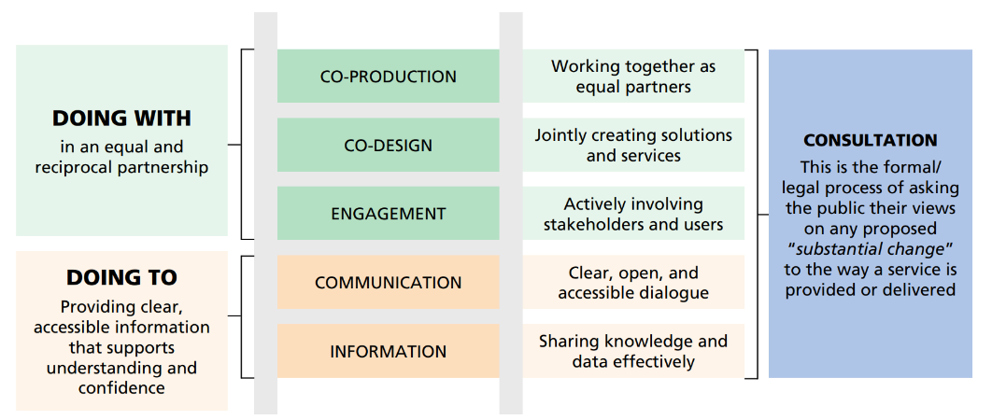
- Connecting People programme:
The Trust has an established network of over 124 trained connectors from partner organisations and local communities, held on a centralised database to support involvement activities. This approach has been used across a range of projects, including stakeholder panels aligned with the Patient and Carer Race Equality Framework (PCREF)
- Stakeholder database:
The Trust maintains a stakeholder database containing details of partner organisations, voluntary, community and social enterprise (VCSE) groups, community representatives and Trust members. This resource was used during the Trust strategy refresh, working in combination with the connectors network
- Internal service user community and dialogue groups:
The Trust has established ward-based community or dialogue groups, including groups such as one voice within forensic services and more generic meetings on other inpatient wards. These groups are facilitated by a mix of staff (including nurses and occupational therapists) and lived-experience leads. This approach has been integral to Culture of Care ward-based quality improvement work
- Peer educator approach:
The Trust employs peer educators on bank contracts across services, with further development planned over the coming year. The equality, diversity and inclusion (EDI) team supports Trust volunteers through a buddying approach to strengthen peer involvement and development
- Carers’ network:
The Trust hosts an external carers’ network, providing a forum to ensure carers’ voices are heard and their roles recognised and valued. The network also enables carers to raise barriers, challenges and inequalities they experience
- External stakeholder service user groups:
Across localities, the Trust engages with a range of service user panels and Mental Health Alliance structures. These groups have been integral to involvement activity, including projects such as the autistic approach development day, delivered with representatives from inpatient services
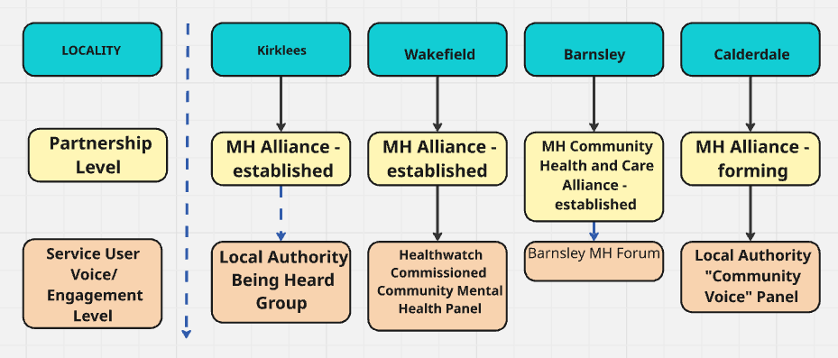
Looking ahead, the involvement approach will continue to evolve, with a focus on the following areas:
- Review and update resources, including intranet and website
- Continued engagement across the Trust with the involvement approach
- Developing a payment approach that compensates individuals directly to ensure equitable participation
- Developing robust feedback loops to demonstrate the impact of involvement to participants, ensuring they see how their insights shaped final decisions

2.2.3.4 Enhanced therapeutic observations of care (ETOC)
The Trust is engaged in the national programme of work on enhanced therapeutic observations of care (ETOC). The overall aim of this programme is to develop and enhance ETOC provision across the Trust, ensuring patients receive the right care, at the right time, delivered by the right person. The programme uses the Model for Improvement and Plan–Do–Study–Act (PDSA) cycles, underpinned by engagement, co-production and just culture principles. This programme commenced in 2025/26 and will continue into 2026/27.

There are six phases to the programme:
- Phase 1 – Governance and foundations:
Establishing clear oversight, consistency and accountability. An ETOC steering group has been established, clear reporting lines have been agreed, and governance arrangements are now operational
- Phase 2 – Policy review and standardisation:
Ensuring a consistent, evidence-based ETOC policy. This includes reviewing the current policy, developing a one-page summary, and undertaking staff engagement sessions. Pre-and post-implementation surveys will be conducted to assess staff knowledge and confidence
- Phase 3 – Training and workforce development:
Developing an ETOC training package, testing the content, and rolling out competency-based training.
- Phase 4 – Integrated model of care:
Embedding therapeutic engagement and positive risk-taking into daily care. This includes developing an integrated model and piloting it across three wards, alongside culture and just culture support
- Phase 5 – Data, insight and assurance:
Evidencing impact and supporting decision making through the development of an ETOC dashboard, triangulation of datasets, and completion of observation quality audits
- Phase 6 – Embed, share and spread:
Ensuring sustained improvement and sharing learning across the Trust. This phase will focus on engagement, embedding multidisciplinary team huddles and reviews, and sharing learning through case studies and learning events
Measures to understand impact (qualitative and quantitative) will include:
- Use of ETOC, incident data, staffing levels and engagement time
- Reduction in incidents of violence and aggression
- Reduction in seclusion and use of intramuscular medication
- Reduction in length of stay
- Staff surveys assessing knowledge and understanding
- Completion of training
- Observation audits assessing quality of care and therapeutic engagement
Success indicators will include:
Patient outcomes
- Improved experience of observations and engagement
- Reduced harm and restrictive practices
Staff outcomes
- Increased confidence and satisfaction
- Improved wellbeing and culture
System outcomes
- Reduced agency usage
- Reduced length of stay and readmissions
Phase 1 is complete and phase 2 is underway. The programme of work is expected to continue throughout 2026/27, with full embedding of ETOC principles by the end of the year. Further detail and outcomes will be reported in the quality account for 2026/27.
2.3.4 We will consistently address health inequalities across our services, ensuring we are inclusive and working to minimise the impact of deprivation

Our priority work on this best quality statement is covered in part 1 where the equality diversity and inclusion strategy is discussed, alongside our work on the Patient and Carer Race Equality Framework (PCREF). Other workstreams, such as Triangle of Care and Culture of Care all support delivery of this best quality statement. Some additional examples are shared below.

2.3.4.1 Wound care clinic for people experiencing homelessness and rough sleeping
Access to planned healthcare can be particularly challenging for people experiencing homelessness. Across our physical health services in Barnsley, it was identified that a significant number of people experiencing homelessness had unmet wound care needs, with multiple factors contributing to this risk. These include limited access to sanitation facilities to keep wounds clean and dry, poor nutritional intake impacting wound healing, exposure to extreme weather conditions, and the effects of substance or alcohol misuse. Without timely intervention, these factors can lead to deterioration in health and an increased reliance on unplanned and emergency care.
Due to the nature of homelessness, it is often unlikely that individuals will be able to attend conventional healthcare provision within traditional clinic settings. As a result, it was identified that specialist and flexible arrangements were required to ensure people experiencing homelessness could access appropriate care.
In response, a collaborative partnership was established involving neighbourhood nursing, the health inclusion service, community matrons, and the tissue viability service, working alongside colleagues from Waythrough (formerly Humankind), Barnsley Metropolitan Borough Council housing and welfare team, town centre wardens, and adult safeguarding teams. Together, these services developed a dedicated wound care drop-in clinic for people experiencing homelessness.
The clinic was established in May 2025 and is located within Waythrough’s premises at the McLintock Building (Summer Lane, Barnsley). It is co-located with an established breakfast club, which is already accessed by people who are rough sleeping or experiencing homelessness, ensuring care is provided in a familiar and trusted environment. The clinic operates once a week between 10am and 12pm.
To date, 39 individuals have received treatment at the clinic for wound-related concerns. Since its inception, the clinic has supported recovery, minimised the risk of deterioration, and helped people to live well, while working to reduce the impact of deprivation within our communities.
Data analysis of these 39 individuals shows that, in the 12 months prior to their first attendance at the clinic, the average number of emergency department (ED) attendances for this cohort was 18.5. In contrast, the average number of ED attendances in the 12 months following their first clinic attendance reduced to 2.01. This demonstrates that the clinic is supporting a substantial reduction in ED attendances for this group.
This clinic is now business as usual. In addition, staff from the service undertake an outreach intervention service alongside the town centre wardens, where they approach the local rough sleeping community to enquire about their welfare and signpost people, where there is an identified need, to the wound care clinic.

2.3.4.2 Suicide prevention
Suicide remains a significant public health concern. In England, 6,069 suicides were registered in 2023, representing the highest number recorded since 1999. Men aged 45–49 were found to have the highest suicide rate, while among women the highest rate was observed in those aged 50–54. Office for National Statistics (ONS) data shows that the male suicide rate reached 17.4 per 100,000 - the highest since 1999 - compared with a female suicide rate of 5.7 per 100,000, the highest since 1994.
Suicide prevention has been a sustained priority for the Trust over a number of years. During 2025/26, activity focused on updating the suicide prevention strategy 2025–2028 and reviewing the associated programme of projects supporting its delivery. In parallel, collaborative work with the Trust’s workforce wellbeing group prioritised support for staff following a suicide, including the development of access to suicide-specific supervision and the delivery of the annual suicide prevention conference.
The programme further strengthened a whole-system approach to suicide prevention by enhancing governance, collaboration, and culture. This included strengthened regional and Trustwide partnerships; updated policies aligned to the refreshed strategy; shared learning through forums and Culture of Care initiatives; and improved access to clear guidance and support for families and carers.
Training and education continued to develop through a programme of in-house and bespoke training, alignment with trauma-informed practice principles, regular drop-in sessions, and specialist postvention training focused on bereavement by suicide.
Family and carer involvement was prioritised through improved access to bereavement support, increased visibility of the family liaison officer role, structured feedback from bereaved families, and the embedding of lived experience insights into strategic planning and service development.
At a regional level, the Trust contributed to multi-agency learning, suicide surveillance, and death review activity across West and South Yorkshire, alongside strengthened links to research and development programmes.
Focus on marginalised and vulnerable communities was enhanced through improved data collection, the inclusion of deprivation data within reporting processes, and continued engagement with safeguarding and review structures to better understand and address inequality.
Support for staff was further strengthened through the development of post-suicide support pathways, promotion of national guidance and e-learning resources, practical support to care groups, and the creation of briefing papers covering suicide prevention, intervention, and postvention. This work supports staff wellbeing while reinforcing safe, compassionate, and learning-focused responses following suicide-related incidents.

Part three: Other information on quality performance
In this section, we report on key national indicators from the Single Oversight Framework (SOF). This section will also share performance in relation to other indicators monitored by the Board and not already reported in parts 2 or 3 of the quality account. We also share some highlights of our successes throughout 2025/26, and the comments received from our stakeholders.

3.1. Key national indicators
There are three domains which the key national priorities fall under for the Trust to report on in part 3. This is explained in the table below.
The three domains for key national indicators
Domain | Indicator
Patient safety | Patient safety information (part 2); Learning from deaths (3.10)
Clinical effectiveness | Clinical audit (3.3); Performance against core indicators (3.11); Performance against national indicators (3.12)
Patient experience | Capturing patient experience (part 2); Community mental health survey (3.11.4)

3.2. Statements of assurance from the Board
This section is a series of statements from the Board for which the format and information required is set out in regulations and therefore it is set out verbatim.
  - During 2025/26 South West Yorkshire Partnership Teaching NHS Foundation Trust provided and/or subcontracted 248 relevant health services (123 service types relating to 248 individual service provided/sub-contracted) including those via SWYPFT as lead provider for the Adult Secure Provider Collaborative in West Yorkshire and South Yorkshire and Bassetlaw. These figures now include all service types (i.e. CAMHS and learning disability services), plus commissioned investment into new service types
  - The South West Yorkshire Partnership Teaching NHS Foundation Trust has reviewed all the data available to us on the quality of care in 248 of these relevant health services
  - The income generated by the relevant health services reviewed in 2025/26 represents 100% of the total income generated from the provision of relevant health services by the South West Yorkshire Partnership Teaching NHS Foundation Trust for 2025/26

3.3. Participation in clinical audits and national confidential enquiries
During 2025/26 15 national clinical audits and one national confidential enquiry covered relevant health services that South West Yorkshire Partnership Teaching NHS Foundation Trust provides.
During that period South West Yorkshire Partnership Teaching NHS Foundation Trust participated in 100% of the national clinical audits and 100% of the national confidential enquiries that we were eligible to participate in.
The national clinical audits that South West Yorkshire Partnership Teaching NHS Foundation Trust was eligible to participate in during 2025/26 are as follows:
- National audit of care at the end-of-life mental health spotlight (NAT02)
- National audit of cardiac rehabilitation (NAT05)
- National respiratory audit programme (NRAP) (NAT06)
- Sentinel stroke national audit programme (NAT08)
- Learning from lives and deaths of people with a learning disability and autistic people (LeDeR) (NAT10)
- National audit of dementia 2025-27 (NAT12)
- National audit of seizures and epilepsies for children and young people (Epilepsy 12) (NAT13)
- National clinical audit of psychosis (NCAP) early intervention in psychosis (EIP) audit (NAT16)
- Learning disabilities improvement standards (NAT17)
- Parkinson’s UK (NAT22)
- Prescribing Observatory for Mental Health (POMH) topic 22b: the use of medicines with anticholinergic (antimuscarinic) properties in older people’s mental health services (NAT24)
- National audit of inpatient falls (NAT26)
- Prescribing Observatory for Mental Health (POMH) topic 18c: the use of clozapine (NAT30)
- National audit of eating disorders (NAT31)
- Prescribing Observatory for Mental Health (POMH) topic 20c: improving the quality of valproate prescribing in adult mental health services (NAT32)
The national clinical audits and national confidential enquiries that South West Yorkshire Partnership Teaching NHS Foundation Trust participated in, and for which data collection was completed during 2025/26 are listed below alongside the number of cases submitted to each audit or enquiry as a percentage of the number of registered cases required by the terms of that audit or enquiry.

The percentage of registered cases required by the terms of the audit is not specified in most cases. This is because the audits we participate in do not specify a minimum number in their sampling framework criteria.
National Clinical Audits 2025/26 |  | Cases submitted (if applicable)
1 | National audit of care at the end-of-life mental health spotlight (NAT02) | January 2025 – January 2026 included:  Trust/health board overview: complete  Case note review: one case submitted based on eligible criteria  Staff reported measure: four staff surveys completed  Annual death data collection: three cases submitted based on eligible criteria
2. | National audit for cardiac rehabilitation (NAT05) | Continuous clinical audit.  In total 241 cases submitted based on eligible criteria. 18 cases saved awaiting further information.
3. | National respiratory audit programme (NRAP) (NAT06) | Continuous clinical audit.  98 cases submitted based on eligible criteria.
4. | Sentinel stroke national audit programme (SSNAP) (NAT08) | Continuous clinical audit.  Issues with national reporting since the web tool was updated in October 2024 and currently on the ICB risk register.
5. | Learning from lives and deaths of people with a learning disability and autistic people (LeDeR) (NAT10) | Continuous data collection model.  LeDeR report 2023 published January 2026.
6. | National audit of dementia 2025-27 (NAT12) | Service mapping exercise. No patient-level data collection in diagnostic services this year.  Report to be published June 2026.
7. | National audit of seizures and epilepsies in children and young people (Epilepsy 12) (NAT13) | Continuous data collection model.  Nine cases submitted for cohort 6 based on eligible criteria.
8. | National clinical audit of psychosis (NCAP) early intervention in psychosis (EIP) audit (NAT16) | NCAP has been transitioning to using routinely collected data from NHS England Mental Health Services Data Set (MHSDS). The last State of the nation report using bespoke data was published in February 2025.
9. | Learning disabilities improvement standards (NAT17) | Eight staff survey submissions.  Service user survey submissions not required this year.
10. | Parkinson’s UK audit (NAT22) | Patient audit: 20 cases submitted based on eligible criteria.  Patient reported experience measure: 15 submissions received.
11. | Prescribing Observatory for Mental Health (POMH) topic 22b: the use of medicines with anticholinergic (antimuscarinic) properties in older people’s mental health services (NAT24) | 128 cases submitted to POMH based on eligible criteria.
12. | National audit of inpatient falls (NAT26) | Continuous data collection model.  National report published October 2025.
13. | Prescribing Observatory for Mental Health (POMH) topic 18c: the use of clozapine (NAT30) | 267 cases submitted to POMH based on eligible criteria.
14. | National audit of eating disorders (NAT31) | Service mapping exercise completed during 2025. Participating in staffing report in 2026.
15. | Prescribing Observatory for Mental Health (POMH) topic 20c: improving the quality of valproate prescribing in adult mental health services (NAT32) | 85 cases submitted to POMH based on eligible criteria.

National clinical audit
The reports of 15 national clinical audits and one national confidential enquiry were reviewed by the provider in 2025/26, and South West Yorkshire Partnership Teaching NHS Foundation Trust intends to take the following actions to improve the quality of health care provided.
- Each clinical audit has a project lead that is responsible for presenting the audit results to their care group
- Each audit enables identification of areas for improvement, and an action plan is developed to enable improvements following audits
- Any immediate areas of concern are highlighted to the relevant care group
- Following development and completion of an action plan, re-measurement/re-audit is planned to assess progress and determine outcomes
- The prioritised clinical audit programme has Trust Board oversight, to ensure that the audit cycle is complete and that there is organisation oversight and support to improvements
Implementation of the action plan is monitored by the care group as part of their governance systems.
Local clinical audit
The reports of 31 local clinical audits were reviewed by the provider in 2025/26, and South West Yorkshire Partnership Teaching NHS Foundation Trust intends to take the following actions to improve the quality of healthcare provided:
- Each clinical audit has a project lead that is responsible for presenting the audit results to their care group
- Each audit enables identification of areas for improvement and an action plan is developed to enable improvements following audits
- Any immediate areas of concern are highlighted to the relevant care group
- Following development and completion of an action plan, re-measurement/re-audit is planned to assess progress and determine outcomes
- The prioritised clinical audit programme has Trust Board oversight, to ensure that the audit cycle is complete and that there is organisation oversight and support to improvements
Implementation of the action plan is monitored by the care group as part of their governance systems.

3.4. Participation in clinical research
The Trust has successfully exceeded its annual recruitment target set by the National Institute for Health Research (NIHR) Regional Research Delivery Network (RRDN) of 525 and is seen as one of the key research partners within the Yorkshire and Humber region.
The number of patients receiving relevant health services provided or sub-contracted by South West Yorkshire Partnership Teaching NHS Foundation Trust in 2025/26, that were recruited by the research department to participate in research that had been approved by a research ethics committee is 770 (please note this figure excludes staff participation and any participant recruits which have been allocated to regional public health or primary care studies which would take this figure to over 850+).

The research and development department has successfully supported over 43 studies maintaining a balanced portfolio of complexity across the range of clinical specialties and care groups i.e. studies are recruiting from CAMHS, working age and older adult services, physical health, learning disabilities, inpatient, forensic and community services within all four of the Trust place areas.

The research and development department continues to deliver and operationalise key aspirations of the Trust research strategy (which is under review to include the NHS 10-year plan as well as the life sciences plan 2025). Key developments for 2025/2026 were

- Major contributor to the successful development of the Teaching Trust accreditation
- The lead NHS provider for the new £11m NIHR Academic Research Centre at University of Huddersfield
- Key NHS research partner with the University of Durham – Institute of Medical Humanities (£9.5m) Wellcome funded award (which provides 5 dedicated research fellowships for the Trust)
- Utilised the research and innovation group (TRIG) to create a clearer pathway between corporate services supporting service evaluation, involvement, engagement and quality improvement to enhance the Trust’s support offer
- Enhanced the profile of the research and development department as a vehicle in enabling patients and carers to become ‘community connectors’ - peer support workers, volunteers and lived experience practitioners within the Trust. The department has recruited over 25 volunteers, peer support workers and patient public involvement workers
- The department has also hosted 15 students from different clinical and academic backgrounds, providing them with an introduction into research and development and research governance
- The department is a key convener of the projects and discussions which are reviewing the implications, processes and management of artificial intelligence (AI), data, and data science research within the Trust
- As part of the wider strategic development of research capacity within the Trust, the research department continues to mentor and support over 28 clinical colleagues to submit funding applications and research bids to funding bodies including the National Institute for Health Research (NIHR). The department has supported the publication and development of 17 peer reviewed journal articles and has supported the development of a second poetry anthology (as part of a research collaboration with the National Poetry Centre in Leeds)
- The research department continues to work closely with higher education institutions and has working agreements and collaborations with over 38 institutions. As a result of which the Trust is listed as a key delivery partner and co-applicant on four major programme grant applications worth over £6.5 million, with research activity extending between five and nine years
As a key partner within the regional research delivery network (RRDN) and respective integrated care board structures, the research department is actively contributing to place based research collaborations within Kirklees, Calderdale, Wakefield and Barnsley. We continue to explore new and innovative ways to support engagement with communities and develop research champions and research ambassadors throughout our places, ensuring that our research activities are reflective of the population that we serve.

3.5. Care Quality Commission (CQC)
South West Yorkshire Partnership Teaching NHS Foundation Trust is required to register with the Care Quality Commission and its current registration status is that it is registered in respect of the following regulated activities:
- Assessment or medical treatment for persons detained under the Mental Health Act 1983
- Diagnostic and screening procedures
- Treatment of disease, disorder or injury
There are no conditions attached to the registration other than the specified locations from which the regulated activities may be carried on, at, or from.
South West Yorkshire Partnership Teaching NHS Foundation Trust’s conditions of registration state that the three regulated activities listed above can only be carried out at the following locations:
- Fieldhead Hospital (Wakefield)
- The Dales (Calderdale Royal Hospital)
- Kendray Hospital (Barnsley)
- The Priestley Unit (Dewsbury District Hospital)
- Lyndhurst (Halifax)
- Enfield Down (Huddersfield)
- The Poplars (Hemsworth)
- Cheswold Park Hospital (Doncaster)
The Care Quality Commission has not taken enforcement action against South West Yorkshire Partnership Teaching NHS Foundation Trust during 2025/26.
South West Yorkshire Partnership Teaching NHS Foundation Trust has not participated in any special reviews or investigations by the CQC during 2025/26.

3.6. NHS number and general medical practice code validity
South West Yorkshire Partnership Teaching NHS Foundation Trust submitted records during 2025/26 to the secondary uses service for inclusion in the hospital episode statistics which are included in the latest published data.

The percentage of records in the published data which included the patient’s valid NHS number was:
- 100% for admitted patient care
The percentage of records in the published data which included the patient’s valid general medical practice code was:
- 100% for admitted patient care

3.7. Data security and protection toolkit
In 2024/25 the data security and protection toolkit (DSPT) changed significantly, which meant a different type of self-assessment and new outcomes for the Trust, plus new objectives for the internal audit review.

Previously the DSPT was based on the National Data Guardian’s 10 data security standards but is now built around the National Cyber Security Centre’s cyber assessment framework (CAF). The CAF profile is stricter, with raised levels of achievement, but brings the health and social care sector in line with other sectors to provide a standard security profile that can be scaled for changing national threats and capabilities.

Previously, the Trust was one of a very small number that consistently exceeded the DSPT standards; however, a major change is that the expected outcome for the CAF-aligned DSPT is “standards met” and that trusts will initially be unable to exceed the standards due to the raised achievement levels.

The Trust achieved a status of ‘standards met’ for the 2024/25 toolkit assessment. The internal audit review outputs were:
Overall risk assurance across all five objectives is low, which means no outcomes were rated as not meeting minimum achievement levels; and
Confidence level in the veracity of the Trust’s DSPT self-assessment/final submission is high.
The Trust will submit the 2025/26 final assessment by 30 June 2026. An audit review is in progress (April/May 2026).

3.8. Clinical coding accuracy
South West Yorkshire Partnership Teaching NHS Foundation Trust was not subject to the Payment by Results clinical coding audit during 2025/26 by the Audit Commission

3.9. Quality of data
Improving data quality remains one of South West Yorkshire Partnership Teaching NHS Foundation Trust’s key priorities. There was continued focus in 2025/26 on improving the quality of clinical record keeping. With several areas routinely reported and monitored to the Trust’s improving clinical information group. This underpins the delivery of safe effective care and assures the executive management team, the quality and safety committee and the Trust Board, that data taken from the clinical record and used for activity and performance monitoring and improvement is robust.
South West Yorkshire Partnership Teaching NHS Foundation Trust will be taking the following actions to improve data quality:
Data Quality | Actions
Bringing clarity to quality | - Continue to improve the training, guidance and support available to help staff and services to understand and improve data quality  - A dedicated resource to work on data quality alongside working with operational staff was identified during 2025/26
Measuring quality | - Continue to develop a wide range of team, service line, care group and Trust level operational and performance reports, and monitor these reports in appropriate forums  - Service line reporting and electronic dashboards will include key performance indicators and will enable users to look at performance at team, service line, care group and Trust levels  - Team dashboards are available via the Trust intranet and will continue to be developed and further rolled out across all service areas  - Internal and external benchmarking will be incorporated in dashboards. The Trust has established a benchmarking group to review benchmarking data and identify areas for opportunity to further increase quality and effectiveness and make comparisons with peers
Publishing quality | - Continue to publish its data to the secondary uses service, NHS England, the CQC, the Department of Health and Social Care, commissioners and partners and to the members’ council
Partnership for quality | - Continue to work with partner organisations to ensure that all our respective quality and performance requirements are met, and that duplication of data collection and inputting is minimised
Leadership for quality | - The improving clinical information group will oversee the development and delivery of the data quality improvement programme and will provide a quarterly progress update to the executive management team  - Care groups will ensure the development, monitoring and delivery of the individual care group level improvement plans
Innovation for quality | - The Trust continues to work to ensure innovation for quality is embedded within this as part of the continued development of the system  - The Trust continues to exploit new technology to make these systems easy to access and use. Particular use of digital solutions for non-face-to-face activity was implemented during the Covid-19 pandemic which allowed continued service delivery in a challenging environment. This continues to be utilised where appropriate
Safeguarding quality | - The Trust’s executive management team will ensure essential standards of safety and quality are maintained and monitored and will take action where data quality issues arise

3.10. Learning from deaths
3.10.1. The number of patients who have died during the reporting period, including a quarterly breakdown of the annual figure.
During 2025/26, 2,125 of South West Yorkshire Partnership Teaching NHS Foundation Trust patients died. This figure relates to deaths of people who had any form of contact with the Trust within 180 days (approx. six months) prior to death, identified from our clinical systems. This includes services such as end-of-life care, district nursing and care home liaison services. There is a delay in information being updated from the national system, particularly for quarter four, and therefore the total figure is likely to increase as records are refreshed.

The following number of deaths occurred in each quarter of that reporting period:
Quarter | Deaths
One | 517
Two | 546
Three | 567
Four | 495

3.10.2. The number of deaths included above which the provider has subjected to a case record review to determine what problems (if any) there were in the care provided to the patient, including a quarterly breakdown of the annual figure.
By 2 April 2026, 262 case record reviews took place in relation to the deaths included above.
The number of deaths in each quarter for which a case record review was carried out was:

Quarter | Deaths reviewed/ investigated
One | 73
Two | 65
Three | 69
Four | 55

The figures for 2025/26 are not comparable with previous reports due to the introduction of Patient Safety Incident Response Framework (PSIRF) and use of different tools to help understand if there were problems in care.
3.10.3. An estimate of the number of deaths during the reporting period included above for which a case record review has been carried out which the provider judges as a result of the review were more likely than not to have been due to problems in the care provided to the patient (including a quarterly breakdown), with an explanation of the methods used to assess this.
0 representing 0% of the patient deaths during the reporting period are judged to be more likely than not to have been due to problems in the care provided to the patient. In relation to each quarter, this consisted of:

Quarter | Deaths reviewed/ investigated found to be due to problems in care
One | 0 (0%)
Two | 0 (0%)
Three | 0 (0%)
Four | 0 (0%)

Of the 262 case record reviews in the reporting period, none identified ‘a problem in care which resulted in death’ at the time of reporting. This is the wording used in the national Patient Safety Incident Response Framework (PSIRF) and Learning from Healthcare Deaths policy.

Understanding the data around the deaths of our patients is a vital part of our commitment to learning from all deaths.

These numbers have been estimated using the methodology below:
- All deaths which are reported on Datix (our incident reporting system) have a service-learning review completed by the teams involved and this includes an initial case record review. This helps to determine if there were any problems in the care provided to the patient leading up to the death occurring
- In some cases where further scrutiny is required, we will commission a structured judgement review (an enhanced case record review) by someone independent of the teams involved to provide an objective review of the records
- Where we identify opportunities to gain new learning, we may commission a Learning Response under the Patient Safety Incident Response Framework (PSIRF) to explore the issue in more detail using systems thinking tools
- Through a case record review or learning response, if we identify a problem in care which led to a death occurring, we would report this to NHS England and undertake a patient safety incident investigation in line with national PSIRF requirements
- Deaths of those with a diagnosis of learning disability and/or autism, would be reported to the national system called Learning from Lives and Deaths Reviews (LeDeR) for an external review of the individual’s care
3.10.4. The number of case record reviews finished in the reporting period (2025/26) which related to deaths during the previous reporting period (2024/25) but were not included above in the relevant document for that previous reporting period.
7 case record reviews and 5 learning responses were completed during 2025/26 which related to deaths which took place before the start of the reporting period.
3.10.5. An estimate of the number of deaths included above which the provider judges as a result of the review were more likely than not to have been due to problems in the care provided to the patient, with an explanation of the methods used to assess this.
0 representing 0% of the patient deaths in 2024/25, completed in 2025/26, are judged to be more likely than not to have been due to problems in the care provided to the patient. This number has been estimated using the Trust mortality review processes described above.
3.10.6. A revised estimate of the number of deaths during the previous reporting period (2024/25) stated above of the relevant document for that previous reporting period, taking account of the deaths referred to above.
0 representing 0% of the patient deaths in 2024/25, completed in 2025/26, are judged to be more likely than not to have been due to problems in the care provided to the patient.

3.11. Reporting against core indicators
South West Yorkshire Partnership Teaching NHS Foundation Trust is required to report performance against a core set of indicators using data made available to the Trust by NHS England. For each indicator, South West Yorkshire Partnership Teaching NHS Foundation Trust must also make assurance statements for which the format and information required is set out in regulations and therefore it is set out verbatim.
3.11.1. The percentage of service users under adult mental illness specialties who were followed up within 72 hours of discharge from psychiatric inpatient care (N.B. this metric has replaced follow up within 7 days).
As set out nationally South West Yorkshire Partnership Teaching NHS Foundation Trust is moving away from the care programme approach (CPA) as set out in the CPA position statement from NHS England. As such we are no longer required to report on data related to CPA. The Trust is working towards developing an approach which is based on the five broad principles within the position statement. Therefore, this data relates instead to all service users under adult mental illness specialties.
Indicator | NHS Outcomes Framework Domain | NHS Digital South West Yorkshire Partnership Teaching NHS Foundation Trust data
The percentage of service users under adult mental illness specialties who were followed up within 72 hours of discharge from psychiatric inpatient care  Performance indicator is 80% | 1: Preventing people from dying prematurely  2: Enhancing quality of life for people with long-term conditions |  | Q1 | Q2 | Q3 | Q4 | TOTAL
 |  | 2025/26 | 91.7% | 89.1% | 88.1% | 88.6% | 89.4%
 |  | 2024/25 | 91.4% | 92.3% | 92.4% | 89.3% | 90.1%
 |  | 2023/24 | 92.6% | 91.6% | 90.9% | 90.9% | 91.5%
 |  | 2022/23 | 86.2% | 89.2% | 88.7% | 87.8% | 88.0%
 |  | 2021/22 | 85.8% | 82.7% | 83.6% | 84.3% | 84.1%
 |  | 2020/21 | 82.7% | 81.0% | 83.9% | 84.6% | 83.0%
The South West Yorkshire Partnership Teaching NHS Foundation Trust considers that this data is as described for the following reasons:
- This information is taken from the electronic clinical record system
- Clinical staff are given training and guidance to input data onto the system. No staff member can use the system until they have received this training
- Data is clinically validated before it is submitted to NHS England
- Performance data is reviewed monthly by the executive management team and also reviewed regularly by the Trust Board

The South West Yorkshire Partnership NHS Foundation Trust has taken the following actions to improve this percentage and therefore the quality of its services:
- The Trust has an established improving clinical information group, sponsored and chaired by the chief nurse and director of quality and professions. This meets quarterly to focus on the quality of clinical data
- Each care group has developed a robust process to improve the quality of their clinical data
Each care group is provided with performance and quality reports monthly. The senior management team scrutinise the reports for any downward trends, investigate and take appropriate action to prevent deterioration in quality.
3.11.2. Percentage of admissions to acute wards for which the crisis resolution home treatment team acted as a gatekeeper
Indicator | NHS Outcomes Framework Domain | NHS Digital South West Yorkshire Partnership Teaching NHS Foundation Trust performance data
The percentage of admissions to acute wards for which the crisis resolution home treatment team acted as a gatekeeper during the reporting period  Performance target is 95% | 2: Enhancing quality of life for people with long-term conditions |  | Q1 | Q2 | Q3 | Q4 | TOTAL
 |  | 2025/26 | 98.4% | 98.4% | 99.6% | 99.6% | 99.0%
 |  | 2024/25 | 97.5% | 97.2% | 99.2% | 99.6% | 98.3%
 |  | 2023/24 | 99.7% | 98.6% | 99.3% | 97.5% | 98.8%
 |  | 2022/23 | 96.2% | 99.3% | 99.6% | 98.7% | 99.0%
 |  | 2021/22 | 99.7% | 99.4% | 98.3% | 97.8% | 98.8%
 |  | 2020/21 | 100% | 96.1% | 98.7% | 99.4% | 98.9%
 |  | 2019/20 | 99.7% | 100% | 99.7% | 97.9%  (local data) | 98.4%  (local data)
 |  | 2018/19 | 97.6% | 97.9% | 98.9% | 96.5%* | 97.7%
 |  | 2017/18 | 98.4% | 96.9% | 96.9% | 99.6% | 98%
 |  | 2016/17 | 96.9% | 99.3% | 99.3% | 99.3%
 |  | 2015/16 | 95.81% | 97.29% | 96.04% | 98.32%
The South West Yorkshire Partnership Teaching NHS Foundation Trust considers that this data is as described for the following reasons:
- This information is taken from the electronic clinical record system
- Clinical staff are given training and guidance to input data onto the system. No staff member can use the system until they have received this training
- We have two specific gatekeeping activity codes that are used for all gatekept admissions - this information can be extracted directly from the electronic record system
- Data is clinically validated before it is submitted to NHS England
- Performance data is reviewed monthly by the executive management team
The South West Yorkshire Partnership Teaching NHS Foundation Trust has taken the following actions to improve this percentage, and therefore the quality of its services:
- The Trust has an established improving clinical information group, sponsored and chaired by the chief nurse and director of quality and professions. This meets quarterly to ensure a focus on the quality of clinical data
- Each care group has developed a robust process to improve the quality of their clinical data
- We undertake a weekly audit of our gate kept admissions to validate the gate keeping function
Each care group is provided with performance and quality reports on a monthly basis. The senior management team scrutinise the reports for any downward trends, investigate and take appropriate action to prevent further deterioration in quality.
3.11.3. Readmission rates
The data made available by NHS England with regard to the percentage of patients aged - (i) 0 to 15; and (ii) 16 or over, readmitted to a hospital, which forms part of the Trust, within 28 days of being discharged from a hospital during the reporting period.
 | NHS Outcomes Framework Domain |  | Indicator Readmission rates by age
 | NHS Outcomes Framework Domain | 2013/14 | 2014/15 | 2015/16 | 2016/17 | 2017/18 | 2018/19 | 2020/21 | 2021/22 | 2022/23 | 2023/24 | 2024/25 |  | 2025/26
0-15 | 3: Helping people to recover from episodes of ill health or following injury | 0 | 0 | 0 | 0 | 0 | 0 | 0 | 0 | 0 | 0 | 0 |  | 0
16 and over |  | 7.02  % | 8.7  % | 9.7% | 9.8% | 9.8% | 9.1% | 5.2% | 4.5% | 3.7  % | 4.3  % | 2.6% |  | 3.0%

South West Yorkshire Partnership Teaching NHS Foundation Trust had no readmissions for patients aged 0-15 during this period. All data applies to people aged 16 or over.
The South West Yorkshire Partnership Teaching NHS Foundation Trust considers that this data is as described for the following reasons:
- 97% of people were not readmitted in 2025/26
- This information is taken from the electronic clinical record system
- Clinical staff are given training and guidance to input data onto the system. No staff member can use the system until they have received this training
- Data is clinically validated before it is submitted to NHS England
The South West Yorkshire Partnership Teaching NHS Foundation Trust intends to take the following actions to improve this score, and so the quality of its services, by:
- The Trust has an established improving clinical information group, sponsored and chaired by the chief nurse and director of quality and professions. This meets quarterly to ensure a focus on the quality of clinical data
- Each care group has developed a robust process to improve the quality of their clinical data
Each care group is provided with performance and quality reports on a monthly basis. The senior management team scrutinise the reports for any downward trends, investigate and take appropriate action to prevent further deterioration in quality.
3.11.4. The Trust’s ‘patient experience of community mental health services’ indicator scores with regard to a patient’s experience of contact with a health or social care worker during the reporting period
Indicator | NHS Outcomes Framework Domain | South West Yorkshire Partnership Teaching NHS Foundation Trust score | National score
The data made available to the National Health Service trust or NHS foundation trust by the Health and Social Care Information Centre with regard to the trust’s “Patient experience of community mental health services” indicator score with regard to a patient’s experience of contact with a health or social care worker during the reporting period and  2: Enhancing quality of life for people with long-term conditions  4: Ensuring that people have a positive experience of care |  | 2024 score | National 2024 score
 |  | 2024 score | National comparison
 |  | 6.7 | About the same as other trusts nationally  (CQC website)
 |  | 2023 score | National 2023 score
 |  | 2023 score | National comparison
 |  | 7.2 | About the same as other trusts nationally  (CQC website)
 |  | 2022 score | National 2022 score
 |  | 2022 score | National comparison
 |  | 7.2 | About the same as other trusts nationally  (CQC website)
 |  | 2021 score | National 2021 score
 |  | 2021 score | National comparison
 |  | 5.8 | About the same as other trusts nationally  (CQC website)
 |  | 2020 score | National 2020 score
 |  | 2020 score | National comparison
 |  | 7.0 | About the same as other trusts nationally  (CQC website)
 |  | 2019 score | National 2019 score
 |  | 2019 score | National comparison
 |  | 7.0 | About the same as other trusts nationally  (CQC website)
 |  | 2018 score | National 2018 score
 |  | 2018 score | National comparison
 |  | 6.7 | About the same as other trusts nationally  (CQC website)
 |  | 2017 score | National 2017 score
 |  | 2017 score | National comparison
 |  | 7.9 | About the same as other trusts nationally  (CQC website)
 |  | 2016 score | National 2016 score
 |  | 2016 score | Highest trust score | Lowest trust score
 |  | 7.5 | 8.5 | 6.8
The South West Yorkshire Partnership Teaching NHS Foundation Trust considers that this data is as described for the following reasons:
- This information was taken from the national CQC community patient survey, which uses approved survey contractors, external to the organisation and uses anonymous information
The South West Yorkshire Partnership Teaching NHS Foundation Trust intends to take the following actions to improve this percentage and therefore the quality of its services:
- This information will be triangulated with other sources of patient and staff experience feedback so that we can successfully focus our improvement action.
3.11.5. The number and percentage of such patient safety incidents that resulted in severe harm or death
The number and, where available, rate of patient safety incidents reported within the Trust during the reporting period, and the number and percentage of such patient safety incidents that resulted in severe harm or death.
Financial Year | Number of patient safety incidents  (at 01/04/26) | Number of patient safety incidents reported on LFPSE (at 01/04/26) | Severe harm | % severe | Death | % death
2025/26 | 9,139 | 4,260 | 15 | 0.16% | 18 | 0.19%

The Trust considers that this data is as described for the following reasons:

- We record all incidents on our local risk management system (LMRS), including incidents affecting staff, visitors and incidents that have been identified by Trust staff that may have occurred in other settings e.g. acute Trust, patient home, care home
- We have included the figures of all our patient safety incidents reported on our LMRS and the percentages have been taken from this figure
- LFPSE data that has been submitted to NHS England is currently being validated and therefore cannot be used for patient safety incident planning or official statistics

In 2025/26, a total of 9,139 patient safety incidents were reported on our LRMS, Datixweb, with 33 resulting in severe harm and patient safety related death incidents. We ask staff to over-estimate the actual harm where this is not confirmed and this will be reflected in this figure.

95% of the 9,139 patient safety incidents resulted in no harm or low harm. Nationally (NHS 2021), it is believed that organisations that report more incidents usually have a better and more effective safety culture. If we understand what our incidents are, we can learn and improve our services.

The implementation of the Patient Safety Incident Response Framework (PSIRF) in the Trust from 1 December 2023 continues to support our strong focus on learning for improvement.

We have multiple methods of sharing learning from incidents including a learning library, bluelight alerts for sharing urgent learning and a learning network. Teams also share learning through care groups.

Plans in place to improve reporting to LFPSE during 2026/27

- Staff education and improved resources to support knowledge of which incidents are patient safety incidents and what is reportable to LFPSE
3.11.6. Guardian of safe working hours
The 2016 junior doctors’ contract introduced stronger safeguards to prevent resident doctors from working excessive hours. The safety of patients is a paramount concern for the NHS and significant staff fatigue is a hazard both to patients and to the staff themselves. The new contract introduced the role of guardian of safe working hours who is responsible for protecting the safeguards outlined in the 2016 terms and conditions of service (TCS) for doctors and dentists in training. The guardian ensures that issues of compliance with safe working hours are addressed, as they arise, with the doctor and/or employer, as appropriate; and provides assurance to the Trust Board or equivalent body that doctors' working hours are safe.
The introduction of the contract for doctors in training impacted on the Trust in February 2017, with new employees moving onto the contract at that point. The Trust appointed a senior medical representative as the guardian of safe working and their 2025/26 annual report and quarterly reports, highlighted the following:
- The number of exception reports has remained low during this period which is in line with the majority of Trusts providing mental health care (table below). The most common issue has been pressure of work on inpatient areas, especially during colleagues’ absence. Trainees have been encouraged to complete exception reports if they do stay late or miss breaks or educational opportunities. Trainees have raised concerns about not receiving their rota in a timely way and there being barriers to arranging annual or study leave. Work is on-going to try to resolve these issues

Exception reports by area
Area | No. exceptions carried over from last report | No. exceptions raised | No. exceptions closed | No. exceptions outstanding
Barnsley | 0 | 2 | 2 | 0
Calderdale | 0 | 0 | 0 | 0
Kirklees | 0 | 0 | 0 | 0
Wakefield | 0 | 9 | 9 | 0
Forensic | 0 | 0 | 0 | 0
Total | 0 | 11 | 11 | 0

- Rota gaps remain high, with 684 shifts being vacant and needing covering. The main reasons include vacancies, less than full-time trainees placed in full-time slots, and occupational health recommendations for trainees to come off the on-call rota. The industrial action taken by trainee doctors has been another factor. All the shifts were covered, and Trust bank doctors have been used to help fill gaps
- Rota coordinators managing the Trust medical bank, with the support of the trainees have done fantastic work to maintain the service despite these challenges
- There has been improved recruitment to core training in psychiatry, with an expansion of training numbers. There have been a number of vacancies across all schemes providing trainees to the Trust, although there were fewer vacancies from February
- The guardian of safe working hours continues to have sessions with all new trainees at induction to offer support and encourage trainees to raise any concerns that they may have. The guardian of safe working hours also meets trainees at the quarterly resident doctors’ forum

3.12. Performance against indicators set out in the national metrics (previously the systems oversight framework)

The table below shows our performance against the indicators which are monitored by NHS Improvement, as required for our regulation process and set out in the national metrics.
Indicator |  | South West Yorkshire Partnership Teaching NHS Foundation Trust data
Indicator | Target | 2020/21 | 2021/22 | 2022/23 | 2023/24 | 2024/25 | 2025/26
Early intervention in psychosis (EIP): people experiencing a first episode of psychosis treated with a National Institute for Health and Care Excellence (NICE) approved care package within two weeks of referral | 60% | 89.5% | 89.0% | 89.1% | 88.7% | 92.3% | 93.9%
NHS Talking Therapies (Formerly improving access to psychological therapies (IAPT)):  a) proportion of people completing treatment who move to recovery (from IAPT dataset) | 50% | 52.2% | 53.5% | 52.2% | 52.3% | 52.8% | 52.9%
b) waiting time to begin treatment (from IAPT minimum dataset):  i. within 6 weeks of referral | 75% | 94.0% | 94.0% | 97.1% | 98.7% | 99.0% | 99.2%
ii. within 18 weeks of referral | 95% | 99.4% | 99.8% | 99.9% | 99.8% | 99.9% | 100%
Admissions to adult facilities of patients under 16 years old | 0 | 1 | 1 | 2 | 0 | 2 | 1
Inappropriate out-of-area placements for adult mental health services | 494 | 1691 bed days | 3216 bed days | 4982 bed days | 3132 bed days | 1358 bed days | 1585 bed days

Appendix 1: Glossary
AHSN | Academic Health Science Networks are membership organisations within the NHS in England. They were created in May 2013 with the aim of bringing together health services, and academic and industry members
CAMHS | Child and adolescent mental health service: Treatment for children and young people with emotional and psychological problems.
Care groups | Formerly business delivery units (BDU). We have five care groups: Barnsley integrated services, adult and older people mental health, CAMHS and children, forensic, learning disabilities and adult ASD and ADHD.
CORE20Plus5 | An NHS England approach to support the reduction in health inequalities.
CMHT | Community mental health team: A community based multi-disciplinary team who aim to help people with mental health problems receive an appropriate community environment for as long as possible, and in many cases preventing hospital admission.
CQC | Care Quality Commission: The health and social care regulator for England. Their aim is to ensure better care for everyone in hospital, in a care home and at home
CQUIN | Commissioning for Quality and Innovation: A payment framework that makes a proportion of providers' income conditional on quality and innovation. Its aim is to support the vision set out in high quality care for all (the NHS next stage review report) of an NHS where quality is the organising principle.
DATIX | Datixweb is the web-based version of the Trust’s risk management system. It enables staff to report incidents that happen at the Trust, electronically
DoH/DHSC | Department of Health and Social Care: A government department which supports ministers in leading the nation’s health and social care to help people live more independent, healthier lives for longer
EMT | Our executive management team (EMT) put into action the strategic direction and priorities set by the Trust Board. They are responsible for the day-to-day running of the Trust, making sure that resources are in the right place to provide high quality care and achieve our mission and objectives. They are held to account by our Trust Board.
EPMA | Electronic prescribing and medicines administration: Digital solution for prescribing and medicines administration.
ESR | Electronic staff record: A workforce solution for the NHS, supports the delivery of national workforce policy and strategy.
FFT | Friends and Family Test: A patient experience and quality improvement tool used across the NHS.
ICB | Integrated Care Board: A statutory NHS organisation responsible for developing a plan for meeting the health needs of the population, managing NHS budget and arranging provision of health services in the ICS area.
ICS | Integrated Care System: Partnerships of organisations that come together to plan and deliver joined-up health and care services, and to improve the lives of people who live and work in their area.
IG | Information governance: The legal framework governing the use of personal confidential data. It includes the NHS Act 2006, the Health and Social Care Act 2012, the Data Protection Act and the Human Rights Act.
KPI/Key performance indicator | A performance indicator or key performance indicator is a type of performance measurement. KPIs evaluate the success of an organisation or of a particular activity in which it engages.
LeDeR | People with a learning disability and autistic people research
LGBT+ | Lesbian, gay, bisexual, transgender, queer and any other sexual orientation or gender identity
MDT | Multi-disciplinary team
MHA | Mental Health Act: the main piece of legislation that covers the assessment, treatment and rights of people with a mental health disorder.
NCISH | The national confidential inquiry into suicide and safety in mental health (NCISH) has collected in-depth information on all suicides in the UK since 1996. Their recommendations have improved patient safety in mental health settings and reduced patient suicide rates, contributing to an overall reduction in suicide in the UK. Their evidence is cited in national policies and clinical guidance and regulation in all UK countries.
NHSE | NHS England: Leads the NHS in England. Includes NHS Improvement and working together as one organisation.
NICE | National Institute for Health and Care Excellence: A national group that works with the NHS to provide guidance to support healthcare professionals make sure that the care they provide is of the best possible quality and value for money
NIHR | National Institute for Health Research
PCREF | Patient and Carer Race Equality Framework: A mandatory framework to reduce racial inequalities in mental health services.
PC&S | Personalised care and support
SafeCare | A daily staffing software tool that matches staffing levels to patient acuity, providing control and assurance from bedside to board. The tool allows trusts to compare staff numbers and skill mix alongside actual patient demand in real time, allowing us to make informed decisions and create acuity driven staffing.
PSIRF | Patient Safety Incident Response Framework: Sets out the NHS’s approach to developing and maintaining effective systems and processes for responding to patient safety incidents for the purpose of learning and improving patient safety.
Safety huddles | A safety huddle is a short multidisciplinary briefing, held at a predictable time and place, and focused on the patients most at risk. Effective safety huddles involve agreed actions, are informed by visual feedback of data and provide the opportunity to celebrate success in reducing harm.
Schwartz round | A Schwartz round provides a structured forum where all staff, clinical and non-clinical, come together regularly to discuss the emotional challenges and social aspects of working in healthcare.
SystmOne | The electronic patient record system used within our Trust.
TIC | Trauma-informed care
TIPD | Trauma informed personality disorder
VCSE | Voluntary, community and social enterprise

Appendix 2: Statements from our stakeholders

- Locala

Dear Caroline

Thank you for the opportunity for us at Locala to review your Quality Account for 2025/26.
This is a strong and comprehensive account which demonstrates a clear strategic direction, robust governance arrangements, and a well-embedded culture of continuous quality improvement. The report provides a credible and balanced overview of performance, priorities, and achievements.

Key strengths
We particularly note:
• Embedded quality improvement approach – A mature and systematic approach to improvement (#allofusimprove), supported by practical examples demonstrating delivery and learning
• Commitment to reducing inequalities – Clear and sustained focus on equality, diversity, and inclusion, including progress against PCREF
• Patient and carer involvement – Strengthened approaches to capturing and acting on patient and carer feedback
• Innovation and partnerships – Continued development in research, digital innovation and system working, supporting future sustainability

To further strengthen the Quality Account, we would suggest:

• Clearer articulation of impact and outcomes from improvement activity
• Continued development of co-production impact
• Consideration of a more concise summary to enhance accessibility

To summarise, your Quality Account reflects a high-performing organisation with strong leadership, a clear commitment to quality and safety, and an embedded improvement culture. The Trust is well positioned to continue delivering high-quality, equitable care for the populations it serves.

Yours sincerely,
Claire Naylor
Director of Quality & Professionals

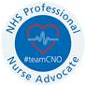

Claire Naylor | Director of Quality and Professionals | Locala Health & Wellbeing | The Eddercliffe Centre WF15 6LP | claire.naylor@locala.org.uk |Teams: 03033309494 Mobile:07720989839

- Barnsley Hospital NHS Foundation Trust
Dear Caroline

Please find below cmments from Barnsley for your Quality account

Barnsley really values the strong and growing partnership with SWYPFT, with teams working more closely together to provide joined-up care. This closer working across acute, community and mental health services is making a difference: helping patients move through services more smoothly, supporting quicker discharges, and enabling more people to be cared for closer to home. It also shows how the relationship between organisations is becoming more open, collaborative and focused on doing what’s best for patients.

As we look ahead to 2026/27, Barnsley Hospital is keen to keep building on this. There’s a shared ambition to keep working together, recognising that strong partnership working is key to improving both the quality of care and the experience for patients and their families.’

Best wishes

Sarah

Sarah Moppett
Chief Nurse
Email: sarah.moppett@nhs.net


- Healthwatch Barnsley
23 Queens Road
Barnsley
S71 1AN

9th June 2026
Dr Caroline Johnson
Chief Nurse/Director of Quality and Professions, Director of Infection Prevention & Control, Caldicott Guardian,South West Yorkshire Partnership Teaching NHS Foundation Trust
Sent via email to QualityGovernanceTeam@swyt.nhs.uk

Healthwatch Barnsley Response to SWYPFT Quality Account 2025–26

Healthwatch Barnsley welcomes the opportunity to review the South West Yorkshire Partnership NHS Foundation Trust (SWYPFT) Quality Account for 2025–26. We recognise the Trust’s commitment to improving quality, safety, and patient experience, and we value the continued focus on community-based and mental health services.

Feedback from Barnsley residents highlights the importance of being listened to and involved in care. However, people report:

- Variable involvement in mental health care planning
- Carers not always being included or informed
- Barriers to engagement for those who are digitally excluded
Access remains a significant issue in Barnsley. With residents reporting:
- Long waits for mental health assessments and follow-up support
- Confusion around referral pathways between services
- Limited communication about support while waiting
We encourage the Trust to improve communication, especially when residents are waiting for assessments and to signpost residents to other support services whilst waiting.

Healthwatch Barnsley recognises the progress made by SWYPFT. Despite ongoing challenges around access, communication, inequalities, and continuity of care. We look forward to continuing to working in partnership with the Trust to ensure that the voices of Barnsley residents remain central to service improvement.

Yours sincerely

Lesley Cooper
Manager, Healthwatch Barnsley

- Barnsley Overview and Scrutiny Committee
Feedback on Draft Quality Accounts – 2025-26
Comments from Barnsley Council’s Overview & Scrutiny Committee

The Overview & Scrutiny Committee would like to thank South West Yorkshire Partnership NHS Foundation Trust for the services they continue to provide to the residents of Barnsley, and for the opportunity to contribute to the Quality Account for 2025-26.

Quality Goals/Priorities

The Committee is satisfied that the majority of priorities for 2025–26 have been successfully delivered or are on track. There is consistent reporting of measureable improvements across key areas including patient experience, patient safety, workforce, and service delivery.
There are a number of areas that have only been partially achieved, and some are currently still in development or in the early implementation phases with full impact expected in future years. These system pressures require continued focus to fully evidence sustained impact and outcomes.
The Committee welcomes developments locally in relation to improving access to services; addressing health inequalities; strengthening workforce and clinical safety; and investment in staff training and capability.
Important Omissions

There do not appear to be any important omissions in the Quality Account.

Public & Patient Involvement

The Trust demonstrates a structured approach to involving patients, carers and the wider public in service design and delivery. It is encouraging to see that work is being undertaken to ensure more inclusive participation so that the Trust can hear from hard to reach groups.

A formal involvement framework has been introduced to support consistent and meaningful engagement, with a strong emphasis on co-production. It is anticipated that this will ensure that lived experience influences service delivery and informs improvement priorities. However, it has been noted by the Committee that this is a work in progress and it will be interesting to see demonstrable impact as a result of this piece of work in the future.

- West Yorkshire Integrated Care Board
