People and Remuneration Committee – 13th May 2025.

Pay Gap Report: Gender, Ethnicity, and Future Disability Monitoring 2025
Executive Summary
This report provides a comprehensive analysis of pay disparities within the South West Yorkshire Partnership NHS Foundation Trust (SWYPFT), focusing on differences between men and women, as well as among various ethnic groups. By comparing our internal data with regional and national statistics, we aim to identify areas for improvement and ensure equitable pay practices.
Producing an annual gender pay gap is a legal requirement and we have met our obligations in this regard. The detailed analysis has been produced and is outlined at Appendix A. In addition, the Yorkshire ICB's high-impact EDI improvement plan includes action 3.2 to eliminate pay gaps by analysing data by protected characteristics and implementing targeted improvement plans.
To meet this ambitious aim, we have successfully met the action to report ethnicity pay gaps for 2024, and a detailed analysis is outlined in Appendix B. We aim to analyse the disability pay gap in 2025, followed by other protected characteristics by 2026. Although the Government does not mandate reporting ethnicity and disability pay gaps, SWYPFT is committed to transparency and fairness by sharing this information proactively. This report underlines our dedication to fostering an inclusive and equitable workplace and our ongoing efforts to address and eliminate pay disparities.

Key Findings
SWYPFT’s median gender pay gap is 5.0%, much lower than the regional average of 10.6%, which shows progress. Our mean gender pay gap is 13.9%, meaning that at the highest-paid levels, differences remain, but we are still doing better than the regional figure of 20.9%. However, we need to focus more on improving representation in senior roles (Bands 8B–8D).
For ethnicity, SWYPFT has mostly closed the pay gap that existed in 2018, with ethnic minority staff now earning slightly more than White staff on average. However, Black employees still earn less than the White benchmark and are underrepresented in senior roles, while Asian and Other staff earn above the White average, which influences the overall figures. National trends show similar disparities, meaning we must take further action to support fair career progression.

Future Disability Pay Gap Reporting
The NHS plans to introduce disability pay gap reporting in 2025, and SWYPFT will include this data in future reports. This step will help ensure fairness and transparency for all staff.

Next Steps
We will combine these findings to produce one cohesive improvement plan linked to our EDI goals and the ICB high priority action. This means we can address all issues together and have a clear strategy for improving equity, diversity, and inclusion in our organisation.
Appendices: The full Gender Pay Gap Report (Appendix A) and Ethnicity Pay Gap Report (Appendix B) are included in the appendices, with detailed analysis and recommendations for future action.

Appendix A: Gender Pay Gap Report – South West Yorkshire Partnership NHS Trust (2025)
Introduction
South West Yorkshire Partnership NHS Foundation Trust (SWYPFT) has a legal duty to report its gender pay gap annually. The gender pay gap reflects the difference in average pay between men and women across the entire organisation and is distinct from equal pay (which compares pay for the same job).
This report presents the Trust’s latest gender pay gap figures (snapshot as of March 2025) and examines how they have changed since 2018. It also compares the Trust’s position with broader NHS and UK benchmarks, using data from authoritative sources (NHS and ONS).
Current Pay Gap (March 2025) – Averages and Medians
In the March 2025 snapshot, male employees had higher average and median hourly pay than female employees at SWYPFT:
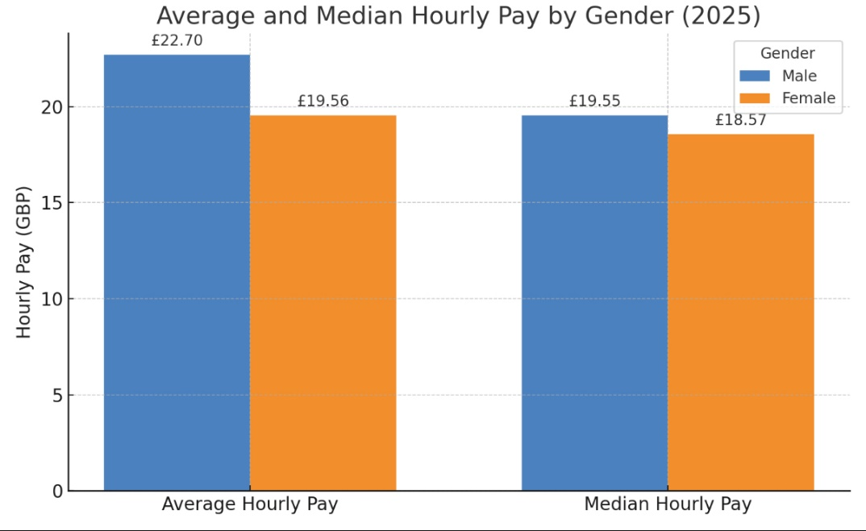
Figure 1: Average vs Median Hourly Pay by Gender (SWYPFT, 2025). Men’s mean hourly rate is £22.70 vs £19.56 for women, a difference of £3.15 (13.9% gap). The median hourly pay is £19.55 for men and £18.57 for women, a £0.98 difference (5.0% gap).
- Mean hourly pay (2025): Men £22.70, Women £19.56 – Pay Gap 13.9% (women earn 86p for every £1 men earn on average).
- Median hourly pay (2025): Men £19.55, Women £18.57 – Pay Gap 5.0% (at the midpoint, women earn 95p for every £1 men earn).
These figures indicate that while the average pay gap is sizeable (driven by more men in higher-paid roles, as discussed later), the median gap is much smaller. A low median gap suggests that at the middle of the pay distribution, male and female earnings are close. This often reflects the effect of national NHS pay scales which ensure similar pay for equivalent roles, combined with the Trust’s workforce composition.
Pay Quartile Distribution (2025)
Examining the gender composition by pay quartiles reveals how men and women are distributed across salary levels. The workforce is predominantly female (about 76% overall), but women are especially concentrated in lower pay quartiles:
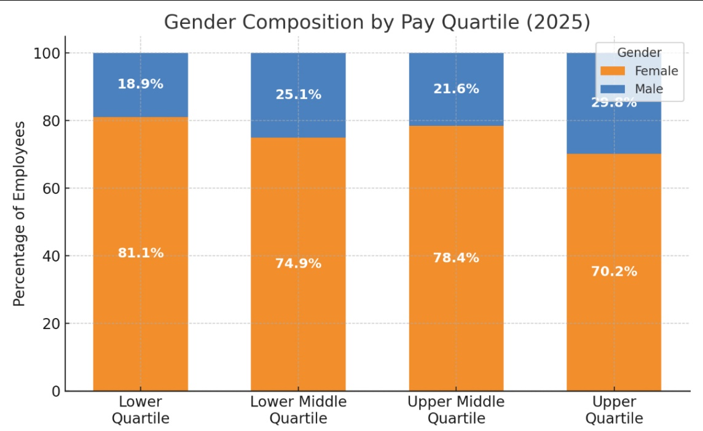
Figure 2: Gender Composition by Pay Quartile (SWYPFT, 2025). Each bar represents a pay quartile (lowest to highest). Orange = female%, Blue = male%. Women form 81% of the lowest-paid quartile, gradually dropping to 70% in the top quartile.
- Lower Quartile (lowest pay group): 81.1% female vs 18.9% male.
- Lower-Middle Quartile: 74.9% female vs 25.1% male.
- Upper-Middle Quartile: 78.4% female vs 21.6% male.
- Upper Quartile (highest pay group): 70.2% female vs 29.8% male.
This quartile breakdown shows men are a smaller minority in lower-paid roles and a larger minority in higher-paid roles. In the highest pay quartile 30% of staff are male, significantly above their representation in the lowest quartile (19%). Women still hold the majority of roles in every pay quartile, but the declining female percentage in the upper quartile indicates that men are more likely to occupy the top-paying positions. This imbalance in senior and higher-paid roles is a key driver of the overall pay gap.
Trend Analysis (2018–2025)
The Trust’s gender pay gap has narrowed over the past several years. Figure 3 illustrates the year-by-year trend in the mean and median pay gap percentages from 2018 through 2025:
Figure 3: Trend in Gender Pay Gap (Mean and Median) at SWYPFT, 2018–2025. Both measures show an overall downward trend (improving). The mean gap (blue line) peaked above 20% in 2019 and has fallen to 13.9% by 2025. The median gap (orange line) dropped dramatically after 2021, reaching 5.0% in 2025.
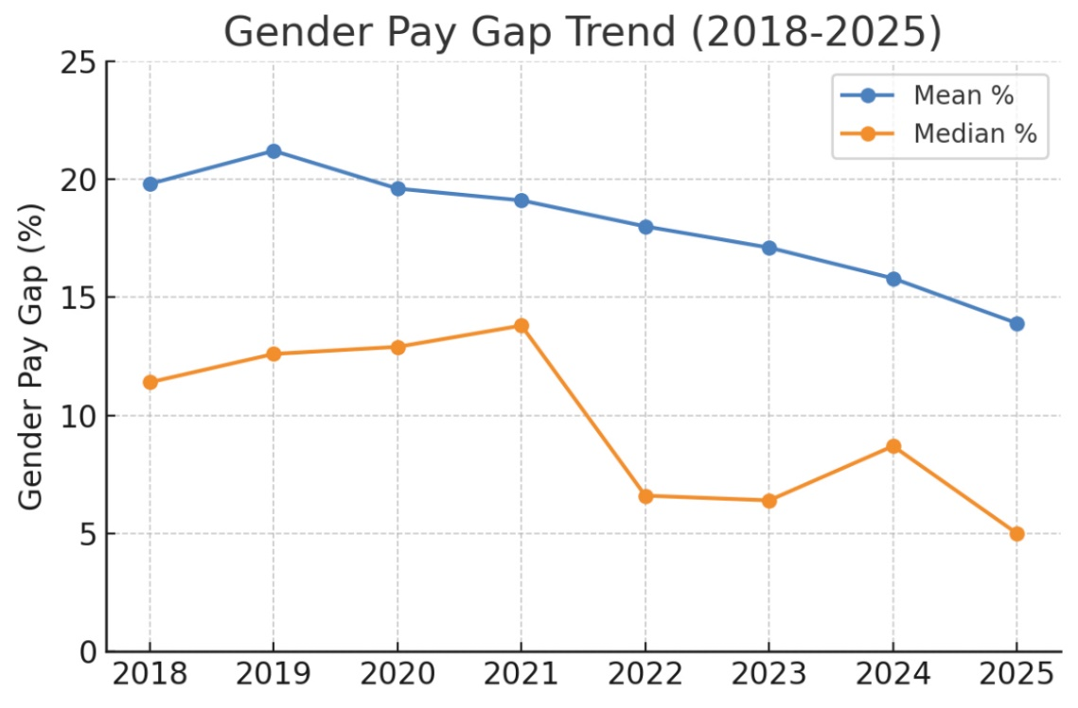
Key observations:
- Mean Pay Gap: Fluctuated around 19–21% in 2018–2020, then decreased steadily from 19.1% (2021) to 13.9% (2025). The mean gap is now about 6 percentage points lower than in 2018. This suggests progress in increasing female representation in higher-paid roles or narrowing of salary differences.
- Median Pay Gap: Held around 11–13% up to 2021, then sharply fell to 6.6% in 2022 and has remained low, at 5.0% in 2025. The median gap reduction implies that the midpoint salaries for men and women have converged significantly in recent years. (The slight uptick to 8.7% in 2024, followed by a drop to 5.0% in 2025, may reflect changes in the workforce structure or specific pay adjustments that temporarily affected the median.)
Overall, the trend is positive: both mean and median gaps have improved since 2018, with the median gap now indicating much more parity at the mid-salary level. The remaining mean gap confirms that some disparity persists at the top end of the pay spectrum, which aligns with the quartile data showing more men in the highest-paid roles.
Comparison with NHS Trusts in the Yorkshire and Humber Region
When benchmarking gender pay gap performance across Yorkshire and the Humber NHS Trusts, South West Yorkshire Partnership NHS Foundation Trust (SWYPFT) stands out for its relatively low mean and median gaps, especially when compared to regional peers.
Mean Gender Pay Gap
As of the most recent comparative data (March 2024), SWYPFT reported a mean gender pay gap of 13.9%, well below the regional average of approximately 20.9%. This places the Trust among the top third of NHS employers in the region in terms of average pay equity.
Several regional Trusts report higher mean gaps:
- Doncaster & Bassetlaw Hospitals NHS FT: 37.6%
- Barnsley Hospital NHS FT: 36.0%
- Calderdale & Huddersfield NHS FT: 27.6%
- Rotherham NHS FT: 27.7%
The chart below presents a visual ranking of mean gender pay gaps by Trust:
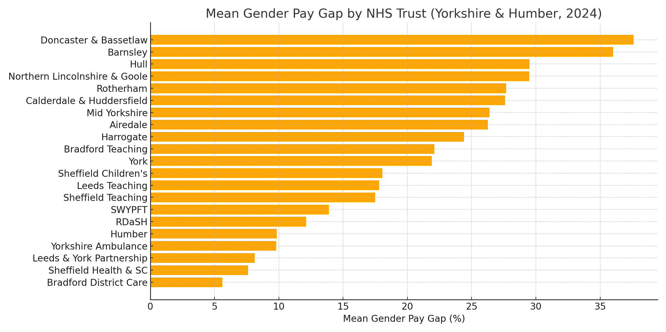
Figure: SWYPFT (13.9%) is positioned well below the regional average, indicating lower disparity in overall average pay compared to most peers.
Median Gender Pay Gap
SWYPFT’s median gender pay gap of 5.0% is particularly strong when compared regionally. The Yorkshire and Humber average median gap is around 10.6%, with many Trusts reporting gaps far exceeding this level.
Trusts with higher median pay gaps include:
- Doncaster & Bassetlaw: 29.4%
- Northern Lincolnshire & Goole: 25.7%
- Rotherham NHS FT: 21.5%
- Calderdale & Huddersfield: 18.9%

Conversely, only a few Trusts reported lower or near-zero median gaps:
- Bradford District Care FT: –6.1% (in favour of women)
- Sheffield Health & Social Care: –1.5%
- Humber Teaching NHS FT: 0.6%
The chart below highlights how SWYPFT compares across the region on this key metric:
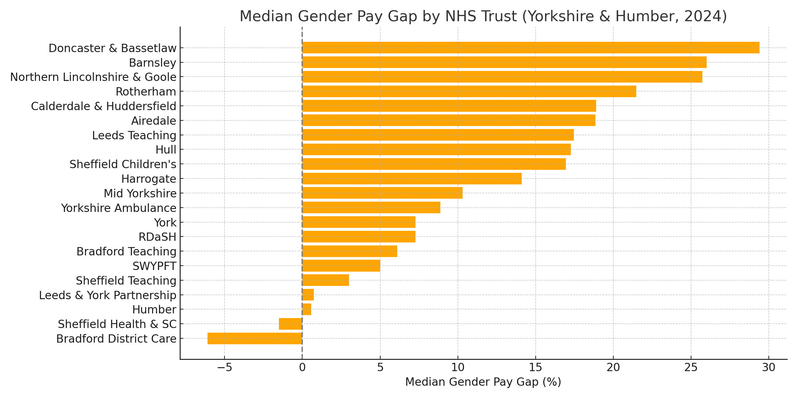
Figure: SWYPFT’s 5.0% median gap places it among the most equitable employers regionally in terms of typical hourly pay.
Summary of Regional Position
- Mean Gap: SWYPFT is better than 16 of 21 regional Trusts
- Median Gap: SWYPFT is in the top 5 most equitable Trusts, and well below the regional median
These figures indicate that SWYPFT is not only making progress over time but is also leading regionally in closing the gender pay gap, particularly at the midpoint of the pay scale where equity impacts the greatest number of staff.

Recommendation
We will combine the ethnicity and gender pay gap insights into the one comprehensive EDI improvement plan. This way, we can address all issues together and have a clear strategy for improving equity, diversity, and inclusion in our organisation.

Conclusion
South West Yorkshire Partnership NHS Trust’s gender pay gap analysis (March 2025) shows that men earn more than women on average. The mean hourly pay gap is 13.9%, while the median gap is 5.0%, indicating that while overall pay differences persist, pay is closer at the middle of the distribution.
Women make up 76% of the workforce yet are more concentrated in lower pay quartiles. In contrast, men are more frequently found in higher-paid roles. For example, 81% of the lowest quartile is female, whereas the top quartile drops to 70% female, revealing an imbalance in senior positions.
The findings suggest that while NHS pay scales promote equal pay for equivalent roles, gender representation at higher levels significantly influences the overall pay gap. Addressing our leadership diversity and career progression opportunities for women could help reduce disparities.

Appendix B: Ethnicity Pay Gap Report (2025), South West Yorkshire Partnership NHS Foundation Trust
Introduction
Analysis of March 2025 data shows that minority ethnic staff at South West Yorkshire Partnership NHS FT have a higher mean hourly pay (£21.88) than White staff (£19.92). However, this masks disparities between specific groups: for example, staff identifying as “Black” earn the lowest mean pay (£18.76) while “Other” and “Asian” staff earn substantially more (around 28 £/hr).
In terms of pay quartiles, minority ethnic representation rises in higher-paid roles (Asian staff double their share from lower to upper quartiles) whereas Black staff are under‐represented at senior pay levels.
Over 2018–2025 the Trust’s pay gap (White vs ethnic minority) has reduced (mean gap from –35% to –10%). These internal findings must be seen in the broader UK context: nationally, significant ethnicity pay gaps persist, especially for Black and other minority workers. Given the diverse and growing workforce in the NHS, ongoing monitoring and targeted action are required.
Key Findings
- Overall Pay Gap (2025): Mean hourly pay for ethnic minority staff (£21.88) exceeds that for White staff (£19.92) by 9.8%. In absolute terms ethnic minority staff earn £1.96 more per hour. (Note: median pay for White British is £18.66 vs ethnic minority medians ranging from £18.51 to £20.15 – see breakdown below.)
- By Ethnic Group: Other staff have the highest mean pay (£28.23), followed by Asian (£27.41); White Other (£22.05) and Mixed (£20.96) are slightly above the overall White mean; White British is about £19.85. Black staff have a mean below White (£18.76, about 5.9% less than White). In median terms, Other and Asian medians (£20.15, £19.92) are above White British/White Other (both £18.66), while Black median (£18.51) is slightly below.
- Pay Quartile Distribution: White British staff dominate every quartile but their share declines slightly at higher pay. Ethnic minority constitute 14.3% of staff in the lowest quartile and 17.1% in the highest. Notably, Asian staff rise from 5.3% of the lowest quartile to 9.9% of the highest, while Black staff drop from 6.8% to 4.2%. This suggests that Asian and Other minorities are more represented in senior pay bands, whereas Black staff are under-represented.
- Trend (2018–2025): The mean pay gap (White vs ethnic minority) has closed significantly over time – from a -35.2% shortfall in 2018 to -9.8% in 2025 (White pay as a percentage of ethnic minority pay). The median gap has fluctuated near parity since 2021.

- This improvement at SWYPFT contrasts with the broader UK trend, where raw gaps have narrowed but underlying factors still disadvantage ethnic minorities.
- UK Labour Market Context: National statistics show that most ethnic minorities earn less than White peers when comparable factors are accounted for. For example, ONS data indicate Black UK-born employees earned 5.6% less than white employees (12/2022 data) and Black workers remain the only group consistently paid less than White employees. The NHS in particular has a large and growing non-UK-born workforce, making equity in pay important.
Figure 1:

- Mean and Median Pay comparing white staff and all ethnic minority (2025): Figure 1 shows ethnic minority staff had a mean hourly pay of £21.88 compared to £19.92 for White staff, reflecting a pay gap of -9.8% in favour of ethnic minority. Median pay was nearly equal (£18.98 for ethnic minority vs £18.66 for White), a -1.7% gap. For context, many UK employers report a positive ethnicity pay gap (minority staff paid less), whereas SWYPFT shows a slightly negative gap on these measures, indicating minority staff earn marginally more on average. The very small median gap here suggests parity at the middle of the pay range, while the wider mean gap is influenced by the distribution of roles (with ethnic minority staff holding some higher-paid positions that lift their average pay).

Figure 2:

- Mean and Median Pay by Ethnicity (2025): Figure 2 above compares mean and median hourly pay for each ethnic group (Asian, Black, Mixed, Other, White British, White Other). This highlights that Other and Asian staff have the highest pay, while Black staff have the lowest.
Figure 3:

- Pay Gap (White vs ethnic minority) by Year: Figure 3 shows the mean and median pay gaps from 2018 to 2025. This shows the narrowing gap (from -35.2% to -9.8% in mean pay) and median gap fluctuating around zero.

Figure 4:

- White and ethnic minority staff by Pay Quartiles (2025): Each bar in Figure 5 below represents one quartile of the pay distribution. The bars are split into the percentage of White (blue) and ethnic minority (green) staff in that quartile.
- Staff by Ethnic Group in Pay Quartiles (2025): Figure 5 below the percentage of each ethnic group in the lower, lower-middle, upper-middle, and upper pay quartiles. White British staff make up the majority in all quartiles but slightly decrease in share toward the upper quartile. Asian staff increase their representation in the upper quartile. Black staff are significantly more represented in the middle quartiles and drop sharply in the upper quartile. Other, Mixed, and White Other categories show consistent but smaller proportions.
Figure 5:
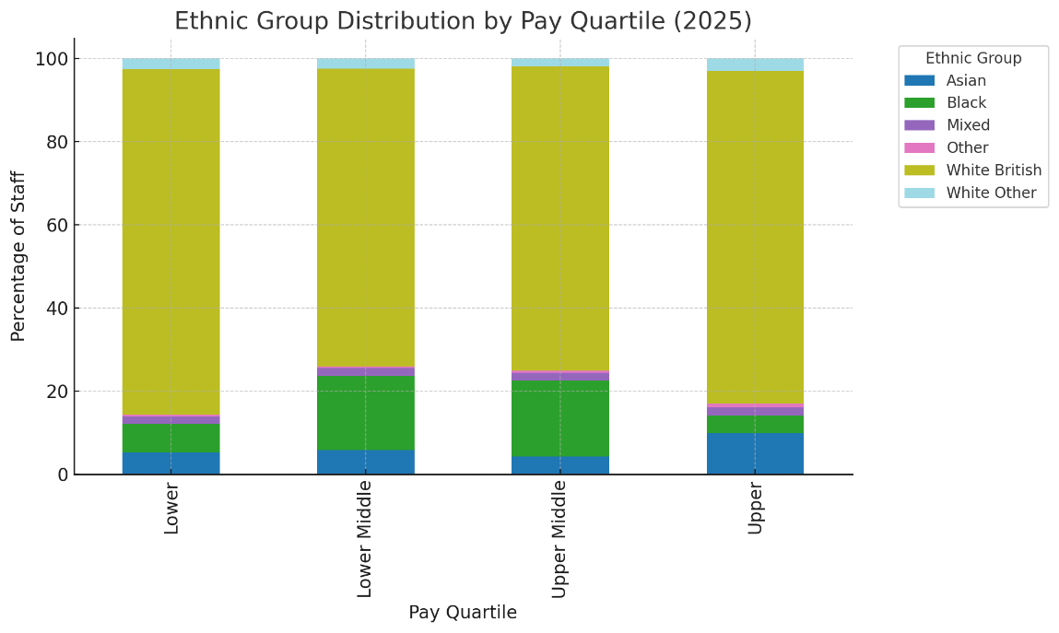
- We see that ethnic minority employees are 14.3% of the lowest-paid quartile and 17.1% of the highest-paid quartile, compared to 82.9%–85.7% White in those bands. In the lower-middle and upper-middle quartiles, ethnic minority make up about 25–26% of staff, with 74–75% White. This visualisation highlights the concentration of minority ethnic staff in the middle pay ranges and their under-representation at the top end. Increasing the green portion of the top quartile bar (to match or exceed 20%) will be a key goal moving forward, so that the leadership reflects the diversity of our overall workforce.
Detailed Ethnic Group Breakdown
Trust data (March 2025) show wide variation by ethnic subgroup. The Other ethnicity category has the highest mean hourly pay at £28.23, substantially above the overall White staff mean (£19.92). Asian staff also earn high mean pay (£27.41). In contrast, Black staff have the lowest mean pay (£18.76), about 5.9% below the White mean. Both White Other (£22.05) and Mixed (£20.96) are modestly above the White British mean (£19.85). Median pay follows a similar pattern: Other (£20.15) and Asian (£19.92) medians exceed the White British median (£18.66), whereas Black median (£18.51) is slightly lower.
These differences indicate that while overall ethnic minority pay is higher, it is driven by some groups. For instance, nearly half of Black staff have pay below £18.77/hr. This aligns with national patterns (ONS shows Black median below White). In contrast, Other and Asian groups pull up the ethnic minority average.
The quartile distribution reinforces this: White British staff make up over 80% of both lowest and highest quartiles, but their share falls from 83% in the lower quartile to 80% in the upper quartile. Asian staff double their share across quartiles (5.3% → 9.9%), and Other staff more than double (0.4% → 0.9%, though numbers are small). Conversely, Black staff comprise 6.8% of the bottom quartile but only 4.2% of the top quartile. This suggests that Black employees face bottlenecks in progression to higher pay bands within the Trust.
Pay Gap Trend Analysis (2018–2025)
Historical data shows the pay gap (mean pay difference between White and ethnic minority) at SWYPFT narrowing. In 2018–2019 White staff earned roughly 35% less per hour than ethnic minority. By 2023 this gap had fallen to around 14%, and by 2024–2025 it stabilised at about 9–10% (favouring ethnic minority). In parallel, the median pay gap turned slightly positive in 2022–2024 (White median just above ethnic minority) and returned to near zero by 2025.
The reduction in SWYPFT’s pay gap may reflect changes in workforce composition. It contrasts with national UK trends: while the raw ethnic pay gap has narrowed overall, ONS and independent analysis emphasise that many minorities (especially Black and Pakistani / Bangladeshi) remain disadvantaged when accounting for occupation, experience, and other factors. In effect, SWYPFT’s improved gap is positive, but national data suggest caution – systemic inequalities can persist even if headline gaps shrink.
Recommendation
We will combine the ethnicity and gender pay gap insights into the one comprehensive EDI improvement plan. This way, we can address all issues together and have a clear strategy for improving equity, diversity, and inclusion in our organisation.
Conclusion
The March 2025 data shows that SWYPFT has largely eliminated the large pay disparity that existed in 2018, with ethnic minority staff now earning slightly more on average than White staff. However, this overall result hides clear disparities for specific groups. Black staff are earning below the White benchmark, and Black employees are under-represented at higher pay levels. Conversely, Asian and Other staff earn notably above the White average, which benefits the aggregate ethnic minority figure.
These findings align partially with UK-wide observations: the only group consistently paid less than Whites is Black staff. The Trust’s Asian and Other pay profiles are higher than many UK comparators. Going forward, care must be taken to ensure that the improvement in aggregate pay equity does not obscure continuing inequities. In particular, the career progression and pay of Black and Mixed-ethnicity staff merit focused attention.
By the nature of NHS employment, SWYPFT’s diverse workforce (many overseas trained) reflects the national picture of an expanding, multicultural service. The Trust’s narrowing pay gap is encouraging, but it should be viewed as progress toward equity.
As this is the first time the Trust has compiled an ethnicity pay gap report, the next step is to develop a targeted action plan in collaboration with our staff networks. This plan will address the identified disparities, ensuring fair career progression and pay for all ethnic groups within the Trust. By involving our diverse workforce, we aim to create strategies that genuinely reflect the experiences and insights of our staff, fostering an inclusive and equitable work environment.

