Gender Pay Gap Report 2026
- Introduction
Organisations are required to report and publish their gender pay gap data within one year of their snapshot date. The Trust’s snapshot date is 31 March 2026, therefore we are required to report and publish our data by 30 March 2027.
In addition to this report, to comply with statutory reporting requirements, Trust data will be reported using the government pay gap reporting portal before 30 March 2027 and will be published on the Trust’s website.
- Purpose
This report presents the Trust’s gender pay gap information using data from the NHS Electronic Staff Record (ESR) and includes our substantive workforce and those engaged via Trust Bank. The reporting hourly pay calculated in accordance with government guidelines.
The report calculates both median and mean averages to measure the gender pay gap – the difference between average hourly rates paid to men and women.
- The Trust’s current gender pay position (31 March 2026)

  - Mean and median hourly rates
The data below shows the comparative mean and median hourly rates for men and women in the Trust on 31 March 2026.
The mean hourly rate is calculated by adding all pay rates together and dividing by the total number of individuals.
The median gender pay gap is the difference in hourly pay between the midpoint female earner and the midpoint male earner. This is calculated by ranking all employees in each group by hourly wage and selecting the middle value. This method reduces the influence of very high or very low salaries on the overall figure.
Measure | Men | Women | Gap
Mean hourly pay | £23.67 | £20.54 | 13.2%
Median hourly pay | £20.27 | £19.33 | 4.7%

In March 2026, male employees had a higher mean and median hourly pay than female employees.
On average, women earned 86.8p for every £1 earned by men, and at the median, women earned 95.3p for every £1 earned by men.
By comparison in 2025, on average, women earned 13.9% less per hour than men and earned 95p for every £1 earned by men.
The improvement in women’s average hourly pay gap either reflects: increasing female representation in higher-paid roles; or that those undertaking higher paid roles are receiving higher rates of pay, as either scenario will influence the average hourly rate. The broadly unchanged median gap indicates that typical pay outcomes for women relative to men have remained stable. That pattern is consistent with national pay bands which help keep pay aligned across comparable roles.
  - Gender distribution by pay quartile
The quartile analysis below shows how men and women are distributed across the pay range. Pay quarters give an indication of women's representation at different levels of the organisation.
Quartile | Female n | Female % | Male n | Male %
Lower quartile | 1,172 | 79.9% | 295 | 20.1%
Lower middle quartile | 1,106 | 75.3% | 362 | 24.7%
Upper middle quartile | 1,096 | 76.6% | 335 | 23.4%
Upper quartile | 1,061 | 70.5% | 444 | 29.5%

Women make up the majority of employees in all pay quartiles. The proportion of men increases steadily at higher pay quartiles, rising from 20.1% in the lower quartile to 29.5% in the upper quartile, whereas the proportion of women in the higher quartile is 9% less than in the lower quartile.
The chart below shows the men to women ratios across the quartiles in 2026. There are approximately 4 women per 1 man in the lower quartile, this ratio narrows as the quartiles increase. In the upper quartile there are 2.4 women per 1 man.
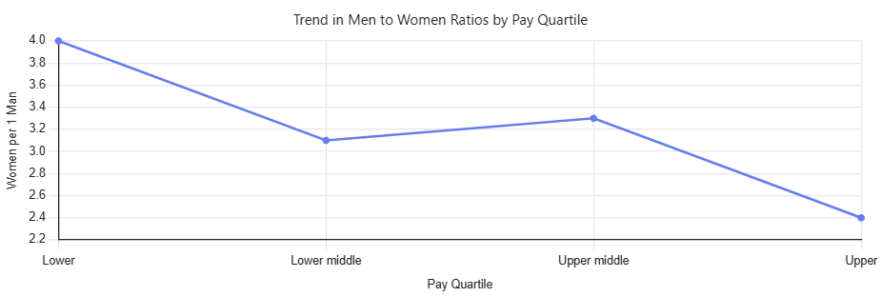

The following bar chart shows the proportion of women to men in each quartile between 2025 and 2026.

- Historic trend analysis
The graph below shows the Trust’s mean and median pay gap since 2018.
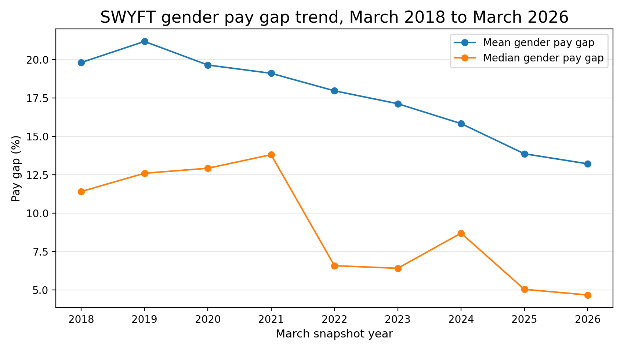
The Trust’s long-term gender pay gap trend shows a clear overall improvement between 2018 and 2026. Over this period, the mean gender pay gap reduced from 19.8% to 13.2%.
The median gender pay gap reduced from 11.4% to 4.7%.
This means the average gap has narrowed by around one third over the period, while the median gap has narrowed by almost three fifths. Taken together, this points to a sustained improvement in pay equity across the organisation, particularly around the middle of the pay distribution.
- Benchmark data
The latest available regional benchmark dataset relates to March 2025. The charts below show the Trust’s benchmark position in relation to the mean and median pay gaps in 2025.
  - Yorkshire and Humber mean pay gap data
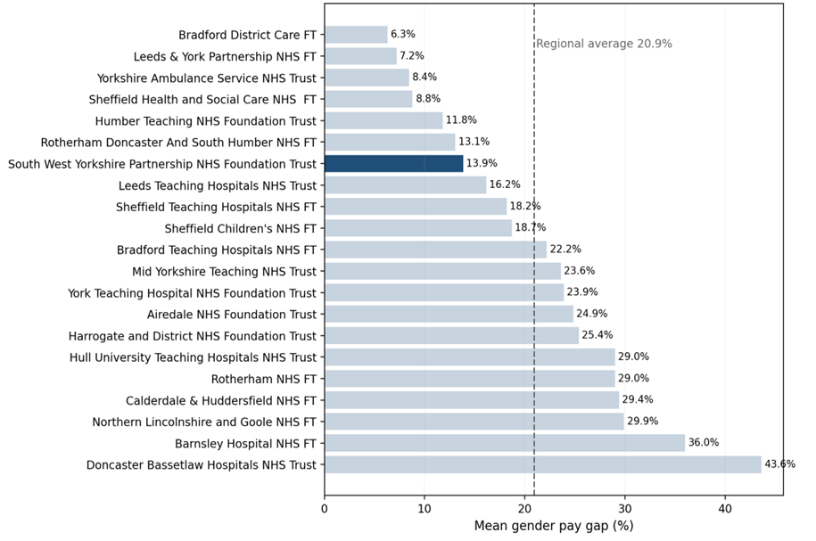
  - Yorkshire and Humber median pay gap data
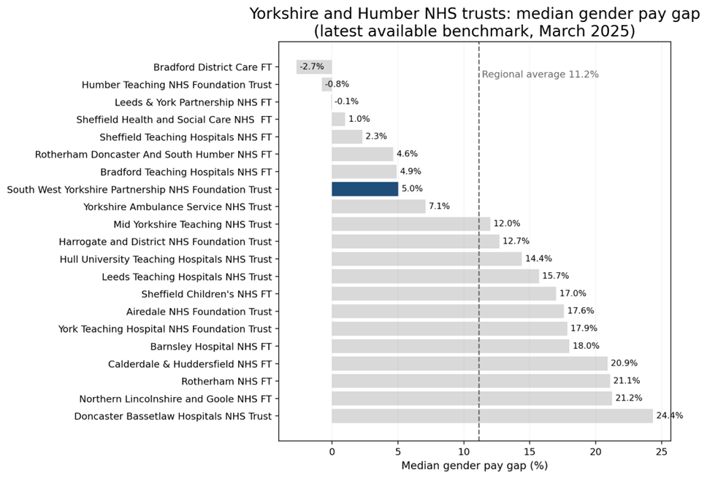
The regional benchmark data show that SWYPFT performs better than most trusts in Yorkshire and Humber on both the mean and median measures.
- Conclusions
The Trust’s gender pay gap remains moderate and is primarily driven by the distribution of men and women across pay quartiles, particularly at senior levels. While women are well represented across the workforce, they are under-represented in the highest-paid roles. Our EDI improvement plan therefore focuses on supporting progression, strengthening recruitment and development pathways and increasing representation at senior levels to maintain progress and further reduce the pay gap through talent and succession planning.

- Recommendations
The committee are asked to note the gender pay gap data and note publication of the data.

Report Authors:
Andrew Prince, Head of Employment Services
Ellie Valentine, Deputy Chief People Officer

